

Setting up Watir and Running the Scripts

Version No | 1.0
Date
Author | Sreedhar Reddy
Approved by
Client Name | Mifos

Revision History

No. | Version No | Nature of change | Affected pages | Approved By
1 | 0.1 | Draft | All
2

Table of Contents

1. Setting up Watir and Running the Scripts 4
2. Through IDE like Eclipse 4
3. Through Command Line without Any IDE like Eclipse 6
4. Test mysql connection using Ruby 7

Setting up Watir and Running the Scripts

The following are the two ways Setting up Watir and run the scripts:
- Through IDE like Eclipse
- Through Command Line with out any IDE like Eclipse

Through IDE like Eclipse

- Download and Install Ruby, Watir and Eclipse
- Install MySql library, steps how to install can be found here http://www.tmtm.org/en/mysql/ruby/
- Download the ruby plug in for eclipse and extract the same into Eclipse folder (http://sourceforge.net/project/showfiles.php?group_id=50233)
- Open the eclipse IDE and go to window ->preferences->ruby->Installed Interpreters add the ruby path with name and path of the ruby (Ex: Name-ruby, Path- C:\ruby\bin\rubyw.exe)

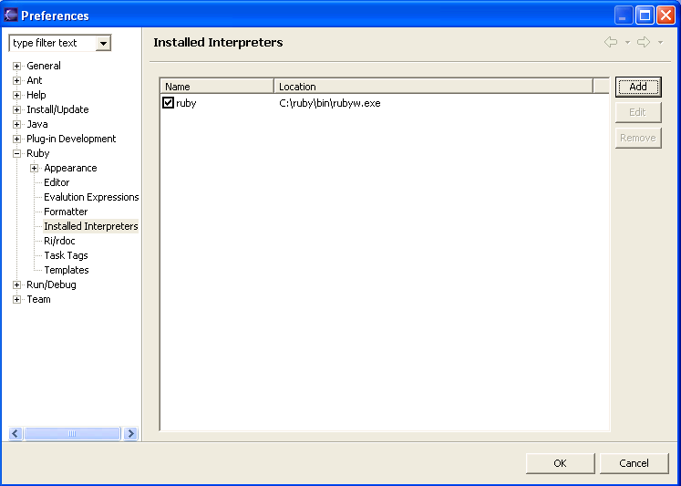
Figure 1

- Install subclipse plug-in for eclipse. From eclipse go to Help ->software updates-> find and install. Then add the URL http://subclipse.tigris.org/update_1.0.x
- Create SVN repository to check out the script from SVN
- Go to File->New->Others->SVN->Checkout Project from SVN and click Next button

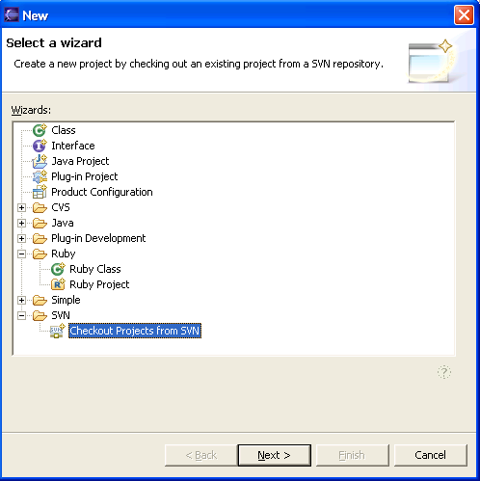
Figure 2

- Select the Create a new repository location option and go to next
- Give the Path of Watir scripts in the URL field (https://mifos.dev.java.net/svn/mifos/trunk/mifos/test/testscripts/Watir ) and go to Next and Finish
- Go to repository and do a check out
- All the scripts are checked out and you can check and run the scripts from here directly
- Folder structure should be as shown in the Figure 3
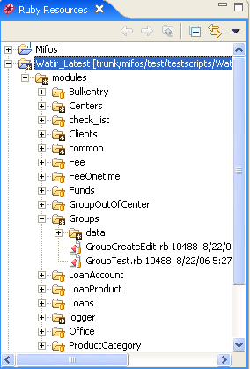
Figure 3

- If you are running the scripts from eclipse then you need to change the following in inputs.rb located under modules/common/inputs.rb
- $test_site. This stores the URL that you want watir to access. For example if you have mifos running on the local machine at port 8080 then this is how $test_site would look
- $test_site="http://localhost:8080/mifos"
- $hostname. Name of the machine where mysql is running
- $dbuser="dbuser” username to connect to the mysql machine
- $dbpwd="mifos" password used to connect to the mysql machine
- $db="mifos" database to connect to on the mysql machine

- To run Groups go to GroupsTest.rb file from eclipse, then right click->run as->Ruby Application

Through Command Line without Any IDE like Eclipse

- First install Ruby
- Set the path to the ruby folder in the path Environment variable.
- Install watir
- Do checkout for the Watir scripts from https://mifos.dev.java.net/svn/mifos/trunk/mifos/test/testscripts/Watir into any
- one of your folders by using SVN Checkout or by using Tortoise SVN.
- If you are running from command line say the script for Groups, which is located at modules/Groups then you need to first issue a cd command to folder where checked out the Watir scripts (ex: c:\watir)
- Here try running the script using the following command Ruby -I ./modules modules/Groups/GroupsTest.rb
- Option I in the above command tells ruby to propend the directories to the $Load_Path variable.

Test mysql connection using Ruby

- Open command prompt and run the following command:-
C:\> gem install mysql
This will give the following result:

Attempting local installation of 'mysql'
Local gem file not found: mysql*.gem
Attempting remote installation of 'mysql'
Updating Gem source index for: http://gems.rubyforge.org
Select which gem to install for your platform (i386-mswin32)
1. mysql 2.7.1 (mswin32)
2. mysql 2.7 (ruby)
3. mysql 2.6 (ruby)
4. mysql 2.5.1 (ruby)
5. Cancel installation
>

- Now Type 1 and press Enter.
The following message will be displayed:
Successfully installed mysql-2.7.1-mswin32
Installing RDoc documentation for mysql-2.7.1-mswin32...

- Open the SCiTE Editor which comes along with ruby and follow the below steps:
  - Copy the code below to a new file
require 'mysql'
begin
# connect to the MySQL server
dbh = Mysql.real_connect("aditidt128", "dilipm", "mifos", "mifos")
# get server version string and display it
puts "Server version: " + dbh.get_server_info
rescue MysqlError => e
print "Error code: ", e.errno, "\n"
print "Error message: ", e.error, "\n"
ensure
# disconnect from server
dbh.close
end

  - Save it as mysql.rb and press F5 to check whether you are able to connect to the db server.
  - Replace username and password with the appropriate values. If the connection is successful the version of the mysql installed will be displayed.

