PANDUAN CI/CD
SIAP + DOVERUNNER
GitHub Actions
Android (sealing.jar) · iOS (AppSealingSDK)
Versi 1.0 | 27 Juli 2026
Project: SIAP (Flutter)
API Production:
https://division-follow-louis-happen.trycloudflare.com/v1

Daftar Isi

Jika daftar isi kosong: klik kanan → Update Field → Update entire table.

Informasi Dokumen
Judul | CI/CD DoveRunner — Project SIAP (GitHub Actions)
Workflow Android | .github/workflows/build-android-sealed.yml
Workflow iOS | .github/workflows/build-ios-sealed.yml
Script Android | android/scripts/doverunner-seal.sh
SDK iOS | ios/AppSealingSDK/Tools/generate_hash
Package | com.miftah.siap
Runner Android | ubuntu-latest
Runner iOS | macos-15
API Base URL | https://division-follow-louis-happen.trycloudflare.com/v1

# CI/CD DoveRunner — Project SIAP
Panduan integrasi GitHub Actions untuk build otomatis APK/IPA ter-seal DoveRunner pada project Flutter SIAP.
Platform | Workflow | Runner
**Android** | `.github/workflows/build-android-sealed.yml` | `ubuntu-latest`
**iOS** | `.github/workflows/build-ios-sealed.yml` | `macos-15`

Item | Nilai
API production | `https://division-follow-louis-happen.trycloudflare.com/v1`
Package | `com.miftah.siap`

Daftar isi
Dokumen | Isi
[OVERVIEW.md](./OVERVIEW.md) | Arsitektur CI/CD Android
[GITHUB_ACTIONS.md](./GITHUB_ACTIONS.md) | Detail workflow Android step-by-step
[SECRETS.md](./SECRETS.md) | GitHub Secrets Android & sealing.jar
[LOCAL_BUILD.md](./LOCAL_BUILD.md) | Build & seal Android lokal
[IOS_CI.md](./IOS_CI.md) | **Checklist & langkah khusus CI/CD iOS**
[IOS_CHECKLIST.md](./IOS_CHECKLIST.md) | Lembar centang cepat iOS
[TROUBLESHOOTING.md](./TROUBLESHOOTING.md) | Exit code, rollback, uji APK/IPA

Dokumen Word
File | Keterangan
**SIAP-DoveRunner-CICD-GitHub.docx** | Panduan lengkap Android + **checklist iOS**

Regenerate:
cd siap/docs/cicd-doverunner
python3 generate_docx.py

Quick start — Android
- Unduh **AppSealing_CI_Integration_Tool_latest** dari DoveRunner Console
- Set secret `DOVERUNNER_AUTH_KEY` di GitHub
- Upload `sealing.jar` ke GitHub Release tag `doverunner-tools`
- **Actions → Build Android (DoveRunner sealed) → Run workflow**
- Download artifact `sealed-apk-release`

Quick start — iOS
- Salin `ios/AppSealingSDK` → `git add -f` → push (repo private)
- Isi 5 secret `IOS_*` (lihat [IOS_CI.md](./IOS_CI.md))
- **Actions → Build iOS (DoveRunner sealed) → Run workflow**
- Download artifact `siap-ios-sealed-ipa`
Lembar centang: IOS_CHECKLIST.md

Overview — Arsitektur CI/CD DoveRunner

Tujuan
Otomatisasi build APK release Flutter SIAP dan proses sealing DoveRunner melalui GitHub Actions, sehingga tim mendapat artifact APK ter-proteksi tanpa manual upload ke Console.

Diagram arsitektur CI/CD
Arsitektur CI/CD DoveRunner SIAP
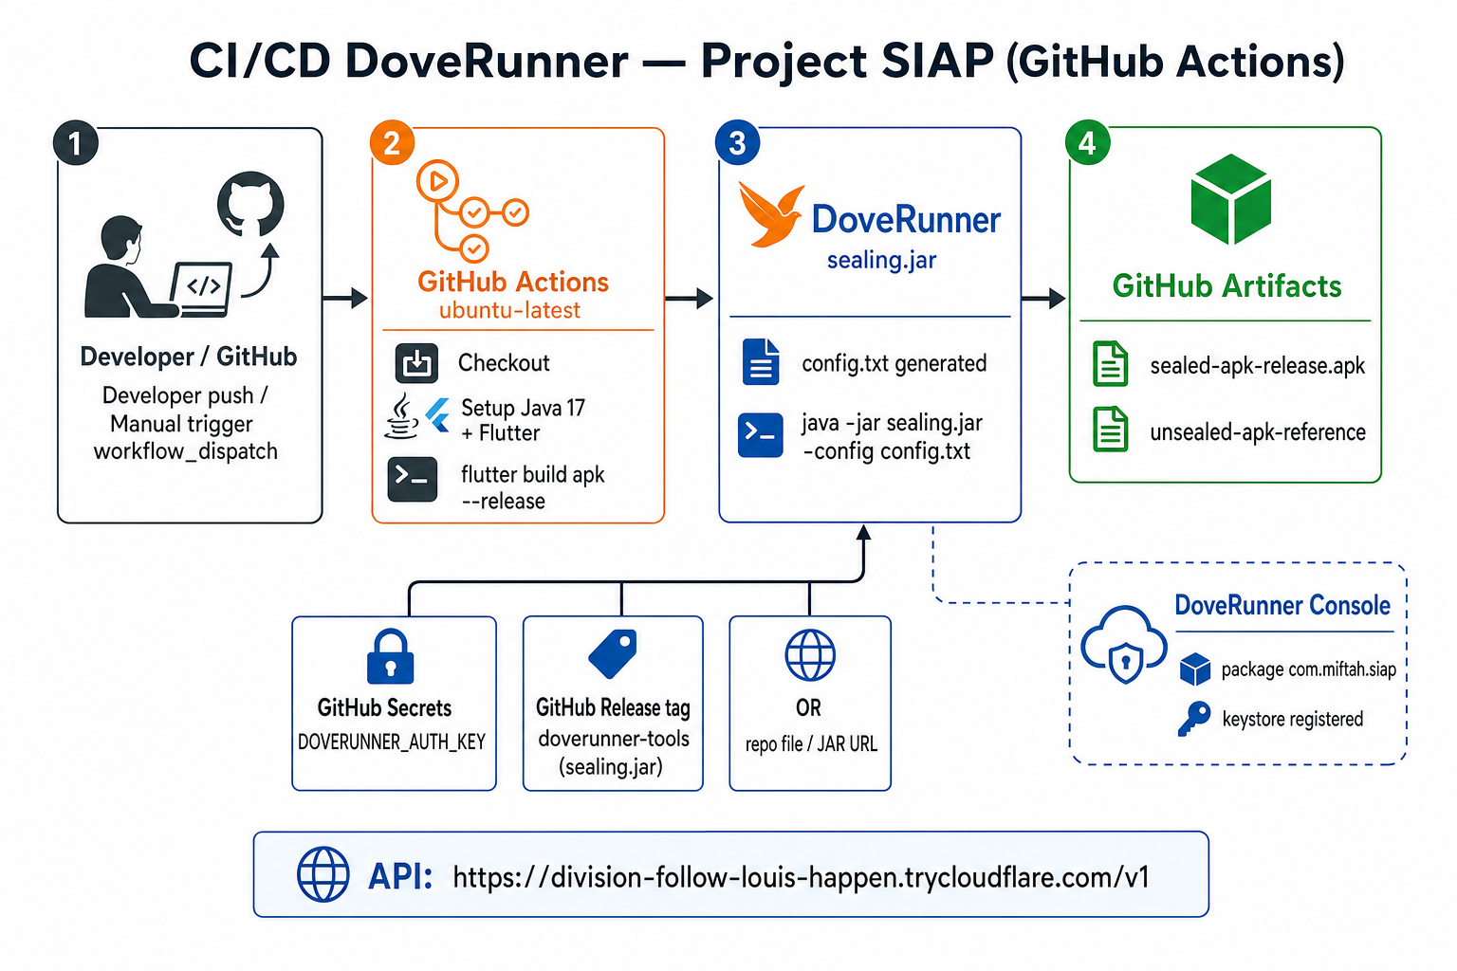

Diagram alur step GitHub Actions
Alur step-by-step build-android-sealed.yml
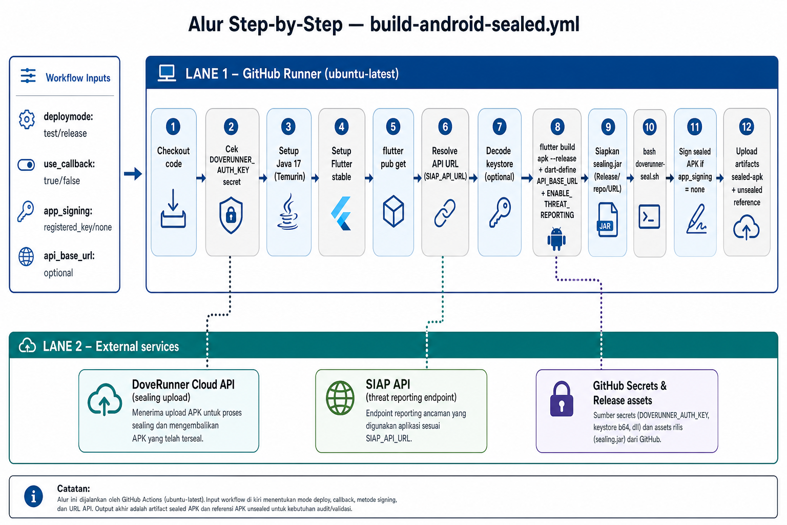

Ringkasan alur
Developer / Tim
│
▼ (manual: workflow_dispatch)
GitHub Actions (ubuntu-latest)
├── Setup Java 17 + Flutter
├── flutter build apk --release
├── Ambil sealing.jar (Release / repo / URL)
├── doverunner-seal.sh → config.txt
├── java -jar sealing.jar -config config.txt
└── Upload artifact APK ter-seal

Komponen di repository SIAP
Komponen | Path | Fungsi
Workflow CI Android | `.github/workflows/build-android-sealed.yml` | Pipeline utama
Workflow CI iOS | `.github/workflows/build-ios-sealed.yml` | IPA sealed (macOS)
Script seal | `android/scripts/doverunner-seal.sh` | Generate config + jalankan jar
Template config | `android/doverunner/config.txt.example` | Basis config AppSecurity 3.x
Contoh resmi | `android/doverunner/examples/` | Template DoveRunner resmi
Threat callback | `android/.../ThreatReceiver.kt` | Monitoring Mode broadcast
Threat reporting | `lib/core/security/threat_guard.dart` | Flutter → API

Trigger workflow
Workflow Android tidak otomatis pada setiap push — hanya `workflow_dispatch` (manual).
Alasan | Keterangan
Quota sealing | Sealing DoveRunner memakai kuota lisensi
Secret | Butuh CLI key & sealing.jar
Kontrol release | Tim memilih `test` vs `release`

Jalankan: GitHub → Actions → Build Android (DoveRunner sealed) → Run workflow

Input workflow
Input | Default | Keterangan
`deploymode` | `release` | `test` = watermark uji; `release` = produksi
`use_callback` | `true` | Monitoring Mode — threat via broadcast, bukan kill app
`app_signing` | `registered_key` | Keystore terdaftar di DoveRunner Console
`api_base_url` | *(secret)* | Override URL API SIAP

Output artifact
Artifact | Retention | Isi
`sealed-apk-{deploymode}` | 14 hari | APK final ter-seal DoveRunner
`unsealed-apk-reference` | 3 hari | APK release sebelum seal (referensi)

Integrasi runtime setelah seal
APK ter-seal
→ DoveRunner Runtime Protection (root, emulator, tampering, ...)
→ ThreatReceiver.kt (broadcast)
→ Flutter ThreatGuard
→ POST /v1/security/threats
→ SIAP API (PostgreSQL)
API production: https://division-follow-louis-happen.trycloudflare.com/v1

Paket resmi DoveRunner CLI
Unduh dari DoveRunner Console → Organization → Third party → CLI Tool for Android AppSealing.
AppSealing_CI_Integration_Tool_latest/
├── sealing.jar (~2.5 MB)
├── CLI Key.txt (auth key CI)
└── Document_EN/
├── config.txt
└── examples/
└── config-for-native-v3.txt
Mode eksekusi resmi:
java -jar sealing.jar -config ./config.txt

Referensi resmi DoveRunner
- [CI/CD Pipeline Integration](https://docs.doverunner.com/mobile-app-security/android/cicd/)
- [How to Integrate](https://docs.doverunner.com/mobile-app-security/android/cicd/how-to-integrate-with-cicd-pipeline/)
- [Basic Configuration](https://docs.doverunner.com/mobile-app-security/android/cicd/basic-configuration/)
- [Troubleshooting](https://docs.doverunner.com/mobile-app-security/android/cicd/troubleshoot/)

GitHub Actions — Detail Workflow
File: .github/workflows/build-android-sealed.yml

Spesifikasi workflow
Property | Nilai
Nama | Build Android (DoveRunner sealed)
Trigger | `workflow_dispatch` (manual)
Runner | `ubuntu-latest`
Timeout | 90 menit
Concurrency | Satu build per branch (`cancel-in-progress`)

Diagram step
Alur step workflow


Step-by-step

1. Checkout
uses: actions/checkout@v5
Clone repository SIAP ke runner GitHub.

2. Cek prasyarat secrets
Memvalidasi DOVERUNNER_AUTH_KEY ada. Jika kosong → workflow gagal.

3. Setup Java 17
uses: actions/setup-java@v5
distribution: temurin
java-version: 17
Dibutuhkan untuk menjalankan sealing.jar.

4. Setup Flutter
uses: subosito/flutter-action@v2
channel: stable
cache: true

5. Install dependencies
flutter pub get

6. Resolve API URL
Prioritas URL API:
- Input manual `api_base_url` (workflow dispatch)
- Secret `SIAP_API_URL`
- Default: `https://division-follow-louis-happen.trycloudflare.com/v1`
Digunakan saat build:
flutter build apk --release \
--dart-define=API_BASE_URL=<url> \
--dart-define=ENABLE_THREAT_REPORTING=true

7. Decode keystore (opsional)
Jika android/key.properties tidak ada di repo, workflow decode dari secrets:
Secret | Fungsi
`ANDROID_KEYSTORE_BASE64` | File keystore release
`ANDROID_KEYSTORE_PASSWORD` | Password keystore
`ANDROID_KEY_ALIAS` | Alias key
`ANDROID_KEY_PASSWORD` | Password key

Output: android/app/siap-release.keystore + android/key.properties

8. Build Flutter release APK
flutter build apk --release \
--dart-define=API_BASE_URL=<resolved_url> \
--dart-define=ENABLE_THREAT_REPORTING=true
Output: build/app/outputs/flutter-apk/app-release.apk

9. Siapkan DoveRunner CLI (sealing.jar)
Urutan pencarian sealing.jar:
Prioritas | Sumber
1 | File sudah ada di repo (`android/doverunner/sealing.jar`)
2 | Secret `DOVERUNNER_SEALING_JAR_URL` (unduh via curl)
3 | GitHub Release tag **`doverunner-tools`** asset `sealing.jar`
4 | Error — jar tidak ditemukan

**Catatan:** `sealing.jar` (~2.5 MB) **tidak bisa** disimpan di GitHub Secret (batas 64 KB).

10. Seal APK
Environment variables ke doverunner-seal.sh:
Variable | Sumber
`DOVERUNNER_AUTH_KEY` | Secret
`DOVERUNNER_API_URL` | Secret (opsional)
`DOVERUNNER_DEPLOY_MODE` | Input `deploymode`
`DOVERUNNER_USE_CALLBACK` | Input `use_callback`
`DOVERUNNER_APP_SIGNING` | Input `app_signing`
`DOVERUNNER_SEALING_PRESET_NAME` | Secret (opsional)
`DOVERUNNER_SEALING_JAR` | `android/doverunner/sealing.jar`

Perintah:
bash android/scripts/doverunner-seal.sh
Output: build/app/outputs/flutter-apk/app-release-sealed.apk

11. Sign sealed APK (kondisional)
Hanya jika app_signing=none:
apksigner sign ... app-release-sealed.apk
Butuh secrets keystore lengkap.

12. Upload artifacts
Artifact name | File
`sealed-apk-{deploymode}` | `app-release-sealed.apk`
`unsealed-apk-reference` | `app-release.apk`

Download: Actions run → Artifacts (bawah halaman run).

Script `doverunner-seal.sh`
Algoritma script:
- Salin `config.txt.example` → `config.txt`
- Isi field: `url`, `authkey`, `srcapk`, `sealedapk`, `deploymode`, `app_signing`, `use_callback_feature`
- Jalankan `java -jar sealing.jar -config config.txt`
Variabel | Default
`DOVERUNNER_API_URL` | `https://api.appsealing.com/covault/gw`
`DOVERUNNER_DEPLOY_MODE` | `release`
`DOVERUNNER_APP_SIGNING` | `registered_key`
`DOVERUNNER_USE_CALLBACK` | `true`

Region Jakarta (opsional):
DOVERUNNER_API_URL=https://jakarta-api.appsealing.com/covault/gw

Opsi config penting (AppSecurity 3.x)
Opsi config | Nilai SIAP | Keterangan
`service_type` | `NATIVE_AOS` | Flutter = native Android
`use_callback_feature` | `true` | Broadcast threat, bukan force-close
`app_signing` | `registered_key` | Keystore terdaftar console
`deploymode` | `test` / `release` | Test = watermark

DoveRunner Console — checklist sebelum CI
No | Tindakan
1 | Registrasi package `com.miftah.siap`
2 | Upload keystore release (`registered_key`)
3 | Aktifkan **Use callback for threat handling**
4 | Pastikan **CLI / enterprise key aktif**
5 | (Opsional) Buat sealing preset

Menjalankan workflow
- Buka repo `siap` di GitHub
- Tab **Actions**
- Pilih **Build Android (DoveRunner sealed)**
- Klik **Run workflow**
- Pilih branch (biasanya `main`)
- Set input → **Run workflow**
- Tunggu hijau → download artifact

GitHub Secrets & sealing.jar
Repository → Settings → Secrets and variables → Actions → New repository secret

Secrets wajib
Secret | Wajib | Isi
`DOVERUNNER_AUTH_KEY` | **Ya** | CLI Key dari `CLI Key.txt` (paket AppSealing_CI_Integration_Tool)

Secrets disarankan
Secret | Isi | Contoh
`SIAP_API_URL` | Base URL API produksi | `https://division-follow-louis-happen.trycloudflare.com/v1`

Secrets opsional
Secret | Fungsi
`DOVERUNNER_API_URL` | Override API DoveRunner (default global; Jakarta: `https://jakarta-api.appsealing.com/covault/gw`)
`DOVERUNNER_SEALING_PRESET_NAME` | Nama preset sealing di Console
`DOVERUNNER_SEALING_JAR_URL` | URL unduh `sealing.jar` jika tidak pakai Release/repo
`ANDROID_KEYSTORE_BASE64` | Keystore release (base64)
`ANDROID_KEYSTORE_PASSWORD` | Password keystore
`ANDROID_KEY_ALIAS` | Alias key (`siap`)
`ANDROID_KEY_PASSWORD` | Password key

Keystore secrets — kapan wajib?
Skenario | Keystore secrets
`app_signing=registered_key` + keystore sudah di Console | Opsional di CI (signing via DoveRunner)
`app_signing=none` | **Wajib** — sign manual setelah seal
Repo sudah punya `android/key.properties` | Tidak perlu decode di CI

sealing.jar — mengapa tidak di Secret?
Fakta | Nilai
Ukuran `sealing.jar` | ~2.5 MB
Base64 encoded | ~3.3 MB
Batas GitHub Secret | **64 KB**

Paste base64 ke secret tidak akan berhasil.

Opsi A — GitHub Release (disarankan)
Upload sekali, CI unduh otomatis:
cd AppSealing_CI_Integration_Tool_latest
gh release create doverunner-tools sealing.jar \
--repo miftah-sdt/siap \
--title "DoveRunner CLI (internal)" \
--notes "Asset sealing.jar untuk CI. Jangan didistribusikan."
# Update asset yang sudah ada:
gh release upload doverunner-tools sealing.jar --repo miftah-sdt/siap --clobber
Workflow mencari release tag `doverunner-tools` dengan asset `sealing.jar`.

Opsi B — Commit ke repo private
cp AppSealing_CI_Integration_Tool_latest/sealing.jar siap/android/doverunner/
cd siap
git add -f android/doverunner/sealing.jar
git commit -m "chore: add sealing.jar for CI (private repo)"
git push
File di .gitignore default — wajib git add -f.

Opsi C — URL unduh (secret)
Host di storage pribadi, set secret:
DOVERUNNER_SEALING_JAR_URL=https://your-storage/sealing.jar

Yang jangan di-commit
File | Alasan
`android/doverunner/config.txt` | Berisi `authkey`
`CLI Key.txt` | Credential
`sealing.jar.b64` | Tidak diperlukan; gunakan Release/repo/URL

Ringkasan secret untuk tim
Copy checklist ini saat onboarding:
[ ] DOVERUNNER_AUTH_KEY
[ ] SIAP_API_URL = https://division-follow-louis-happen.trycloudflare.com/v1
[ ] sealing.jar via Release doverunner-tools (atau opsi B/C)
[ ] Keystore diregistrasi di DoveRunner Console
[ ] (Opsional) DOVERUNNER_SEALING_PRESET_NAME
[ ] (Opsional) ANDROID_KEYSTORE_* jika app_signing=none

Build & Seal Lokal
Panduan build dan sealing di mesin developer (Windows/Linux/macOS) tanpa GitHub Actions.

Prasyarat
Tool | Versi
Flutter | 3.12+ stable
JDK | 17
Paket CLI | `AppSealing_CI_Integration_Tool_latest`

Langkah 1 — Build APK release
cd siap
flutter build apk --release \
--dart-define=API_BASE_URL=https://division-follow-louis-happen.trycloudflare.com/v1 \
--dart-define=ENABLE_THREAT_REPORTING=true
Output: build/app/outputs/flutter-apk/app-release.apk

Langkah 2 — Salin sealing.jar
cp ../AppSealing_CI_Integration_Tool_latest/sealing.jar android/doverunner/

Langkah 3 — Set environment & seal
export DOVERUNNER_AUTH_KEY="$(sed -n 's/^CLI Key: //p' ../AppSealing_CI_Integration_Tool_latest/CLI\ Key.txt | tr -d '\r\n')"
export DOVERUNNER_DEPLOY_MODE=release
export DOVERUNNER_USE_CALLBACK=true
export DOVERUNNER_APP_SIGNING=registered_key
# Opsional region Jakarta:
# export DOVERUNNER_API_URL=https://jakarta-api.appsealing.com/covault/gw
bash android/scripts/doverunner-seal.sh
Output: build/app/outputs/flutter-apk/app-release-sealed.apk

Windows (Git Bash / PowerShell)
PowerShell — set auth key manual:
$env:DOVERUNNER_AUTH_KEY = "CLI_KEY_ANDA"
$env:DOVERUNNER_DEPLOY_MODE = "test"
$env:DOVERUNNER_USE_CALLBACK = "true"
$env:DOVERUNNER_APP_SIGNING = "registered_key"
bash android/scripts/doverunner-seal.sh

Uji APK sealed
adb install -r build/app/outputs/flutter-apk/app-release-sealed.apk
adb logcat | grep -E "ThreatTracker|ThreatGuard|ThreatReceiver"

deploymode: test vs release
Mode | Kegunaan | Catatan
`test` | Uji integrasi, QA | Watermark DoveRunner, quota berbeda
`release` | Distribusi produksi | Tanpa watermark test

Mulai dengan test sebelum release.

CI/CD iOS — Checklist Khusus (DoveRunner Sealed)
Panduan menjalankan workflow Build iOS (DoveRunner sealed) di GitHub Actions.
Item | Nilai
Workflow | `.github/workflows/build-ios-sealed.yml`
Runner | `macos-15`
Trigger | Manual (`workflow_dispatch`)
Bundle ID | `com.miftah.siap`
SDK path | `ios/AppSealingSDK/Tools/generate_hash`

Credential dari Windows: [IOS_SIGNING_WINDOWS.md](../IOS_SIGNING_WINDOWS.md)
Detail lengkap: [IOS_DOVERUNNER_CI.md](../IOS_DOVERUNNER_CI.md)

Prasyarat mutlak
No | Item | Wajib | Keterangan
1 | Apple Developer Program | **Ya** | $99/tahun — tanpa ini workflow gagal
2 | DoveRunner iOS SDK | **Ya** | Folder `ios/AppSealingSDK/`
3 | GitHub Secrets iOS (5 buah) | **Ya** | Certificate + profile + Team ID
4 | Repo GitHub **private** | **Ya** | SDK berlisensi — jangan public
5 | Mac lokal | Tidak | Build di runner GitHub

Checklist sebelum Run workflow
Centang semua item berikut:
[ ] ios/AppSealingSDK/Tools/generate_hash ada di repo (sudah di-push)
[ ] IOS_DIST_CERT_P12_BASE64 — base64 file .p12 (Apple Distribution)
[ ] IOS_DIST_CERT_PASSWORD — password export .p12
[ ] IOS_MOBILEPROVISION_BASE64 — base64 provisioning profile
[ ] IOS_TEAM_ID — Team ID 10 karakter Apple
[ ] IOS_PROFILE_NAME — nama persis provisioning profile
[ ] (Opsional) SIAP_API_URL — https://division-follow-louis-happen.trycloudflare.com/v1
[ ] App ID com.miftah.siap terdaftar di Apple Developer
[ ] Bundle ID terdaftar di DoveRunner Console
[ ] UDID iPhone terdaftar (jika export_method = release-testing / ad-hoc)

Langkah 1 — Salin AppSealingSDK ke repo SIAP
SDK dari DoveRunner Console biasanya diunduh terpisah. Di mesin lokal:
cd siap
# Contoh: SDK ada di folder sibling (sesuaikan path)
cp -r "../ios/AppSealingSDK_Xcode_1.14.0.0-AdhocEnabled_[com.miftah.siap]/AppSealingSDK" ios/
# Pastikan tool sealing executable
chmod +x ios/AppSealingSDK/Tools/generate_hash
# Verifikasi
test -x ios/AppSealingSDK/Tools/generate_hash && echo "OK"
SDK sudah disalin ke siap/ios/AppSealingSDK. Commit ke repo private:
cd siap
git add -f ios/AppSealingSDK
git commit -m "chore: add AppSealingSDK for iOS CI (private repo)"
git push
Folder `AppSealingSDK/` ada di `.gitignore` — wajib `git add -f`.

Langkah 2 — Isi GitHub Secrets
Repo → Settings → Secrets and variables → Actions
Secret GitHub | Isi | Catatan
`IOS_DIST_CERT_P12_BASE64` | Base64 `.p12` | Apple **Distribution** certificate
`IOS_DIST_CERT_PASSWORD` | Password `.p12` | Password saat export pkcs12
`IOS_MOBILEPROVISION_BASE64` | Base64 `.mobileprovision` | Ad Hoc atau App Store profile
`IOS_TEAM_ID` | `AB12CD34EF` | developer.apple.com → Membership
`IOS_PROFILE_NAME` | `SIAP AdHoc` | Nama **persis** di portal Apple

Mapping error CI → secret yang benar
Pesan error di log Actions memakai alias singkat; secret GitHub aslinya:
Pesan error CI | Secret GitHub yang harus diisi
`Secret CERT belum di-set` | `IOS_DIST_CERT_P12_BASE64`
`Secret CERT_PW belum di-set` | `IOS_DIST_CERT_PASSWORD`
`Secret PROFILE belum di-set` | `IOS_MOBILEPROVISION_BASE64`
`Secret TEAM_ID belum di-set` | `IOS_TEAM_ID`
`Secret PROFILE_NAME belum di-set` | `IOS_PROFILE_NAME`

Encode base64 (Git Bash / Windows)
base64 -w0 ios_dist.p12 > ios_dist_p12.b64.txt
base64 -w0 SIAP_AdHoc.mobileprovision > profile.b64.txt
Copy seluruh isi file .b64.txt ke secret (tanpa spasi/baris baru).
Panduan buat certificate dari Windows: IOS_SIGNING_WINDOWS.md

Langkah 3 — Buat credential Apple (ringkas)
- **App ID** — `com.miftah.siap` di developer.apple.com
- **Team ID** → secret `IOS_TEAM_ID`
- **Apple Distribution certificate** → export `.p12` → base64
- **Device UDID** — daftarkan iPhone (untuk ad-hoc)
- **Ad Hoc profile** — pilih cert + device → download `.mobileprovision`
- Nama profile → secret `IOS_PROFILE_NAME`

Langkah 4 — Jalankan workflow
- GitHub → repo **siap** → tab **Actions**
- Pilih **Build iOS (DoveRunner sealed)**
- Klik **Run workflow**
- Pilih branch (`main`)
- Input:
Input | Pilihan | Kapan dipakai
`export_method` | `release-testing` | Ad-hoc — install langsung ke iPhone (UDID terdaftar)
`export_method` | `app-store-connect` | TestFlight / App Store
`api_base_url` | opsional | Override `SIAP_API_URL`

- Tunggu status **hijau** (success)
- Download artifact **`siap-ios-sealed-ipa`**

Alur workflow (12 step)
1. Checkout
2. Cek prasyarat (SDK + 5 secrets) ← gagal di sini jika checklist belum lengkap
3. Resolve API URL
4. Setup Flutter
5. Import certificate & provisioning profile
6. flutter pub get
7. flutter build ios --release --no-codesign
8. apply_appsealing.sh (embed SDK)
9. xcodebuild archive (signed)
10. xcodebuild export IPA
11. seal_ipa.sh (generate_hash)
12. Upload artifact siap-ios-sealed-ipa

Troubleshooting iOS CI
Gejala | Penyebab | Solusi
`ios/AppSealingSDK tidak ada` | SDK tidak di-push | Langkah 1 — `git add -f ios/AppSealingSDK`
`Secret CERT/CERT_PW/...` | Secret kosong | Langkah 2 — isi 5 secret `IOS_*`
Archive/sign gagal | Cert/profile mismatch | Cek Team ID, profile name, bundle ID
`generate_hash tidak ada` | Tools hilang / tidak executable | `chmod +x ios/AppSealingSDK/Tools/generate_hash`
Install ad-hoc gagal | UDID tidak di profile | Tambah UDID di Apple Developer → regenerate profile
OpenSSL import gagal | Enkripsi .p12 baru | Buat ulang dengan `openssl pkcs12 -export -legacy ...`

Perbandingan Android vs iOS CI
 | Android | iOS
Workflow | `build-android-sealed.yml` | `build-ios-sealed.yml`
Runner | `ubuntu-latest` | `macos-15`
Tool sealing | `sealing.jar` | `AppSealingSDK` + `generate_hash`
Apple account | Tidak perlu | **Wajib** $99/tahun
Secrets utama | `DOVERUNNER_AUTH_KEY` + jar | 5× `IOS_*` + SDK di repo
Artifact | `sealed-apk-release` | `siap-ios-sealed-ipa`

Referensi
- [IOS_DOVERUNNER_CI.md](../IOS_DOVERUNNER_CI.md)
- [IOS_SIGNING_WINDOWS.md](../IOS_SIGNING_WINDOWS.md)
- [ANDROID_DOVERUNNER_CI.md](../ANDROID_DOVERUNNER_CI.md)

Checklist Cepat — CI/CD iOS DoveRunner
Gunakan halaman ini sebagai lembar centang sebelum menjalankan Build iOS (DoveRunner sealed).

A. File di repository
- [ ] `ios/AppSealingSDK/` sudah ada di repo (force-add: `git add -f ios/AppSealingSDK`)
- [ ] `ios/AppSealingSDK/Tools/generate_hash` executable
- [ ] Perubahan sudah `git push` ke branch yang di-run workflow
- [ ] Repo GitHub **private** (SDK tidak boleh public)

B. GitHub Secrets (Settings → Actions)
- [ ] `IOS_DIST_CERT_P12_BASE64`
- [ ] `IOS_DIST_CERT_PASSWORD`
- [ ] `IOS_MOBILEPROVISION_BASE64`
- [ ] `IOS_TEAM_ID`
- [ ] `IOS_PROFILE_NAME`
- [ ] `SIAP_API_URL` (opsional): `https://division-follow-louis-happen.trycloudflare.com/v1`

C. Apple Developer
- [ ] Akun Apple Developer Program aktif ($99/tahun)
- [ ] App ID `com.miftah.siap` terdaftar
- [ ] Apple Distribution certificate dibuat
- [ ] Provisioning profile dibuat (Ad Hoc atau App Store)
- [ ] UDID iPhone terdaftar (jika ad-hoc / `release-testing`)

D. DoveRunner Console
- [ ] Bundle `com.miftah.siap` terdaftar
- [ ] **Use callback for threat handling** aktif (Monitoring Mode)

E. Jalankan workflow
- [ ] Actions → **Build iOS (DoveRunner sealed)** → Run workflow
- [ ] `export_method`: `release-testing` (ad-hoc) atau `app-store-connect` (TestFlight)
- [ ] Download artifact **siap-ios-sealed-ipa**

Jika gagal di step "Cek prasyarat"
Error log | Perbaikan
AppSealingSDK tidak ada | Bagian A
Secret CERT / CERT_PW / PROFILE / TEAM_ID / PROFILE_NAME | Bagian B (lihat mapping di [IOS_CI.md](./IOS_CI.md))

Troubleshooting & Rollback

Exit code sealing.jar
Exit | Penyebab | Solusi
**208** | `enterprise_key is inactive` | Hubungi DoveRunner — aktivasi lisensi CLI
**110** | Auth key salah / package belum terdaftar | Cek CLI Key; daftar `com.miftah.siap`
**120** | Path APK salah | Pastikan `flutter build apk` sukses
**130–160** | Network / upload gagal | Retry; CLI retry otomatis 10x

Referensi: DoveRunner Troubleshoot

Error GitHub Actions umum
Pesan | Penyebab | Solusi
`DOVERUNNER_AUTH_KEY belum di-set` | Secret kosong | Tambah secret di repo Settings
`sealing.jar tidak ditemukan` | Tidak ada jar di Release/repo/URL | Setup opsi A/B/C di SECRETS.md
`APK sumber tidak ada` | Flutter build gagal | Cek log step build APK
`app_signing=none butuh keystore` | Sign manual tanpa secret | Set `ANDROID_KEYSTORE_*`
Keystore mismatch | `registered_key` tidak cocok Console | Registrasi ulang keystore

Error GitHub Actions — iOS (`build-ios-sealed.yml`)
Pesan error CI | Secret / perbaikan
`ios/AppSealingSDK tidak ada` | `git add -f ios/AppSealingSDK` → push — lihat [IOS_CI.md](./IOS_CI.md)
`Secret CERT belum di-set` | Isi `IOS_DIST_CERT_P12_BASE64`
`Secret CERT_PW belum di-set` | Isi `IOS_DIST_CERT_PASSWORD`
`Secret PROFILE belum di-set` | Isi `IOS_MOBILEPROVISION_BASE64`
`Secret TEAM_ID belum di-set` | Isi `IOS_TEAM_ID`
`Secret PROFILE_NAME belum di-set` | Isi `IOS_PROFILE_NAME`
Archive/sign gagal | Cek Team ID, profile name, bundle ID `com.miftah.siap`
`generate_hash tidak ada` | `chmod +x ios/AppSealingSDK/Tools/generate_hash`
Import .p12 gagal | Buat ulang: `openssl pkcs12 -export -legacy ...`

Checklist lengkap: IOS_CHECKLIST.md

Threat reporting tidak jalan
Gejala | Solusi
App tidak kirim threat | Build dengan `--dart-define=ENABLE_THREAT_REPORTING=true`
API 404 | `ENABLE_THREAT_REPORTING=true` di `.env` API
Callback tidak fire | `use_callback=true` saat seal; cek `ThreatReceiver.kt`

Rollback Flutter: siap/lib/core/security/ROLLBACK.md

Rollback CI/CD

Nonaktifkan workflow sementara
- Jangan jalankan workflow manual
- Atau rename/disable file `.github/workflows/build-android-sealed.yml`

Hapus integrasi DoveRunner CI
- Hapus `.github/workflows/build-android-sealed.yml`
- Hapus `android/scripts/doverunner-seal.sh`
- Hapus folder `android/doverunner/` (kecuali examples jika perlu)
- Hapus secrets DoveRunner di GitHub Settings

Build tanpa sealing
flutter build apk --release \
--dart-define=API_BASE_URL=https://division-follow-louis-happen.trycloudflare.com/v1

Checklist verifikasi setelah build CI
No | Uji | Harapan
1 | Workflow status | Hijau (success)
2 | Artifact `sealed-apk-*` | File APK ada, ukuran > unsealed
3 | `adb install` | Install sukses
4 | App launch | Tidak crash
5 | Threat di emulator/root | ThreatGuard log + API menerima POST
6 | DoveRunner protection | Deteksi aktif di build sealed

iOS (sealed IPA)
No | Uji | Harapan
1 | Step "Cek prasyarat" | Prasyarat OK (SDK + 5 secrets)
2 | Artifact `siap-ios-sealed-ipa` | File `.ipa` ada
3 | Install ad-hoc | Sukses di iPhone (UDID terdaftar)
4 | Threat callback | Monitoring Mode aktif

Navigasi
- [README.md](./README.md)
- [OVERVIEW.md](./OVERVIEW.md)
- [GITHUB_ACTIONS.md](./GITHUB_ACTIONS.md)
- Integrasi SIEM: [../../../api/docs/siem/README.md](../../../api/docs/siem/README.md)

Lampiran — File Repository
- .github/workflows/build-android-sealed.yml
- android/scripts/doverunner-seal.sh
- android/doverunner/config.txt.example
- android/doverunner/examples/
- docs/ANDROID_DOVERUNNER_CI.md
- docs/cicd-doverunner/

