Machine Learning Results and the ML-Guided Multilevel Model Enhancement
The preceding chapter established the econometric baseline: a plain logistic regression and a nested multilevel logistic regression (Division/District random intercepts) fit to the Bangladesh Household Income and Expenditure Survey (HIES) 2022 sample (N = 12,759 households). This chapter asks whether flexible machine learning models out-predict that baseline, whether the source of any advantage can be identified and decomposed, and whether it can be folded back into an interpretable statistical model. Three machine learning models are benchmarked against the two econometric baselines: a Tabular Multilayer Perceptron with learned entity embeddings for geography (Tabular MLP), a Random Forest, and XGBoost [1], [2]. Performance is evaluated on a standard 80/20 split and on a stricter spatial generalizability split in which entire villages (PSUs) are held out, so no model can rely on a memorized village-level random intercept. TreeSHAP is then used to decode the best tree-based model, derive household archetypes, and test whether those archetypes carry genuine predictive information. The chapter closes with the ML-Guided Multilevel Model (MLM): a discovery-and-refit procedure that mines the machine learning model's learned non-linearities and interactions and reintroduces them into the multilevel logistic regression.
Machine Learning Models
Three models are reported, each using the encoding that performed best for that model class: XGBoost and Random Forest trained on one-hot encoded features, and the Tabular MLP trained with learned entity embeddings in place of a one-hot block for the 64-category District variable. All three share the same 14 socio-demographic, economic, and structural predictors, the same leakage-free 80/20 train/test partition, and the same 5-fold cross-validation folds used to generate out-of-fold predictions.
• Tabular MLP: a PyTorch feed-forward network with batch-normalized continuous inputs and a learned low-dimensional continuous embedding for District, trained with AdamW and binary cross-entropy loss.
• Random Forest: trained via the ranger package (a high-performance C++ implementation).
• XGBoost: gradient-boosted decision trees (300 rounds, learning rate 0.05, max depth 6, subsample and column-sample rates of 0.8).
Predictive Performance on the Standard Test Split
Table 1 reports test-set performance (N = 2,551) on AUC-ROC, Brier Score, Expected Calibration Error (ECE), Accuracy, Sensitivity, and Specificity.
Table 1. Test-set performance, standard 80/20 split (N = 2,551).
Model | AUC-ROC | 95% CI | Brier | ECE | Accuracy | Sensitivity | Specificity
Tabular MLP (EE) | 0.8739 | [.861,.887] | 0.1434 | 0.0161 | 79.62% | 0.8046 | 0.7868
XGBoost (OHE) | 0.8718 | [.858,.885] | 0.1450 | 0.0195 | 79.58% | 0.8531 | 0.7322
MLM (Div/Dist RE) | 0.8670 | [.853,.881] | 0.1471 | 0.0153 | 78.91% | 0.8531 | 0.7182
Random Forest (OHE) | 0.8663 | [.853,.880] | 0.1493 | 0.0463 | 79.11% | 0.8479 | 0.7281
Plain Logistic | 0.8436 | [.829,.859] | 0.1592 | 0.0284 | 76.87% | 0.7897 | 0.7455

Tabular MLP and XGBoost are statistically tied for best (DeLong Z = 0.813, p = .208) [11], and both significantly beat Random Forest, Plain Logistic, and the MLM (p ≤ .012 in every case). The MLM's competitiveness with Random Forest (0.8670 vs. 0.8663) shows that modeling geographic clustering at all — not non-linear flexibility per se — closes much of the gap from Plain Logistic. XGBoost and the MLM favor sensitivity over specificity at their default thresholds (useful for a poverty-targeting tool where missing a poor household is usually costlier than over-inclusion), while Tabular MLP is the most balanced. Figures 1-3 show ROC, calibration, and Decision Curve Analysis (DCA); the latter confirms XGBoost and Tabular MLP dominate the other models' net policy benefit across nearly the entire realistic targeting-threshold range.
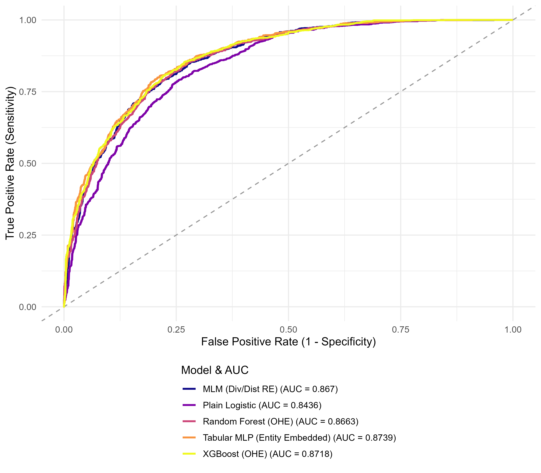
Figure 1. ROC curves, standard test split.
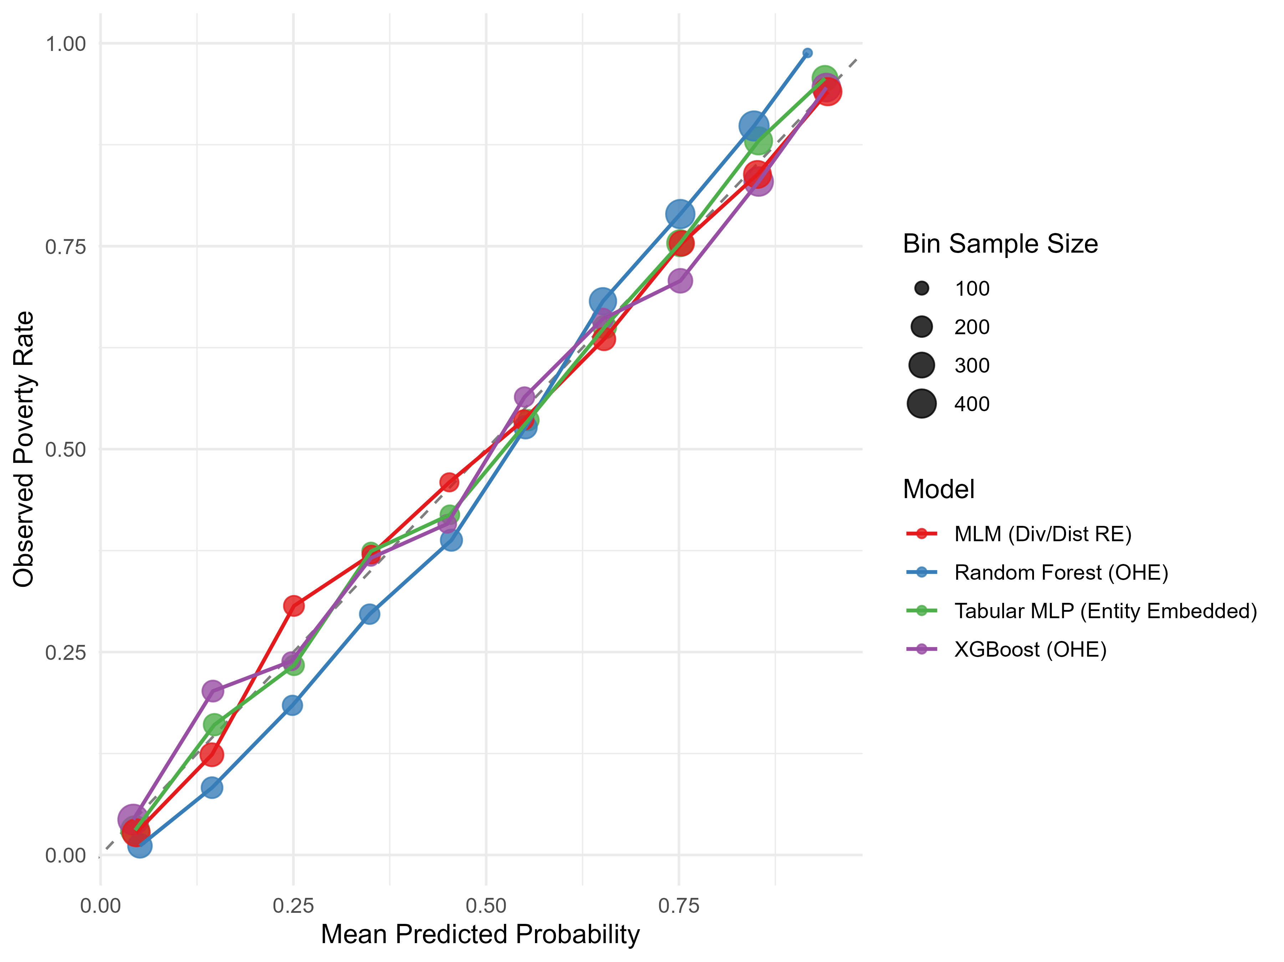
Figure 2. Calibration curves (10-quantile bins).
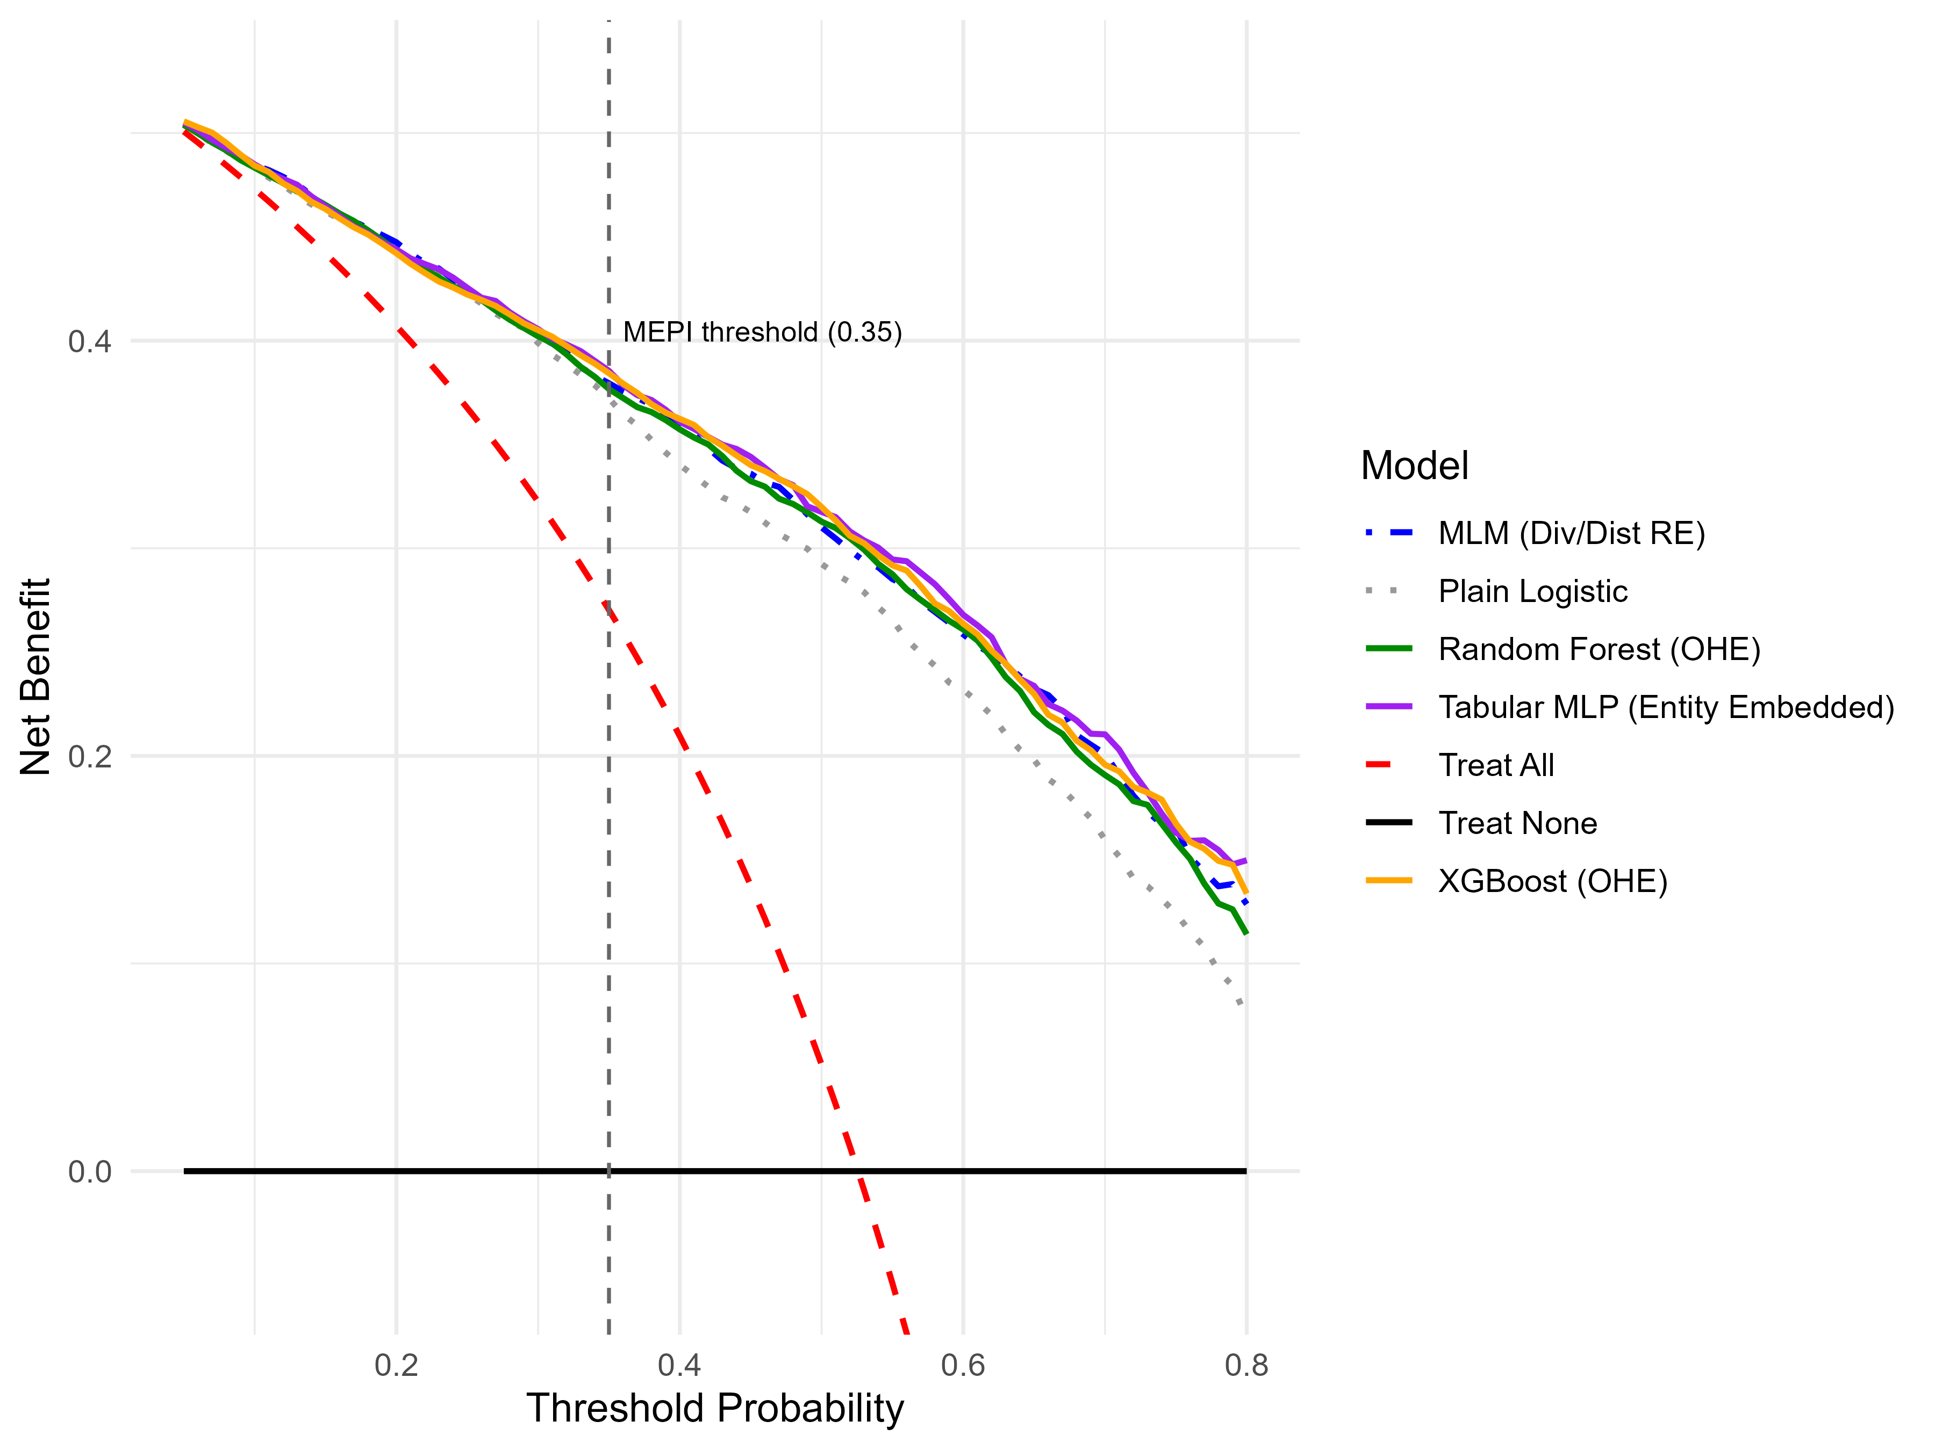
Figure 3. Decision Curve Analysis.
Spatial Generalizability: Unseen PSUs
The standard split evaluates models on villages (PSUs) also seen in training making it favorable to the MLM, which can partially memorize each PSU's deviation via its random intercept. To test a harder, policy-realistic setting, the sample was repartitioned by whole PSU: 573 PSUs for training, the remainder (N = 2,592 households) held out entirely for predicting energy poverty in villages never seen during training. This is the more decision-relevant test, since deployment to new, unsurveyed villages is exactly where a targeting tool is most needed.
Table 2. Spatial generalizability audit on unseen PSUs (N = 2,592).
Model | AUC-ROC | 95% CI | Brier | Accuracy | Sensitivity | Specificity
XGBoost (OHE) | 0.8838 | [.871,.896] | 0.1386 | 80.67% | 0.7885 | 0.8242
Random Forest (OHE) | 0.8761 | [.863,.889] | 0.1475 | 79.82% | 0.7987 | 0.7977
Tabular MLP (EE) | 0.8755 | [.862,.889] | 0.1433 | 79.98% | 0.8279 | 0.7728
MLM (Div/Dist RE) | 0.8751 | [.862,.888] | 0.1433 | 79.78% | 0.8153 | 0.7811
XGBoost is the clear leader here (AUC = 0.8838), significantly ahead of the MLM (Z = 2.938, p = .0017), Random Forest (Z = 2.994, p = .0014), and Tabular MLP (Z = 2.930, p = .0017). Once a village-level random intercept is unavailable, the MLM, Random Forest, and Tabular MLP converge to nearly identical performance (0.8751-0.8761), while XGBoost pulls ahead, indicating it captures transferable household-level structure rather than memorized local intercepts. Two robustness checks confirm this is not an artifact of chance: the Tabular MLP's 5-fold AUC is stable across four random seeds (range 0.8719-0.8732), and downsampling the training set to exact class balance changes validation AUC by only 0.0001 — the sample's near-53% prevalence is not a material confound.
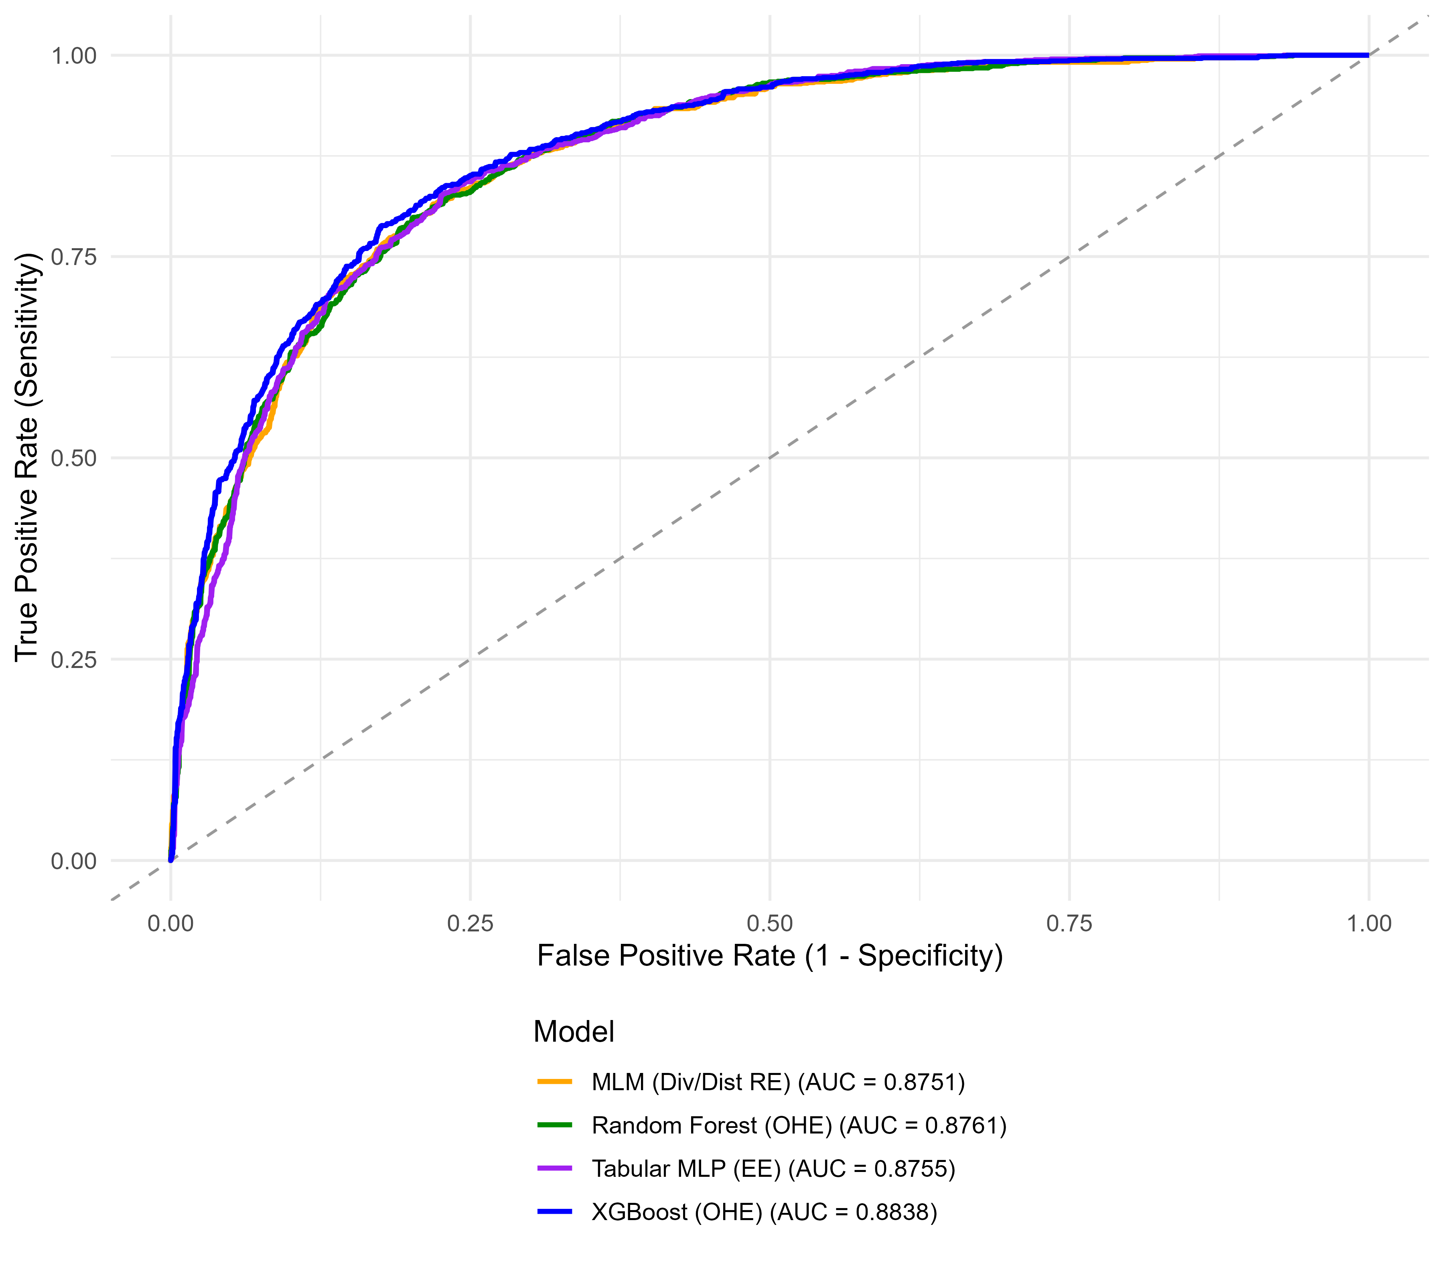
Figure 4. ROC curves, unseen-PSU audit.
Decoding the Black Box: TreeSHAP and Household Archetypes
Having established that XGBoost carries a genuine, spatially transferable advantage, this section opens the model with TreeSHAP [3], [4] to test the thesis's central claim: that households do not experience energy poverty through one homogeneous pathway (Scenario A) but cluster into distinct socioeconomic archetypes with different drivers (Scenario B).
Mean absolute SHAP value ranks structural housing quality, energy spending, urban residence, and income as the four most influential predictors (Figure 5) — consistent with the classic fuel-poverty framework of low income, high energy costs, and poor housing/insulation quality jointly driving deprivation [8]. A naive comparison of this ranking against the MLM's fixed-effect coefficient ranking yields weak agreement (Spearman ρ ≈ 0.37) — but this figure is distorted by District, which ranks first by SHAP importance in every archetype yet is forced to rank last in the MLM comparison because it enters as a random intercept, not a fixed effect with a comparable magnitude. Excluding District raises ρ to approximately 0.68-0.69 — moderate-to-strong agreement, not the near-total discordance the raw figure implies, though still short of the near-1.0 agreement Scenario A would predict.
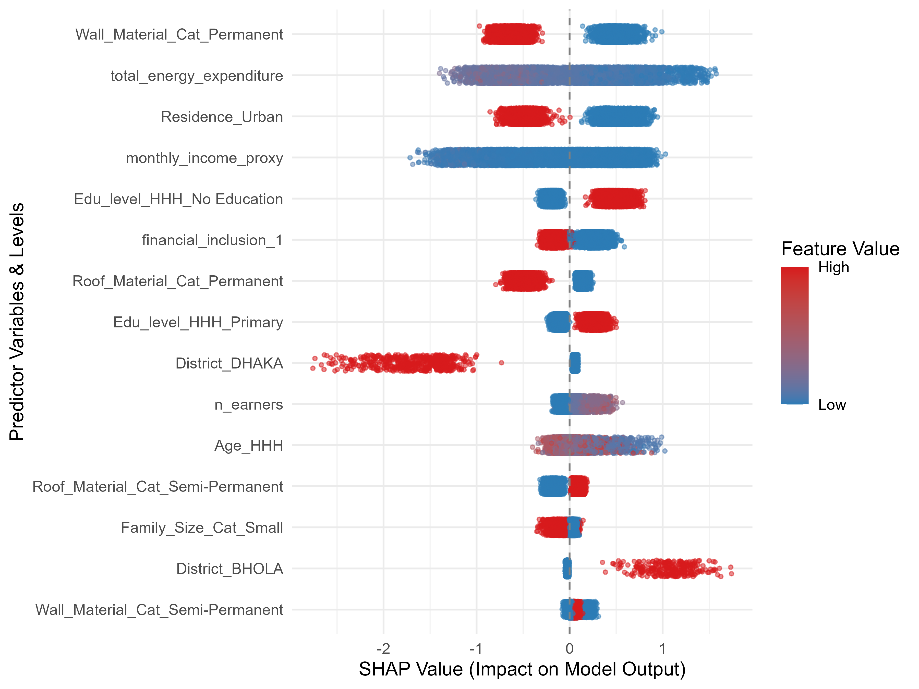
Figure 5. Global SHAP beeswarm, top 15 features.
K-means clustering of standardized per-household SHAP vectors (k = 3, chosen on substantive rather than purely statistical grounds — internal silhouette scores are highest at k=2 and decline thereafter) yields three archetypes with sharply different poverty rates (Table 3).
Table 3. Socioeconomic profile of the three SHAP-derived household archetypes.
Archetype | N (%) | % Rural | Mean Income (BDT) | % No Education | Poverty Rate
Rural Poor | 6,617 (51.9%) | 70.4% | 17,489 | 43.0% | 78.16%
Urban Resilient | 2,652 (20.8%) | 19.7% | 48,605 | 9.4% | 12.59%
Urban Working-Class | 3,490 (27.3%) | 34.4% | 26,043 | 21.9% | 36.16%

These archetypes are not an artifact of TreeSHAP: an independent K-means clustering run directly on raw demographic features recovers nearly the same partition (Adjusted Rand Index [10] = 0.759; the Urban Resilient archetype alone matches its raw-cluster counterpart in 2,650 of 2,652 households), externally validating the segmentation (Figure 6). The rural/urban and divisional stratification underlying these archetypes (Rural Poor concentrated in Barisal, Urban Resilient in Khulna) echoes prior national-level multilevel analyses of multidimensional energy poverty in Bangladesh, which likewise identify residence and division as key structuring factors [9]. Fitting separate local logistic regressions within each cluster, however, surfaces a caution: the Urban Resilient subgroup (only 334 poverty-positive households) shows textbook quasi-complete separation in an unregularized fit (Wall_Material_Permanent estimate +12.0, SE 1,455); Ridge regularization stabilizes this (shrinking to +0.39) but leaves residual sign disagreement on housing-material coefficients in 3 of 19 and 2 of 20 compared terms for the two urban archetypes, suggesting genuine local heterogeneity rather than pure noise.
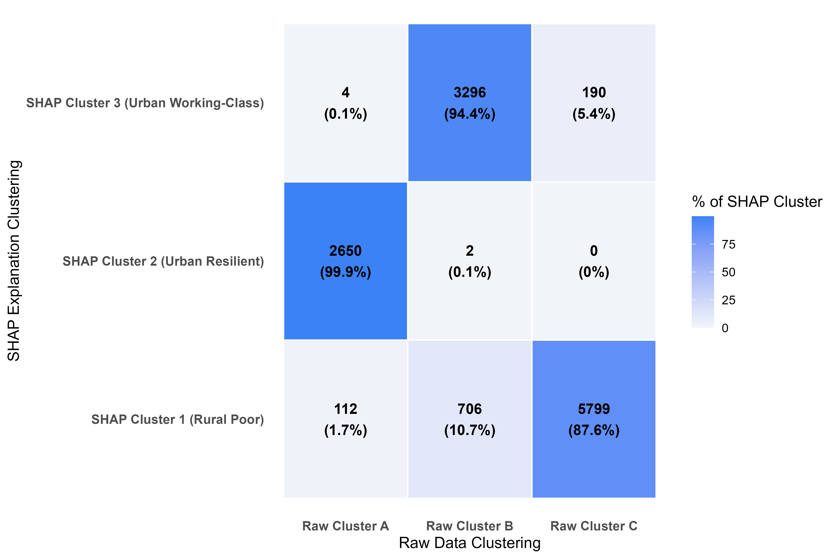
Figure 6. SHAP-cluster vs. raw-cluster agreement (ARI = 0.759).
Two further checks test whether this descriptive structure has independent predictive value or is simply a proxy for geography. First, a leakage-free 5-fold cross-validation (cluster assignment, TreeSHAP, and model fitting all confined to training folds) compared baseline, raw-cluster-interaction, and SHAP-cluster-interaction logistic specifications: none of the cluster-augmented models beat the baseline (Mean AUC 0.8421 vs. 0.8427 vs. 0.8404), and SHAP-cluster interactions perform significantly worse than raw-cluster interactions (Z = -2.088, p = .037). SHAP clustering's value here is descriptive and diagnostic, not predictive. Second, re-fitting the MLM with added district-level slope interactions for the top predictors closes only 10.07% of the MLM-to-XGBoost gap (0.8670 → 0.8675 vs. XGBoost's 0.8718) — ruling out a simple geographic-slope confound as the source of XGBoost's edge. Household-level prediction divergence (XGBoost minus MLM) differs significantly by archetype (Kruskal-Wallis χ² = 22.18, p = 1.5 × 10⁻⁵), further indicating the advantage is household-level, not geographic.
The ML-Guided Multilevel Model Pipeline
Rather than discard the interpretable MLM in favor of the black box, this section uses XGBoost/TreeSHAP purely as a diagnostic instrument: identifying where and how much non-linear flexibility the MLM is missing, and injecting only that much back in. This targets a middle ground between two extremes — XGBoost's high accuracy with no reportable coefficients, and the MLM's full interpretability with left-on-the-table accuracy — without defaulting to a fully automatic Generalized Additive Model (GAM), which would add a second, less transparent layer of smoothing-parameter selection on top of the TreeSHAP diagnostic step already performed. Fixing spline degrees of freedom at 3 in advance instead keeps the refit model a fully parametric GLMM, with the same standard errors and p-values as the baseline for every term [5], [6].
Discovery — training a diagnostic XGBoost model strictly on the training split, then testing each continuous feature for non-linearity via an R²-gain test and ranking candidate feature-pair interactions by aggregated TreeSHAP interaction strength — flags three of four continuous features for spline expansion (Table 4) and selects three interaction terms.
Feature | R² Gain | Flagged
monthly_income_proxy | 0.415 | Yes
total_energy_expenditure | 0.107 | Yes
Age_HHH | 0.483 | Yes
n_earners | 0.050 | No

Table 4. Non-linearity detection (training-split-only discovery).
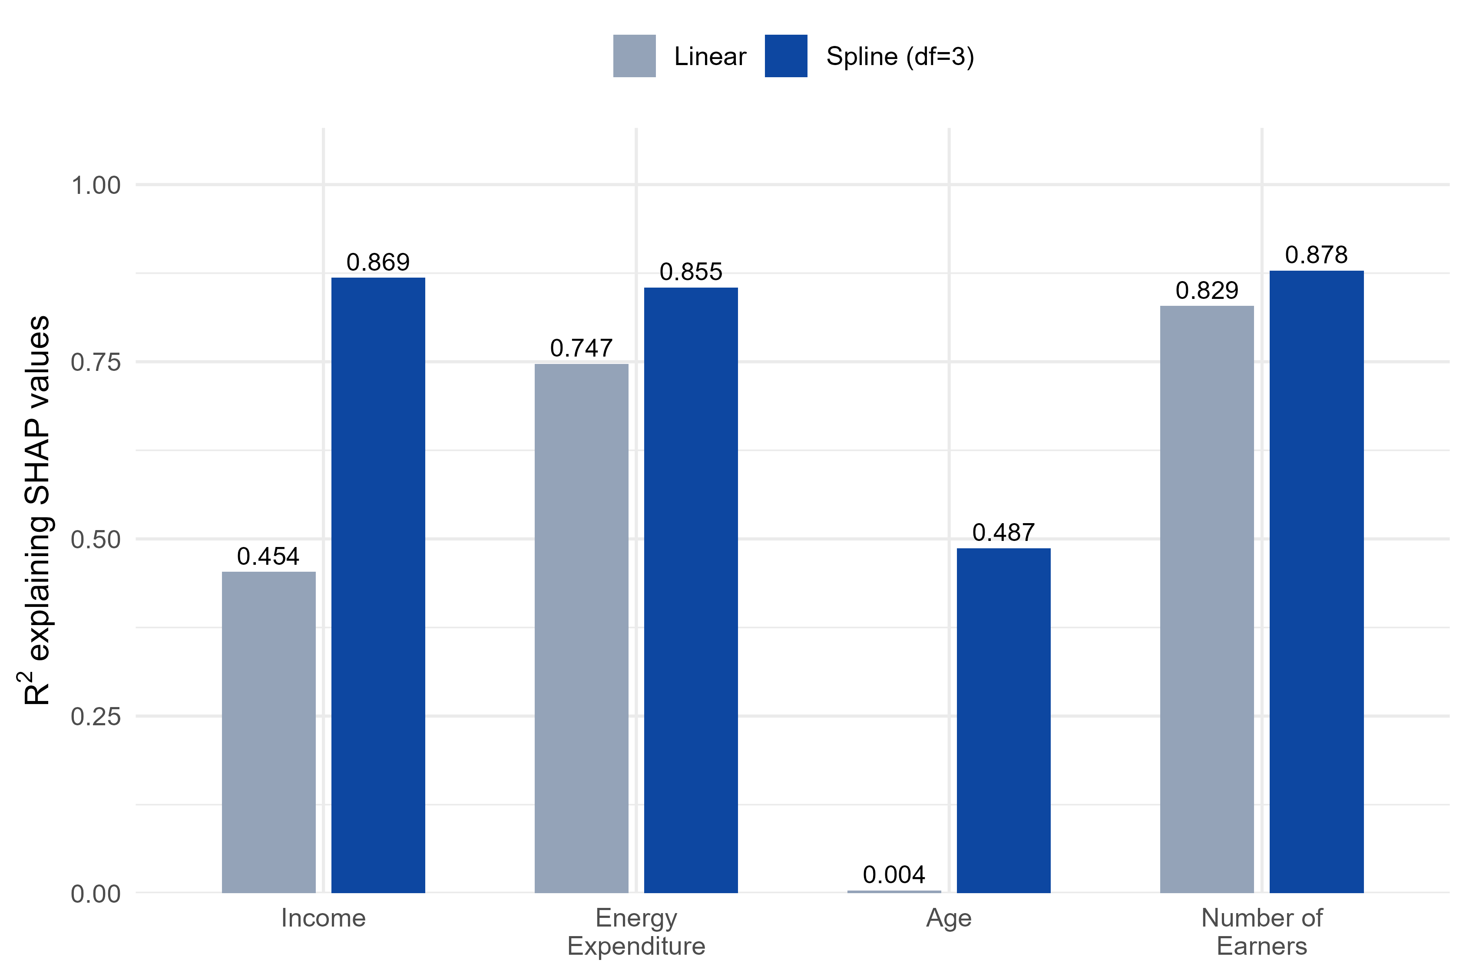
Figure 7. R² explaining SHAP values: linear fit vs. 3-DF spline fit, all four continuous features.
Age's R² gain is the most striking case: a straight line explains almost none of the pattern in its SHAP values (R² = 0.004), while the fitted spline recovers a clear U-shape (Figure 8) — risk is highest for the youngest and oldest household heads and lowest in middle age, consistent with a lifecycle-earnings pattern. Energy expenditure and number of earners, by contrast, show nearly identical linear and spline R² (Figure 7), which is exactly why the R²-gain test correctly leaves the latter untouched.
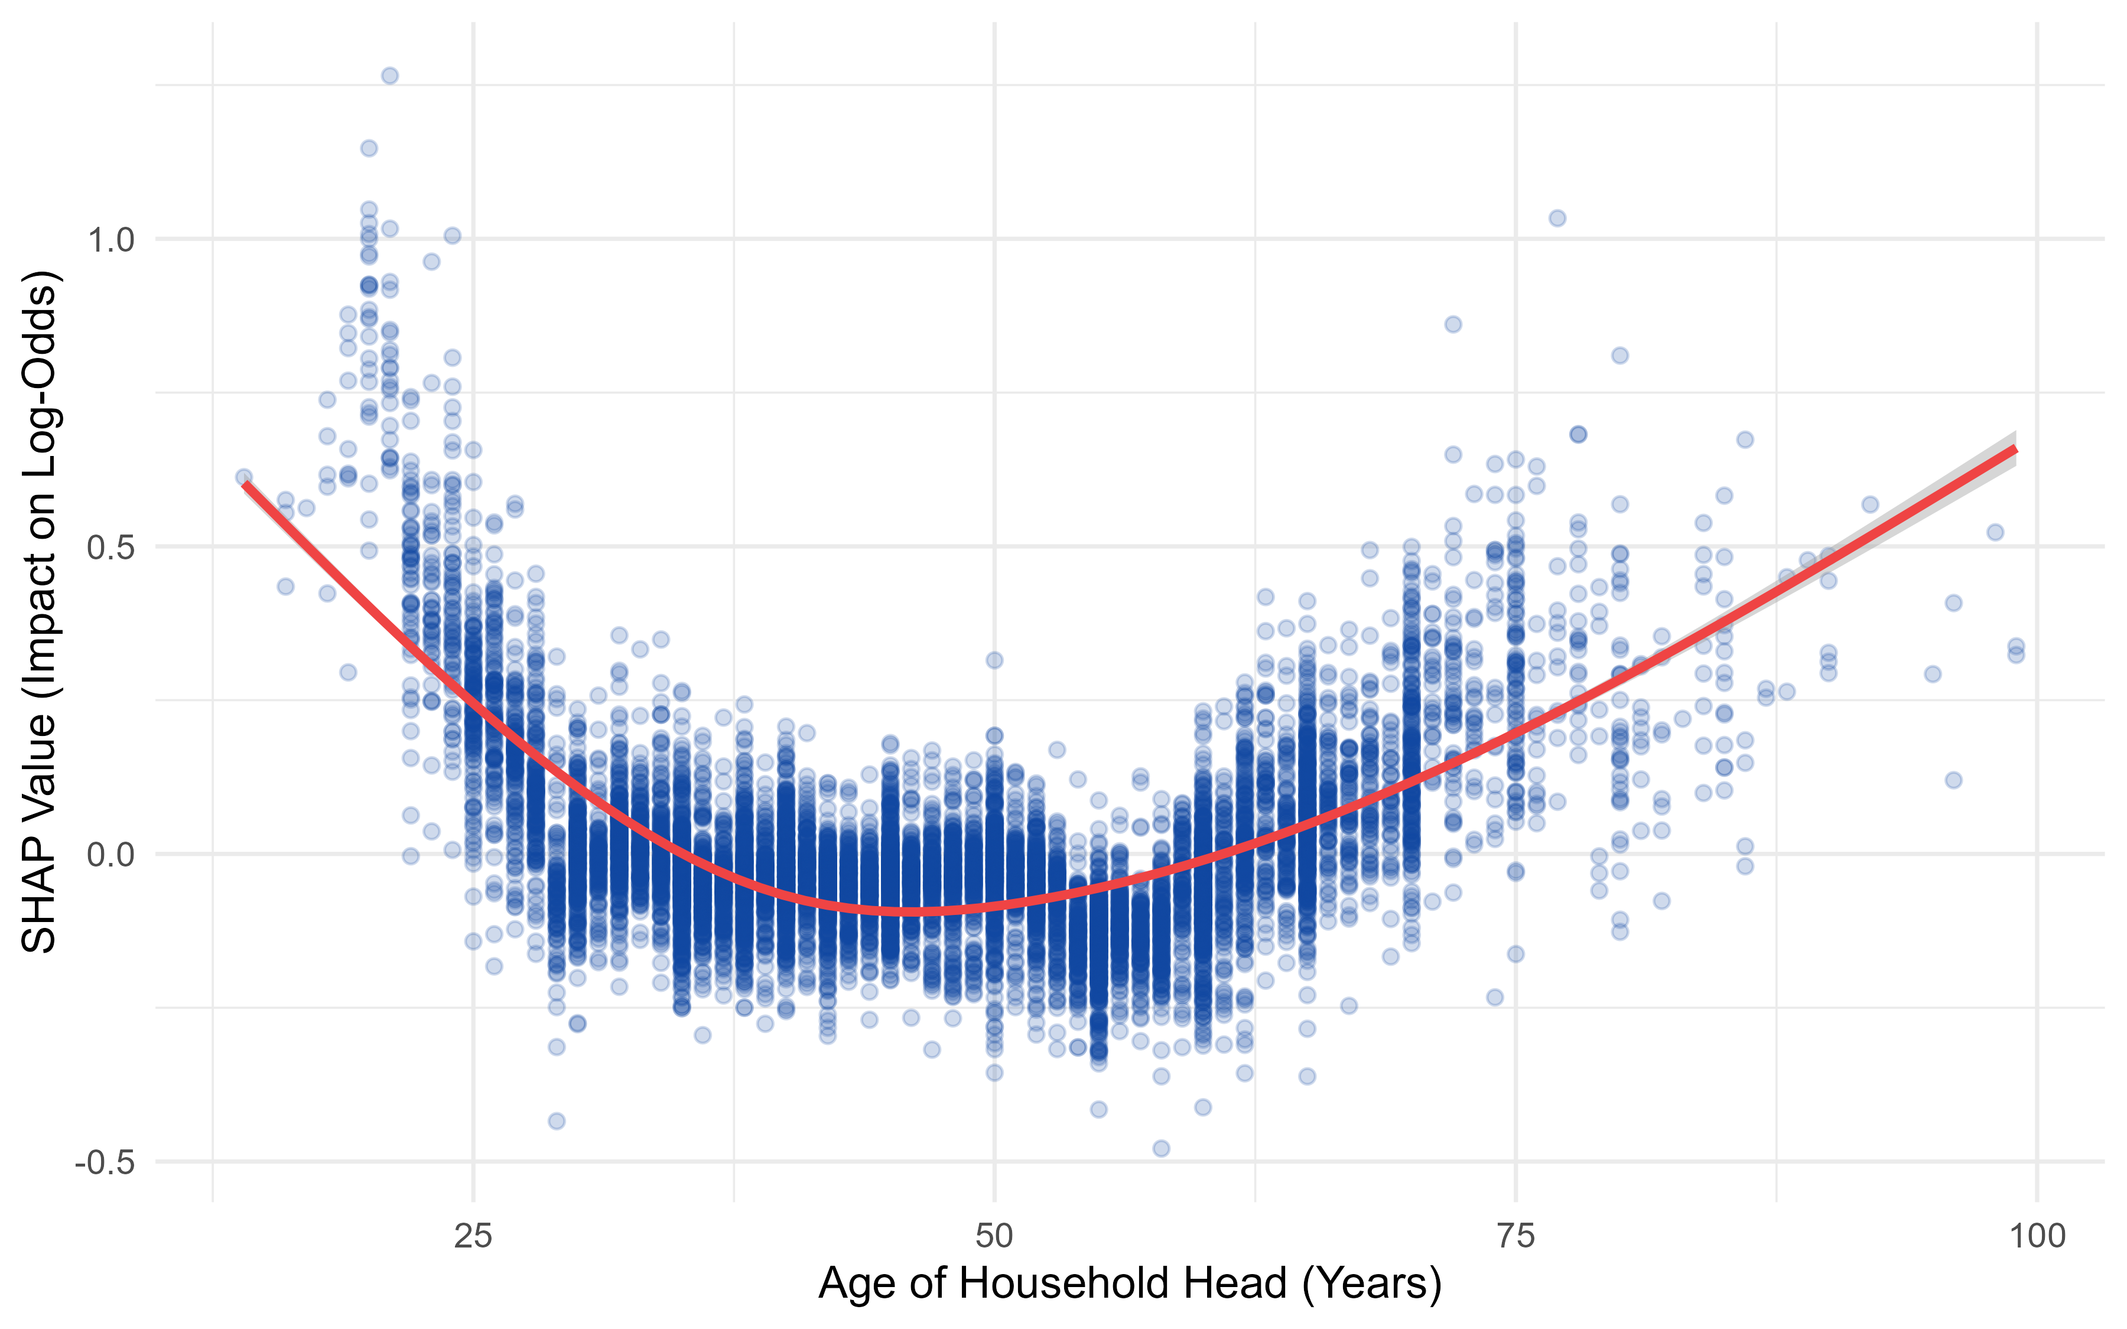
Figure 8. SHAP dependence plot for age with fitted natural spline (training-split-only).
A companion robustness check is essential here: re-running discovery independently within each of five cross-validation folds shows residence × wall-material is selected in all six discovery runs (five folds plus the main split) and energy × wall-material in four of six, while income × education and income × energy expenditure are markedly less stable (two and one runs respectively). A separate null-DGP test — applying the identical discovery procedure to synthetic data with no true interaction anywhere, across three seeds and two covariate-correlation conditions — shows this ranking step cannot be trusted at face value: a known-fake pairing achieved the same 6-of-6 consistency purely by chance, and the real data's top-ranked interaction strength (0.0512) falls below every noise-only value the null test produced (0.0538-0.0646). Income × energy expenditure — the interaction actually selected into the model — matches a documented artifact shape (two independently strong continuous predictors) and should be read as a likely false discovery; its own refit p-value is non-significant (p = .58), consistent with this. Residence × wall-material and energy × wall-material are more plausible on substantive and stability grounds but should still be treated as motivated hypotheses rather than confirmed findings absent a permutation-based significance test.
Figure 9 illustrates the more trustworthy of the two: energy expenditure's SHAP dependence, fit separately by wall-material category. The three lines diverge rather than overlap — steepest for Permanent-wall households, shallowest for Flimsy — mirroring the refit model's own coefficients (-0.711 for Permanent vs. -0.384 for Semi-Permanent, relative to Flimsy). Substantively, this means an extra taka of energy spending buys more protection against energy poverty in a well-built home than in a flimsy one, consistent with better-insulated housing making energy spending more effective rather than simply reflecting income differences already captured elsewhere in the model.
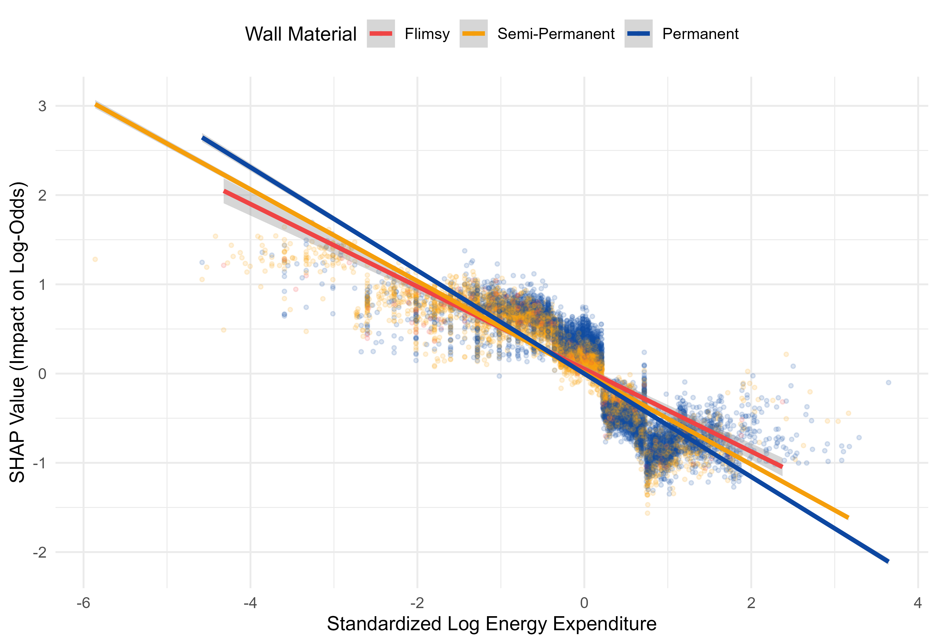
Figure 9. SHAP dependence for energy expenditure, fit separately by wall material (training-split-only).
Model | Single-Split AUC | CV Mean AUC (SD)
Baseline MLM (linear) | 0.8670 | 0.8660 (0.0095)
ML-Guided MLM | 0.8708 | 0.8708 (0.0101)
XGBoost (OHE) | 0.8718 | 0.8738 (0.0088)

Table 5. ML-Guided MLM predictive performance, single split vs. leakage-free cross-validation.
The ML-Guided MLM closes 79.18% of the baseline-to-XGBoost gap on the single split (DeLong Z = 1.982, p = .047) and a more conservative, more defensible 61.35% under cross-validation with discovery re-run per fold (paired t = 7.949, p = .0014; pooled DeLong Z = 5.470, p = 4.5 × 10⁻⁸). All spline and interaction coefficients are numerically stable (no standard error exceeds 5), and the recovered income spline (Figure 10) shows a steep protective effect that flattens above roughly 25,000 BDT, consistent with an energy-ladder saturation pattern documented in the household energy-transition literature [7].
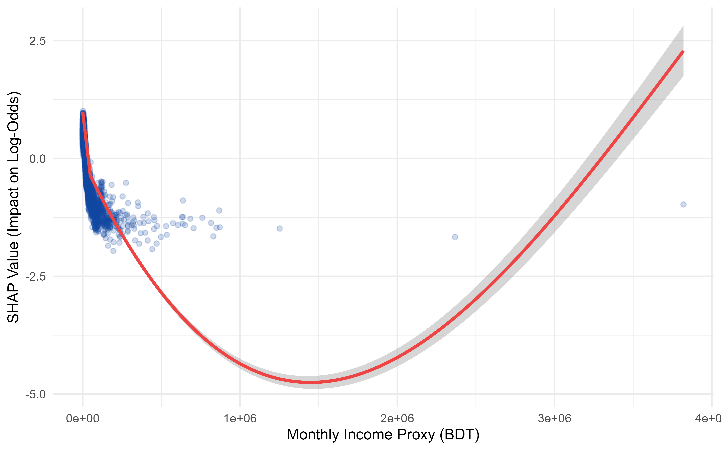
Figure 10. SHAP dependence plot for income with fitted natural spline (training-split-only).
Chapter Summary
XGBoost and the Tabular MLP both significantly outperform the multilevel logistic baseline on the standard split, and XGBoost alone retains a significant, widening advantage on entirely unseen villages — the policy-relevant test for a targeting tool intended for deployment beyond the surveyed sample. This advantage is not primarily a geographic-slope confound (district interactions close only 10% of the gap) and does not stem from hidden predictive information in the SHAP archetypes (cluster interactions do not improve leakage-free cross-validated performance). The three archetypes are nonetheless real and externally validated (ARI = 0.759) and carry clear descriptive and policy value — the Rural Poor archetype's near-eightfold poverty-rate gap over the Urban Resilient archetype is itself a targeting-relevant finding, independent of predictive modeling. The ML-Guided MLM recovers most of XGBoost's advantage inside a fully interpretable multilevel logistic regression, closing 61.35% of the predictive gap under leakage-free cross-validation. The non-linear income, energy, and age effects driving most of that gain are trustworthy — recovered in every discovery run and validated against known ground truth in a companion simulation study. The three specific interaction terms are not trustworthy to the same degree: neither cross-fold selection consistency nor raw interaction strength reliably distinguishes a real interaction from one produced by chance. Income × energy expenditure should be read as a likely discovery artifact; residence × wall material and energy × wall material are more plausible but should be presented as motivated hypotheses pending a proper permutation-based test, not as validated findings.
References
[1] Chen, T., & Guestrin, C. (2016). XGBoost: A scalable tree boosting system. Proceedings of the 22nd ACM SIGKDD International Conference on Knowledge Discovery and Data Mining, 785-794.
[2] Wright, M. N., & Ziegler, A. (2017). ranger: A fast implementation of random forests for high dimensional data in C++ and R. Journal of Statistical Software, 77(1), 1-17.
[3] Lundberg, S. M., & Lee, S.-I. (2017). A unified approach to interpreting model predictions. Advances in Neural Information Processing Systems, 30.
[4] Lundberg, S. M., Erion, G., Chen, H., DeGrave, A., Prutkin, J. M., Nair, B., Katz, R., Himmelfarb, J., Bansal, N., & Lee, S.-I. (2020). From local explanations to global understanding with explainable AI for trees. Nature Machine Intelligence, 2(1), 56-67.
[5] Bates, D., Mächler, M., Bolker, B., & Walker, S. (2015). Fitting linear mixed-effects models using lme4. Journal of Statistical Software, 67(1), 1-48.
[6] Hastie, T., Tibshirani, R., & Friedman, J. (2009). The Elements of Statistical Learning: Data Mining, Inference, and Prediction (2nd ed.), Chapter 5: Basis Expansions and Regularization. Springer.
[7] Hosier, R. H., & Dowd, J. (1987). Household fuel choice in Zimbabwe: An empirical test of the energy ladder hypothesis. Resources and Energy, 9(4), 347-361.
[8] Boardman, B. (1991). Fuel Poverty: From Cold Homes to Affordable Warmth. Belhaven Press.
[9] Hasanujzaman, M., & Omar, M. A. (2022). Household and non-household factors influencing multidimensional energy poverty in Bangladesh: Demographics, urbanization and regional differentiation via a multilevel modeling approach. Energy Research & Social Science, 92, 102803.
[10] Hubert, L., & Arabie, P. (1985). Comparing partitions. Journal of Classification, 2(1), 193-218.
[11] DeLong, E. R., DeLong, D. M., & Clarke-Pearson, D. L. (1988). Comparing the areas under two or more correlated receiver operating characteristic curves: A nonparametric approach. Biometrics, 44(3), 837-845.

