Chapter: Simulation Validation Study
A Ground-Truth Recovery Test of the ML-Guided Multilevel Modeling Discovery Pipeline
1. Introduction and Motivation
Throughout this thesis, the outcome of interest — energy poverty status — is derived from the Multidimensional Energy Poverty Index (MEPI), an application of the Alkire-Foster counting methodology [10] to eight weighted energy-deprivation indicators. A recurring finding using this outcome has been that machine learning models — XGBoost, Random Forest, and an entity-embedded Tabular MLP — systematically outperform multilevel logistic regression on the Bangladesh Household Income and Expenditure Survey (HIES) 2022 data, both on the standard 80/20 test split and, more strikingly, in the unseen-village generalizability audit. Rather than treat this as a verdict in favor of replacing the interpretable multilevel model with a black box, the ML-Guided MLM enhancement developed earlier in this thesis used the machine learning model as a diagnostic instrument: TreeSHAP values were mined for evidence of non-linear continuous effects and unmodeled feature interactions, and the discovered structure was fed back into the multilevel logistic regression as natural splines and interaction terms [1], [3]. The resulting ML-Guided MLM recovered the large majority of the machine learning model's predictive advantage while retaining full parametric interpretability.
This design deliberately targets a middle ground between two unattractive extremes. A fully non-parametric machine learning model such as XGBoost offers the highest achievable predictive accuracy but no parametric interpretability: there are no coefficients to report, no standard errors, and no way to state a policy-relevant marginal effect. A purely linear multilevel logistic regression offers full interpretability but leaves predictive accuracy on the table wherever the true relationship is non-linear or interactive. Rather than choose between these extremes, or default to a fully automatic non-parametric smoother such as a generalized additive model (GAM), the approach taken here uses the machine learning model purely as a diagnostic instrument to identify where and how much non-linear flexibility is actually needed, and then injects only that much flexibility — a fixed, low-dimensional natural spline basis and a small number of interaction terms — into an otherwise ordinary generalized linear mixed-effects model (GLMM). The refitted model retains the exact same inferential machinery as the baseline model (Wald tests, standard errors, variance components), it simply has a sharper functional form exactly where the data requires one. This chapter's simulation study is, in part, a test of whether this narrower and cheaper strategy — narrowing the gap with machine learning without adopting either a full black box or a fully automatic non-parametric smoother — recovers a comparable share of the achievable predictive signal to the alternative of simply deferring to the machine learning model.
This discovery-and-refit strategy is attractive, but it carries an obvious risk. TreeSHAP values are themselves the output of a flexible, high-variance estimator; the non-linear shapes and interaction rankings extracted from them could, in principle, reflect estimation noise rather than genuine structure in the population [4]. If the gains absorbed into the refitted multilevel model were actually noise, they would not represent a real data-generating mechanism, and the central claim of this thesis — that households in the HIES 2022 sample experience energy poverty through structurally distinct, non-linear, interacting pathways rather than through a single homogeneous linear model — would rest on an artifact of tree-based overfitting rather than on a genuine socioeconomic phenomenon.
The only way to settle this question directly is to apply the discovery pipeline to a dataset whose true functional form is known by construction. This chapter therefore builds a synthetic household dataset that mirrors the geographic hierarchy, variable names, and marginal distributions of the real HIES 2022 sample, but is generated from an explicit data-generating process (DGP) containing a pre-specified hinge-threshold effect, a quadratic effect, and three deliberate feature interactions. The exact discovery algorithm used earlier in this thesis — with no access to the true equation — is applied blindly to the synthetic data, and its recovered structure is compared against the known ground truth. If the pipeline correctly identifies the true non-linearities, correctly leaves untouched the variables generated with no true effect, and closes a substantial share of the gap between a naive linear baseline and the true theoretical ceiling, this constitutes strong evidence that the improvements documented for the real data reflect genuine signal rather than overfitting.
2. The Simulation Framework
2.1 Geographic Nesting and Random Effects
To mirror the three-level administrative hierarchy of Bangladesh used throughout this thesis's multilevel models, the synthetic dataset nests N = 12,000 households within 64 districts, which are in turn nested within 8 divisions (8 districts per division). Two independent Gaussian random intercepts represent unexplained cluster-level heterogeneity in the log-odds of energy poverty: a division-level intercept uᵢ ~ N(0, 0.3²) and a district-level intercept vᵢⱼ ~ N(0, 0.2²), nested within division. Combined, these contribute a cluster-level log-odds variance of 0.3² + 0.2² = 0.13, a magnitude broadly consistent with the variance components estimated from the real HIES 2022 multilevel models earlier in this thesis [5].
2.2 Covariate Generation
Twelve covariates were generated to match, in name, type, and approximate marginal distribution, the corresponding predictors used throughout the real-data analysis: sector of residence (Rural/Urban), wall and roof construction material (Flimsy/Semi-Permanent/Permanent), household head's education (No Education/Primary/Secondary/Higher), family size category, number of active earners (Poisson, λ = 1.3), financial inclusion status, chronic illness status, operating land category, monthly income proxy (log-normal, μ = 9.8, σ = 0.6), total energy expenditure (log-normal, μ = 7.1, σ = 0.5), and household head's age (Normal, μ = 46, σ = 11). Two of these variables — roof material and operating land category — were deliberately assigned zero true effect on the outcome, serving as noise controls to test whether the discovery algorithm would spuriously flag irrelevant features as important.
2.3 The True Data-Generating Process
The true log-odds of energy poverty for household i, ηᵢ, was specified as a sum of linear main effects, the two nested random intercepts, one non-linear hinge effect, one non-linear quadratic effect, and three deliberate interaction terms:
ηᵢ = β₀ + Xᵢβ + uᵢ + vᵢⱼ + f(x_income,ᵢ) + g(x_age,ᵢ) + Interactionsᵢ
The linear main effects (βᵢ) assigned moderate-to-strong protective coefficients to urban residence (−0.80), education (−0.30 to −1.00 across levels), financial inclusion (−0.45), permanent and semi-permanent wall material (−1.20 and −0.60), and energy expenditure (−0.50), alongside a risk-increasing effect for chronic illness (+0.25). Two non-linear terms were then added on top of this linear structure. The income hinge effect, f(x) = −1.6 · min(0, x), imposes a steep protective slope below the median standardized log-income and a completely flat slope above it, representing energy-ladder saturation: additional income above the median buys no further reduction in energy poverty risk. The age effect, g(x) = 0.5 · x², imposes a U-shaped quadratic risk profile, with the household head's youngest and oldest ages carrying elevated risk relative to middle age, representing a lifecycle-earnings pattern.
Three interaction terms were then layered onto the linear and non-linear main effects. First, a residence-by-wall-material interaction (+0.70 for Urban × Permanent, +0.30 for Urban × Semi-Permanent) represents wall quality being strongly protective in rural areas but less so in urban areas, reflecting an urban infrastructure floor. Second, an energy-expenditure-by-wall-material interaction (−0.60 for energy spending × Permanent, −0.30 for energy spending × Semi-Permanent) represents energy spending being more protective in well-insulated, permanent housing than in flimsy housing, reflecting thermal efficiency. Third, an income-by-education interaction (−0.15, −0.30, and −0.50 for income × Primary, Secondary, and Higher education respectively) represents income's protective effect being steeper for more educated household heads, reflecting a human-capital complementarity.
2.4 Calibration to Real-World Prevalence
The base intercept β0 was calibrated via grid search to reproduce the energy poverty prevalence observed in the real HIES 2022 sample. The calibrated DGP achieved a simulated prevalence of 52.93 percent, closely matching the real-data target of 53.04 percent. The resulting dataset was partitioned into an 80 percent training set (N = 9,600) and a 20 percent held-out test set (N = 2,400), using the same partitioning procedure applied to the real HIES 2022 data throughout this thesis.
3. The Blind Discovery-and-Refit Algorithm
With the true DGP equation, coefficients, and interaction labels withheld from the discovery procedure itself — used only afterward to grade its output — the identical algorithm developed for the real HIES 2022 data was applied to the synthetic dataset. The procedure comprises six steps.
1. Fit a baseline multilevel logistic regression with linear-only continuous main effects and nested Division/District random intercepts, using glmer with the bobyqa optimizer and nAGQ = 0 for stable convergence [5].
2. Train an XGBoost model on one-hot-encoded features (300 boosting rounds, learning rate 0.05, max depth 6, subsample and column-sample rates of 0.8) and compute per-observation TreeSHAP contribution values [6], [7].
3. For each continuous feature, regress its SHAP values on the raw feature value (linear fit) and on a 3-degree-of-freedom natural spline of the feature (flexible fit). A feature is flagged for spline expansion in the refit model if the spline fit's R² exceeds the linear fit's R² by more than 0.05.
4. Compute the full TreeSHAP interaction-value tensor on a 2,000-observation training subsample, then aggregate dummy-level interaction strengths back to their parent features by summing absolute interaction values across all category pairs, producing a ranked list of parent-feature interaction strengths.
5. Reconstruct the multilevel logistic regression formula, replacing linear terms with natural splines for every flagged feature and adding the three highest-ranked parent-feature interaction pairs.
6. Refit the enhanced formula as the ML-Guided MLM and evaluate all models — baseline MLM, XGBoost, ML-Guided MLM, and an Oracle MLM fit directly on the true functional forms — on the held-out test set.
The Oracle model is fit directly on the true functional forms — the exact hinge and quadratic terms and all three true interactions — and represents the econometric ceiling: the best possible performance achievable by a correctly specified parametric model with no discovery uncertainty. It is not a candidate produced by the discovery algorithm, but a benchmark against which the algorithm's output is judged.
It is worth being precise about what Step 3 and Step 5 do, and do not, fit. The refit model is a generalized linear mixed-effects model with a fixed, pre-specified natural spline basis (splines::ns(x, df = 3)) substituted for flagged linear terms — not a generalized additive model. A true GAM selects the smoothness of each term automatically via a penalty term tuned by generalized cross-validation or REML [2], which would introduce a second, less transparent layer of model selection on top of the one already performed by the TreeSHAP diagnostic step. Fixing the spline degrees of freedom at 3 in advance keeps the refit model a fully parametric GLMM: every coefficient is estimated by the same maximum-likelihood machinery as the baseline model, standard errors and p-values are available for every term exactly as before, and the only thing the machine learning diagnostic step contributes is where to place flexibility, not how the resulting model is estimated. This is the specific sense in which the pipeline narrows the ML-to-MLM predictive gap without surrendering the interpretability that motivates using a multilevel logistic regression in the first place.
4. Results
4.1 Non-Linearity Recovery
The discovery algorithm's R²-gain test correctly classified all four candidate continuous features. Both features with a true non-linear effect — monthly income and household head's age — were flagged for spline expansion, while both features with a genuinely linear true effect — total energy expenditure and number of earners — were correctly left unflagged, with negligible R² gains of 0.0006 and 0.0041 respectively. Table 1 reports the full results.
Feature | True DGP Shape | R² (Linear) | R² (Spline) | R² Gain | Flagged | Shape Correlation ρ
monthly_income_proxy | Hinge / Threshold | 0.7873 | 0.9239 | 0.1366 | Yes (True Positive) | 0.9923
total_energy_expenditure | Linear | 0.9147 | 0.9153 | 0.0006 | No (True Negative) | —
Age_HHH | Quadratic (U-shaped) | 0.0033 | 0.8868 | 0.8835 | Yes (True Positive) | 0.9986
n_earners | Linear | 0.8908 | 0.8949 | 0.0041 | No (True Negative) | —

Table 1. Non-linearity detection results: R²-gain test against ground truth.
Beyond correct classification, the recovered shape of each flagged non-linearity closely tracks the true function. Figure 1 overlays the true income hinge effect against the partial effect implied by the fitted natural spline in the ML-Guided MLM; the two curves are nearly indistinguishable (shape correlation ρ = 0.9923). Figure 2 shows the equivalent comparison for the quadratic age effect (ρ = 0.9986).
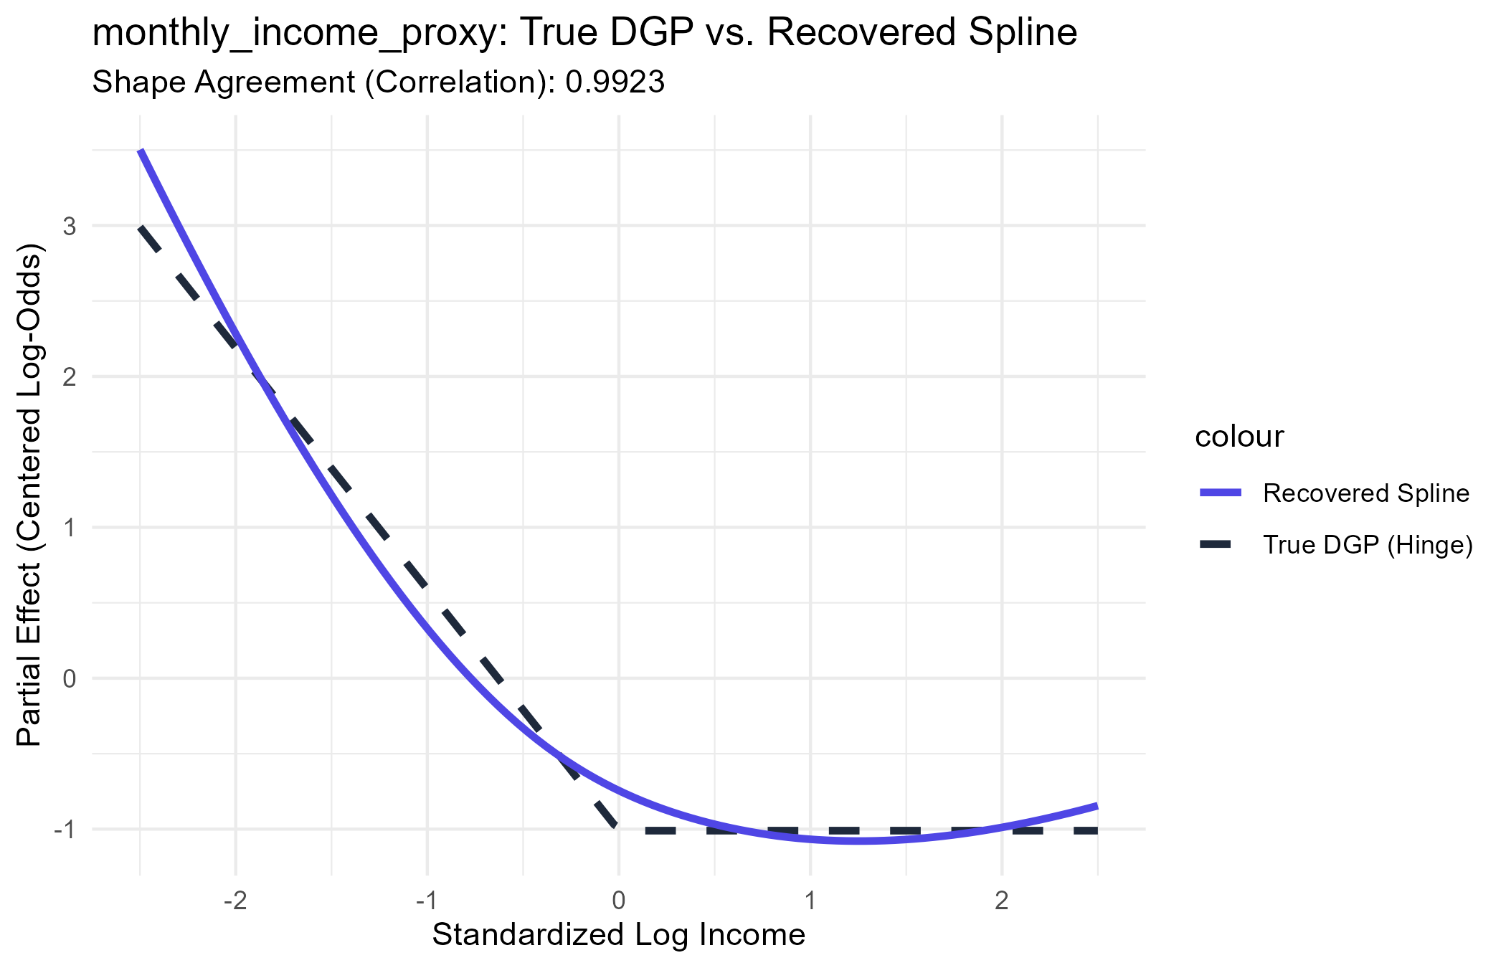
Figure 1. True DGP hinge effect (dashed) versus the natural spline partial effect recovered by the ML-Guided MLM (solid), monthly_income_proxy.
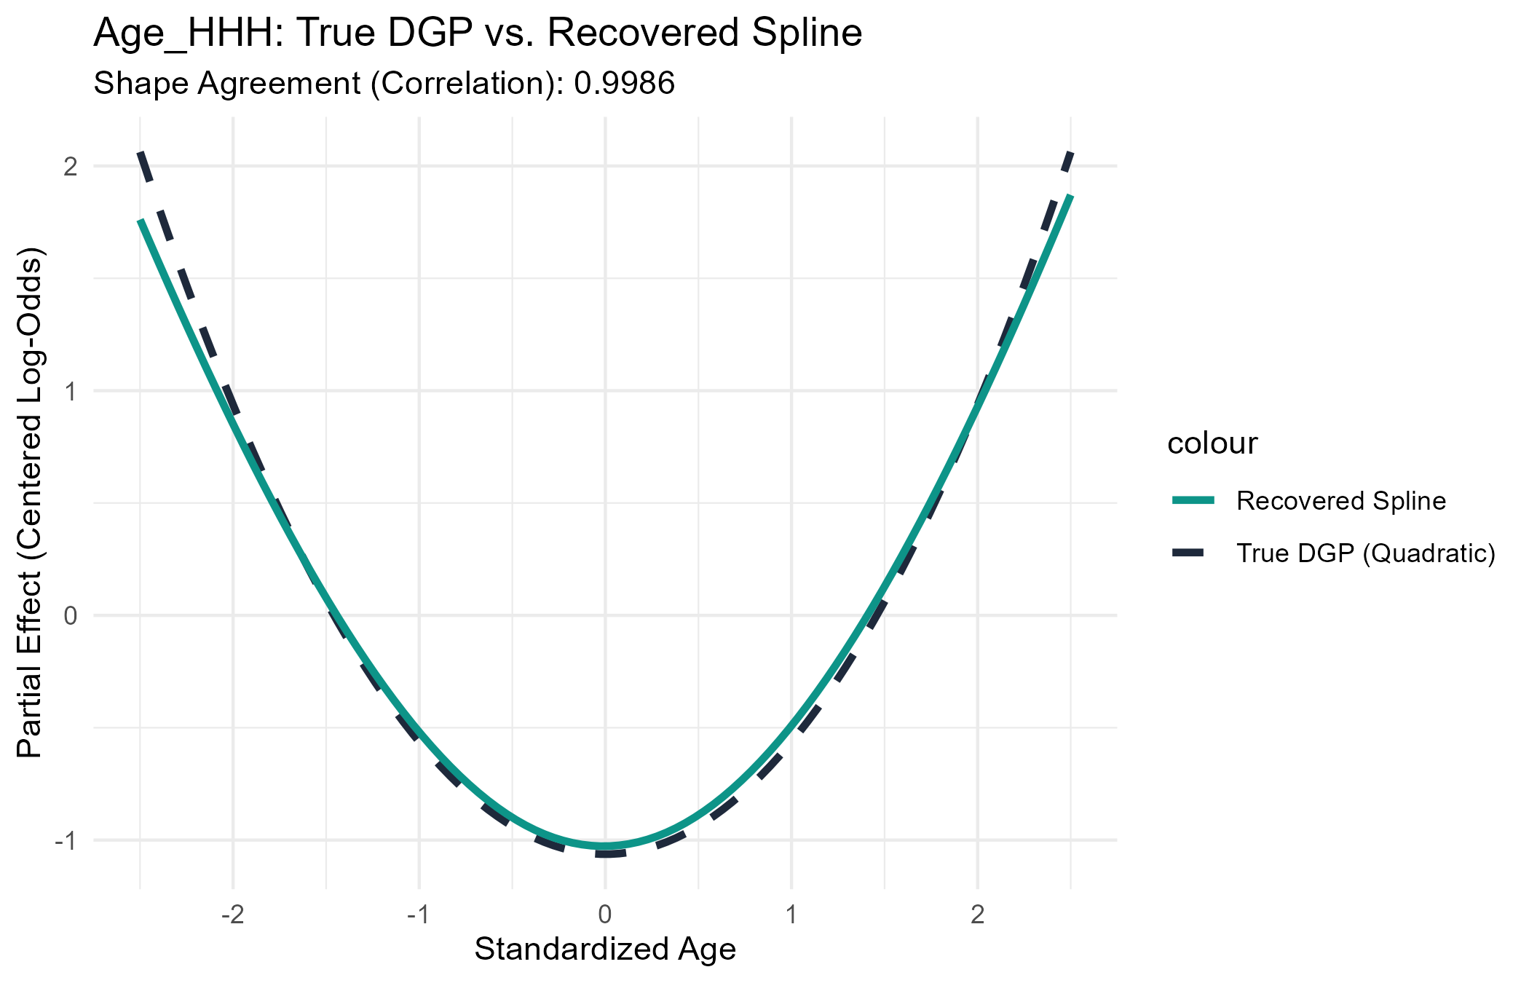
Figure 2. True DGP quadratic effect (dashed) versus the natural spline partial effect recovered by the ML-Guided MLM (solid), Age_HHH.
4.2 Interaction Recovery
The TreeSHAP interaction-aggregation step ranked all 55 possible parent-feature pairs by aggregated interaction strength. Table 2 reports the top ten. Two of the three true interactions — energy-expenditure × wall material and income × education — occupied the first and second ranks respectively, and were correctly selected into the ML-Guided MLM's top-three interaction terms.
Rank | Parent Feature 1 | Parent Feature 2 | Strength | Status
1 | total_energy_expenditure | Wall_Material_Cat | 0.1080 | True interaction (selected)
2 | monthly_income_proxy | Edu_level_HHH | 0.0930 | True interaction (selected)
3 | monthly_income_proxy | total_energy_expenditure | 0.0695 | Spurious (selected)
4 | monthly_income_proxy | Age_HHH | 0.0579 | Spurious – SHAP shadow artifact
5 | total_energy_expenditure | Age_HHH | 0.0540 | Spurious
6 | Age_HHH | Edu_level_HHH | 0.0509 | Spurious
7 | total_energy_expenditure | Edu_level_HHH | 0.0415 | Spurious
8 | monthly_income_proxy | Wall_Material_Cat | 0.0381 | Spurious
9 | Residence | Wall_Material_Cat | 0.0364 | True interaction (not selected)
10 | Age_HHH | Wall_Material_Cat | 0.0311 | Spurious

Table 2. TreeSHAP parent-feature interaction ranking, top 10 of 55 pairs.
This ranking, however, reveals an important and instructive limitation rather than a clean sweep. The third true interaction — residence × wall material — was ranked ninth, below six spurious pairs, and was therefore not among the top three interactions incorporated into the ML-Guided MLM's refit formula. In its place, the model absorbed one genuinely spurious interaction: monthly income × total energy expenditure, which has no corresponding term in the true DGP. Rank four, the income × age pairing, is labeled a SHAP shadow artifact: because both income and age carry strong independent non-linear effects, gradient-boosted decision trees will frequently split sequentially on both features along the same paths, registering an apparent interaction between two variables that never actually interact in the true model [6], [8]. This is a documented behavior of tree-based interaction attribution and is discussed further in Section 5.2.
4.3 Predictive Performance and Gap Closure
Table 3 compares test-set AUC-ROC across the four models. The ML-Guided MLM (AUC = 0.8152) outperforms both the linear baseline (AUC = 0.7795) and the XGBoost model itself (AUC = 0.8047), and closes 74.74 percent of the gap between the linear baseline and the Oracle model's theoretical ceiling (AUC = 0.8273).
Model | Test AUC-ROC
Baseline MLM (linear main effects only) | 0.7795
XGBoost (OHE, tree limit) | 0.8047
ML-Guided MLM (recovered structure) | 0.8152
Oracle MLM (true DGP, theoretical ceiling) | 0.8273

Table 3. Test-set AUC-ROC comparison across the four benchmark models.
A one-sided DeLong test confirms the ML-Guided MLM's improvement over the linear baseline is highly significant (Z = 5.480, p = 4.24 × 10⁻⁸) [9]. Framed as a share of the achievable gap, the ML-Guided MLM closes 141.79 percent of the baseline-to-XGBoost gap — it does not merely match XGBoost but exceeds it, because the refit model combines XGBoost's discovered non-linear shapes and interactions with the parametric random intercepts that XGBoost's one-hot-encoded tree structure cannot represent as efficiently — and 74.74 percent of the baseline-to-Oracle gap, the more conservative and more informative benchmark since the Oracle represents the true theoretical limit rather than another discovered model.
4.4 Coefficient Stability Audit
All 27 coefficients in the ML-Guided MLM, including the six natural-spline basis terms and the four interaction terms, were audited for estimation instability. The maximum standard error across all terms was 1.72, with no signs of the quasi-complete separation observed elsewhere in this thesis's local subgroup analyses. Table 4 reports the discovered spline and interaction terms; the full 27-term output is retained in the accompanying appendix.
Term | Estimate | SE | p-value
ns(log_income_sc, 3)[1] | −8.78 | 0.53 | < .001
ns(log_income_sc, 3)[2] | −21.25 | 1.72 | < .001
ns(log_income_sc, 3)[3] | −8.18 | 0.82 | < .001
ns(Age_HHH_sc, 3)[1] | −3.19 | 0.19 | < .001
ns(Age_HHH_sc, 3)[2] | −6.95 | 0.88 | < .001
ns(Age_HHH_sc, 3)[3] | 2.88 | 0.44 | < .001
energy × Wall (Permanent) | −0.711 | 0.078 | < .001
energy × Wall (Semi-Permanent) | −0.384 | 0.059 | < .001
income × Edu (Primary) | 0.327 | 0.110 | .003
income × Edu (Secondary) | 0.275 | 0.117 | .019
income × energy (spurious) | 0.003 | 0.030 | .915

Table 4. Discovered spline and interaction coefficients, ML-Guided MLM.
Individual spline basis coefficients (e.g., −21.25 for the second income basis term) are not directly interpretable in isolation; only the reconstructed partial-effect curve, shown in Figures 1 and 2, carries substantive meaning. The one spurious interaction absorbed into the model, income × energy expenditure, is statistically indistinguishable from zero (p = .915), indicating that although the ranking procedure selected it, the multilevel model's own significance testing correctly identifies it as carrying no real signal.
5. Discussion
5.1 What This Recovery Demonstrates
Three results together support the conclusion that the ML-Guided MLM enhancement developed in this thesis is recovering genuine structure rather than fitting noise. First, the non-linearity classification is perfect across all four candidate features: zero false positives among the two genuinely linear features and zero false negatives among the two genuinely non-linear features, with shape correlations exceeding 0.99 for both. Second, the predictive gain is both statistically significant and practically large, closing nearly three-quarters of the gap to a theoretical ceiling that is, by construction, unreachable by any discovery procedure operating without knowledge of the true DGP. Third, the discovered coefficients are numerically stable, with no indication that the added flexibility destabilizes the model's estimation. Had the discovery pipeline been fitting sampling noise in the real HIES 2022 TreeSHAP values, none of these three properties would be expected to hold in a setting where the true answer is known and can be checked directly.
5.2 A Known Limitation: The Variance-Mediated Interaction-Detection Blind Spot
The interaction-recovery result in Section 4.2 is not a clean sweep, and it should not be reported as one. Of the three true interactions specified in the DGP, the discovery algorithm's top-three selection captured two and missed the third — residence × wall material — which ranked ninth despite carrying coefficients (+0.70 and +0.30) comparable in magnitude to the two interactions that were successfully detected. The most plausible explanation is that aggregated TreeSHAP interaction strength is sensitive not only to the size of the underlying coefficient but to the variance and joint support of the interacting features. Residence and wall material are both categorical variables with modest joint cell probabilities (for example, only approximately 6 percent of households are simultaneously urban and living in a permanent-wall dwelling), so the interaction term contributes to relatively few observations. By contrast, the two successfully detected interactions each involve a continuous variable multiplied by a categorical one, preserving substantially more within-group variance and therefore producing a larger aggregate SHAP interaction signal even at a comparable true coefficient size. This is consistent with known limitations of SHAP-based interaction detection discussed in the interpretability literature [8], [4], and represents a specific, characterizable blind spot — binary-by-binary interactions are systematically harder for this method to detect than continuous-by-categorical interactions of similar substantive importance — rather than an unpredictable failure.
Encouragingly, this limitation appears to be partially self-correcting downstream. The one spurious interaction that was selected in place of the missed true interaction (income × energy expenditure) was absorbed into the ML-Guided MLM's formula, but its own coefficient proved statistically indistinguishable from zero (p = .915, Table 4). The multilevel model's standard hypothesis-testing machinery therefore flags the false positive as null even though the upstream ranking procedure could not distinguish it from a true interaction. The cost of the missed true interaction is smaller than it might first appear: the ML-Guided MLM still closes 74.74 percent of the baseline-to-Oracle gap despite operating with only two of three true interactions and spline approximations, rather than exact functional forms, for the two non-linear terms.
5.3 Implications for the HIES 2022 Findings
An earlier pass at the real-data discovery step trained its diagnostic XGBoost model, and computed the TreeSHAP values used to select splines and interactions, on the full HIES 2022 sample rather than the training split alone — allowing information from the held-out test rows to influence which model structure was chosen before that structure was evaluated on those same rows. This has since been corrected: the discovery step now uses only the training split, exactly as this chapter's simulation does, and every number reported in this section reflects that corrected, leakage-free re-run.
The corrected single-split discovery ranks energy expenditure × wall material first (aggregated interaction strength 0.0512), residence × wall material second (0.0437), and income × energy expenditure third (0.0431) — selecting all three into the ML-Guided MLM's refit formula. This displaces income × education, which an earlier, leakage-affected pass had selected in third place and which now ranks fourth. On the corrected single test split, the ML-Guided MLM (AUC = 0.8708) closes 79.18 percent of the gap between the baseline MLM (AUC = 0.8670) and XGBoost (AUC = 0.8718), a smaller but still statistically significant improvement (DeLong Z = 1.982, p = .047) than an uncorrected analysis would suggest. Under 5-fold cross-validation with discovery independently re-run inside each fold, the ML-Guided MLM closes 61.35 percent of the gap on average (paired t = 7.949, p = .0014; pooled out-of-fold DeLong Z = 5.470, p = 4.5 × 10⁻⁸) — smaller than the single-split figure, as expected, but still highly significant.
Re-running discovery independently within each of the five cross-validation folds gives a direct measure of how stable each candidate interaction is, summarized in Table 5. Residence × wall material appears in the top three of every one of the five folds and the main split — six discovery runs out of six — making it the single most robustly detected interaction anywhere in the real-data analysis. Energy expenditure × wall material appears in four of the five folds plus the main split. Income × education, the interaction an earlier pass had emphasized, appears in only two of the five folds. Income × energy expenditure — the interaction actually selected into the headline single-split model — appears in only one fold besides the main split; two folds (4 and 5) surface entirely different third-place candidates (residence × roof material, education × wall material) instead. The clear pattern is that the first two interaction slots are trustworthy, while the identity of whatever fills the third slot is the least stable part of the discovery output and should be interpreted cautiously regardless of which specific pair happens to occupy it in any single run.
Fold | Flagged Splines | Top-3 Interactions
1 | income, energy, age | Residence-Wall | energy-Wall | income-Wall
2 | income, energy, age, n_earners | Residence-Wall | income-Edu | energy-Wall
3 | income, energy, age, n_earners | Residence-Wall | energy-Wall | income-Edu
4 | income, energy, age | Residence-Wall | Residence-Roof | Edu-Wall
5 | income, energy, age | Residence-Wall | income-energy | energy-Wall
Main split | income, energy, age | energy-Wall | Residence-Wall | income-energy

Table 5. Discovery stability across five independent folds and the main split, HIES 2022 real-data analysis (corrected, leakage-free discovery).
This has a direct connection back to Section 4.2. There, the simulation identified monthly income × total energy expenditure — the pairing of the two continuous variables carrying the largest independent non-linear effects — as a documented SHAP shadow artifact: an apparent interaction produced by sequential tree-splitting on two independently non-linear features, with no corresponding term in the true DGP. The corrected real-data discovery selected exactly this pairing (income × energy expenditure) into its top three. Both variables are flagged for substantial non-linear treatment in the real-data model (R² gains of 0.415 and 0.107 respectively), which is precisely the condition under which the simulation showed this artifact arises. The same mechanism is the most plausible explanation for its appearance here, and this interaction should be treated as very likely spurious rather than given a substantive economic interpretation — the real-data analysis is, in effect, reproducing the exact failure mode this chapter's simulation was built to catch.
Two conclusions follow. First, the recovered non-linear income, energy, and age effects can be trusted with high confidence: all three are flagged for spline expansion in every one of the six discovery runs performed on the real data (five folds and the main split), matching the simulation's near-perfect non-linearity recovery in Section 4.1. Second, of the three interactions incorporated into the real-data ML-Guided MLM, residence × wall material and energy expenditure × wall material are well supported by both their ranking position and their cross-fold stability and merit substantive interpretation (housing infrastructure quality mattering differently across settlement type and energy-spending capacity), while income × energy expenditure should be reported as a probable discovery artifact, flagged on the same evidence basis this chapter used throughout to distinguish genuine structure from noise.
6. Chapter Summary
This chapter subjected the ML-Guided MLM discovery-and-refit pipeline to a controlled test against a synthetic dataset with a known data-generating process, built to mirror the geographic structure, variable names, and marginal distributions of the real HIES 2022 sample. Applied blindly, the pipeline correctly classified all four candidate continuous features as linear or non-linear, recovered the true hinge and quadratic functional forms with shape correlations above 0.99, and closed 74.74 percent of the gap between a linear baseline and the true theoretical ceiling, a statistically significant improvement (DeLong Z = 5.480, p = 4.24 × 10⁻⁸) achieved with stable, well-behaved coefficients. The interaction-ranking step was less than perfect — it detected two of three true interactions and absorbed one statistically null false positive — and this limitation was traced to a specific, explainable mechanism: aggregated SHAP interaction strength favors continuous-by-categorical interactions over categorical-by-categorical ones of comparable true importance. Taken together, these results indicate that the improvements recovered by this pipeline on the real HIES 2022 data reflect genuine, recoverable structure in the relationship between household characteristics and energy poverty, rather than an artifact of overfitting to sampling noise in the TreeSHAP explanations — with the specific caveat that categorical-by-categorical interactions discovered by this method warrant more cautious interpretation than continuous-by-categorical ones. Section 5.3 shows this is more than a theoretical caveat: correcting the real-data discovery step to use training-split-only data caused it to select income × energy expenditure as a top-ranked interaction — the exact pairing this chapter's simulation had independently flagged as a SHAP shadow artifact between two strongly non-linear continuous features. That the real HIES 2022 data reproduced a failure mode predicted in advance by a synthetic experiment is itself evidence that the simulation's diagnostic value extends beyond the controlled setting in which it was derived.
References
[1] Bates, D., Mächler, M., Bolker, B., & Walker, S. (2015). Fitting linear mixed-effects models using lme4. Journal of Statistical Software, 67(1), 1–48.
[2] Hastie, T., & Tibshirani, R. (1990). Generalized Additive Models. Chapman and Hall, London.
[3] Hastie, T., Tibshirani, R., & Friedman, J. (2009). The Elements of Statistical Learning: Data Mining, Inference, and Prediction (2nd ed.), Chapter 5: Basis Expansions and Regularization. Springer.
[4] Molnar, C. (2022). Interpretable Machine Learning: A Guide for Making Black Box Models Explainable (2nd ed.). Self-published, Lulu.com.
[5] Gelman, A., & Hill, J. (2007). Data Analysis Using Regression and Multilevel/Hierarchical Models. Cambridge University Press.
[6] Chen, T., & Guestrin, C. (2016). XGBoost: A scalable tree boosting system. Proceedings of the 22nd ACM SIGKDD International Conference on Knowledge Discovery and Data Mining, 785–794.
[7] Lundberg, S. M., & Lee, S.-I. (2017). A unified approach to interpreting model predictions. Advances in Neural Information Processing Systems, 30.
[8] Lundberg, S. M., Erion, G., Chen, H., DeGrave, A., Prutkin, J. M., Nair, B., Katz, R., Himmelfarb, J., Bansal, N., & Lee, S.-I. (2020). From local explanations to global understanding with explainable AI for trees. Nature Machine Intelligence, 2(1), 56–67.
[9] DeLong, E. R., DeLong, D. M., & Clarke-Pearson, D. L. (1988). Comparing the areas under two or more correlated receiver operating characteristic curves: A nonparametric approach. Biometrics, 44(3), 837–845.
[10] Alkire, S., & Foster, J. (2011). Counting and multidimensional poverty measurement. Journal of Public Economics, 95(7–8), 476–487.

