Cara menginstall octave 4.2.0 di ubuntu 16.04

Download octave 4.2.0 source:
jalankan diterminal:
wget https://ftp.gnu.org/gnu/octave/octave-4.2.0.tar.gz
ekstrak octave:
tar -xvf octave-4.2.0.tar.gz

atau download melalui browser:
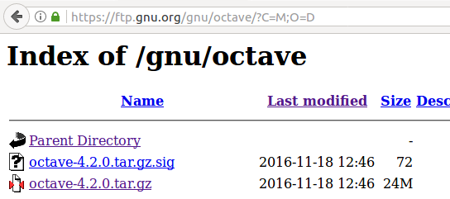

Install dependencies:
sudo apt-get install gcc g++ gfortran make libblas-dev liblapack-dev libpcre3-dev libarpack2-dev libcurl4-gnutls-dev epstool libfftw3-dev transfig libfltk1.3-dev libfontconfig1-dev libfreetype6-dev libgl2ps-dev libglpk-dev libreadline-dev gnuplot-x11 libgraphicsmagick++1-dev libhdf5-serial-dev openjdk-8-jdk libsndfile1-dev llvm-dev lpr texinfo libgl1-mesa-dev libosmesa6-dev pstoedit portaudio19-dev libqhull-dev libqrupdate-dev libqscintilla2-dev libqt4-dev libqtcore4 libqtwebkit4 libqt4-network libqtgui4 libqt4-opengl-dev libsuitesparse-dev texlive libxft-dev zlib1g-dev autoconf automake bison flex gperf gzip icoutils librsvg2-bin libtool perl rsync tar

Agar semua linked libraries support 64-bit variables:
Download OpenBLAS disini:
https://github.com/xianyi/OpenBLAS.git
https://github.com/xianyi/OpenBLAS

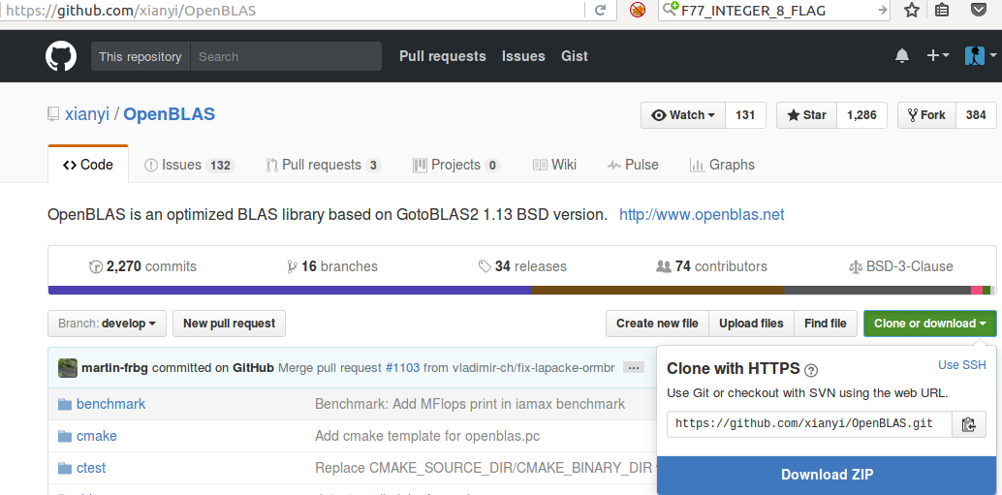
ekstrak, ke directory OpenBLAS, kemudian buka file Makefile.rule

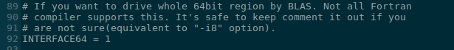

hilangkan tanda # pada BINARY=64 dan INTERFACE64=1
kemudian save

pada terminal:
make
sudo make install
sudo apt-get install libopenblas-base

ke folder octave yang telah diekstrak tadi
./configure JAVA_HOME=/usr/lib/jvm/java-7-openjdk-amd64 LD_LIBRARY_PATH=/opt/OpenBLAS/lib CPPFLAGS=-I/opt/OpenBLAS/include LDFLAGS=-L/opt/OpenBLAS/lib –enable-64
make
sudo make install

jika muncul error berikut:
octave-cli: error while loading shared libraries: libopenblas.so.0: cannot open shared object file: No such file or directory

solusinya:
sudo apt-get install libopenblas-base

octave –force-gui
kemudian set to launcher

jika muncul error ketika menjalankan command diatas, solusinya adalah ganti owner dari root menjadi user
sudo chown -R user:user /home/username/.config/octave/

jika ctrl+c menyebabkan crash, lakukan ini di terminal:
export OMP_NUM_THREADS=1

sumber:
http://wiki.octave.org/Octave_for_Debian_systems
https://github.com/xianyi/OpenBLAS
https://github.com/xianyi/OpenBLAS/wiki/Installation-Guide

