NAMA MATA KULIAH | Komunikasi Data | Sub - Capaian Pembelajaran Mata Kuliah
KODE MATA KULIAH | TE201417 | - Mahasiswa mampu memahami konsep komunikasi data pada physical layer (C2, P1, A1)
SEMESTER/ SKS | IV / 2
TANGGAL UJIAN | 15 Februari 2024
WAKTU UJIAN | 100 Menit
RUANG | Asynchronous LMS
JENIS UJIAN | Terbuka
DOSEN PENGAMPU | Mifta Nur Farid, S.T. M.T.

Data Communications and Networking with TCP/IP Protocol Suite, 6th Edition, Chapter 1 Introduction
- Q: Identify the five components of a data communications system.
A: The five components of a data communication system are the sender, receiver, transmission medium, message, and protocol.
- Q: A router connects three links (networks). How many of each of the following layers can the router be involved with?
  - physical layer
  - data-link layer
  - network layer
A: The router is involved in three physical layers, three data-link layers, and only one network layer.
- Q: A host communicates with another host using the TCP/IP protocol suite. What is the unit of data sent or received at each of the following layers?
  - application layer
  - network layer
  - data-link layer
A: At the application layer, the unit of data is a message. At the network layer, the unit of data is a datagram. At the data-link layer, the unit of data is a frame.
- Q: Which of the following data units has an application-layer message plus the header from layer 4?
  - a frame
  - a user datagram
  - a bit
A: The data unit should belong to layer 4. In this case, it is a user datagram.
- Q: If a port number is 16 bits (2 bytes), what is the minimum header size at the transport layer of the TCP/IP protocol suite?
A: The transport-layer packet needs to include two port numbers: source and destination port numbers. The transport-layer header needs to be at least 32 bits (four bytes) long, but we will see in Chapter 3 that the header size is normally much longer because we need to include other pieces of information.
Data Communications and Networking with TCP/IP Protocol Suite, 6th Edition, Chapter 2 Physical Layer
- Q: Which of the following are causes of transmission impairment?
  - attenuation
  - modulation
  - noise
A: Attenuation and noise are two causes of transmission impairment.
- Q: Which of the following techniques are examples of digital-to-digital conversion?
  - line coding
  - block coding
  - amplitude modulation
A: Line coding is the example of digital-to-digital conversion.
- Q: Which of the two digital-to-analog conversion techniques is more susceptible to noise?
  - ASK
  - FSK
A: We can say that the most susceptible technique is ASK because the amplitude is more affected by noise than the phase or frequency.
- Q: Which of the three multiplexing techniques are used to combine analog signals?
A: FDM and WDM are used to combine analog signals; the bandwidth is shared. TDM is used to combine digital signals; the time is shared.
- Q: What is the position of the transmission media in the TCP/IP protocol suite?
A: The transmission media is located beneath the physical layer and controlled by the physical layer.
- Q: What are the three major classes of guided media?
A: The three major categories of guided media are twisted-pair, coaxial, and fiber-optic cables.
- Q: Which of the four digital-to-analog conversion techniques (ASK, FSK, PSK, or QAM) is the most susceptible to noise?
A: We can say that the most susceptible technique is ASK because the amplitude is more affected by noise than the phase or frequency.
- Q: Describe the goals of multiplexing.
A: Multiplexing is the set of techniques that allows the simultaneous transmission of multiple signals across a single data link.
- Q: How do guided media differ from unguided media?
A: Guided media have physical boundaries, while unguided media are unbounded.
From: Data Communications and Networking 4th Edition, Chapter 2 Network Models
- Q: Which layers in the Internet model are the network support layers?
A: The network support layers are the physical, data link, and network layers.
- Q: Which layer in the Internet model is the user support layer?
A: The application layer supports the user.
- Q: What is the difference between network layer delivery and transport layer delivery?
A: The transport layer is responsible for process-to-process delivery of the entire message, whereas the network layer oversees host-to-host delivery of individual packets.
From: Data Communications and Networking 4th Edition, Chapter 4 Digital Transmission
- Q: Find the 8-bit data stream for each case
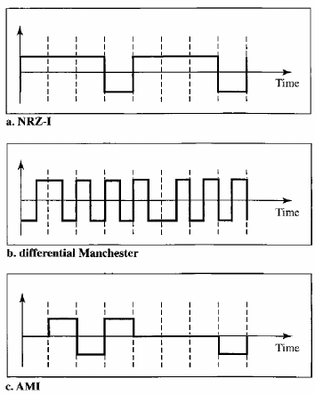
A: The data stream can be found as
  - NRZ-I: 10011001.
  - Differential Manchester: 11000100.
  - AMI: 01110001.
- Q: What is the result of scrambling the sequence 11100000000000 using one of the following scrambling techniques? Assume that the last non-zero signal level has been positive
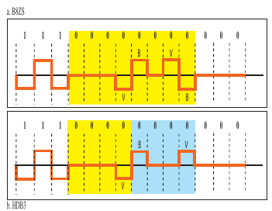
A:
From: Data Communications and Networking 4th Edition, Chapter 6 Bandwidth Utilization
- Q: Figure below shows a demultipleer in a synchronous TDM. If the input slot is 16 bits long (no framing bits), what is the bit stream in each output? The bits arrive at the demultiplexer as shown by the arrows.
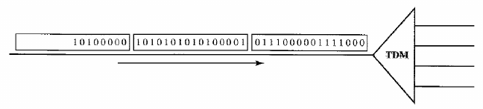
- A:
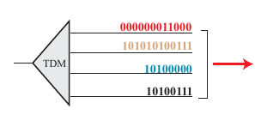

~ Selamat Mengerjakan ~

