Vibration Transmissibility Measurement on Multi Pump Damage Detection Using Accelerometer Array
Anisatul Fauziyah, Try R. Sulistomo, Dhany Arifianto
Dept of Engineering Physics, Faculty of Industrial Technology, Institut Teknologi Sepuluh Nopember, Kampus ITS Sukolilo , Surabaya 60111, Indonesia

nisafauziyah91@gmail.com, rahaditekfis@gmail.com,
Abstract. Pump damage detection methods (based on vibration) are normally used on a pump located on a single foundation. However, when more than one pump located on a single foundation, the vibration transmissibility at one pump with other pump vibrations will affect each other. In this case, we can’t use pump damage detection methods normally. Hence, this research used accelerometer array to know the effect of vibration transmissibility to the result of pump damage detection method. Using Fast Fourier Transform (FFT) analysis we known that the effect of vibration transmissibility on the diagnosis of detection of pump damage is destructive superposition occurs in the configuration of Misalignment & Unbalance pump (-7.7296 dB) and Misalignment & bearing fault pump (-8.037dB). While the Constructive superposition occurs in the configuration of Unbalance & bearing fault pump (3.6719dB). The conclusion is Transmissibility ratio from accelerometer array measurement could be used to determine the superposition of vibration between two different pump which mounted on same supporting base.

- Introduction
In Industrial process, Installed machine have integrated work mechanism. Hence, once the machine fault occurred, whole industrial process may be impacted. To maintain the machines in good condition, good maintenance strategies need to be implemented. Predictive maintenance is one of the maintenance strategy that often be implemented in industry, especially for rotating machine. In this maintenance strategy, it is compulsory to monitor machine condition overtime, thus it is often be called condition-based maintenance [1].
In rotating machine, condition of the machine is determined through the vibration analysis. Thus, by having preliminary condition analysis, machine could maintain in proper schedule and treated correctly [1]. However, when there is more than one machine being operated and mounted in same base, which in this study we call it “multi-pump”, the vibration of one machine will transmitted to the other, thus the collected vibration data of one machine could be superposition of the other machine. This may result in wrong interpretation of machine condition, and continue to wrong corrective treatment. This paper shows the evaluation of the effect of vibration transmissibility of two machines that mounted in same base.
- Vibration Analysis
Vibration analysis is one of the methods for implementing predictive maintenance. This method has been widely applied in industrial field. Vibration of machine represented by its acceleration, although it may also being state in term of velocity or displacement. Since vibration is oscillating motion, there are three main features that being utilized in the analysis. Those are amplitude, frequency, and phase.
Amplitude of vibration indicated the level of machine damage. Increasing in vibration amplitude indicated increasing of machine severity. Amplitude of vibration stated in root mean square value of the recorded vibration, as shown in equation (1).
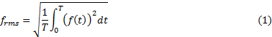
Whre is time domain signal, T is length of data.
Frequency of vibration often being corresponded to the failure mode of rotating machine. Each of the failure modes have different frequency characteristic. Frequency of Vibration can be acquired by transforming the time domain signal to frequency domain signal using Fourier Transform.

Where . In this paper FFT algorithm implemented to acquired frequency domain signal.
- Failure Mode of Rotating Machine
Rotating machine assembled from different kind of parts. Wrong installation and defect of rotating machine part may affected the vibration frequency and amplitude of rotating machine. In this paper 3 kinds of failure mode will be analyzed, which is unbalance, misalignment, bearing fault, and mechanical looseness.

Unbalance
Unbalance is the condition where the centre of gravity isn’t aligned with the axis of rotation [2]. Unbalance condition can be recognize when peak of frequency exist in 1xRPM of radial vibration (horizontal and vertical direction) [3].

Misalignment
Misalignment is the condition when rotating shaft is not aligned. It may be result from bended shaft or improper coupling. Peak frequency of this failure exist on 1-3 x RPM [3]. This failure can be detected by shifted phase of the vibration.

Bearing Fault
This failure mode detected by peak in high frequency (may exist until 10x RPM) [3]. This failure mode occurred due to defect or wear of bearing.

Figure 1 Vibration Spectrum of (A) Unbalance; (B) Bearing Fault, (C) Miss Alignment
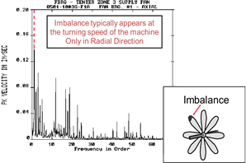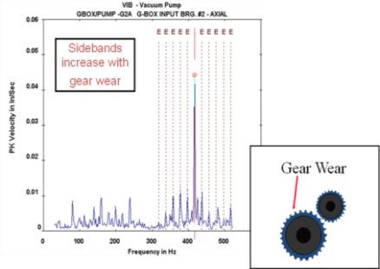
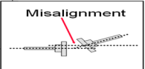
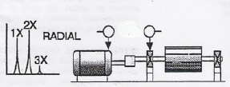
- Transmissibility
Rotating machine vibration could propagate through the supported base. If there are two or more than one machine operating, this propagated vibration may added to the other machine. Hence the measured vibration of that machine is the result of superposition between the machine own vibration and other machine vibration which propagate through the base [4]. The ratio of machine vibration force which transmitted to the supported base to its actual force is called transmissibility factor.
Where S is the total summation of machine vibration and transmitted vibration and B is machine vibration when operating alone[5].
- Experiment Setup
The experiment conducted in Vibrastic and Acoustic Laboratory. Two pumps will be mounted in same supporting base with the distance of 15.5 cm as shown in Figure 2. Pumps operated in 3000 RPM (50Hz). Three accelerometer were placed in three different axis, vertical, horizontal, and axial to measure vibration of the pump. Combination of two pump failure mode can be seen in table 1.

Figure 2 Configuration of experiment
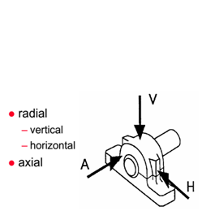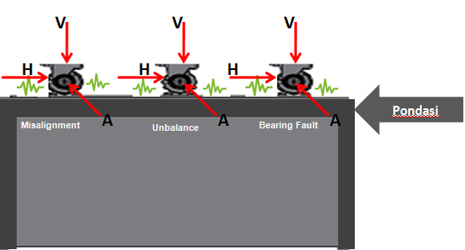
Observed
pump
Disturbance pump

After signal have been acquired, it will be transformed to frequency domain using FFT. Each of the amplitude of harmonic frequency will be compared to the baseline signal to determine the transmissibility of each configuration using equation (3).
- Transmissibility Measurement
Calculation of Transmissibility factor was shown in table 1. The negative sign indicated that there was destructive superposition, since acquired signal pump vibration less powerful than the vibration where the pump operation solely. The positive sign indicated opposite event, thus superposition was constructive.
In constructive superposition case, recorded signal behave like a pump with 2 failure mode. Figure 3a shown the recorded vibration signal of bearing fault pump, which operated along with the unbalance pump. Transmissibility of this configuration is 3.6 dB (configuration 4, pump 2 vertical axis), thus it is belong to constructive superposition. The amplitude of first harmonic frequency increased when compared to the baseline signal. This event may lead to wrong analysis of machine condition failure mode, the pump which only have bearing fault also contain vibration of nearby pump which have unbalance.
In destructive superposition case, the wave cancel out each other, thus made the recorded signal have lower power of vibration. Figure 3b shows the frequency spectrum of pump 2 vibration in configuration 2 horizontal. The transmissibility value of this configuration is -7.729 dB. The amplitude of 1st, 2nd, and 3rd harmonic frequency were decrease. This may lead to wrong analysis of machine failure severity.

Figure 3. Vibration Spectrum of : a) Bearing Fault Pump and Unbalance; b)Misalignment 2mm Pump and Bearing Fault
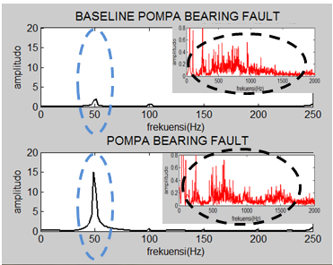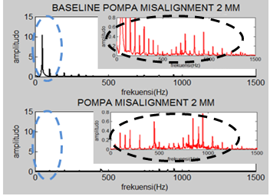

Table 1 Configuration of experiment
No | TRANSMISSIBILITY (dB)
No | Pump 1 | Axis |  |  | Pump 2 | Axis
No | Pump 1 | V | H | A | Pump 2 | V | H | A
1 | Unb 18 g• 1.5 cm | -0.354 | -0.558 | -0.731 | Mis - 1 mm | 10.378 | -2.798 | 1.705
2 | Unb 18 g• 1.5 cm | 1.244 | -0.548 | -1.180 | Mis - 2 mm | 1.764 | -7.729 | 2.841
4 | Unb 18 g• 1.5 cm | -0.036 | -0.908 | -1.249 | Bearing F | 3.672 | 0.385 | 4.265
5 | Bearing F | 0.006 | 0.068 | 5.456 | Mis - 1 mm | 5.025 | -2.347 | -2.879
6 | Bearing F | 0.541 | 0.501 | 5.720 | Mis - 2 mm | -0.129 | -8.037 | 4.489

- Conclusion
- Transmissibility ratio from accelerometer array measurement could be used to determine the superposition of vibration between two different pump which mounted on same supporting base.
- Destructive superposition occurs in the configuration of Misalignment & Unbalance pump (-7.7296 dB) and Misalignment & bearing fault pump (-8.037dB). While the Constructive superposition occurs in the configuration of Unbalance & bearing fault pump (3.6719dB).
- Signal processing such as Independent Component Analysis is required to using Pump Damage Detection Method based on ISO 13373 on multi-pump scenario.
References
- ISO 13373 - Condition monitoring and diagnostics of machines — Vibration condition monitoring
- Girdhar, Pares.2004. Practical machinery vibration and analysis & Predictive Maintenance. Oxford: Newnes Inc.
- Tri P., Agung, 2011. “Pembelajaran Vibrasi Bengkel Mesin Fasilitas Pemeliharaan Kapal Surabaya”, LANTAMAL V.
- Saktyo,Haris. 1997. Simulasi Superposisi Getaran dengan menggunakan Metode FFT. ITS
- AmirHossein, 2013 Aplication of Transmissibility Measure in Estimation of Modal Parameters for a Structure. Blekinge Institute of Technology. Sweden

