|  |  |  |
| --- | --- | --- |
| **NAMA MATA KULIAH** | **Sinyal dan Sistem** | **CAPAIAN PEMBELAJARAN MATA KULIAH** |
| **KODE MATA KULIAH** | **TE201416** | Mahasiswa mampu menganalisis permasalahan dari sinyal dan sistem sehingga diperoleh bentuk penyelesaian permasalahan dalam permasalahan sinyal. |
| **SEMESTER/ SKS** | **4 / 3 SKS** |
| **TANGGAL UJIAN** | **13 April 2022** |
| **WAKTU UJIAN** | **90 menit** |
| **RUANG** | **F205/G205** |
| **JENIS UJIAN** | **Close Book** |
| **DOSEN PENGAMPU** | **Mifta Nur Farid, S.T., M.T.**  **Risty Jayanti Yuniar,S.T.,M.T.** |

1. A continuous-time signal x(t) is shown in Figure 1. Sketch and label carefully each of the following signals.
2. x (2t+1)
3. x(t) u(1-t)

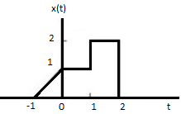

Figure 1. Continous-time signal x(t)

**Score: 20**

1. Consider an input x(n) and unit impulse response h(n) given by

x(n)={-1,2,0,1}; h(n)={3,1,0,-1}

Determine and plot the outputy(n) = x(n)*h(n) !

**Score: 20**

1. Consider a causal LTI system with frequency response

H (j $⍵$) = $\frac{1}{j⍵+2}$

For a particular input x(t) this system is observed to produce the output

y(t) = $e^{−2t}u\left(t\right)−e^{−5t}u\left(t\right)$

Determine x(t)!

**Score: 20**

1. Determine the complex exponential fourier series representations for Figure 2.

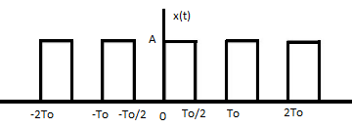

Figure 2

**Score: 20**

1. Determine the fourier transform representations for Figure 3.

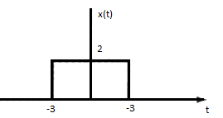

Figure 3

**Score: 20**

*“Nothing is impossible, the word itself says ‘I’m possible’! – Audrey Hepburn”*