# Problem 2.Event Tracker

**Environment Specifics**

Please be aware that every JS environment may **behave differently** when executing code. Certain things that work in the browser are not supported in **Node.js**, which is the environment used by **Judge**.

The following actions are **NOT** supported:

* **.forEach()** with **NodeList** (returned by **querySelector()** and **querySelectorAll()**)
* **.forEach()** with **HTMLCollection** (returned by **getElementsByClassName()** and **element.children**)
* using the **spread-operator** (**...**) to convert a **NodeList** into an array
* **append()** (use only **appendChild()**)
* **prepend()**
* **replaceWith()**
* **replaceAll()**
* **closest()**
* **replaceChildren()**

If you want to perform these operations, you may use **Array.from()** to first convert the collection into an array.

**Use the provided skeleton to solve this problem.**

**Note**: You **can't** and you have no permission to **change** directly the given HTML code (index.html file).

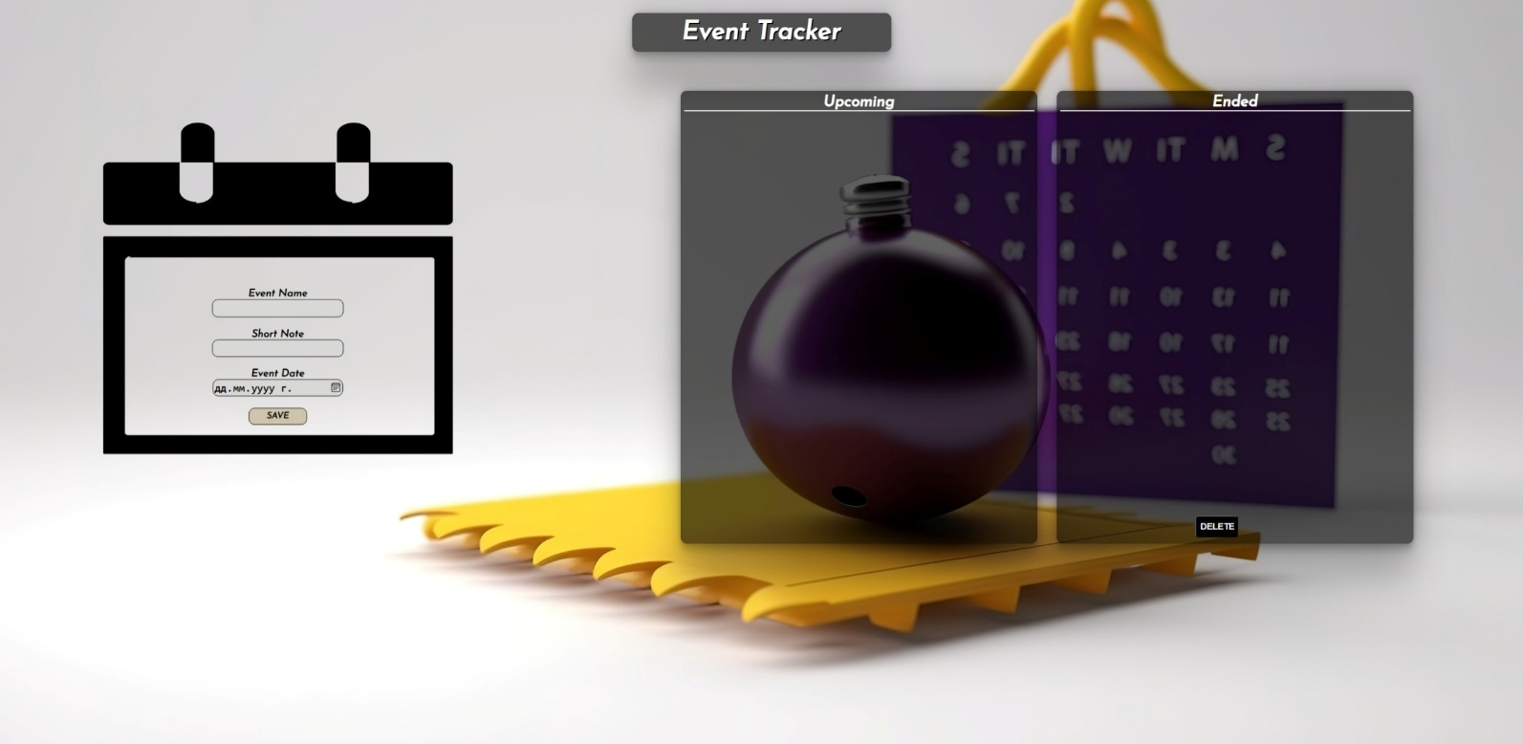

# Your Task

**Write the missing JavaScript code** to make the **Event Tracker** work as expected:

* + **Event Name, Note,** and **Date** should be **non**-**empty** **strings**. If any of them are empty, the program should not do anything.

# Get the information from the form

When you click the **[Save]** button, the information from the input fields must be added to the <ul> with the id "upcoming-list",**[Save]** button **should allow multiple event adding** and **the input fields should be cleared**.

The HTML structure should look like this:

Картина, която съдържа текст, екранна снимка, Шрифт

Описанието е генерирано автоматично

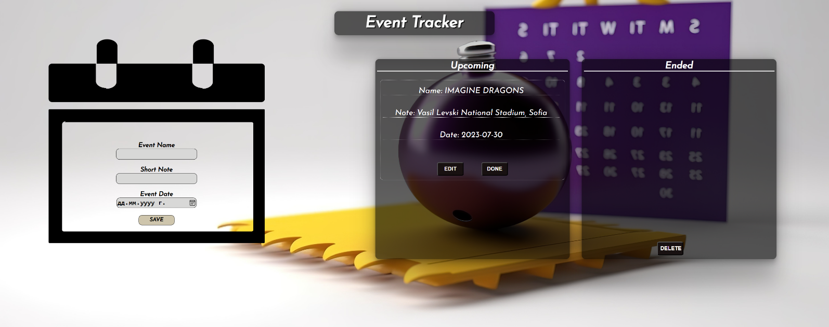

# Edit the Information

When the **[Edit]** button is clicked, the information from the post must be sent to the input fields on the left side, the record should be deleted from the <ul> "upcoming-list".

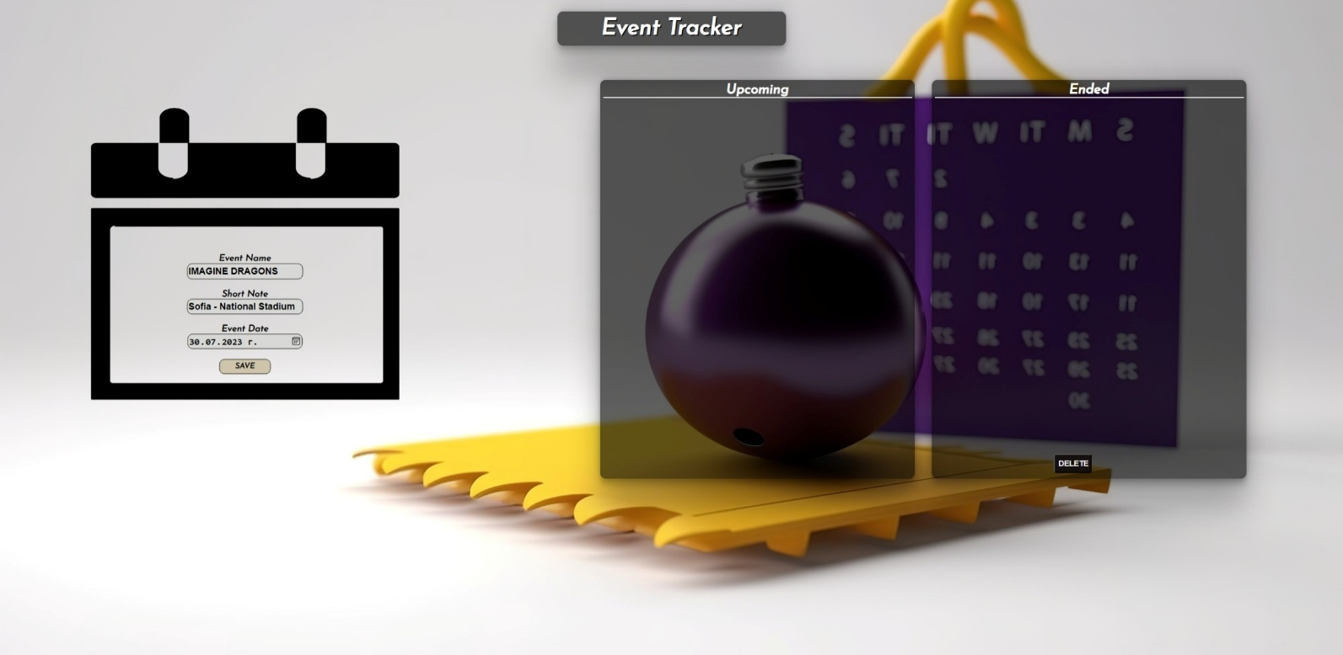

After editing the information, add a new item to the <ul> "upcoming-list" with the updated information.

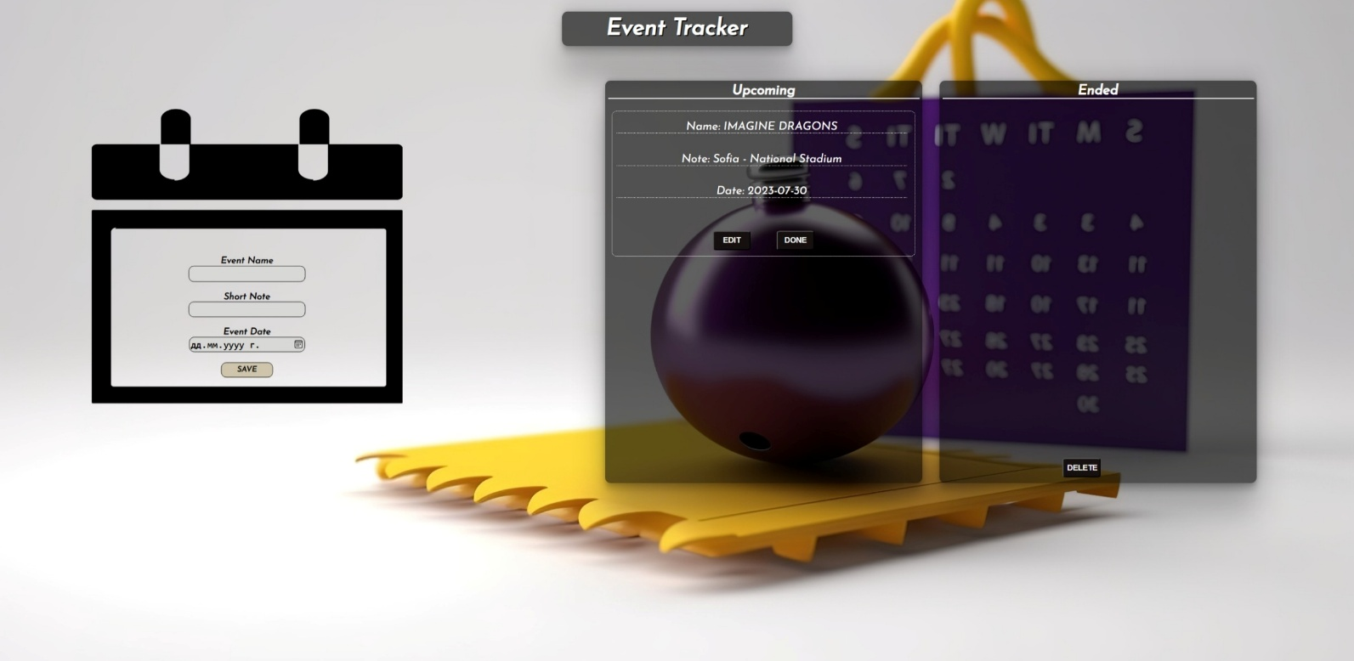

# End the event

When you click the **[Done]** button, the record must be **deleted** from the <ul>withid"upcoming-list" and appended to the <ul> with id "events-list".

The **buttons [Edit]** and **[Done]** should be removed from the <li> element.

Картина, която съдържа текст, екранна снимка, Шрифт

Описанието е генерирано автоматично

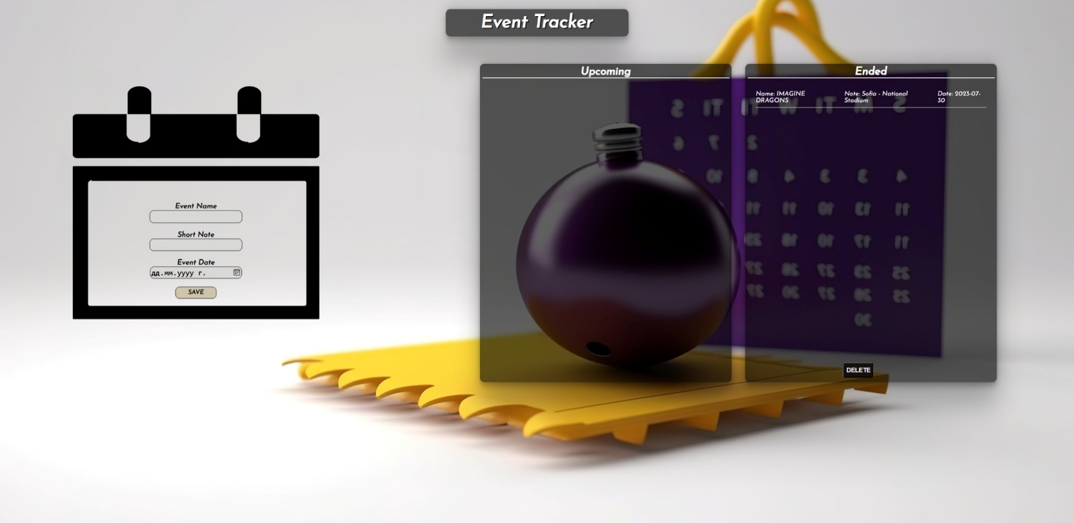

# Delete Ended Events

When the **[Delete]** button is clicked, you must **delete all ended events.**

# Submission

Submit only your **solve()** function.