TASK 1

The graph below shows the percentage of household with different kinds of technology in the U.S from 1995 to 1999.Summerize the information by selecting and reporting the main features, and make comparisons where relevent.Write as least 150 words.

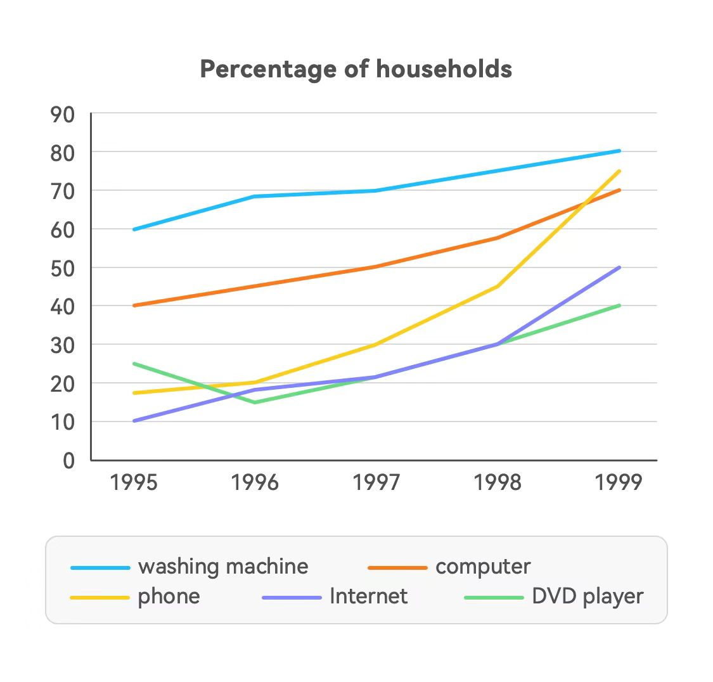

The line graph show the proportion of five kinds of household appliances using different technologies in the U.S between 1995 and 1999.

Overall,all kinds of household illustrated increase trend as whole with the washing machine kept staying at the highest level. Other four types had the lower percentage and larger data gap.

The starts of DVD player, phone and Internet were similar, which began around 25%, 18% and 10% respectively.It's noticeable that there was a steep mountain on the percentage of phone, which rose by 50% and reached 75% in 1999. For DVD player and Internet, they almost shared a same trend from 1996 to 1998, climbing from over 15% to 30%, reached different end at 40% and 50% respectively.

Concerning the computer,it had a net increase during 5 years rising from 40% to 70% steadily.It stayed at the second high position following washing machine until rose to 65%, exceeded by the kind of phone. The washing machine accounted for the most percentage over years with climbing from 60% to 80%.None of other kinds can catch up with it from 1995 to 1999.

TASK 2

1. In many societies in the world, the population is ageing rapidly and this is leading to an

unsustainable increase in the cost of public healthcare. A nation’s population should pay for

their healthcare provision in the future. To what extent do you agree or disagree? （养老应该

由全体公民付费？）

Aging society is facing the problem that the expenditure of public healthcare is continuously increasing.Some people claim the whole people of the nation should pay for the health care provision in the futures.I believe it is reasonable for those people who are active in workplace paying for that through taxes, especially the enterprises and individuals with higher net income should take more social responsibilities than others.

Adults with jobs should take the burden to pay the cost of the healthcare provision of the whole society. Children don’t have stable resource of earning money and they should pay attention to their study in school instead. In term of the elder people, which account for a large amount in an aging society, they have been far away form workplace and their retirement funds usually offer not too much.Therefore, people with stable jobs and pay taxes timely should lend a helping hand.

Despite employers, the employees and high income groups are ought to share the cost of society healthcare.With great power comes great responsibility. They have absorbed wealth from the society so that it is inevitable for them to take the coming responsibilities and feedback to more people.Contribution of money into the healthcare insurance is beneficial for the nation’s population.

In conclusion,everyone is facing the aging problem, so as the country. People who take the burden to spend money on improving healthcare provision are taking care of the elder and protecting the children. The enterprise and rich groups in society should never limit to put emphasis on making profit with give back to the community.