Fundamentals of the Faith

Introduction

Table of Contents

Objective & Preliminary Comments ............................................................. i

I. Introduction ..................................................................................................... 1

II. Course Goals ................................................................................................... 2

A. The assurance of eternal life
B. To become equipped for ministry
C. Strengthen our love for God’s laws (obedience)
D. To know God deeper

III. Class Format ................................................................................................... 6

A. Course introduction
B. Materials the student will need

IV. The Navigator’s Wheel ................................................................................... 7

A. Christ - The center of our lives
B. The Obedient Christian
C. The Bible - God’s Word
D. Prayer
E. Fellowship
F. Witnessing

V. Application ...................................................................................................... 14

Fundamentals of the Faith

Introduction

Objectives & Preliminary Comments

The Objectives of the Introduction:
1. To set the course goals.
2. To explain the commitment (i.e. homework, memory verses, etc.)
3. To give an overview of the FOF course; a roadmap to where you will be going over the next 20 weeks or so.
4. To integrate in the gospel, in case there are those who are in the class who do not yet know Christ as Savior and Lord.

The class plan is divided into four parts:

1. Introduction
2. Course Goals
3. Class Format
4. The Navigator's Wheel

Exhortation to the teacher:
Use every opportunity you have to build a bond with your class. Get to know them; build a relationship with them, love them. Learn their names. Remember:

"They will not care how much you know, until they know how much you care."

This will aid in building a foundation for your future discussions as well as give opportunity for sharing the gospel with those who are not saved.

Before entering the classroom, always ...

Pray that Christ will be glorified through all that you say, remembering that your strength is supplied by God and the power of your message is the Word of God (1 Peter 4:11).

Fundamentals of the Faith

Introduction

Lesson Outline

I. Introduction

A. Handout as the students come in:

1. Name tags
2. Information sheets

B. Prayer

C. Introductions
(start with yourself)

1. Name
2. Where you live
3. Occupation
4. School and major (if applicable)
5. How did you hear about FOF?
6. Why did you decide to take FOF?

II. Course Goals (put up on board as discussed)
A. The Assurance of Eternal Life - 1 John 5:11-13
11 "And the witness is this, that God has given us eternal life, and this life is in His Son.

12 He who has the Son has the life; he who does not have the Son of God does not have the life.

13 These things I have written to you who believe in the name of the Son of God, in order that you may know that you have eternal life."

Q. According to verse 13 - What can we know for sure?
...we can know we have eternal life
Q. Do you know that you have eternal life?
Q. According to verse 12, who has eternal life? ... he who has the Son
Q. What does it mean to "have the Son?" ... eternal life is a relationship with the Son ... possessing His nature (2Pet. 1:4)
... new creation (2Cor. 5:17)
... the Spirit will be in you (John 14:17)
... Christ in you (Col. 1:26-27)

B. To become equipped for ministry
1. Adequate for every good work - 2 Timothy 3:16-17
16 "All Scripture is inspired by God and profitable for teaching, for reproof, for correction, for training in righteousness;
17 that the man of God may be adequate, equipped for every good work."

Q. What does it mean to be equipped?
Equipped – Greek "artios" – completely, fitted
Adequate – Greek "exartizo" – to equip fully
2. Equipped for ministry - Ephesians 4:11-12
11 "And He gave some as apostles, and some as prophets, and some as evangelists, and some as pastors and teachers,
12 for the equipping of the saints for the work of service, to the building up of the body of Christ;"

Q. He is Christ ... What did Christ (He) give to the Church?
... Apostles, prophets, evangelists, pastors, teachers
Q. Why did Christ give them to the Church? ... to equip the saints
Q. What are we being equipped for? ... the work of the service
Q. What service? ... to build up the Body of Christ
Q. Who is to carry out this service, the pastor? .... no the saints, us!
Q. Do you want to be better equipped to serve? … this is one of our goals.

3. To be able to share your faith - 1 Peter 3:15
"but sanctify Christ as Lord in your hearts, always being ready to make a defense to everyone who asks you to give an account for the hope that is in you, yet with gentleness and reverence;"

Q. What should we be able to do? .. be ready to make a defense for our hope
Q. What is the hope within us? Acts 24:15; Rom. 5:2,5
Hope – def. expectations
Acts 24:15, "having a hope in God, which these men cherish themselves, that there shall certainly be a resurrection of both the righteous and the wicked."

Recapping:

Goal #1 – The Assurance of our Eternal Life
Goal #2 – To become equipped for ministry

Next:
Goal #3 – To strengthen our love for God's law (obedience)
C. Strengthen our love for God's laws (Obedience)

1. David loved God's laws - Psalms 119:159-165
159 "Consider how I love Thy precepts; Revive me, O Lord, according to Thy lovingkindness.
160 The sum of Thy word is truth, And every one of Thy righteous ordinances is everlasting.
161 Princes persecute me without cause, But my heart stands in awe of Thy words.
162 I rejoice at Thy word, As one who finds great spoil.
163 I hate and despise falsehood, But I love Thy law.
164 Seven times a day I praise Thee, Because of Thy righteous ordinances.
165 Those who love Thy law have great peace, And nothing causes them to stumble."
Q. What did David love (verses 159 & 163)? ... God's precepts.
Q. What is a precept? Greek "piqqud" – a commandment;
an instruction or a rule.
Q. What are the rewards of loving God's commandments or God's law?
(verse 165) ... they have great peace ... and they do not stumble

2. What happens if we don't follow God's law? - 1 Peter 2:8
Answer: We stumble?
"A stone of stumbling and a rock of offense"; for they stumble because they are disobedient to the word, and to this doom they were also appointed."

Recapping:

Goal #1 – The Assurance of our Eternal Life
Goal #2 – To become equipped for ministry
Goal #3 – To strengthen our love for God's law (obedience)

The 4th Goal is found in Exodus 33:13.
D. To know God Deeper
1. Moses desired to know God - Exodus 33:13
"Now therefore, I pray Thee, if I have found favor in Thy sight, let me know Thy ways, that I may know Thee, so that I may find favor in Thy sight. Consider too, that this nation is Thy people."

Q. What did Moses desire? ... to know Thee ... not to know about God
Hebrew "yada" – to know; to comprehend; to understand

2. We can know God - John 17:3
"And this is eternal life, that they may know Thee, the only true God, and Jesus Christ whom Thou hast sent."
Note: As our knowledge of God grows deeper our worship of God grows truer.

Q. Do you want to know God deeper? …God will be on display in throughout FOF.

Recapping:

Goal #1 – The Assurance of our Eternal Life .... so we will never doubt our salvation
Goal #2 – To become equipped for ministry ................ to be able to defend our faith
Goal #3 – To strengthen our love for God's law (obedience) .. so we will not stumble
Goal #4 - To know God deeper .................................... so we can worship Him truer
III. Class Format

A. Course Introduction:

1. 13 lessons
2. 18 to 20 weeks
3. Homework - 1 to 3 hours/week
4. Lessons are to be handed in ... graded and handed back
... don't want errors in your lessons!
5. Explain purpose of the quizzes:
a. For the instructors use ... to determine the level of the class; to help in preparing the class.
b. Quizzes are given the week before the lesson is taught.
c. Don't guess ... if don't know leave it blank ... or I will not know to cover it.
d. The quizzes will also be used to review the lesson – after it is taught.

6. Tape procedure ... $2.00 deposit
7. Memory verses

B. Materials the student will need:

1. Bible
2. Lesson Workbook
3. 3-Ring Notebook (1") ... you will be tearing out your lessons & handing them in.
4. Pen or pencil

PLEASE .... PLEASE ... PLEASE

Be on Time !!

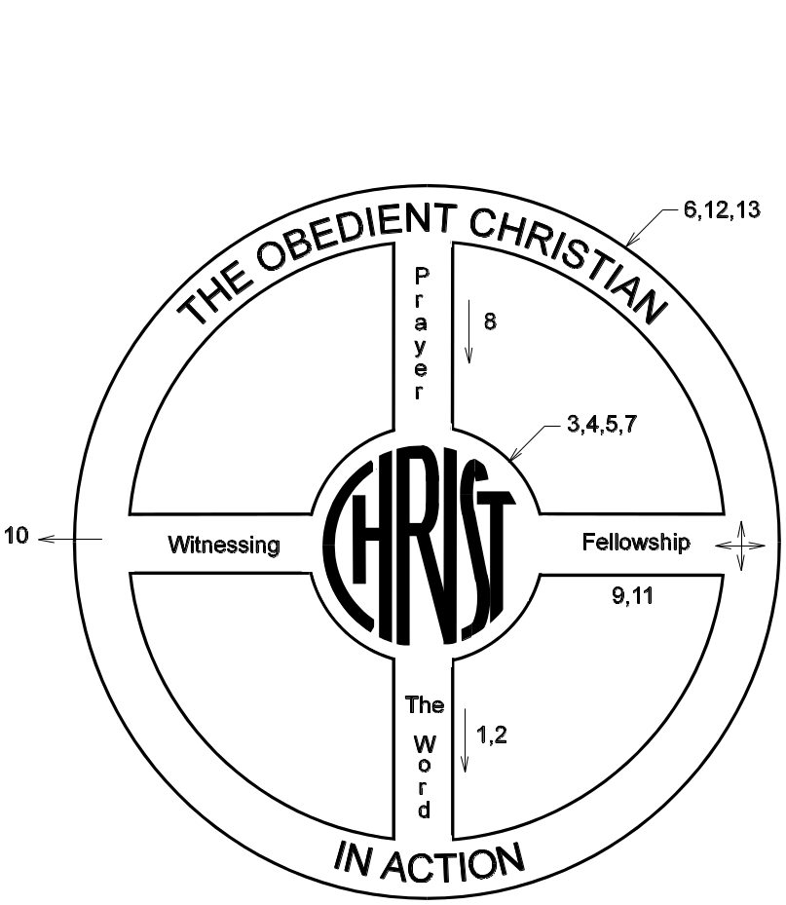

Christ The Center

Galatians 2:20
John 15:5
Colossians 1:27

Obedience to Christ

John 14:21
Romans 12:1,2
Luke 6:46

The Word

1 Peter 2:2
2 Timothy 3:16,17
Joshua 1:8

Prayer

Matthew 7:7
Philippians 4:6,7
John 15:7

Fellowship

Matthew 18:20
Hebrews 10:24,25
1 John 1:3

Witnessing

Matthew 4:19
Romans 1:16
Lesson #1 Introduction: The Bible 1 Peter 3:15
Lesson #2 How to Know the Bible
Lesson #3 God: His Character & Attributes
Lesson #4 The Person of Jesus Christ
Lesson #5 The Work of Christ
Lesson #6 Salvation
Lesson #7 The Person and Ministry of the Holy Spirit
Lesson #8 Prayer and the Believer
Lesson #9 The Church: Fellowship and Worship
Lesson #10 Spiritual Gifts
Lesson #11 Evangelism and the Believer
Lesson #12 Obedience

Lesson #13 God's Will and Guidance
IV. The Navigator's Wheel

Note: The Navigators - An evangelistic group on college campuses and military bases.

A. Christ - The center of our lives

1. Keep your eyes fixed on Christ - Hebrews 12:2

"fixing our eyes on Jesus, the author and perfecter of faith, who for the joy set before Him endured the cross, despising the shame, and has sat down at the right hand of the throne of God."

Q. What are we commanded to do (beginning of the verse)?
...fix our eyes on Jesus
Fixing – Greek "aphorao" – to look away from all else.

2. You can do nothing of value away from Christ - John 15:5

"I am the vine, you are the branches; he who abides in Me, and I in him, he bears much fruit; for apart from Me you can do nothing."

Q. How much can we do apart from Christ? ... nothing

3. No longer I, but Christ in me - Galatians 2:20

"I have been crucified with Christ; and it is no longer I who live, but Christ lives in me; and the life which I now live in the flesh I live by faith in the Son of God, who loved me, and delivered Himself up for me."

4. Paul summed it up: To live is Christ - Philippians 1:21

"For to me, to live is Christ, and to die is gain."

Q. Are your eyes fixed on Christ? Is Christ the center of your life?
… this should be the desire of every Christian.

NOTE: The wheel is powered from the center.

 The following FOF lessons address the God-head:
➢ Lesson #3 - God: His Character & Attributes
➢ Lesson #4 - The Person of Jesus Christ
➢ Lesson #5 - The Work of Christ
➢ Lesson #6 – Salvation
➢ Lesson #7 - The Person & Ministry of the Holy Spirit
B. The Obedient Christian

1. Obedience as a mark of a true believer - 1 John 2:4,5

4 "The one who says, "I have come to know Him," and does not keep His commandments, is a liar, and the truth is not in him;

5 but whoever keeps His word, in him the love of God has truly been perfected. By this we know that we are in Him:"

Q. How do you know if you have come to know Christ?
... You will keep His commandments.

Q. Does this mean that if we keep His commandments we will be saved?
... No. This means that if we keep His word, this is a sign that His love has been perfected in us.

2. Lordship implies our obedience - Luke 6:46

"And why do you call Me, 'Lord, Lord,' and do not do what I say?"

Q. What will a true Christian desire to do?
... he will desire to do what the Lord says.

 The following FOF lessons address the Christian walk:

➢ Lesson #12 - Obedience
➢ Lesson #13 - God's Will and Guidance
C. The Bible - God's Word
Q. How do we know what God wants us to do?
Q. How does God communicate with us?

(earlier) 1. The Bible is God's word - 2 Timothy 3:16,17
II.B.1 16 "All Scripture is inspired by God and profitable for teaching, for reproof, for correction, for training in righteousness;
17 that the man of God may be adequate, equipped for every good work."
Q. What does Timothy say Scripture is? ... inspired
Q. What does inspired mean? ... breath out, Scripture is God breathed!
Q. How much of Scripture is God breathed? ... all

2. Scripture can bring one to salvation – 2 Timothy 3:15 (previous verse)
"and that from childhood you have known the sacred writings which are able to give you the wisdom that leads to salvation through faith which is in Christ Jesus."
Q. What are the Scriptures, or sacred writings, able to do?
... lead one to salvation

3. Causes us to grow - 1 Peter 2:2
"like newborn babes, long for the pure milk of the word, that by it you may grow in respect to salvation,"
Q. It says we should long for the Word of God. Why (2nd part of verse)?
… that you may grow … spiritually! … The Word of God will do this.

4. The Bible reveals God’s commanded will - which we should love to obey
John 14:15
“If you love Me, you will keep My commandments,”

3. We need to spend time in it - Joshua 1:8
“This book of the law shall not depart from your mouth, but you shall meditate on it day and night, so that you may be careful to do according to all that is written in it; for then you will make your way prosperous, and then you will have success.”

 The following FOF lessons address the Bible:
➢ Lesson #1 - Introduction - The Bible
➢ Lesson #2 - How to know the Bible
D. Prayer

Q. How do we communicate with God?

1. We are commanded to pray - Ephesians 6:18

"With all prayer and petition pray at all times in the Spirit, and with this in view, be on the alert with all perseverance and petition for all the saints,"

Q. According to this verse is prayer an option? ... No
Q. In fact, how often are commanded to pray? ... at all times!
1Thess. 5:17, ""pray without ceasing"
… As if Christ were walking next to you all the time.

2. God knows what we need before we ask Him – Matt. 6:7-8
7 "And when you are praying, do not use meaningless repetition, as the Gentiles do, for they suppose that they will be heard for their many words.
8 "Therefore do not be like them; for your Father knows what you need, before you ask Him.

Q. What does the end of verse 8 say that the Father knows?
... the "your Father knows what you need, before you ask Him"
Q. Then why pray? ... we will find out when studying lesson #8 on prayer.
… We will see that prayer is more for us than for God!

3. Questions that need answering:

a. How do we pray?
b. What should we pray for?
c. If God knows all then why do we have to pray?

Note: Prayer does not give God information.
Prayer shows dependence upon God for all things.

 The following FOF lesson addresses Prayer:

➢ FOF Lesson #8 - Prayer and the Believer
E. Fellowship

1. Fellowship with God - 1 John 1:3
"what we have seen and heard we proclaim to you also, that you also may have fellowship with us; and indeed our fellowship is with the Father, and with His Son Jesus Christ."

Q. What does this verse say we have with each other and with God?
… fellowship

Q. What is fellowship?
Fellowship is summarized in the One-another's
➢ Love one another
➢ Bear one another's burdens
➢ Pray for one another
➢ Be at peace with one another
➢ Admonish one another
➢ Encourage one another
➢ Etc.

Q. Who do we have fellowship with?
... Other believers and with God!

… For Christians:
➢ God loves you
➢ God will help bear your burdens
➢ Christ intercedes for you
➢ God is at peace with you
➢ God will admonish you
➢ God will encourage you

2. Encouraging & Assembling together - Hebrews 10:24,25
24 and let us consider how to stimulate one another to love and good deeds,
25 not forsaking our own assembling together, as is the habit of some, but encouraging one another; and all the more, as you see the day drawing near."

 The following lessons address fellowship:

➢ Lesson #9 - The Church: Fellowship and Worship
➢ Lesson #10 - Spiritual Gifts
F. Witnessing

Q. What is our responsibility to unbelievers?

1. The power of the Gospel - Romans 1:16
"For I am not ashamed of the gospel, for it is the power of God for salvation to everyone who believes, to the Jew first and also to the Greek."
Q. What is the gospel? ... Gospel means "Good news, or good tidings"
Q. The 1st part of verse says, "we are not to be ashamed of the gospel."
Why?
... it is the power of God!

2. Fishers of men - Matthew 4:19
"And He said to them, 'Follow Me, and I will make you fishers of men.'"

3. Witness with you life - Matthew 5:16
"Let your light shine before men in such a way that they may see your good works, and glorify your Father who is in heaven."
Q. Does your life shine for Christ?
… We proclaim Christ with our life and with our words.

4. Proclaiming Christ - I Peter 2:9
"But you are a chosen race, a royal priesthood, a holy nation, a people for God's own possession, that you may proclaim the excellencies of Him who has called you out of darkness into His marvelous light;"

Q. Are you telling others about Christ?
Q. Do you know how?

 The following FOF lesson addresses Witnessing:

➢ FOF Lesson #11 - Evangelism and the Believer
V. APPLICATION

A. How does your life compare:

1. Is Christ the center of your life?
Is HE the most important priority to you?

2. Are you obedient to His word?
Do you know what God wants you to obedient to?

3. How well do you know the Bible?

4. Do you spend time in prayer?
Do you know how to pray?

5. Do you have fellowship with other believers?
Do you practice the one another's?

6. Does your life give a testimony to Christ?
Do you know how to explain the Gospel?

B. Closing prayer

VI. Reminders

A. Handout lesson #1
B. Remember your memory verse!

