

Miguel Guevara - 4968505

Ekaterina Gumnova - 2598224

COP-4610 U01

Lab 4

I/O Scheduling

April 22, 2016

The purpose of this report is to demonstrate the test results of the CLOOK I/O scheduler implemented in the lab exercise 4. The CLOOK scheduler was implemented on top of the NOOP scheduler in the Linux kernel.

Summary of changes:

A global variable *dh* was introduces to store the current position of the disk head. We modified 2 functions in order to implement the algorithm: *clook_dispatch* and *clook_add_request*, we added printk statement to both functions in order to be able to prove that the implemented CLOOK algorithm is working. *clook_dispatch* changes: update the *dh* global variable every time the request is dispatched from the queue to store the current position of the head. *clook_add_request* changes: iterate though the request queue and insert the request according to the CLOOK algorithm (implementation described in detail in the source code).

The tester folder includes 10 simple test files and the script testscript, which simply reads from those files and writes to a new file. Multiple test files had to be used in order to test reads.

Below is the output log after testing the CLOOK I/O scheduler:

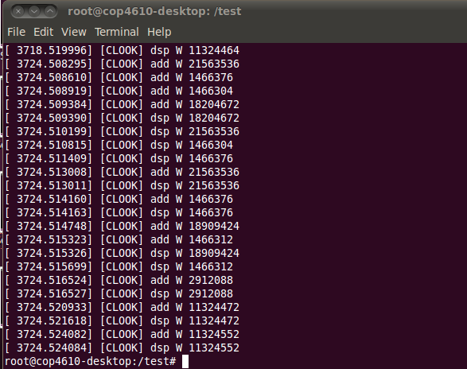

The first line shows us that the request was dispatched and the current head position now is 11324464, the next 4 lines show that 4 requests were added to the dispatch queue in the following order: 21563536, 1466376, 1466304, 18204672. Since our current head position is on sector 11324464, the requests should have been added to the queue and get sorted in the following order according to the CLOOK algorithm: 18204672, 21563536, 1466304, 1466376. We can see from the next 4 lines that the CLOOK algorithm was implemented correctly and the requests were dispatched in order according to the CLOOK algorithm:

[ 3724.509390] [CLOOK] dsp W 18204672

[ 3724.510199] [CLOOK] dsp W 21563536

[ 3724.510815] [CLOOK] dsp W 1466304

[ 3724.511409] [CLOOK] dsp W 1466376