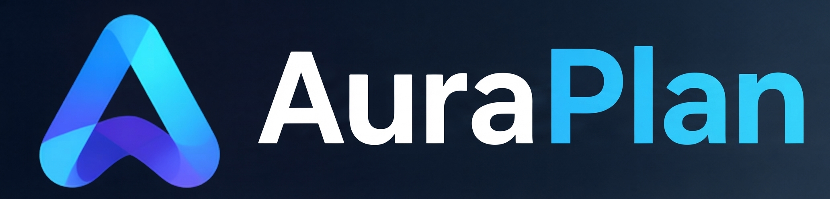
AuraPlan
Time tracking, shift planning and vacations — built right into AuraChat.

What is AuraPlan?
AuraPlan is a standalone time-tracking and workforce-planning app that connects seamlessly with AuraChat. Employees can clock in and out by click, chat or voice command, shifts are planned in a weekly calendar, and vacation requests are managed with a full-year colour overview.

Features at a glance
● Time Tracking
Clock in/out by click, chat or voice command. Manual entry, breaks, activity types including military service, sickness, accident, public holiday and unpaid leave.
● Shift Planning
Weekly calendar with colour-coded cards per person, open shifts to self-assign, roles/positions per shift.
● Vacation
Submit and approve requests, balance overview, full-year colour timeline — see at a glance who's off when.
● Overview
One row per person: hours, shifts and vacation for the whole team at a glance.
● AuraChat Widget
Green/red button to clock in/out right inside AuraChat, vacation balance at a glance, proactive notifications on approvals.
● Administration
Two-factor authentication, backup & restore, automatic SSL, AuraDirect integration for central login.

Getting Started
1. Alternative: download the ready-made quickstart package from the website — uses pre-built Docker Hub images, no building required.
2. Install Docker and Docker Compose on your server/NAS, if not already present.
3. Unpack the AuraPlan installation package into a folder on the server (e.g. /opt/AuraPlan).
4. In the .env file, enter your own random value for SESSION_SECRET (e.g. generated with: openssl rand -hex 32).
5. Start with "docker compose up -d --build". Default login: admin / admin — change the password after first login.
6. Optional: under Admin Panel → Domain & SSL, set up your own address with an automatic certificate.

Pricing
All prices are indicative, excl. VAT.
— | Preis | Umfang
Basic | free | Simple time tracking: clock in/out, manual entry, basic activity types.
Pro | CHF 3.50 / user / mo.  CHF 7.50 / admin / mo. | All features: shift planning, vacation with colour timeline, overview, notifications, AuraChat widget.
Questions or would you like a live demo? info@gerber-backoffice-solutions.com

