Sacrebleu! The Infinity War damaged a lot of worldwide monuments, including the Eiffel Tower. For some unknown reason (to be revealed in Infinity War 2), all we have left for building materials are Geomags™. The country of France has tasked you with building a new Eiffel Tower with Geomags™. About how many Geomags™ would you need? How would you build it? Describe each step in your thought process.

* 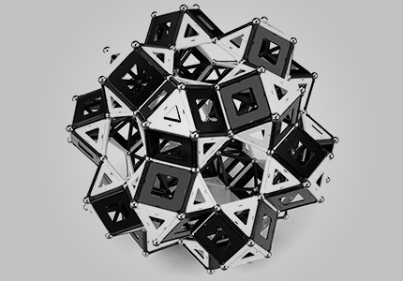Geomag Classic Black and White chosen due to thick rods and to its ability to form perfect vertices polynomials.
* Using eye test, cubed plane containing 4 rods and 4 circular vertices is measured 4in both length and width.

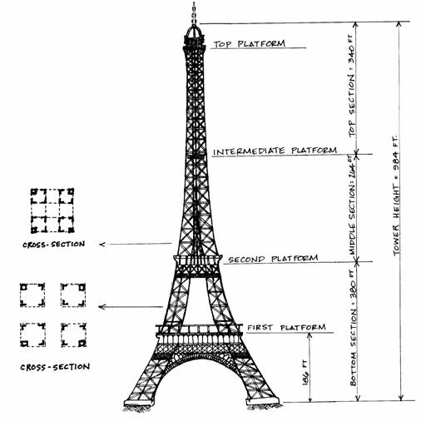

* Two cross section diagram displaying the placement of the 4 legs from ground to second platform and from second platform to top platform.
* Divide tower into 4 pillars (legs) and 3 platforms (where visitors stand), to which the Geomags will be used to construct.

1 Geomag Cube = 4in L, 4in W, 4in H

4in x $\frac{2.5}{1cm}$ x $\frac{1m}{100cm}$ = 0.1m

**PLATFORMS**

* length and height interchangeable.

1st: Area = 350m2 = 18.65m (L) x 18.65 (W)

# Geomag = 18.65m ÷ 0.1m = 186.5 ≈ 187 (cubes)

2nd: Area = 1650m2 = 40.96m (L) x 40.96m (W)

# Geomag = 40.96m ÷ 0.1m = 409.6 ≈ 410 (cubes)

Top: Area = 4200m2 = 70.69m (L) x 70.69m (W)

#Geomag = 70.69m ÷ 0.1m = 706.9 ≈ 707 (cubes)

**PILLARS**

(by levels of height from ground to top platform)

* Each leg has a width of 50.66m on all 4 sides
* #Geomag = (50.66 ÷ 0.1m) x 4 (sides) = 2026.4 ≈ 2027 (planes)

Ground to First-Platform

height = 57.64m

#Geomag = [ (57.64m ÷ 0.1m) x (50.66 ÷ 0.1m) x 4 (sides) ] = 1168016.96 ≈ 1168017 (planes)

First-Platform to Second-Platform

height = 115.73m – 57.64m = 58.09m

#Geomag = [ (58.09m ÷ 0.1m) x (50.66 ÷ 0.1m) x 4 (sides) ] = 1177135.76 ≈ 1177136 (planes)

Second-Platform to Top-Platform

height = 276.13m – 115.73m = 160.4m

#Geomag = [ (160.4m ÷ 0.1m) x (50.66 ÷ 0.1m) x 4 (sides) ] = 3250345.6 ≈ 3250346 (planes)

**TIP**

* no planes, but vertex-rod-vertex still 4in.

Top-Platform to Tip

height = 324m – 276.13m = 47.87m

#Geomag = [ (47.87m ÷ 0.1m) x 4 (poles to create beam) ] = 1914.8 ≈ 1915

**TOTAL**

* 1304 cubes (8 vertices, 12 rods), 5595499 planes (4 vertices, 4 rods), 1915 poles (2 vertices, 1 rod).

#Geomag = [ (1304 x 20) + (5595499 x 8) + (1915 x 3) ] = 44793902 pieces

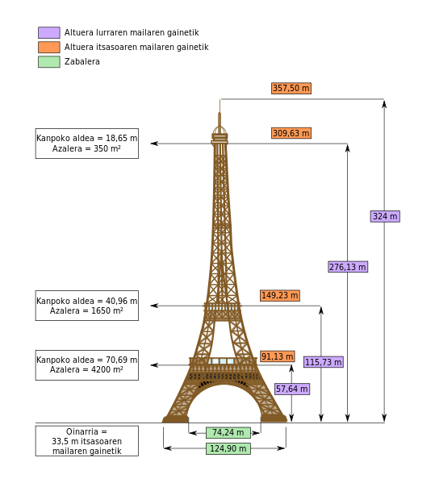

* Actual measurements used.