CPE301 – SPRING 2019

Design Assignment 2A

Student Name: Michael Johnson

Student #: 2000878717

Student Email: johnsm17@unlv.nevada.edu

Primary Github address: https://github.com/miggnuggets/submissions.git

Directory: CPE_301

1. **COMPONENTS LIST AND CONNECTION BLOCK DIAGRAM w/ PINS**

Atmega328p and Dangershield.

1. **INITIAL/MODIFIED/DEVELOPED CODE OF TASK 1/A**

**Task 1 in C**

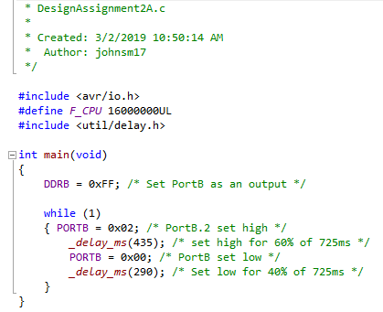

**Task 1 in Assembly**

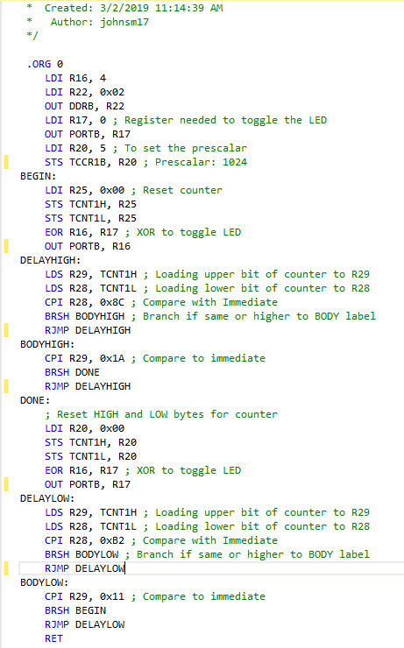

1. **DEVELOPED MODIFIED CODE OF TASK 2/A from TASK 1/A**

**Task 2 in C**

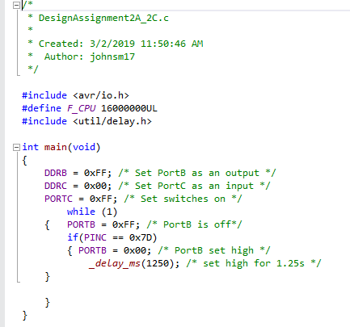

Task 2 in Assembly

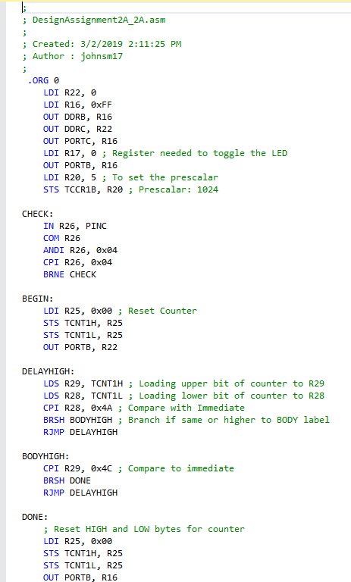

1. **SCHEMATICS**

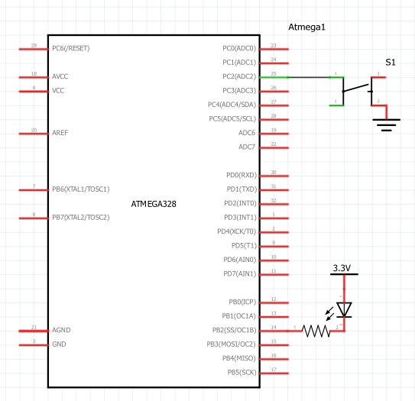

1. **SCREENSHOTS OF EACH TASK OUTPUT (ATMEL STUDIO OUTPUT)**

**Task 1 in C duty cycle of 60% (725*.6=435)**

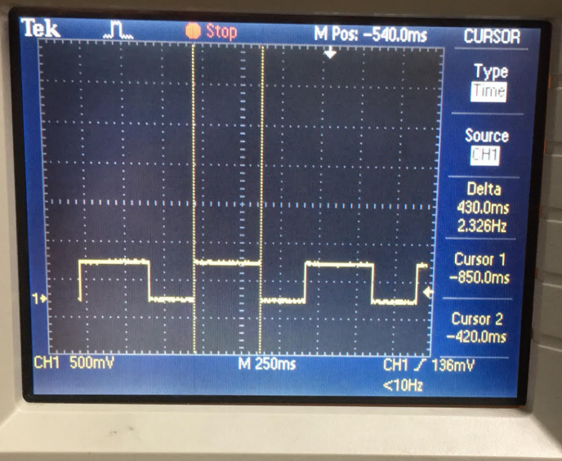

Task 1 in Assembly duty cycle of 60%

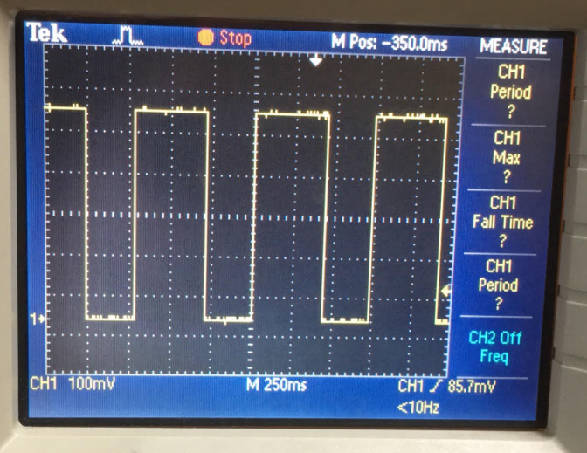

Task 2 in C LED on for 1.25 sec

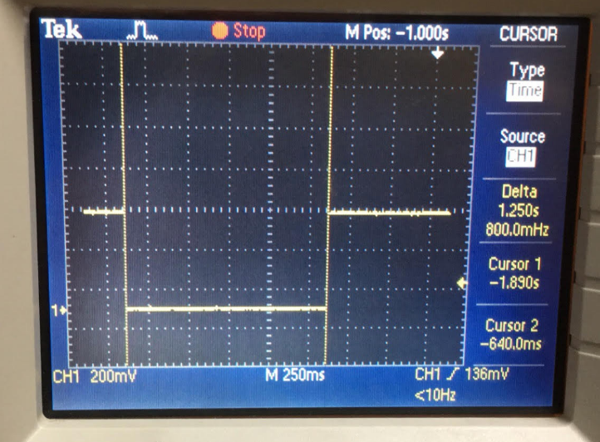

Task 2 in Assembly for LED on for 1.25 sec

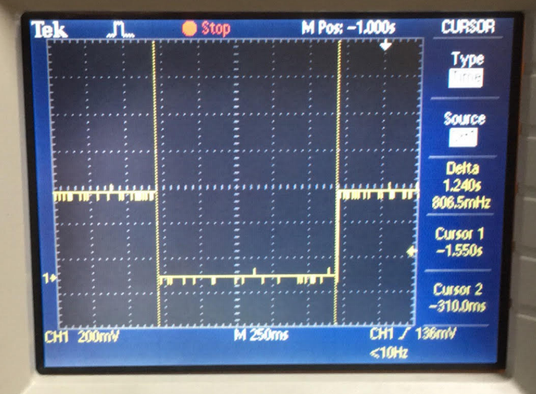

1. **SCREENSHOT OF EACH DEMO (BOARD SETUP)**

N/A

1. **VIDEO LINKS OF EACH DEMO**

https://youtu.be/_XdMgerH_VQ

1. **GITHUB LINK OF THIS DA**

https://github.com/miggnuggets/submissions.git

**Student Academic Misconduct Policy**

<http://studentconduct.unlv.edu/misconduct/policy.html>

“This assignment submission is my own, original work”.

Michael Johnson