CPE301 – SPRING 2019

Design Assignment 2B

Student Name: Michael Johnson

Student #: 2000878717

Student Email: johnsm17@unlv.nevada.edu

Primary Github address: https://github.com/miggnuggets/submissions.git

Directory: Repository_301

1. **COMPONENTS LIST AND CONNECTION BLOCK DIAGRAM w/ PINS**

List of Components used

ATMEGA 328P, Danger Shield, Logic Analyzer

1. **INITIAL/MODIFIED/DEVELOPED CODE OF TASK 2/A**

**C Code for 2B**

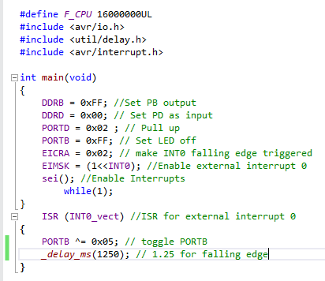

**Assembly Code for 2B**

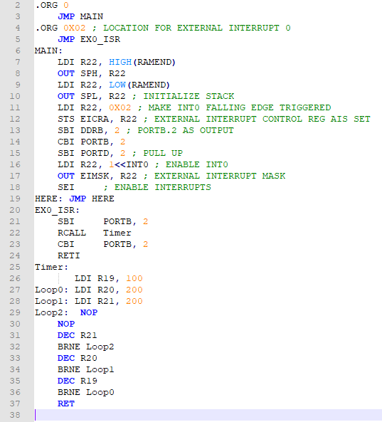

1. **SCHEMATICS**

**The schematic is the same except instead of PINC switch, we ground PORTD.2 to switch LED**

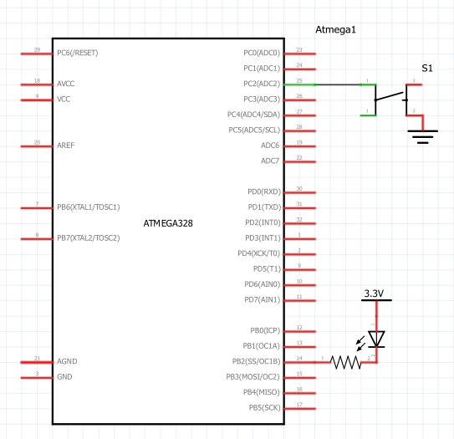

1. **SCREENSHOTS OF EACH TASK OUTPUT (ATMEL STUDIO OUTPUT)**

**C Code Analysis**

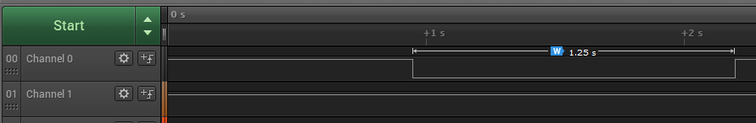

Assembly Code Analysis

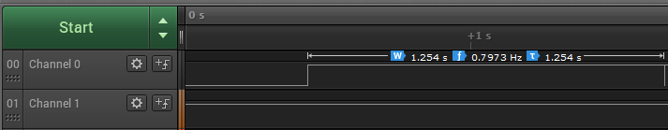

1. **SCREENSHOT OF EACH DEMO (BOARD SETUP)**

**Analyzer connected to PORTB with Shield on top. Then just grounded PORTD.2**

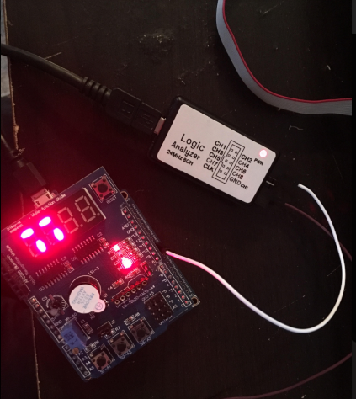

1. **VIDEO LINKS OF EACH DEMO**

**https://youtu.be/fBp4l-NL_4E**

1. **GITHUB LINK OF THIS DA**

**https://github.com/miggnuggets/submissions.git**

**Student Academic Misconduct Policy**

<http://studentconduct.unlv.edu/misconduct/policy.html>

“This assignment submission is my own, original work”.

Michael Johnson