CPE301 – SPRING 2019

Design Assignment 3A

Student Name: Michael Johnson

Student #: 2000878717

Student Email: johnsm17@unlv.nevada.edu

Primary Github address: https://github.com/miggnuggets/submissions.git

Directory: Repository_301

1. **COMPONENTS LIST AND CONNECTION BLOCK DIAGRAM w/ PINS**

List of Components used

Block diagram with pins used in the Atmega328P

1. **INITIAL/MODIFIED/DEVELOPED CODE OF TASK 1/A**

**ALL CODE IN NOTEPAD SO ITS CLEANER**

Task 1 Print characters, integer and floating

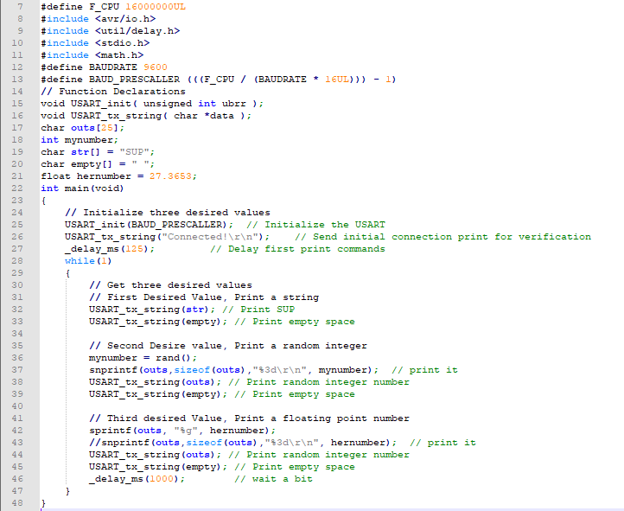

1. **SCHEMATICS**

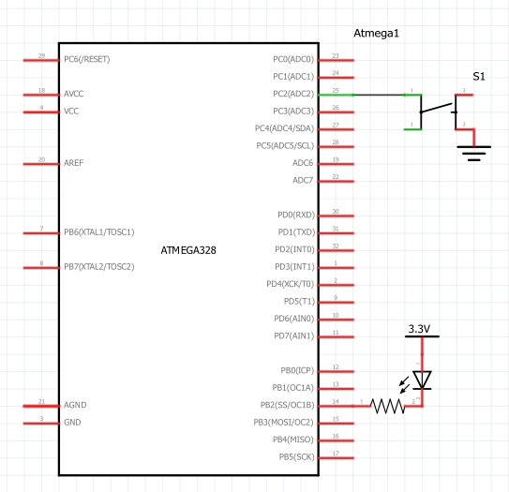

Use fritzing.org

1. **SCREENSHOTS OF EACH TASK OUTPUT (ATMEL STUDIO OUTPUT)**

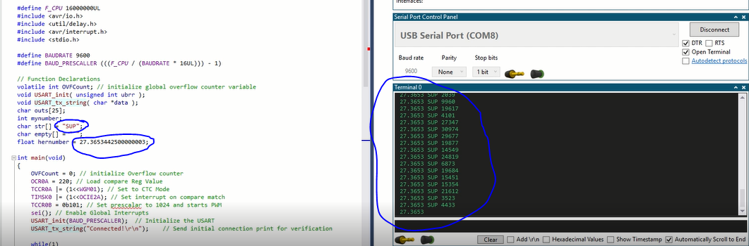

1. **SCREENSHOT OF EACH DEMO (BOARD SETUP)**

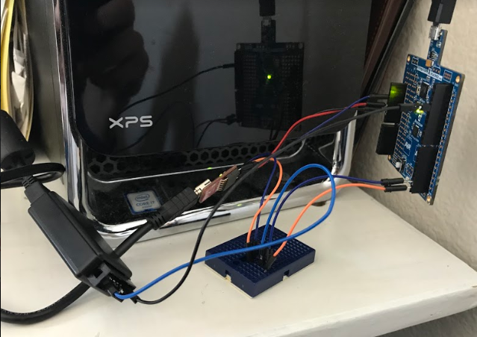

1. **VIDEO LINKS OF EACH DEMO**

**https://youtu.be/qUhbjw5_VkY**

1. **GITHUB LINK OF THIS DA**

**https://github.com/miggnuggets/submissions.git**

**Student Academic Misconduct Policy**

<http://studentconduct.unlv.edu/misconduct/policy.html>

“This assignment submission is my own, original work”.

Michael Johnson