CPE301 – SPRING 2019

Design Assignment 6

Student Name: Michael Johnson

Student #: 2000878717

Student Email: johnsm17@unlv.nevada.edu

Primary Github address: https://github.com/miggnuggets/submissions.git

Directory: Repository_301

1. **COMPONENTS LIST AND CONNECTION BLOCK DIAGRAM w/ PINS**

List of Components used

Block diagram with pins used in the Atmega328P

MPU6050

1. **INITIAL/MODIFIED/DEVELOPED CODE OF TASK 1/A**

**ALL CODE IN NOTEPAD SO ITS CLEANER**

#ifndef F_CPU

#define F_CPU 16000000UL

#endif

#include <avr/io.h>

#include <util/delay.h>

#include <math.h>

#include <stdlib.h> /* Include standard library file */

#include <stdio.h> /* Include standard library file */

#include "MPUlibraries/MPU6050_def.h" /* Include MPU6050 register define file */

#include "MPUlibraries/i2c_master.h" /* Include I2C Master header file */

#include "MPUlibraries/uart.h" /* Include USART header file */

#define MPU6050_WRITE 0xD0

#define MPU6050_READ 0xD1

float Acc_x;

float Acc_y;

float Acc_z;

float Gyro_x;

float Gyro_y;

float Gyro_z;

void init_uart(*uint16_t* baudrate){

*uint16_t* UBRR_val = (F_CPU/16)/(baudrate-1);

UBRR0H = UBRR_val >> 8;

UBRR0L = UBRR_val;

UCSR0B |= (1<<TXEN0) | (1<<RXEN0) | (1<<RXCIE0); // UART TX (Transmit - senden) einschalten

UCSR0C |= (1<<USBS0) | (3<<UCSZ00); //Modus Asynchron 8N1 (8 Datenbits, No Parity, 1 Stopbit)

}

void uart_putc(unsigned char c){

while(!(UCSR0A & (1<<UDRE0))); // wait until sending is possible

UDR0 = c; // output character saved in c

}

void uart_puts(char *s){

while(*s){

uart_putc(*s);

s++;

}

}

void init_MPU6050(void){

*_delay_ms*(150); /* Power up time >100ms */

i2c_start(MPU6050_WRITE); // Set Gyroscope Sample Rate = 1 KHz, Accelerometer Sample Rate = 1 KHz (default)

i2c_write(SMPLRT_DIV); // Sample Rate is generated by dividing the gyroscope output rate by SMPLRT_DIV

i2c_write(0x07); // Gyroscope Output Rate = 8kHz, Sample Rate = Gyroscope Output Rate / (1 + SMPLRT_DIV)

i2c_stop();

i2c_start(MPU6050_WRITE);

i2c_write(PWR_MGMT_1);

i2c_write(0x01); // PLL with X axis gyroscope reference

i2c_stop();

i2c_start(MPU6050_WRITE);

i2c_write(CONFIG); //Frame Synchronization & Digital Low Pass Filter (DLPF) setting

i2c_write(0x00);

i2c_stop();

i2c_start(MPU6050_WRITE);

i2c_write(GYRO_CONFIG); //gyroscopes’ scale range = FS_SEL selects = 11 = ± 2000 °/s

i2c_write(0x18); // accelerometer range = ± 2g (default)

i2c_stop();

i2c_start(MPU6050_WRITE);

i2c_write(INT_ENABLE); // DATA_RDY_EN = 1

i2c_write(0x01);

i2c_stop();

}

void getreading(void){

// ACCEL X

i2c_start(MPU6050_WRITE);

i2c_write(ACCEL_XOUT_H); // set pointer

i2c_start(MPU6050_READ);

Acc_x = (((int)i2c_read_ack()<<8) | (int)i2c_read_ack());

// ACCEL Y

Acc_y = (((int)i2c_read_ack()<<8) | (int)i2c_read_ack());

// ACCEL Z

Acc_z = (((int)i2c_read_ack()<<8) | (int)i2c_read_ack());

// GYRO X

Gyro_x = (((int)i2c_read_ack()<<8) | (int)i2c_read_ack());

// GYRO Y

Gyro_y = (((int)i2c_read_ack()<<8) | (int)i2c_read_ack());

// GYRO Z

Gyro_z = (((int)i2c_read_ack()<<8) | (int)i2c_read_ack());

i2c_stop();

}

int main(void){

char buffer[20], float_[10];

char* PAX = "X Acceleration = ";

char* PAY = "Y Acceleration = ";

char* PAZ = "Z Acceleration = ";

char* PGX = "X Gyro Position = ";

char* PGY = "Y Gyro Position = ";

char* PGZ = "Z Gyro Position = ";

float Xa;

float Ya;

float Za;

float Xg;

float Yg;

float Zg;

init_uart(9600);

i2c_init();

init_MPU6050();

while(1){

getreading();

Xa = Acc_x/16384.0; /* Divide raw value by sensitivity scale factor to get real values */

Ya = Acc_y/16384.0;

Za = Acc_z/16384.0;

Xg = Gyro_x/131;

Yg = Gyro_y/131;

Zg = Gyro_z/131;

*dtostrf*( Xa, 3, 2, float_ ); /* Take values in buffer to send all parameters over USART */

*sprintf*(buffer,"%s, ",float_);

USART_SendString(PAX);

USART_SendString(buffer);

*_delay_ms*(100);

*dtostrf*( Ya, 3, 2, float_ ); /* Take values in buffer to send all parameters over USART */

*sprintf*(buffer,"%s, ",float_);

USART_SendString(PAY);

USART_SendString(buffer);

*_delay_ms*(100);

*dtostrf*( Za, 3, 2, float_ ); /* Take values in buffer to send all parameters over USART */

*sprintf*(buffer,"%s, ",float_);

USART_SendString(PAZ);

USART_SendString(buffer);

USART_SendString("\r\n");

*_delay_ms*(1000);

*dtostrf*( Xg, 3, 2, float_ ); /* Take values in buffer to send all parameters over USART */

*sprintf*(buffer,"%s, ",float_);

USART_SendString(PGX);

USART_SendString(buffer);

*_delay_ms*(100);

*dtostrf*( Yg, 3, 2, float_ ); /* Take values in buffer to send all parameters over USART */

*sprintf*(buffer,"%s, ",float_);

USART_SendString(PGY);

USART_SendString(buffer);

*_delay_ms*(100);

*dtostrf*( Zg, 3, 2, float_ ); /* Take values in buffer to send all parameters over USART */

*sprintf*(buffer,"%s, ",float_);

USART_SendString(PGZ);

USART_SendString(buffer);

USART_SendString("\r\n");

*_delay_ms*(1000);

}

return 0;

}

1. **SCHEMATICS**

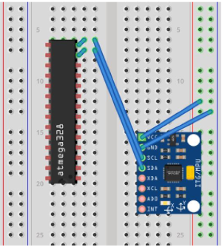

Fritzing.org

1. **SCREENSHOTS OF EACH TASK OUTPUT (ATMEL STUDIO OUTPUT)**

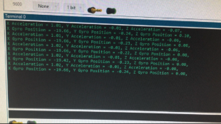

1. **SCREENSHOT OF EACH DEMO (BOARD SETUP)**

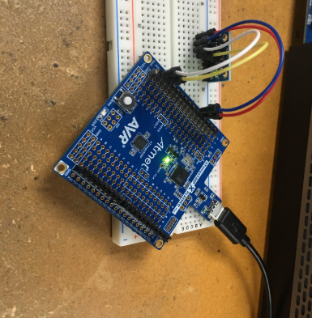

1. **VIDEO LINKS OF EACH DEMO**

**https://youtu.be/Lxty8gzRchc**

1. **GITHUB LINK OF THIS DA**

**https://github.com/miggnuggets/submissions.git**

**Student Academic Misconduct Policy**

<http://studentconduct.unlv.edu/misconduct/policy.html>

“This assignment submission is my own, original work”.

Michael Johnson