CPE301 – SPRING 2019

Design Assignment 1A

Student Name: Michael Johnson

Student #: 2000878717

Student Email: johnsm17@unlv.nevada.edu

Primary Github address: https://github.com/miggnuggets/submissions.git

Directory: Repository_301

Write, simulate, and demonstrate using Atmel Studio 7 an assembly code for the AVR ATMEGA328p microcontroller that performs the following functions:

1. Perform a multiplication of a 16-bit multiplicand with an 8-bit multiplier without using the MUL instruction. Use iterative addition to perform the above multiplication.

2. Registers R25:R24 hold the 16-bit multiplicand, R22 hold 8-bit multiplier, and R20:R19:R18 should hold the result.

3. Verify your algorithm and answers using the AVR mul instruction or C or any high-level program. 4. Determine the execution time @ 16MHz/#cycles of your algorithm using the simulation.

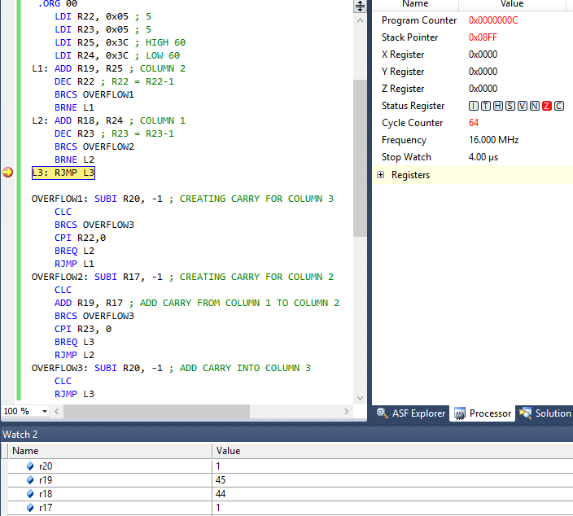

@16MHz for 64 cycles the time executed was 4us.

The assembly code and results through debugging.

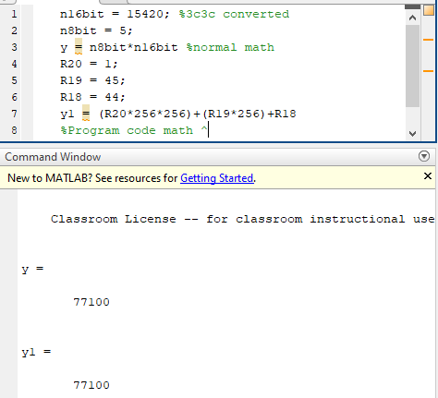

Here is the upper level coding to prove the assembly was correct. I used to MATLAB to prove the code worked.

“This assignment submission is my own, original work”.

Michael Johnson