CPE301 – SPRING 2019

Design Assignment 1B

Student Name: Michael Johnson

Student #: 2000878717

Student Email: johnsm17@unlv.nevada.com

Primary Github address: https://github.com/miggnuggets/submissions.git

Directory: Repository_301

1. Store 99 numbers starting from the STARTADDS=0x0200 location. Populate the value of the memory location by adding high(STARTADDS) and low(STARTADDS). Use the X/Y/Z registers as pointers to fill up 99 numbers that are greater than 10 and less than 255. The numbers can be consecutive or random numbers.

2. Use X/Y/Z register addressing to parse through the 99 numbers, if the number is divisible by 3 store the number starting from memory location 0x0400, else store at location starting at 0x0600. 3. Use X/Y/Z register addressing to simultaneously add numbers from memory location 0x0400 and 0x0600 and store the sums at R16:R17 and R18:R19 respectively. Pay attention to the carry overflow. 4. Verify your algorithm and answers using C or any high-level program. 5. Determine the execution time @ 16MHz/#cycles of your algorithm using the simulation.

Part 1 of DA1B: STARTADDS into Z

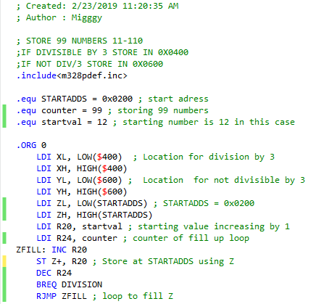

Part 2 of DA1B: Checking if number is divisible by 3

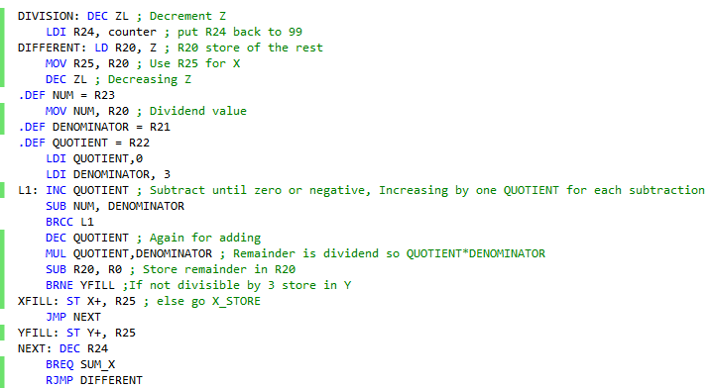

Part 3 of DA1B: Adding numbers into x or y if/if not divisible by 3

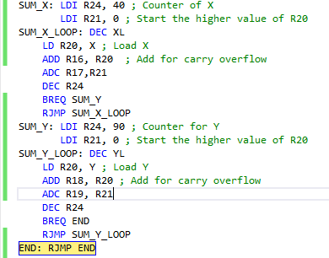

X = 0x081F

Y = 0x0FDB

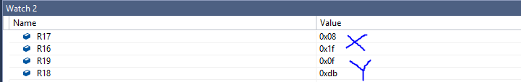

Proof of working code using C or higher

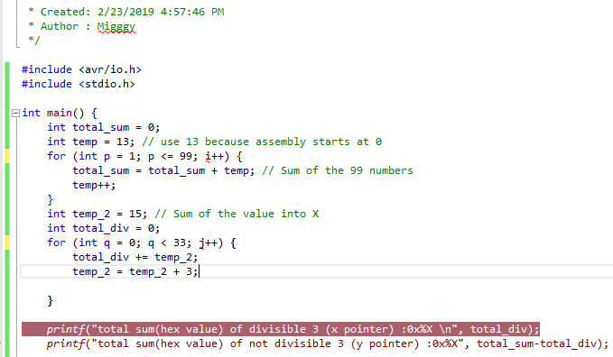

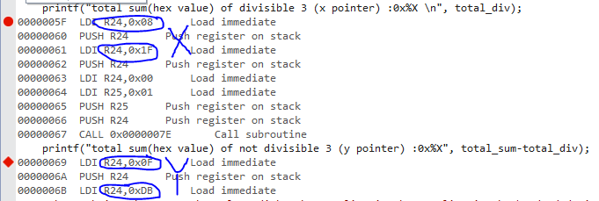

@16MHz with 12,168 cycles there was an execution time of 760.5us

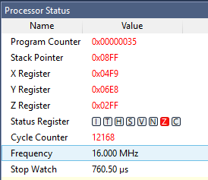

“This assignment submission is my own, original work”.

Michael Johnson