Uber Fare Prediction
Business Analysis Report
Portfolio Machine Learning Project | 50,000 Trip Dataset

Executive Summary
This project evaluates a supplied 50,000-row Uber-style trip dataset and builds a regression model to estimate fare before trip completion. After cleaning, 49,997 rows remained for analysis and 42,538 completed trips were eligible for model development. Three regression algorithms were compared. The selected model was Linear Regression, with MAE 2.474, RMSE 3.093, and R² 0.7543 on the held-out test set.
Trip distance is the clearest business driver in the supplied data, with a strong positive association with fare. Time, city, coordinates and payment method add additional predictive context. The project deliberately excludes trip identifiers and post-trip information from model inputs to reduce leakage and memorization risk.

1. Business Problem
Uber needs a reasonable estimate of a ride fare before the trip is completed. A reliable pre-trip estimate can improve rider transparency, reduce pricing surprise, support operational planning, and provide a consistent benchmark for downstream pricing systems.

2. Dataset Assessment
Metric | Value
Source rows | 50000
Columns | 14
Missing values | 0
Duplicate rows | 0
Clean analytical rows | 49997
Completed trips used for ML | 42538
The source dataset contains trip IDs, rider/driver IDs, city, coordinates, supplied trip distance, fare, trip status, payment method, pickup time and drop time. It does not contain passenger_count. Passenger count was therefore not fabricated for training or business conclusions.
Important limitation: the data appears synthetic. City labels and geographic coordinates are not consistently aligned, so city/coordinate findings should be interpreted as properties of the dataset rather than real-world Uber geography.

3. Data Cleaning and Feature Engineering
- Removed duplicate records.
- Removed zero/negative distance or fare rows.
- Validated latitude and longitude ranges.
- Parsed pickup/drop timestamps and removed invalid or non-positive durations.
- Created pickup year, month, day, hour, day-of-week, weekend and rush-hour features.
- Created trip duration and fare-per-km for analysis only; these post-target/derived measures are not used as prediction inputs when inappropriate.

4. Exploratory Business Analysis

4.1 Fare and Distance
The Pearson correlation between distance_km and fare_amount is approximately 0.871, indicating a strong positive relationship in this dataset. This makes trip distance the most important intuitive pricing signal.
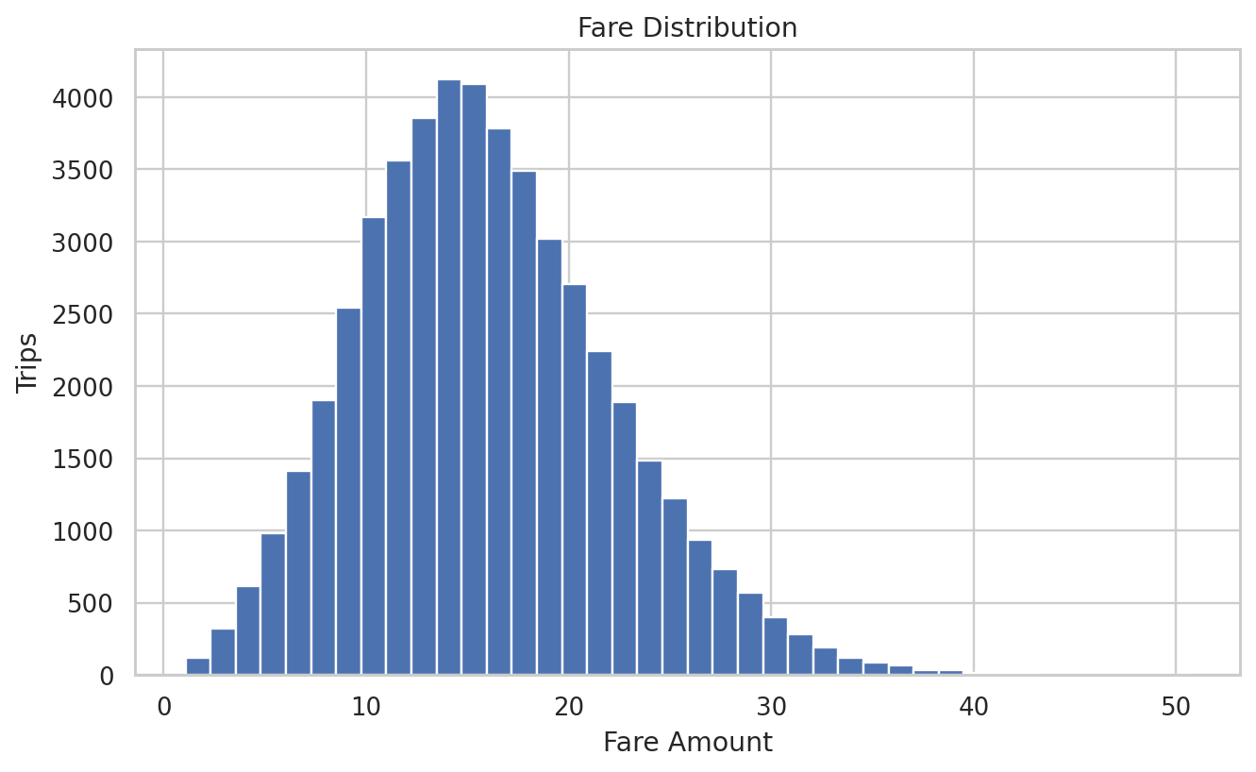
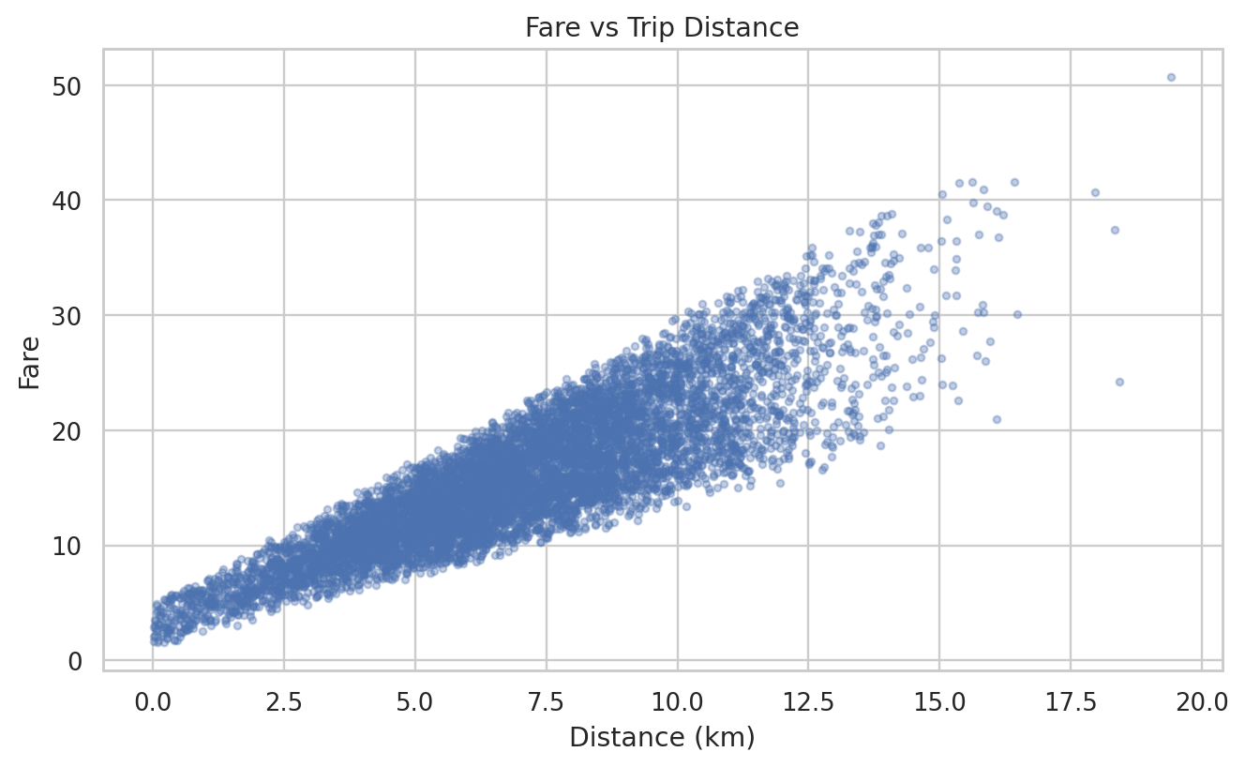

4.2 City and Time Patterns
city | trips | avg_fare | avg_distance
Seattle | 8236 | 16.06 | 7.07
Boston | 8454 | 16.05 | 7.02
New York | 8247 | 16.05 | 7.01
San Francisco | 8401 | 16.02 | 7.03
Chicago | 8344 | 15.90 | 6.96
Los Angeles | 8315 | 15.77 | 6.95
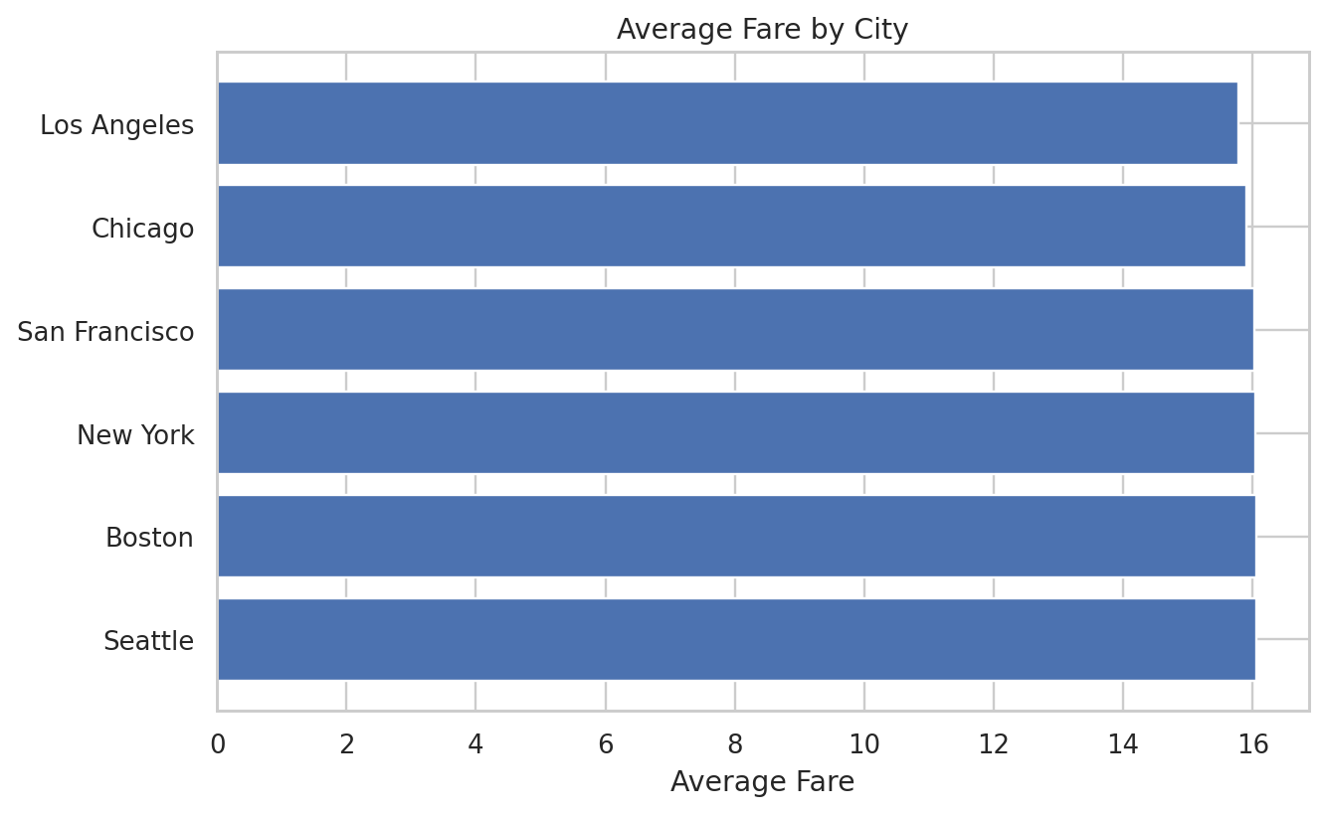
The highest average-fare pickup hour in the supplied data is 6:00, with an average fare of about $16.16. Hourly differences should be interpreted as descriptive rather than causal because the dataset does not contain live demand/surge variables.
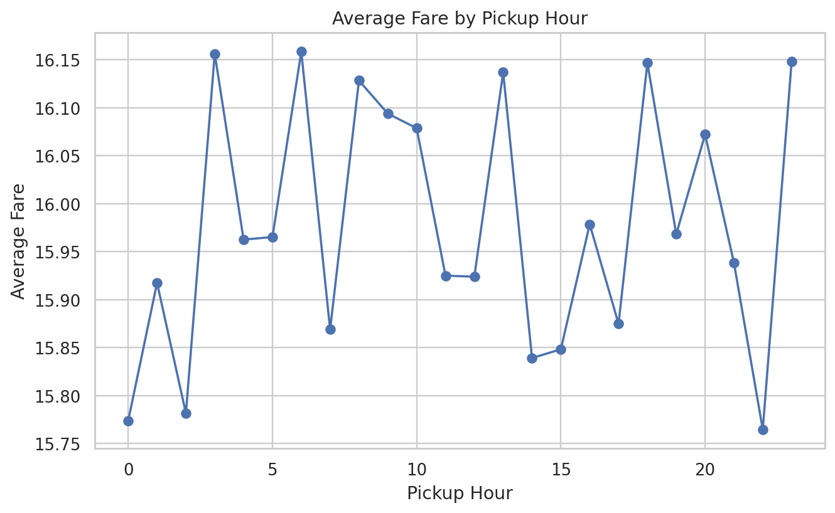

4.3 Trip Completion and Payment
Trip-status mix: Completed 85.08%, Cancelled 9.97%, No-Show 4.95%. Cancelled and no-show records remain useful for operational dashboard analysis but are excluded from fare-model training.
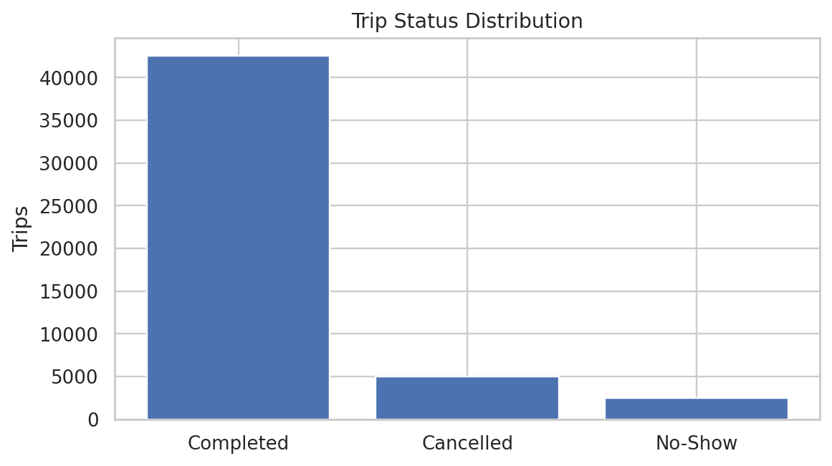

5. Machine Learning Methodology
The modeling sample includes only Completed trips. Inputs available or reasonably knowable before trip completion include city, payment method, pickup/drop-off coordinates, supplied trip distance, and pickup-date/time features. Trip IDs, driver IDs and rider IDs are excluded because they are identifiers rather than transferable pricing signals. Status, actual drop time and actual trip duration are excluded because they are post-trip information.

6. Model Comparison
Model | MAE | MSE | RMSE | R2
Linear Regression | 2.474 | 9.566 | 3.093 | 0.7543
Gradient Boosting | 2.476 | 9.596 | 3.098 | 0.7535
Random Forest | 2.512 | 9.979 | 3.159 | 0.7437
Linear Regression achieved the lowest RMSE and was selected as the final serialized model. MAE means the model is off by about $2.47 on average in absolute terms on this held-out sample. R² of 0.7543 indicates the share of fare variance explained by the model in this synthetic dataset.
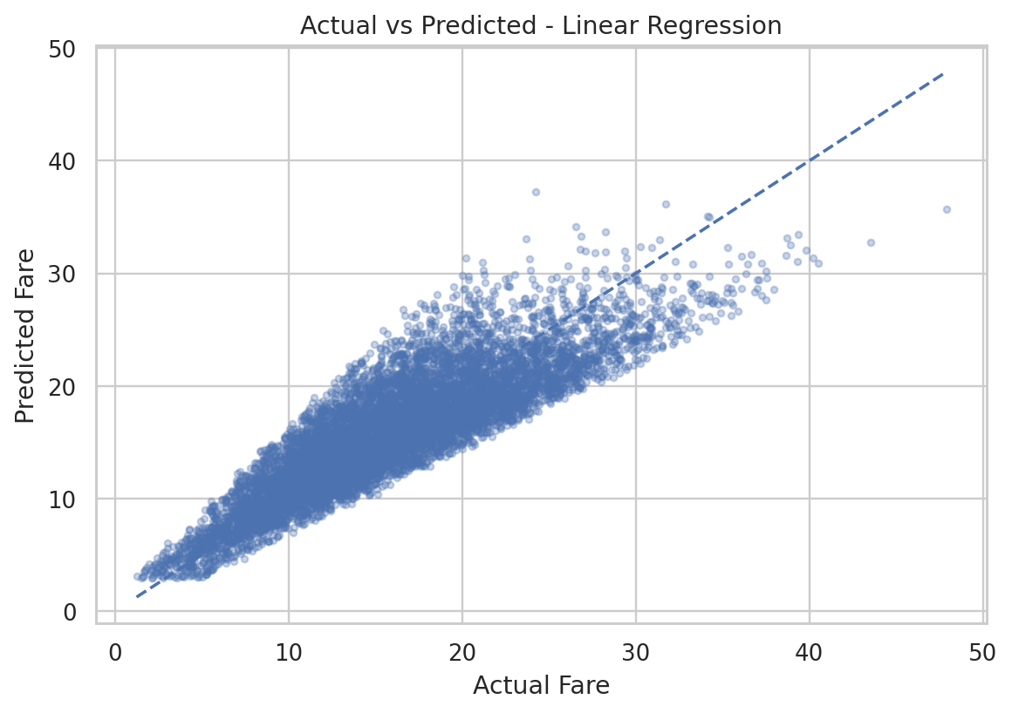

7. Answers to Core Business Questions
What factors most strongly influence fare? Distance is the strongest simple driver in the dataset (correlation ≈ 0.871). The final model also uses location, city, payment and pickup-time features.
How does trip distance affect fare? Fare rises strongly with distance. The relationship is not perfectly linear, so tree-based ensemble models can capture nonlinear effects and interactions better than a simple linear baseline.
Does passenger count significantly affect fare? This cannot be answered from the supplied data because passenger_count is absent. Creating synthetic counts would make any conclusion invalid.
Which hours have higher average fares? Hour 6:00 has the highest average fare in this sample (about $16.16), but the dataset lacks causal demand/surge variables.
Which model performs best? Linear Regression has the lowest test RMSE among the compared models.
How accurate is the final model? On the test split: MAE 2.474, RMSE 3.093, R² 0.7543.
Can it estimate a new trip? Yes. The Streamlit app reproduces the model feature schema and accepts city, payment, coordinates, distance and pickup date/time to generate a fare estimate.

8. Business Recommendations
- Use trip distance as the primary explanatory feature in fare-estimation monitoring because it carries the strongest observable signal.
- Keep estimation features limited to information available before trip completion to avoid leakage.
- Track model error by city, distance band and pickup hour; aggregate metrics can hide weak segments.
- If a real production dataset is available, add authentic passenger count, traffic, tolls, booking type, demand/supply and surge variables rather than fabricating them.
- Re-train and validate when data-generating conditions change, especially pricing rules or geographic coverage.
- Treat this model as an educational benchmark, not a production Uber pricing engine.

9. Deployment Design
The Streamlit application contains four tabs: Fare Prediction, Business Dashboard, Model Performance and About. Dashboard filters include city, status, payment method, distance, fare, pickup hour and date range. KPI cards summarize trip count, average fare, average distance, completion rate and duration. Users can also download filtered data.

10. Risks and Limitations
- Synthetic-data risk: results may not represent real Uber economics.
- Geographic inconsistency: city labels and coordinates are not consistently aligned.
- No passenger_count: the requested passenger analysis is not supported by the source data.
- No live demand, traffic, toll or surge variables: these can materially affect real fares.
- Supplied distance may use a different routing definition than straight-line distance from coordinates.

11. Conclusion
The project delivers an end-to-end fare-prediction workflow from data validation through deployment. Linear Regression is the best-performing model among the tested candidates on the supplied data. The project is suitable as a portfolio demonstration because it combines reproducible preprocessing, leakage-aware modeling, comparison metrics, a serialized model, an interactive dashboard, and explicit limitations rather than overstating the data.

