Bacarro, Dan III H.

AC 192

Flowchart

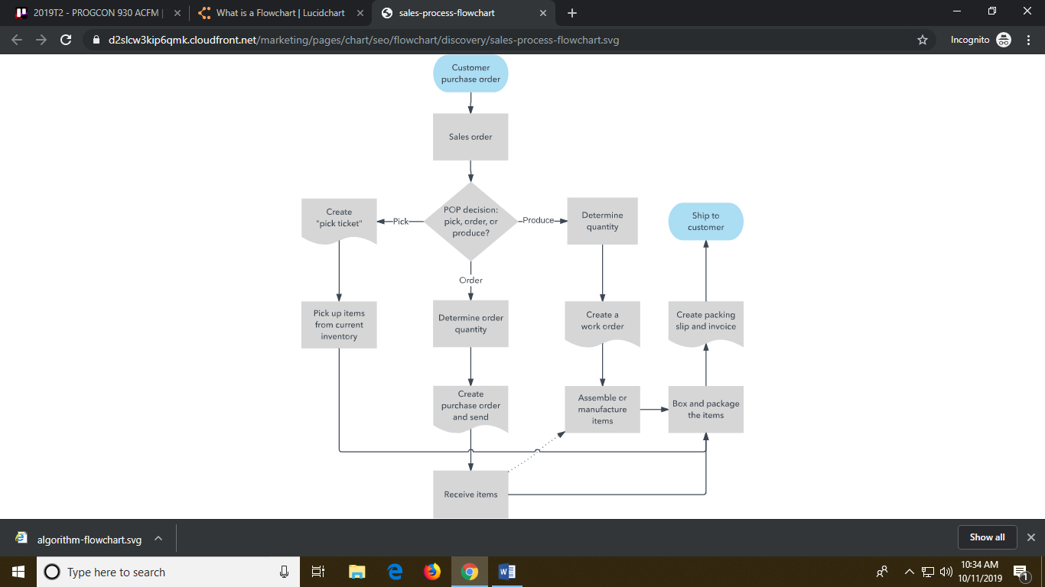**Flowchart** is a diagram that depicts a process, system or computer algorithm. They are widely used in multiple fields to document, study, plan, improve and communicate often complex processes in clear, easy-to-understand diagrams. Flowcharts, sometimes spelled as flow charts, use rectangles, ovals, diamonds and potentially numerous other shapes to define the type of step, along with connecting arrows to define flow and sequence. They can range from simple, hand-drawn charts to comprehensive computer-drawn diagrams depicting multiple steps and routes. If we consider all the various forms of flowcharts, they are one of the most common diagrams on the planet, used by both technical and non-technical people in numerous fields. Flowcharts are sometimes called by more specialized names such as Process Flowchart, Process Map, Functional Flowchart, Business Process Mapping, Business Process Modeling and Notation (BPMN), or Process Flow Diagram (PFD). They are related to other popular diagrams, such as Data Flow Diagrams (DFDs) and Unified Modeling Language (UML) Activity Diagrams.

Symbols:

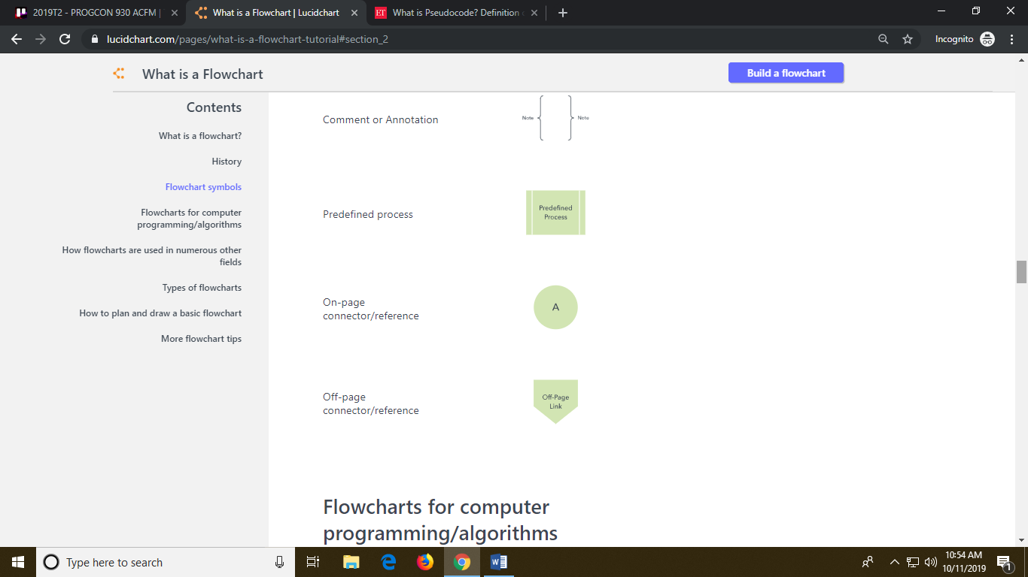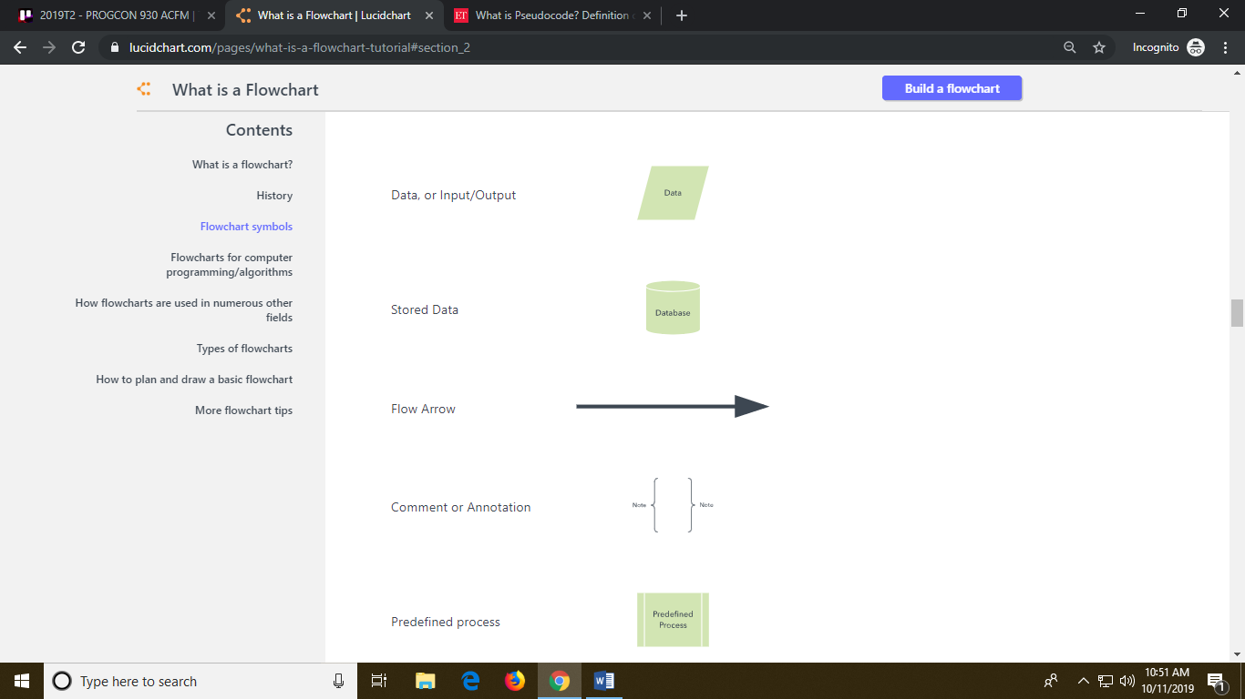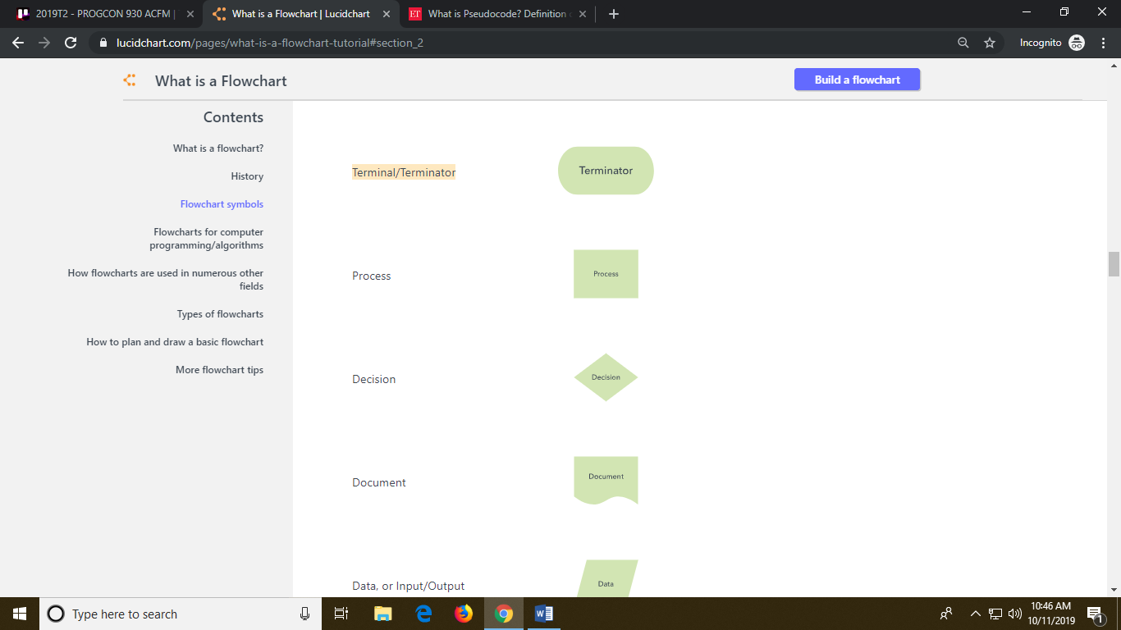Terminal/Terminator Decision Document Data Flow Arrow Off-page connector



Process Data Base Comment/Annotation Predefined Process On-page Connector

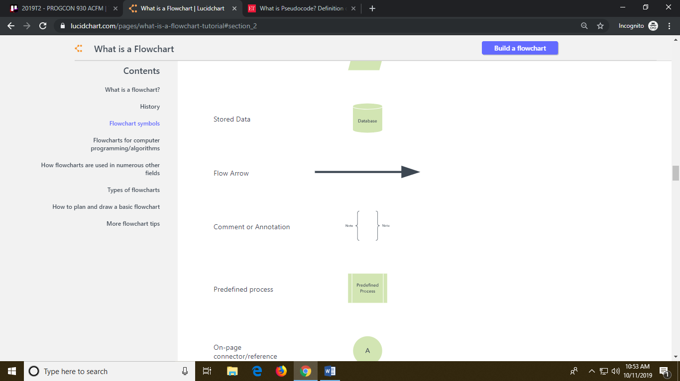

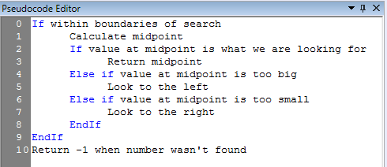**Pseudocode** is an informal way of programming description that does not require any strict programming language syntax or underlying technology considerations. It is used for creating an outline or a rough draft of a program. Pseudocode summarizes a program’s flow, but excludes underlying details. System designers write pseudocode to ensure that programmers understand a software project's requirements and align code accordingly.

Refrences:

<https://www.lucidchart.com/pages/what-is-a-flowchart-tutorial#section_1>

<https://www.google.com/url?sa=i&source=images&cd=&ved=2ahUKEwjf5oHBlpPlAhUXat4KHTwkAEgQjRx6BAgBEAQ&url=https%3A%2F%2Fwww.rapidqualitysystems.com%2FTechnicalDocumentation%2FCodeRocketDesigner%2Fpseudocode-editor.htm&psig=AOvVaw3Rxr-vqlqovBqnYjcEoUq3&ust=1570847858466883>

<https://economictimes.indiatimes.com/definition/pseudocode>