Bhanuja Nagore

001994132  ADS

**Week 5 Assignment**

|  |
| --- |
| > library(ggplot2)  > clusterPlot <- function(type) {  + clusters <- hclust(dist(iris[, 3:4]), method = type)  + plot(clusters)  + clusterCut <- cutree(clusters, 3)  + show(table(clusterCut, iris$Species)) # show required, else will not print  + ggplot(iris, aes(Petal.Length, Petal.Width, color = iris$Species)) +  + geom_point(alpha = 0.4, size = 3.5) + geom_point(col = clusterCut) +  + scale_color_manual(values = c('black', 'red', 'green'))  + }  > clusterPlot('complete')    clusterCut setosa versicolor virginica  1 50 0 0  2 0 21 50  3 0 29 0  > clusterPlot('average')    clusterCut setosa versicolor virginica  1 50 0 0  2 0 45 1  3 0 5 49  > clusterPlot('single')    clusterCut setosa versicolor virginica  1 50 0 0  2 0 49 50  3 0 1 0  > clusterPlot('ward.D')    clusterCut setosa versicolor virginica  1 50 0 0  2 0 45 1  3 0 5 49  > clusterPlot('ward.D')    clusterCut setosa versicolor virginica  1 50 0 0  2 0 45 1  3 0 5 49  > clusterPlot('average')    clusterCut setosa versicolor virginica  1 50 0 0  2 0 45 1  3 0 5 49 |
|  |
| |  | | --- | | > | |

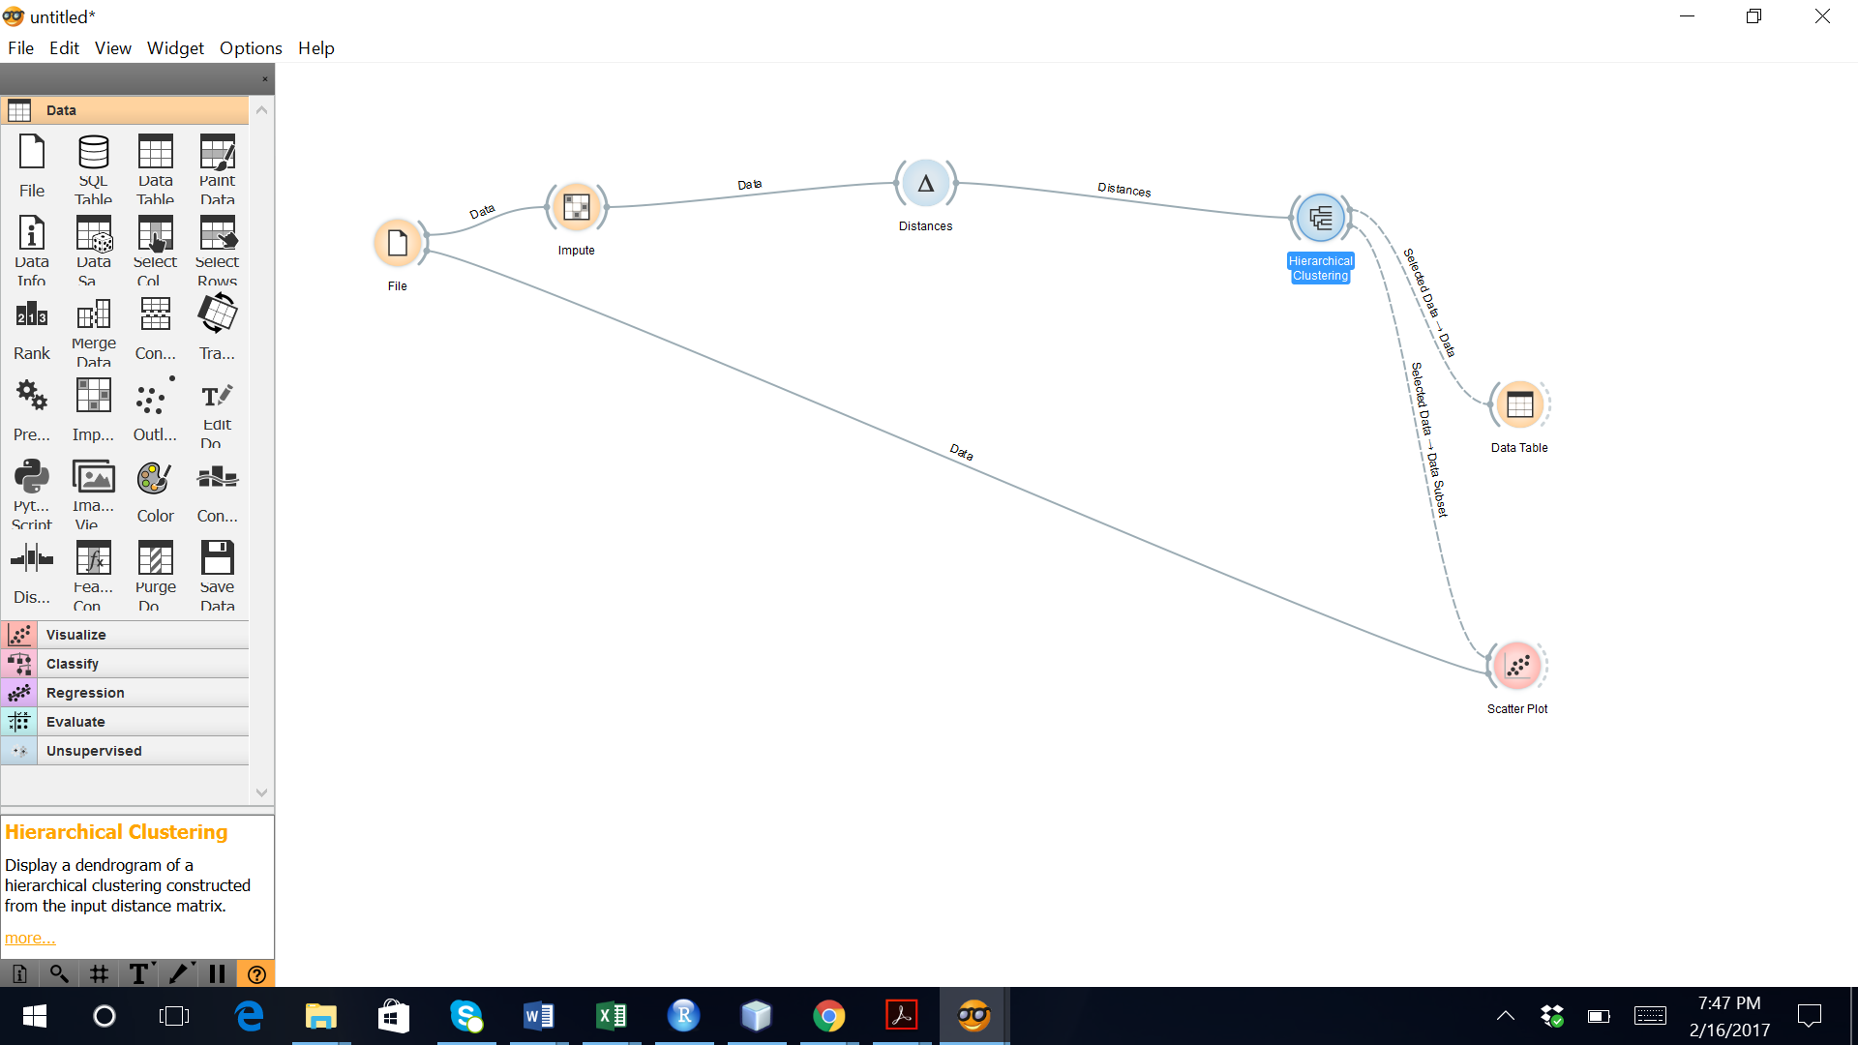

Animal

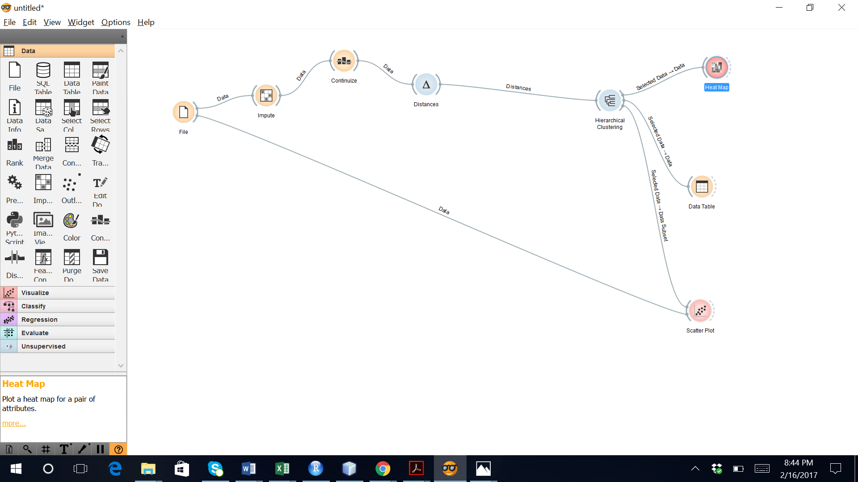

PLAY

> library(ggplot2)

> library(XLConnect)

> play <- readWorksheetFromFile("D:/Subjects/ADS/assignment week5/play.xlsx", sheet = 1)

> clusters <- hclust(dist(play[, 2:3]))

> plot(clusters)

> clusterCut <- cutree(clusters, 2)

> table(clusterCut, play$Decision)

clusterCut dont_play play

1 3 2

2 2 7

> clusters <- hclust(dist(play[, 2:3]), method = 'average')

> plot(clusters)

> clusterCut <- cutree(clusters, 2)

> table(clusterCut, play$Decision)

clusterCut dont_play play

1 3 4

2 2 5

> ggplot(play, aes(play$Temperature, play$Humidity, color = play$Decision)) +

+ geom_point(alpha = 0.4, size = 3.5) + geom_point(col = clusterCut) +

+ scale_color_manual(values = c('black', 'red', 'green'))