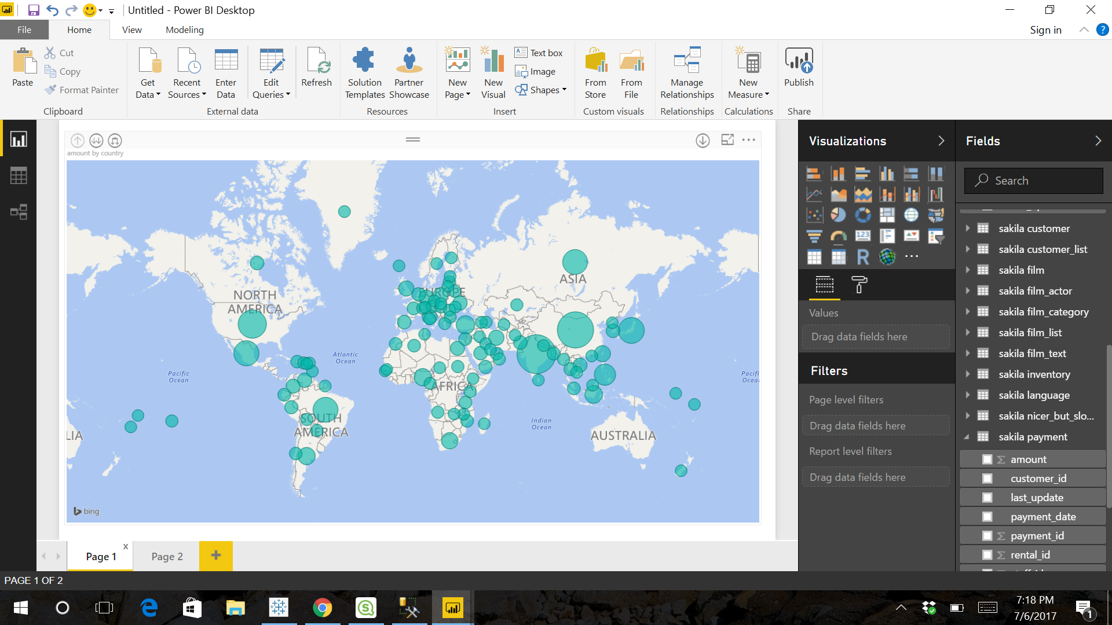









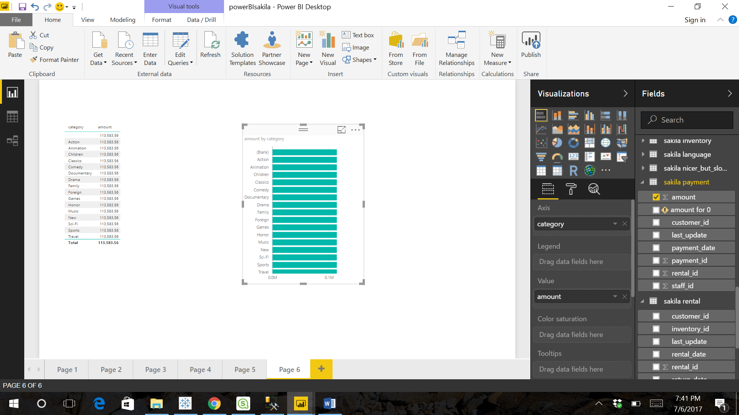

Query:

/* 1 */

select sum(p.amount), count(p.amount), f.rating, f.rental_rate, f.replacement_cost, [c.name](http://c.name/) from payment p

join rental r on p.rental_id = r.rental_id

join inventory i on r.inventory_id = i.inventory_id

join film f on i.film_id = f.film_id

join film_category fc on f.film_id = fc.film_id

join category c on fc.category_id = c.category_id

group by f.rating, f.rental_rate, f.replacement_cost, [c.name](http://c.name/)

having f.rating = 'NC-17';

/* 2 */

select sum(p.amount) from payment p

join customer c on p.customer_id = c.customer_id

join address a on c.address_id = a.address_id

join city ci on a.city_id = ci.city_id

join country co on ci.country_id = co.country_id

group by co.country_id;

select * from customer;

/* 3 */

select c.first_name, c.last_name, sum(p.amount), count(p.amount), c.active, ci.CITY, co.COUNTRY from payment p

join customer c on p.customer_id = c.customer_id

join address a on c.address_id = a.address_id

join city ci on a.city_id = ci.city_id

join country co on ci.country_id = co.country_id

group by c.first_name, c.last_name, c.active, ci.CITY, co.COUNTRY

having c.active = 1

/* 4 */

with temp as(

    select * from film

    where film.rental_rate = '2.99'

)

select [c.name](http://c.name/), sum(p.amount), count(p.amount) from payment p

join rental r on p.rental_id = r.rental_id

join inventory i on r.inventory_id = i.inventory_id

join temp f on i.film_id = f.film_id

join film_category fc on f.film_id = fc.film_id

join category c on fc.category_id = c.category_id

group by [c.name](http://c.name/);