MYSQL -

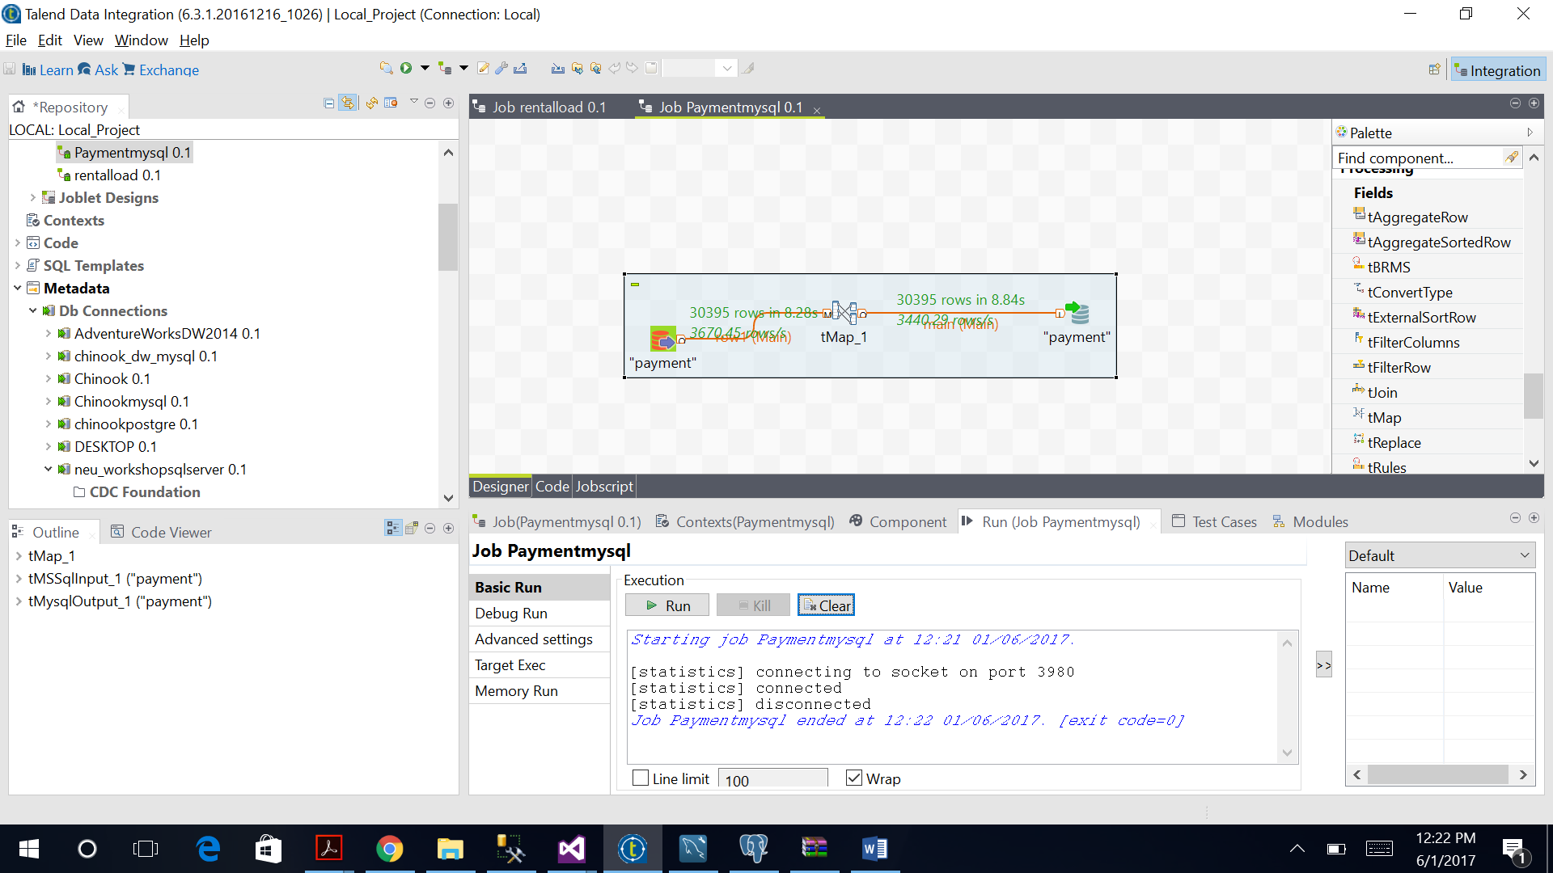

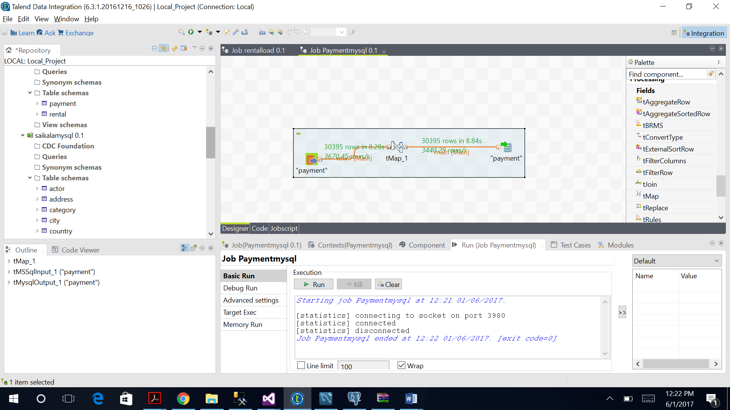

Row count –

30395

Top 10 customers (ranked or sorted descending) by rental amount from Payment table in each db

SELECT querytable.*,

CASE

WHEN @prevRank = amount THEN @rank

WHEN @prevRank := amount THEN @rank := @rank + 1

END AS rank

FROM (

select sum(p.amount) as amount,c.first_name

from payment p

join customer c

on p.customer_id = c.customer_id

group by c.first_name

) querytable, (SELECT @rank := 0,@prevRank := NULL) variablename

ORDER BY amount DESC;

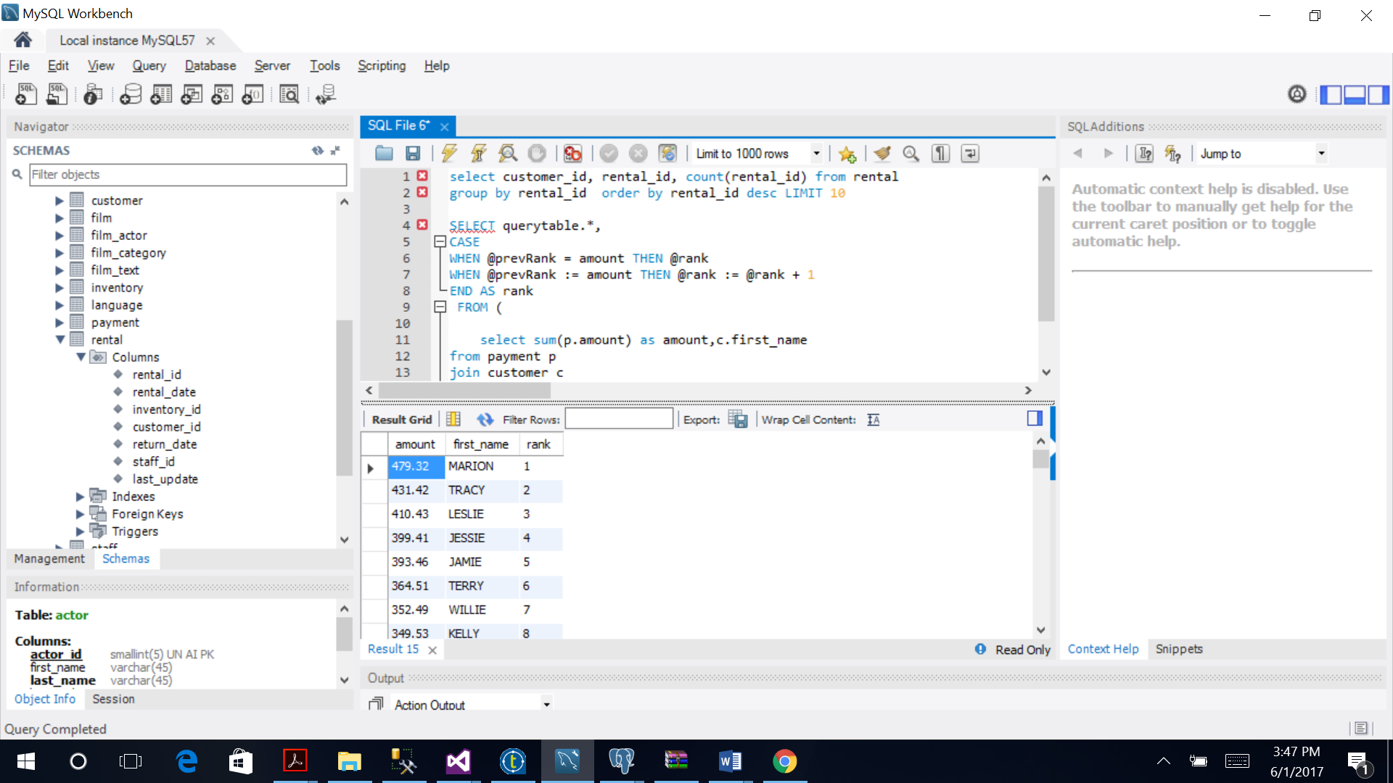

Top 10 customers (ranked or sorted descending) by number rented from Rental table in each db

select customer_id, rental_id, count(rental_id) from rental

group by rental_id order by rental_id desc LIMIT 10

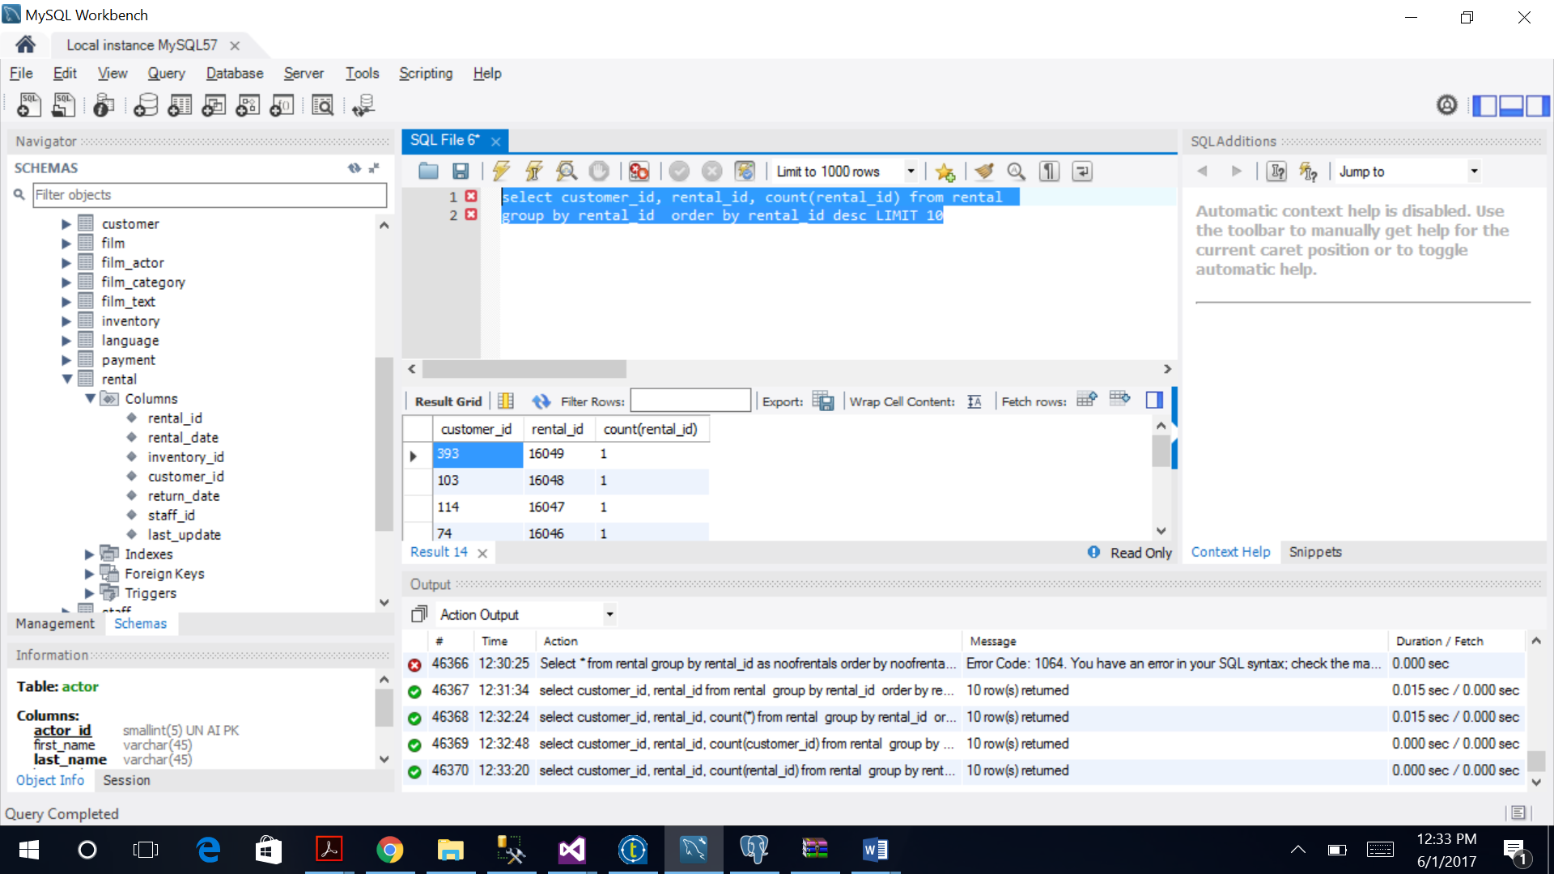

SQLSERVER –

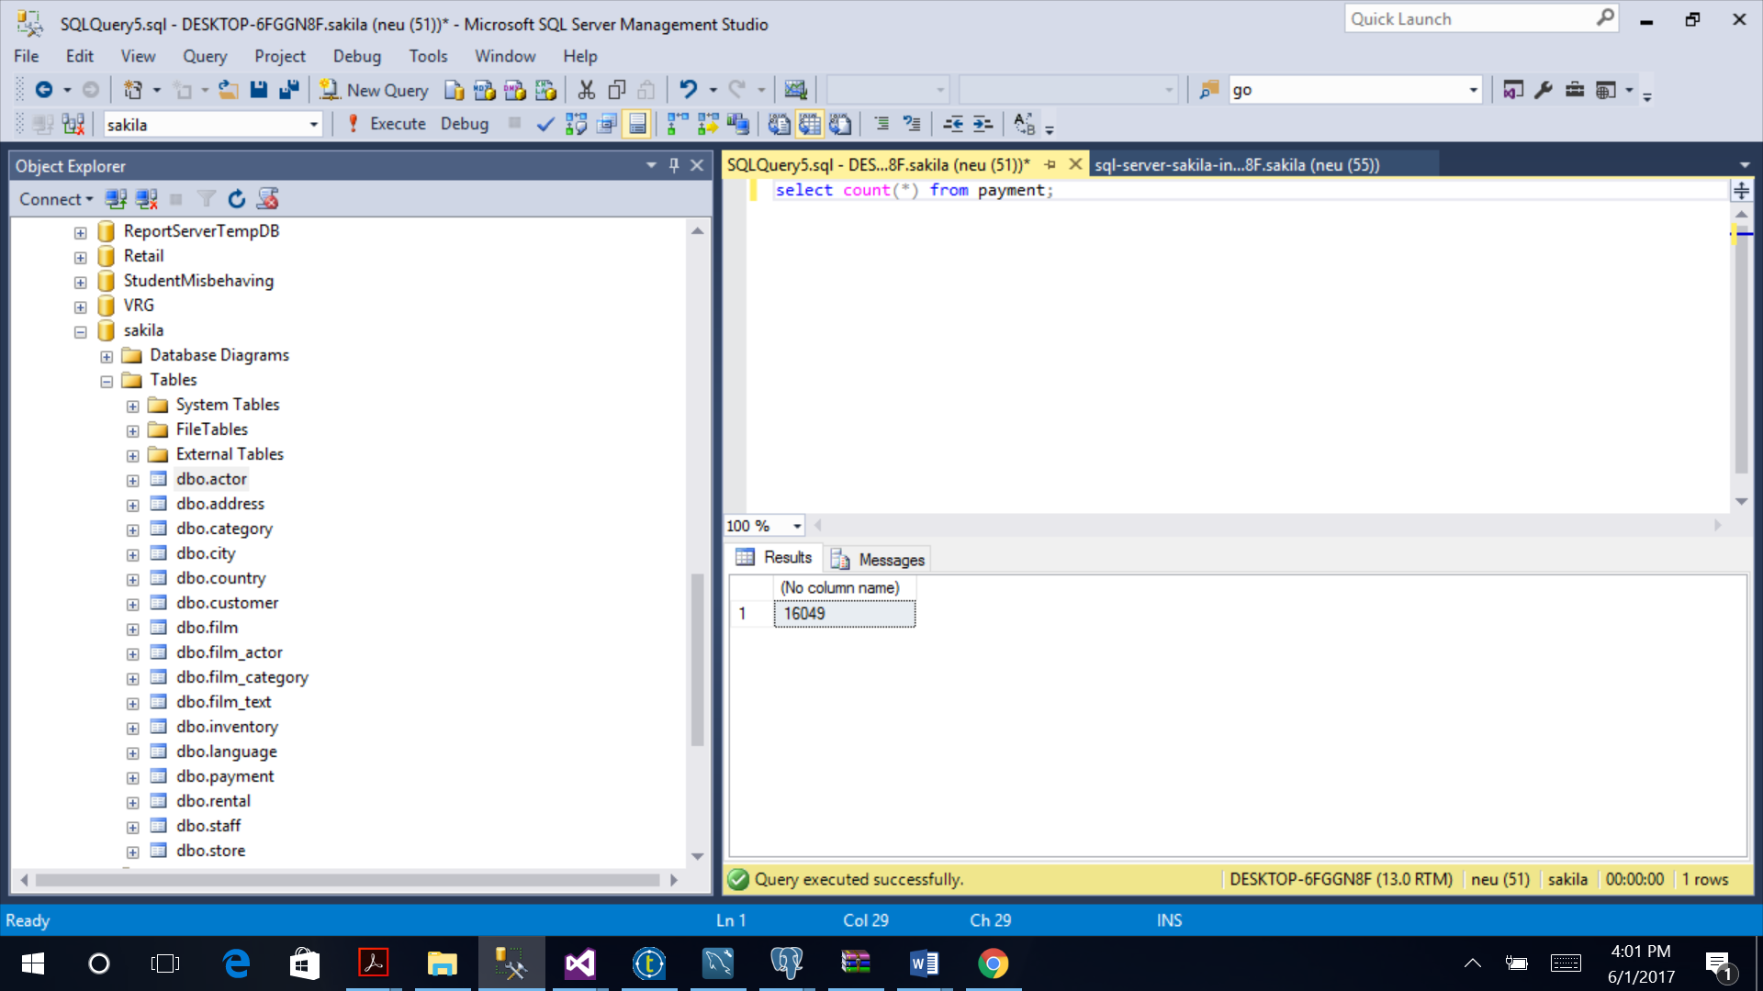

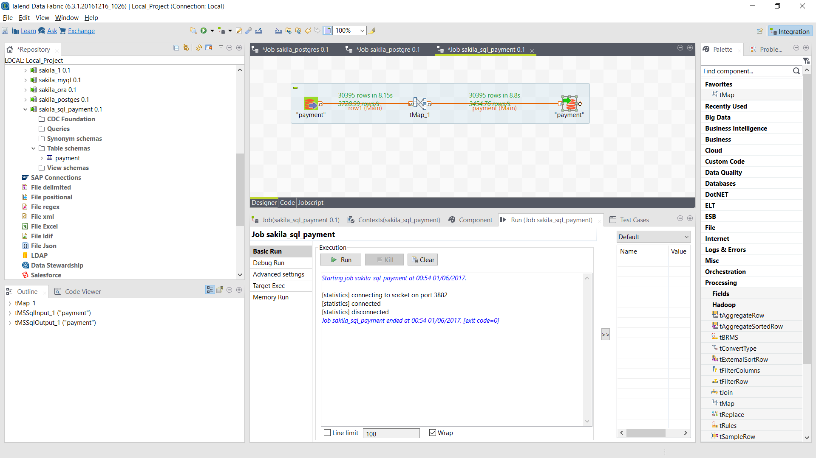

Row count –

30395

QUERY TO FIND TOP 10 CUSTOMER

select top 10 sum(p.amount) Total_Amount,c.first_name,

RANK() OVER(ORDER BY sum(p.amount) desc) FinalRank

from payment p

join customer c

on p.customer_id = c.customer_id

group by c.first_name

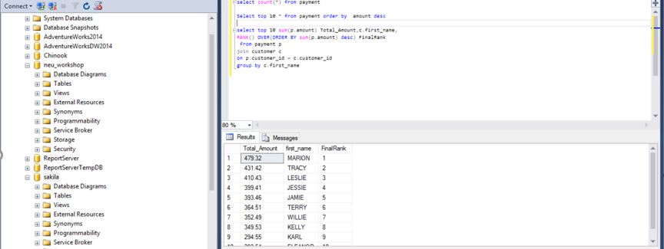

ORACLE –

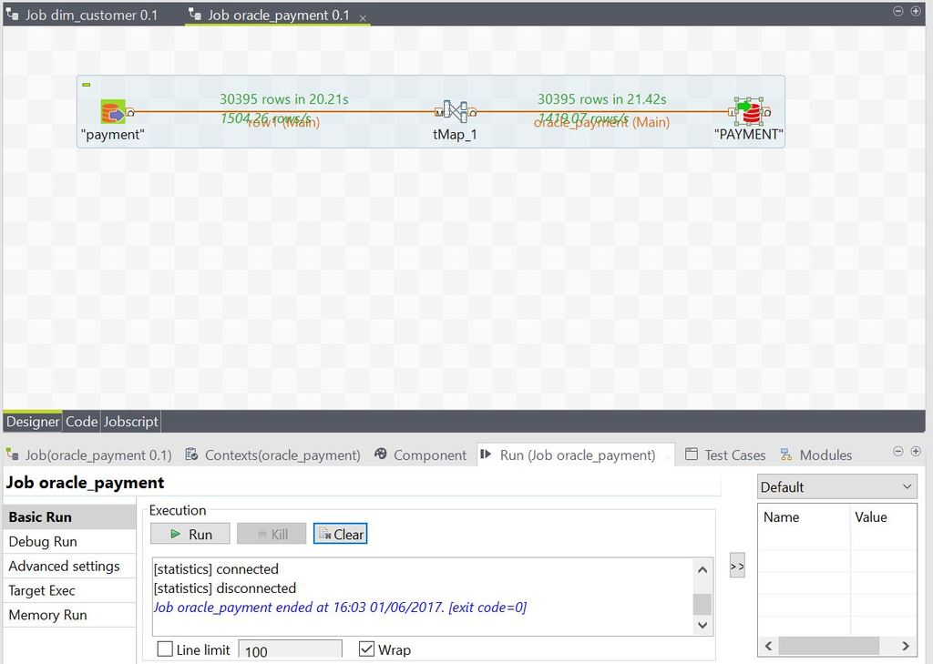

Row count –

30395

QUERY TO FIND TOP 10 CUSTOMER

SELECT *

FROM (select sum(p.amount) Total_Amount,c.first_name,

RANK() OVER(ORDER BY sum(p.amount) desc) FinalRank

from payment p

join customer c

on p.customer_id = c.customer_id

group by c.first_name

)

WHERE ROWNUM < 10;

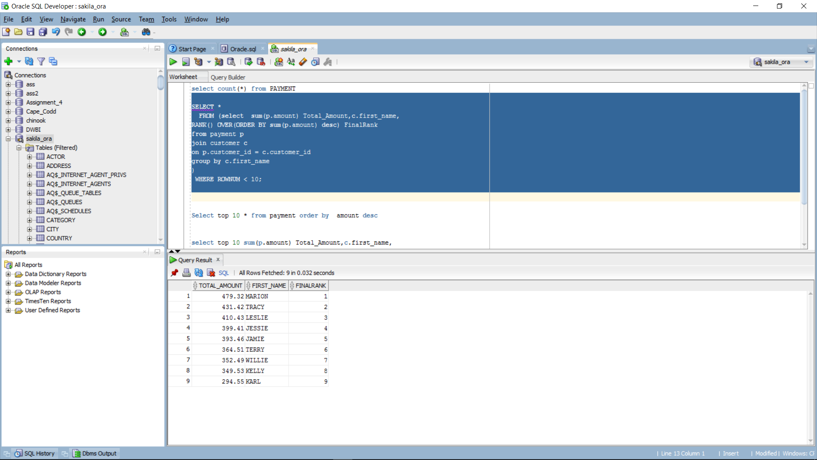

POSTGRE –

