**Create Query:**

|  |  |  |  |  |  |
| --- | --- | --- | --- | --- | --- |
| 3 | 4 | 01:17:16 | CREATE TABLE Customer (  CustomerID Int NOT NULL,  FirstName Nvarchar(50)  NOT NULL,  LastName Nvarchar(50)  NOT NULL,  BirthDate Date NULL,  Gender Nvarchar(1)  NULL,  EmailAddress Nvarchar(50)  NULL,  Phone Nvarchar(20)  NOT NULL,  CustomerType Nvarchar(15)  NULL,   CONSTRAINT Customer_CustomerKey_PK PRIMARY KEY (CustomerID) ) | 0 row(s) affected | 0.031 sec |

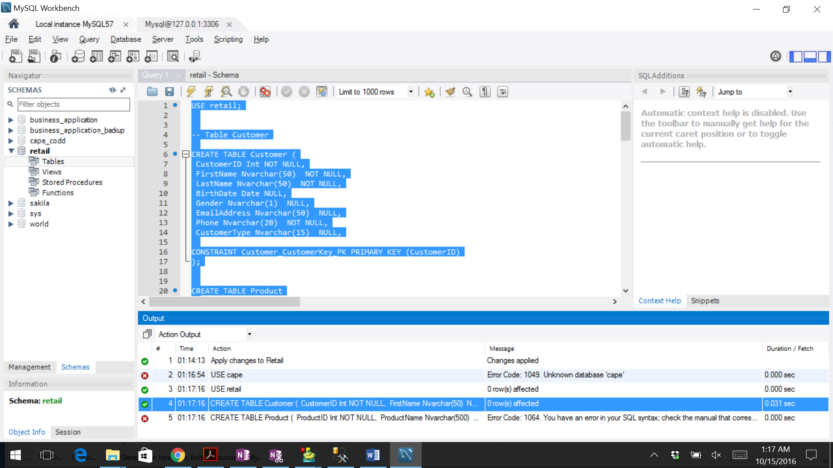

USE retail;

-- Table Customer

CREATE TABLE Customer (

CustomerID Int NOT NULL,

FirstName Nvarchar(50) NOT NULL,

LastName Nvarchar(50) NOT NULL,

BirthDate Date NULL,

Gender Nvarchar(1) NULL,

EmailAddress Nvarchar(50) NULL,

Phone Nvarchar(20) NOT NULL,

CustomerType Nvarchar(15) NULL,

CONSTRAINT Customer_CustomerKey_PK PRIMARY KEY (CustomerID)

);

CREATE TABLE Product

(

ProductID Int NOT NULL,

ProductName Nvarchar(500) NULL,

ProductDescription Nvarchar(400) NULL,

ProductSubcategoryID Int NULL,

BrandName Nvarchar(50) NULL,

UnitCost Money NULL,

UnitPrice Money NULL,

WishListID Int NOT NULL,

CONSTRAINT Productq_ProductID_PK PRIMARY KEY (ProductID),

CONSTRAINT Product_WishListID UNIQUE (WishListID)

);

-- Table ProductCategory

CREATE TABLE ProductCategory

(

ProductCategoryID Int NOT NULL,

ProductCategoryName Nvarchar(30) NOT NULL,

ProductCategoryDescription Nvarchar(50) NOT NULL,

CONSTRAINT ProductCategory_ProductCategoryKey_PK PRIMARY KEY (ProductCategoryID)

);

-- Table ProductSubcategory

CREATE TABLE ProductSubcategory

(

ProductSubcategoryID Int NOT NULL,

ProductSubcategoryName Nvarchar(50) NOT NULL,

ProductSubcategoryDescription Nvarchar(100) NULL,

ProductCategoryID Int NULL,

CONSTRAINT ProductSubcategory_ProductSubcategoryKey_PK PRIMARY KEY (ProductSubcategoryID)

);

CREATE TABLE Promotion

(

PromotionID Int NOT NULL,

PromotionName Nvarchar(100) NULL,

DiscountAmount nchar NULL,

CONSTRAINT Promotion_PromotionKey_PK PRIMARY KEY (PromotionID)

);

-- Table OnlineSales

CREATE TABLE OnlineSales

(

SalesID Int NOT NULL,

ProductID Int NOT NULL,

PromotionID Int NOT NULL,

CustomerID Int NOT NULL,

SalesOrderNumber Nvarchar(20) NOT NULL,

SalesQuantity Int NOT NULL,

SalesAmount nchar NOT NULL,

DiscountAmount nchar NULL,

TotalCost nchar NOT NULL,

UnitCost nchar NULL,

UnitPrice nchar NULL,

VendorID Int NOT NULL,

CONSTRAINT PK_OnlineSales_SalesID PRIMARY KEY (SalesID),

CONSTRAINT OnlineSales_VendorID UNIQUE (VendorID)

);

-- Table ProductVendor

CREATE TABLE ProductVendorr

(

AccountNumber Int NOT NULL,

VendorName Char(50) NULL,

Rating Nchar(10) NULL,

VendorID Int NOT NULL,

CONSTRAINT PK_ProductVendor_VendorID PRIMARY KEY (VendorID),

CONSTRAINT ProductVendor_AccountNumber UNIQUE (AccountNumber),

CONSTRAINT ProductVendor_VendorName UNIQUE (VendorID)

);

CREATE TABLE WishListProducts

(

ProductName Nvarchar(500) NOT NULL,

WishListID Int NOT NULL,

CustomerID Int NOT NULL,

CONSTRAINT PK_WishListProducts_WishListID PRIMARY KEY (WishListID),

CONSTRAINT ProductName UNIQUE (WishListID)

);

**Insert Query:**

USE Cape;

/*** Customer data ******************************************************/

INSERT INTO Customer VALUES (

123451, 'Tim', 'Tom', '2001-01-01', 'M','tim@gmail.com','6786784573','Regular');

INSERT INTO Customer VALUES (

123452, 'Tuum', 'Tkom', '2001-03-01', 'F','tvjkvm@gmail.com','6786775763','First Time');

INSERT INTO Customer VALUES (

123453, 'Gyim', 'Thomas', '2001-05-01', 'F','timjhh@gmail.com','6786787878','Regular');

INSERT INTO Customer VALUES (

123454, 'Kim', 'Tomdf', '2001-01-03', 'M','tibbm@gmail.com','6786784987','Second Time');

/*** Online Sales data **********************************************************/

INSERT INTO OnlineSales VALUES (

100100, 2345, 7878, 123451, 89888, 7, 10000, 56, 10056, 100, 200, 9000);

INSERT INTO OnlineSales VALUES (

100200, 2325, 7008, 123452, 89868, 17, 100000, 46, 100046, 130, 200, 8000);

INSERT INTO OnlineSales VALUES (

100300, 2355, 7908, 123453, 89878, 27, 10044, 53, 10098, 200, 200, 7000);

INSERT INTO OnlineSales VALUES (

100400, 2945, 7128, 123454, 89858, 3, 10300, 58, 10358, 400, 200, 6000);

/*** Product data ********************************************************/

INSERT INTO Product VALUES (

2345,'Mouse', 'Compact and easy to use', 88888,'HP', 100, 200, 0001);

INSERT INTO Product VALUES (

2325,'Remote', 'easy to use', 77777,'Sony', 130, 200, 0002);

INSERT INTO Product VALUES (

2355,'Dress', 'Compact and easy to handle', 66666,'Vero moda', 200, 200, 0003);

INSERT INTO Product VALUES (

2945,'Bottle', 'Compact and easy to use', 55555,'Tupperware', 400, 200, 0004);

/*** Product SubCategory data *********************************************************/

INSERT INTO ProductSubcategory VALUES (

88888, 'Laptop items', 'Good to use', 125000);

INSERT INTO ProductSubcategory VALUES (

77777, 'Electronics', 'Robust', 100000);

INSERT INTO ProductSubcategory VALUES (

66666, 'Clothing', 'Good quality', 150000);

INSERT INTO ProductSubcategory VALUES (

55555, 'Utensils', 'life long', 130000);

/*** Product Category data *********************************************************/

INSERT INTO ProductSubcategory VALUES (

125000, 'Technology', 'Latest version');

INSERT INTO ProductSubcategory VALUES (

100000, 'Household', 'compatible');

INSERT INTO ProductSubcategory VALUES (

150000, 'Apparels', 'All colors');

INSERT INTO ProductSubcategory VALUES (

130000, 'Platic households', 'recycled');

/********************************************************************************/

/*        Promotion */

INSERT INTO Promotion VALUES (

7878,'Thanksgiving', 56);

INSERT INTO Promotion VALUES (

7008, 'Pumpkin Day', 46);

INSERT INTO Promotion VALUES (

7908, 'Only Wednesday',53);

INSERT INTO Promotion VALUES (

7128, 'lowest price', 58);

/* WishList Products */

INSERT INTO WishListProducts VALUES (

'Mouse', 0001, 123451);

INSERT INTO WishListProducts VALUES (

'Remote', 0002,123452);

INSERT INTO WishListProducts VALUES (

'Dress', 0003, 123453);

INSERT INTO WishListProducts VALUES (

'Bottle', 0004, 123454);

/* Product Vendor */

INSERT INTO WishListProducts VALUES (

989898,'Mickey', 1, 9000);

INSERT INTO WishListProducts VALUES (

989897,'Minnie', 1,8000);

INSERT INTO WishListProducts VALUES (

989896,'Pluto', 2, 7000);

INSERT INTO WishListProducts VALUES (

989895,'Goofy', 2, 6000);

select * FROM Customer;

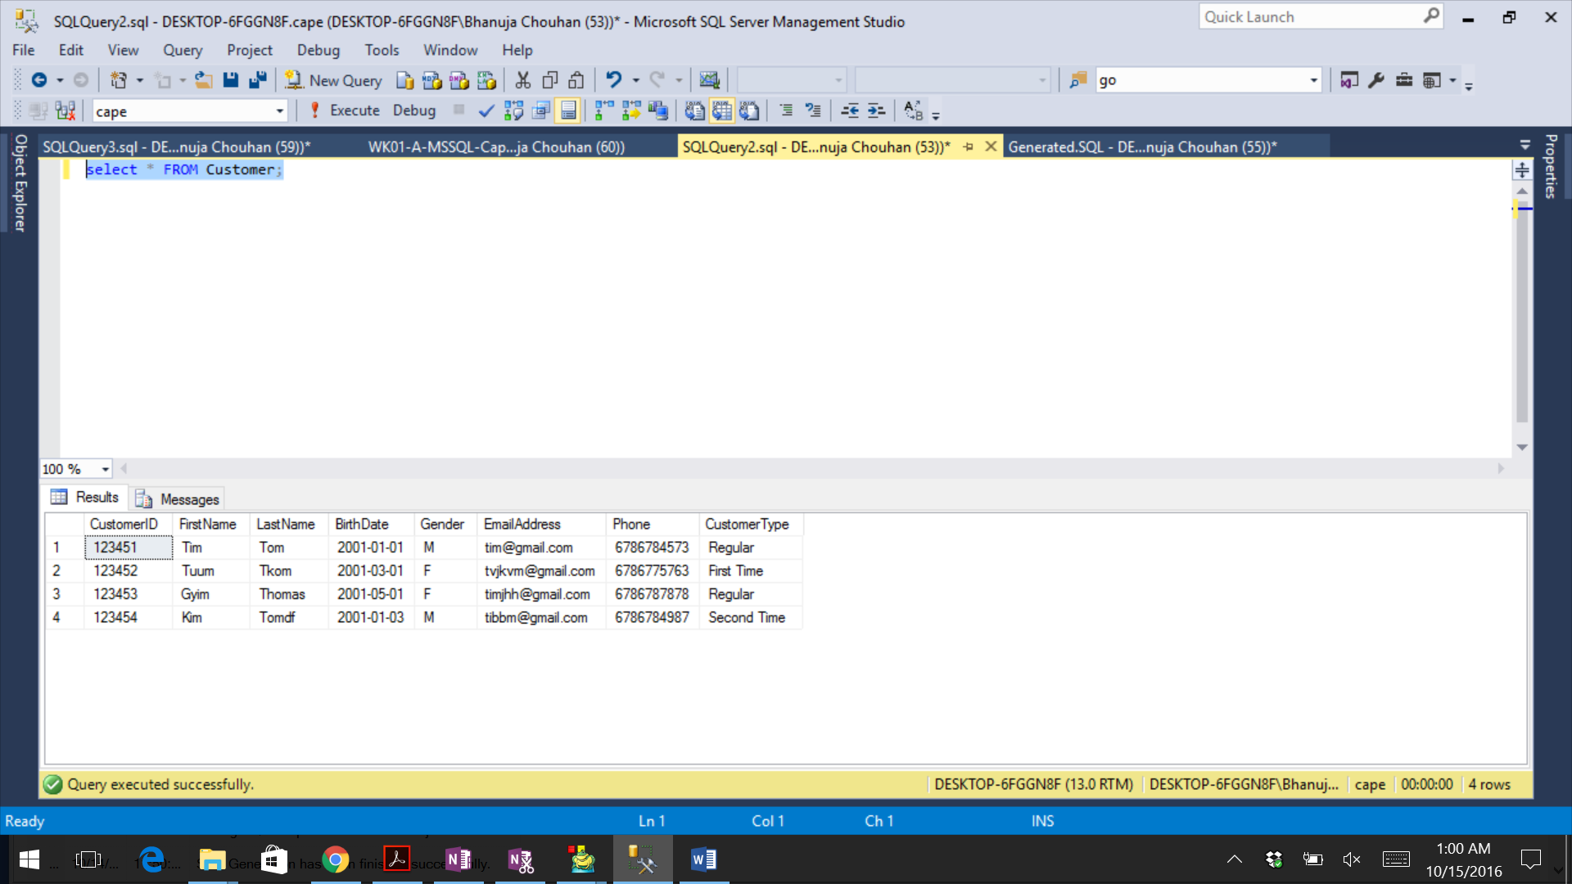

select * from wishlistproducts;

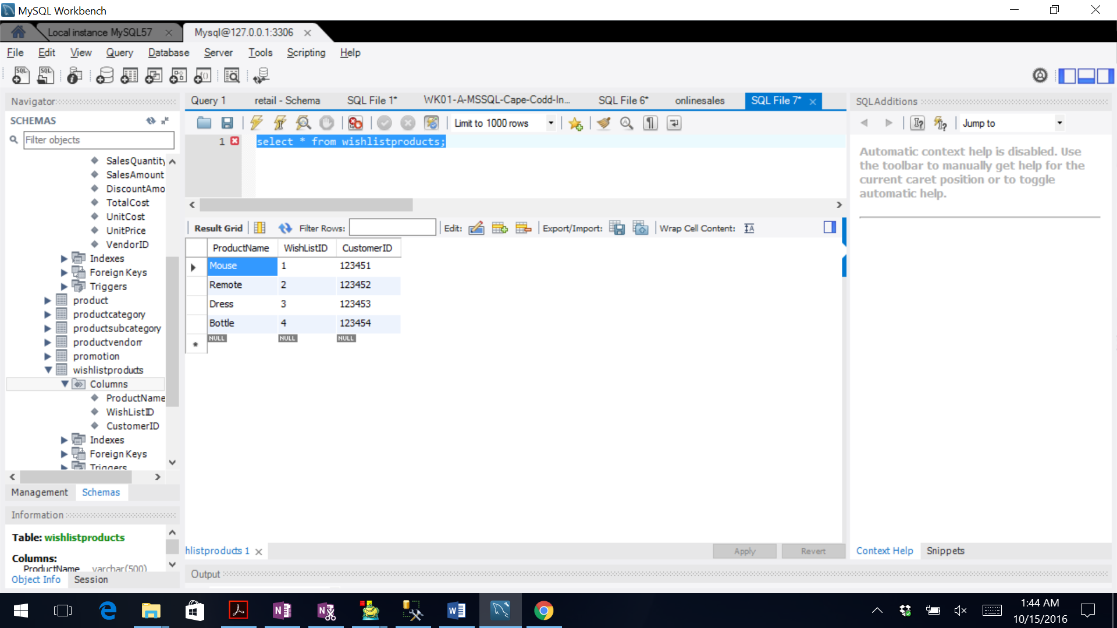

select * from wishlistproducts,product,productcategory;

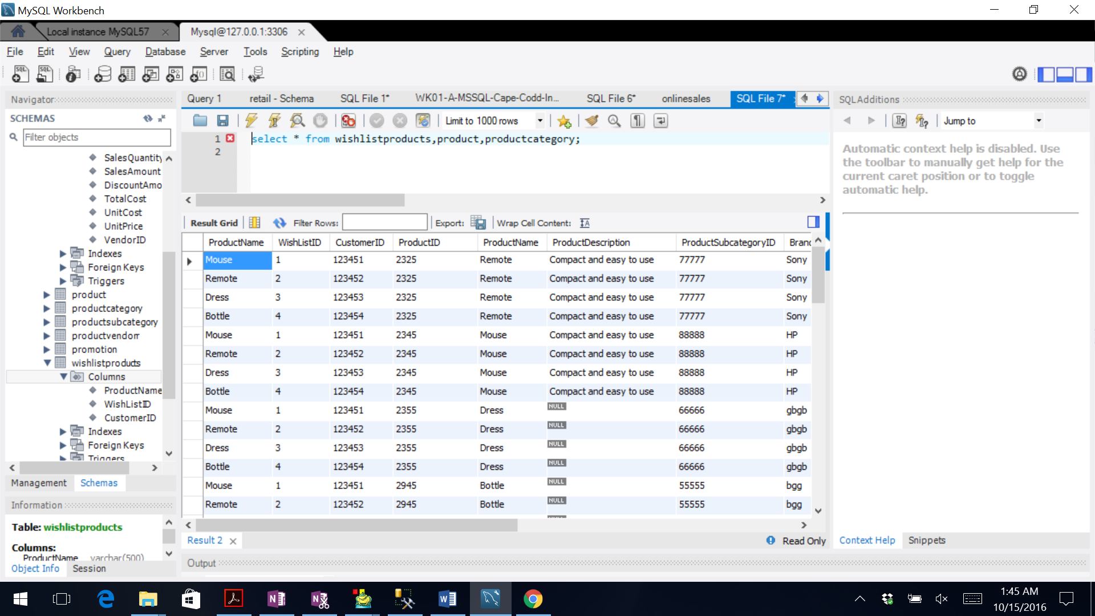

select product.BrandName, product.ProductName, sum(onlineSales.TotalCost) as totalsalesamount

from onlineSales,product

where product.ProductID = onlinesales.ProductID

group by product.BrandName order by totalsalesamount desc;

