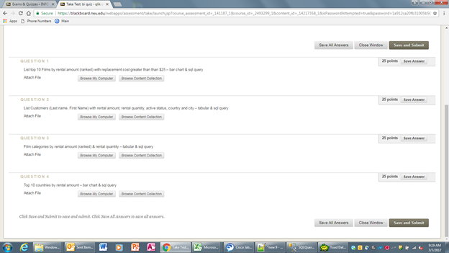

select title as Film, sum(amount) as RentalAmount, film.rating, rental_rate, replacement_cost, category.name as Category,

RANK() OVER (order by sum(amount) desc) as Rank

from film

join inventory

on inventory.film_id=film.film_id

join rental

on inventory.inventory_id=rental.inventory_id

join payment

on rental.rental_id=payment.rental_id

join film_category

on film.film_id=film_category.film_id

join category

on category.category_id=film_category.category_id

where replacement_cost>25

group by film.film_id,title, film.rating, rental_rate, replacement_cost, category.name

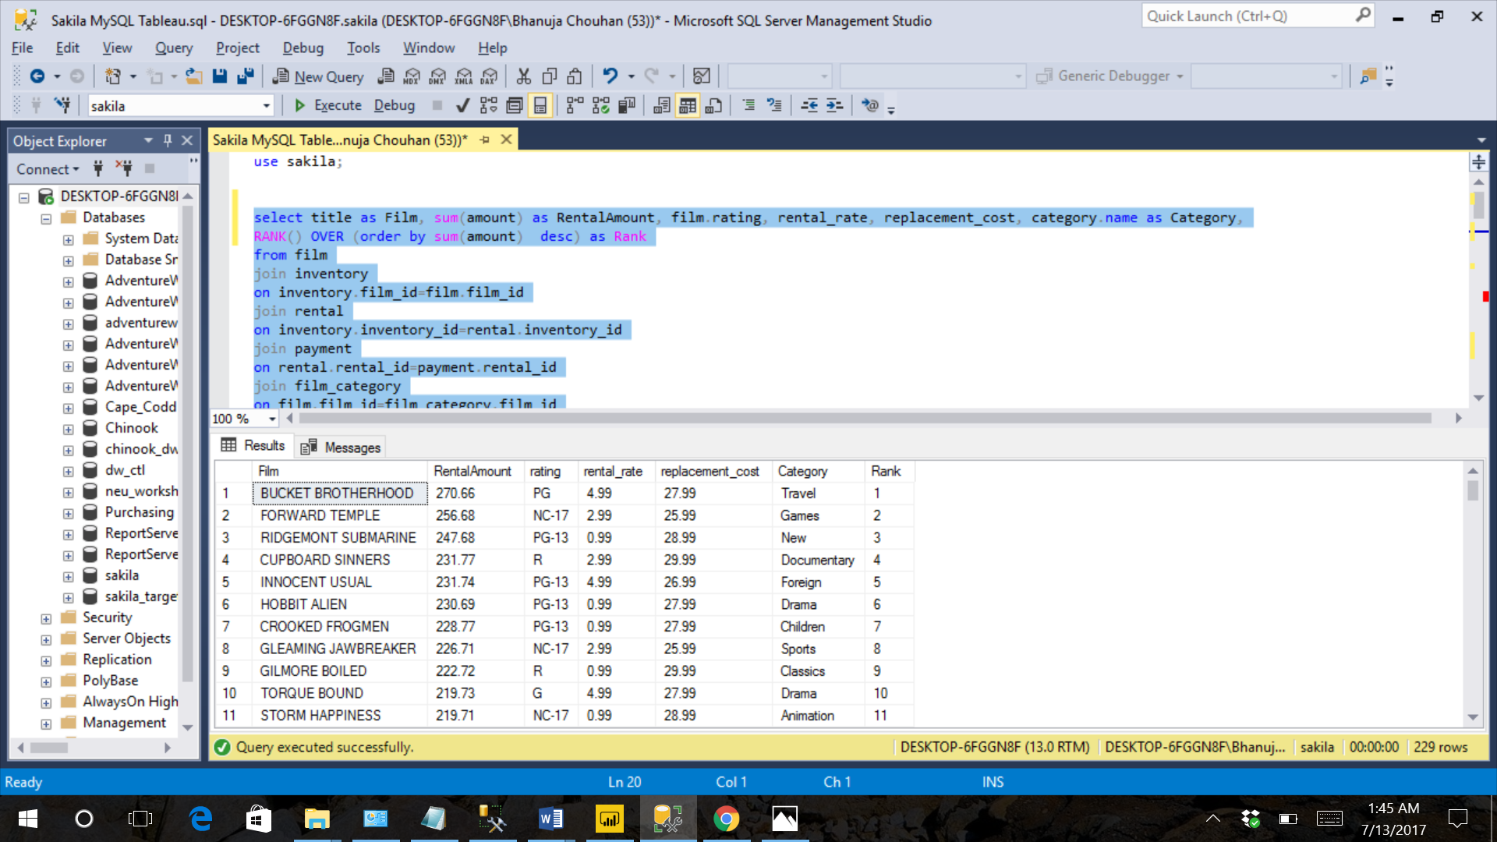

/* 2 */

select c.first_name, c.last_name, sum(p.amount), count(p.amount), c.active, ci.CITY, co.COUNTRY from payment p

join customer c on p.customer_id = c.customer_id

join address a on c.address_id = a.address_id

join city ci on a.city_id = ci.city_id

join country co on ci.country_id = co.country_id

group by c.first_name, c.last_name, c.active, ci.CITY, co.COUNTRY

having c.active = 1

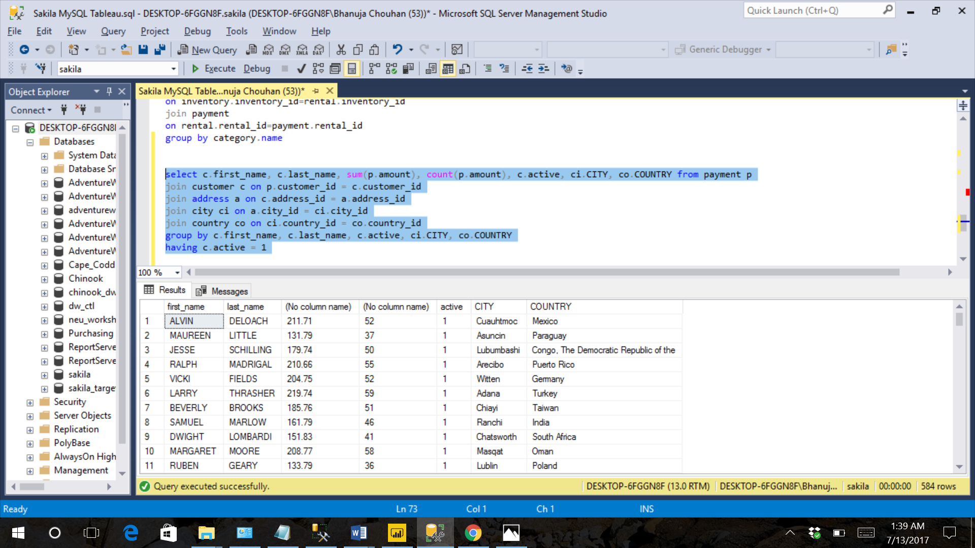

/*3- film categories by rental amount and rental quantity*/

select category.name, sum(amount)

from category

join film_category

on film_category.category_id=category.category_id

join film

on film.film_id=film_category.film_id

join inventory

on film.film_id=inventory.film_id

join rental

on inventory.inventory_id=rental.inventory_id

join payment

on rental.rental_id=payment.rental_id

group by category.name

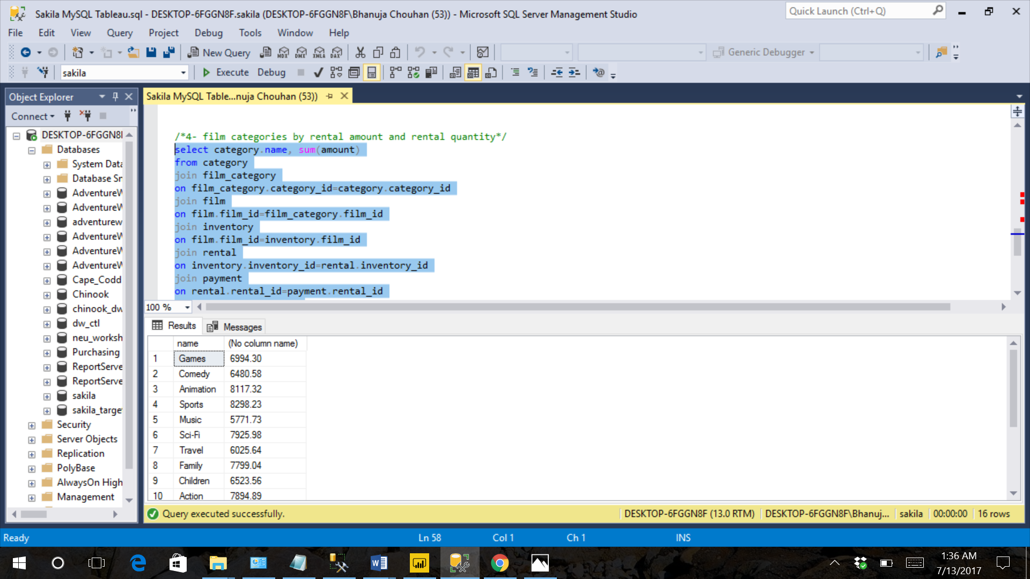

/*4- top 10 countries by rental amount*/

select top 10 country, sum(amount)

from country

join city

on city.country_id=country.country_id

join address

on address.city_id=city.city_id

join customer

on customer.address_id=address.address_id

join rental

on rental.customer_id=customer.customer_id

join payment

on payment.rental_id=rental.rental_id

group by country

order by sum(amount) desc

