Capstone Project 1 - In Depth Machine Learning Analysis

Overall Approach
Machine learning algorithms were employed in order to produce a more balanced sample set and predictions.
- Preprocess and Fitting Model to the data: The full data set had a drastically higher number of automobiles not in accidents compared to those in accidents. Adjustments in what was sampled was in order for the model to work without being biased due to this. There was a random sample taken from the total automobiles not in accidents to match the sample size of each color of automobiles in accidents, which lead to a balanced overall sample set.
- Evaluate the Model: Scikit learn was employed to build models with the given data. Logistic Regression and Decision Tree methods were used. Logistic Regression is used as the predictive analysis which looks to explain the relationship between the color of an automobile and likelihood to be in an accident. The Decision Tree is used to place a predicted value for each color of automobile.
Regression
The sampling was adjusted to only include a total of 34,796 automobiles in accidents, and 34,796 automobiles not in accidents. 75% of the data was being used for the model training and 25% used for model testing. When running a logistic regression matrix, the resulting array came in with approximately a 77% accuracy rating.
array([[8396, 170],
[3815, 5017]])
Confusion Matrix Plots
Visualizing the matrix as a heat map lot. The classification rate is around 77%, which is a good accuracy. The precision, or how often the model is correct, predicts that automobiles will or will not get in accidents 95.9% of the time. If there are automobiles that will or will not get in accidents, this Logistic Regression model can identify it 57.7% of the time.
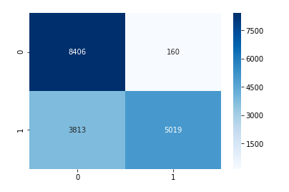
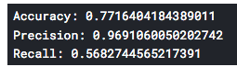

Classification
The ROC curve shows this model is doing better than a random model.
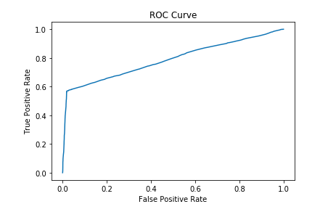
A decision tree may lead to further understanding on predicting whether a particular automobile may be in an accident. I am not sure I should include this or if it is complete
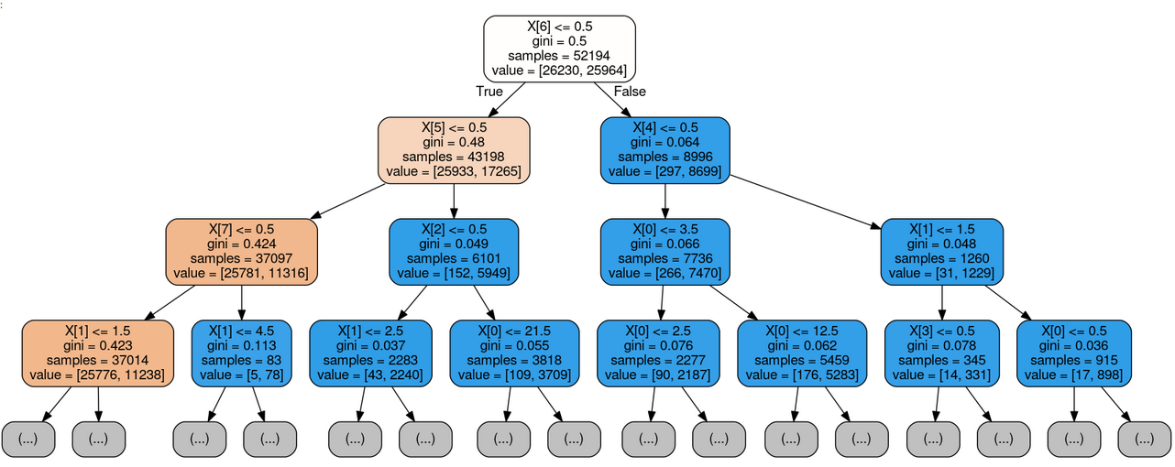

Conclusion
It was best to create balanced models for the predictions and drawing conclusions. This model had a good amount of accuracy and showed to be doing better than a random model. Using models such as this in other counties or statewide, could potentially give a little more insight into the likelihood of a particular automobile getting into an accident.

Future Work
- Can accidents be predicted based on the day of the week? What about weekdays vs. weekends?
- Can conclusions be made that driving a certain color car on a certain day of the week is more likely to get in an accident?

