

|  |
| --- |
| Business Template  **Political campaign** |
| **L**merchandise image |

Contents

1 Business Description 3

1.1 Business background 3

1.2 Problems. Current Situation 3

1.3 the Benefits of implementing a database. Project Vision 3

2 Model description 3

2.1 Definitions & Acronyms 3

2.2 Logical Scheme 3

2.3 Objects 4

# 

# Business Description

## Business background

An independent commission is responsible for collecting and managing data related to political elections. This includes information on voters, donors, campaign volunteers, events, finances, and survey results. The data is crucial for campaign analysis, decision-making, and ensuring transparency.

## Problems. Current Situation

Currently, political campaign data is managed in fragmented systems, making it difficult to analyze and track key metrics effectively. The lack of an integrated database leads to inefficiencies in managing volunteers, tracking financial contributions, and analyzing voter engagement. Additionally, challenges such as unexpected budget overruns, volunteer shortages, and ineffective outreach strategies often go untracked, making it difficult to improve future campaign.

## the Benefits of implementing a database. Project Vision

A well-structured database will allow for better data organization, improved tracking of campaign contributions, streamlined volunteer management, and enhanced analysis of campaign effectiveness.

* Volunteer Contributions Tracking: A dedicated Volunteer Task table will record tasks assigned to volunteers, their completion status, and their impact on the campaign.
* Issue Tracking for Future Analysis: A Campaign Issues table will be introduced to log problems encountered during preparation and execution, along with their resolutions.
* Event Management: Events will be linked to campaigns, ensuring structured planning and execution tracking.
* Finance Transparency: Campaign financials will be categorized and monitored, providing real-time insights into spending and donations.
* Social Media Engagement: A Social Media table will now include URLs for posts, allowing for better tracking and impact measurement.

This system will provide real-time access to campaign-related data, ensuring a smooth and transparent election process.

# Model description

## Definitions & Acronyms

* **PK (Primary Key):** A unique identifier for records in a table.
* **FK (Foreign Key):** A reference to a primary key in another table.
* **NOT NULL:** Critical fields (such as names, emails, and dates) are required to be non-null to prevent incomplete data entries.
* **CHECK:** Constraints are used to enforce data validity, such as ensuring donation amounts are greater than zero.
* **UNIQUE**: Applied to prevent duplicate entries where necessary, such as ensuring unique email addresses for donors and volunteers.
* **Campaign:** A political effort to influence elections.
* **Donor:** An individual contributing funds to a campaign.
* **Survey:** A structured questionnaire to gather voter opinions.

## Logical Scheme

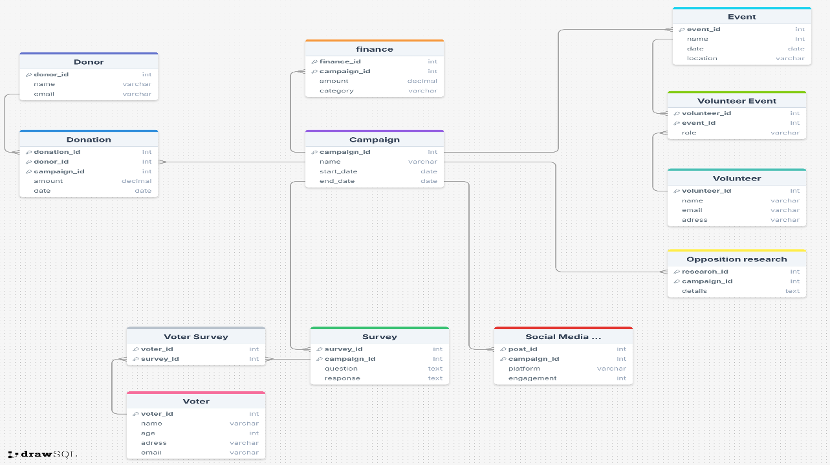

## Objects

**1. Donor Table**

The Donor table stores information about individuals or organizations that contribute donations to political campaigns.

|  |  |  |  |
| --- | --- | --- | --- |
| Table Name | Field name | Field Description | Data Type |
| Donor | Donor_id | Unique identifier for each donor, PK | Int |
| name | Name of the donor, NOT NULL | VARCHAR(255) |
| email | Email address of the donor, UNIQUE | VARCHAR(255) |

One Donor can make multiple Donations (1:M relationship with Donation table).

Example with data

|  |  |  |
| --- | --- | --- |
| Donor_id | name | email |
| 1 | Migle Skystimaite | miglesky@gmail.com |
| 2 | Jane doe | Jane.doe@gmail.com |

**2. Donation Table**

The Donation table records financial contributions made by donors to specific campaigns.

|  |  |  |  |
| --- | --- | --- | --- |
| Table Name | Field name | Field Description | Data Type |
| Donation | Donation_id | Unique identifier for each donation, PK | Int |
| Donor_id | Donor reference, FK | Int |
| Campaign_id | Campaign reference, FK | Int |
| amount | Donation amount, NOT NULL | Decimal |
| date | Date of donation, NOT NULL | Date |

Each Donation is linked to one Donor (M:1 with Donor).

Each Donation is linked to one Campaign (M:1 with Campaign).

Example with data

|  |  |  |  |  |
| --- | --- | --- | --- | --- |
| Donation_id | Donor_id | Campaign_id | amount | date |
| 101 | 1 | 10 | 500.00 | 2024-01-15 |
| 102 | 2 | 11 | 300.00 | 2024-02-10 |

**3. Campaign Table**

The Campaign table represents a political campaign, storing details about the campaign and its timeline.

|  |  |  |  |
| --- | --- | --- | --- |
| Table Name | Field name | Field Description | Data Type |
| Campaign | Campaign_id | Unique identifier for each campaign, PK | Int |
| Name | Name of the campaign, NOT NULL | VARCHAR(255) |
| Start_date | Start date of the campaign, NOT NULL | Date |
| End_Date | End date of the campaign, NOT NULL | Date |

Campaign has multiple Donations (1:M with Donation).

Campaign has multiple Finance records (1:M with Campaign Finance).

Campaign has multiple Surveys (1:M with Survey).

Campaign has multiple Social Media Posts (1:M with Social Media Post).

Campaign has multiple Opposition Research records (1:M with Opposition Research).

Campaign has multiple Events (1:M with Events).

Example with data

|  |  |  |  |
| --- | --- | --- | --- |
| Campaign_id | Name | Start_date | End_date |
| 10 | 2024 Presidential | 2024-01-01 | 2024-12-01 |
| 11 | Governor Election | 2024-03-01 | 2024-11-01 |

**4.Campaign Finance table**

The Campaign Finance table tracks financial expenses related to a campaign.

|  |  |  |  |
| --- | --- | --- | --- |
| Table Name | Field name | Field Description | Data Type |
| CampaignFinance | Finance_id | Unique identifier for each finance record, PK | Int |
| Campaign_id | Campaign reference, FK | Int |
| Amount | Amount spent | Decimal |
| Category | Category of expense | VARCHAR(255) |

Each Finance record is linked to one Campaign (M:1 with Campaign).

Example with data

|  |  |  |  |
| --- | --- | --- | --- |
| Financce_id | Campaign_id | Amount | Category |
| 201 | 10 | 2000.00 | Advertising |
| 202 | 11 | 1500.00 | Logistics |

**5. Event table**

The Event table stores details about campaign-related events.

|  |  |  |  |
| --- | --- | --- | --- |
| Table Name | Field name | Field Description | Data Type |
| Event | Event_id | Unique identifier for each event, PK | Int |
| Campaign_id | Unique identifier for each event, FK | Int |
| Name | Name of the event, NOT NULL | Int |
| Date | Date of the event, NOT NULL | Date |
| Location | Location of the event, NOT NULL | VARCHAR(255) |

Events have multiple Volunteers (M:M through Volunteer_Event).

Each event is linked to one Campaign (M:1 through Campaign).

Example with data

|  |  |  |  |
| --- | --- | --- | --- |
| Event_id | Name | Date | Location |
| 301 | Rally in NY | 2024-05-20 | New York |
| 302 | Debate Night | 2024-06-15 | Washington |

**6. Volunteer Table**

The Volunteer table stores information about campaign volunteers..

|  |  |  |  |
| --- | --- | --- | --- |
| Table Name | Field name | Field Description | Data Type |
| Volunteer | Volunteer_id | Unique identifier for each volunteer, PK | Int |
| Name | Name of the volunteer, NOT NULL | VARCHAR(255) |
| Contact_info | Contact information of the volunteer, NOT NULL | VARCHAR(255) |
| Availability | Availability of the volunteer, NOT NULL | Boolean |

Volunteers participate in multiple Events (M:M through Volunteer_Event).

Example with data

|  |  |  |  |
| --- | --- | --- | --- |
| Volunteer_id | Name | Contact_info | Availability |
| 401 | Migle Skystimaite | miglesky@gmail.com | Yes |
| 402 | Mike Ross | mike@yahoo.com | No |

**7. Volunteer_Event Table (Junction Table)**

This table connects volunteers to events they participate in.

|  |  |  |  |
| --- | --- | --- | --- |
| Table Name | Field name | Field Description | Data Type |
| Volunteer_Event | Volunteer_id | Unique identifier for each volunteer, FK | Int |
| Event_id | Unique identifier for each event, FK | Int |
| Role | Role of the volunteer at the event, NOT NULL | VARCHAR(255) |

Many-to-Many between Volunteer and Event.

Example with data

|  |  |  |
| --- | --- | --- |
| Volunteer_id | Event_id | Role |
| 401 | 301 | Speaker |
| 402 | 302 | Organizer |

**8. Survey Table**

The Survey table records survey questions and responses related to a campaign.

|  |  |  |  |
| --- | --- | --- | --- |
| Table Name | Field name | Field Description | Data Type |
| Survey | Survey_id | Unique identifier for the survey, PK | Int |
| Campaign_id | Unique identifier for the campaign, FK | Int |
| Question | Survey question, NOT NULL | Text |
| Response | Response to the survey, NOT NULL | Text |

One campaign can have multiple surveys (1:M).

A survey can be answered by multiple voters (M:M through VoterSurvey).

Example with data

|  |  |  |  |
| --- | --- | --- | --- |
| Survey_id | Campaign_id | Question | Response |
| 301 | 201 | Do you support clean energy policies? | Yes |
| 302 | 202 | Do you think education should be free? | No |

**9. VoterSurvey Table**

The VoterSurvey table tracks which voters participated in which surveys.

|  |  |  |  |
| --- | --- | --- | --- |
| Table Name | Field name | Field Description | Data Type |
| Voter Survey | Voter_id | Unique identifier for the voter, FK | Int |
| Survey_id | Unique identifier for the survey, FK | Int |

Many-to-Many between Voter and Survey.

Example with data

|  |  |
| --- | --- |
| Voter_id | Survey_id |
| 101 | 301 |
| 202 | 302 |

**10. Opposition Research Table**

The **OppositionResearch** table stores data about the campaign’s research on opposing candidates.

|  |  |  |  |
| --- | --- | --- | --- |
| Table Name | Field name | Field Description | Data Type |
| OppositionResearch | Research_id | Unique identifier for the research, PK | Int |
| Campaign_id | Unique identifier for the campaign, FK | Int |
| Details | Research details, NOT NULL | Text |

One campaign can have multiple research records (1:M).

Example with data

|  |  |  |
| --- | --- | --- |
| Research_id | Campaign_id | Details |
| 501 | 201 | Competitor's policy review |
| 502 | 202 | Environmental impact analysis |

**11. SocialMedia Table**

The SocialMedia table tracks campaign-related social media activity.

|  |  |  |  |
| --- | --- | --- | --- |
| Table Name | Field name | Field Description | Data Type |
| SocialMedia | Post_id | Unique identifier for each post (PK) | Int |
| Campaign_id | Campaign associated with the post (FK) | Int |
| Platform | Social media platform (e.g., Instagram, Facebook), NOT NULL | VARCHAR(255) |
| Engagement | Number of interactions (likes, shares, comments), NOT NULL | Int |
| URL | URL to the campaign social media site, NOT NULL | VARCHAR(255) |

One Campaign can have multiple SocialMedia posts (1:M).

Example with data

|  |  |  |  |
| --- | --- | --- | --- |
| Post_id | Campaign_id | Platform | Engagement |
| 1201 | 201 | Facebook | 150 |
| 1202 | 202 | Instagram | 300 |

**12. Voter Table**

The Voter table stores information about individuals eligible to vote in the campaign.

|  |  |  |  |
| --- | --- | --- | --- |
| Table Name | Field name | Field Description | Data Type |
| Voter | Voter_id | Unique identifier for each voter (PK) | Int |
| Name | Name of the voter,NOT NULL | VARCHAR(255) |
| Age | Age of the voter, NOT NULL | Int |
| Address | Residental address of the voter, NOT NULL | VARCHAR(255) |
| Email | Contact email of the voter, NOT NULL To maintain data integrity and consistency, the following constraints are applied across the database:   * **Primary Key (PK):** Each table has a unique primary key constraint to ensure unique identification of records. * **Foreign Key (FK):** Referential integrity is enforced through foreign key constraints linking related tables. * **NOT NULL:** Critical fields (such as names, emails, and dates) are required to be non-null to prevent incomplete data entries. * **CHECK:** Constraints are used to enforce data validity, such as ensuring donation amounts are greater than zero. * **UNIQUE:** Applied to prevent duplicate entries where necessary, such as ensuring unique email addresses for donors and volunteers. | VARCHAR(255) |

A voter can participate in multiple surveys (M:M through **VoterSurvey**).

Example with data

|  |  |  |  |  |
| --- | --- | --- | --- | --- |
| Voter_id | Name | Age | Address | Email |
| 101 | John Doe | 35 | Chicago, IL | john@gmail.com |
| 102 | Luke Ham | 29 | New York, NY | haml@gmail.com |