Business Template

Political campaign
L

Contents
1 Business Description 3
1.1 Business background 3
1.2 Problems. Current Situation 3
1.3 the Benefits of implementing a database. Project Vision 3
2 Model description 3
2.1 Definitions & Acronyms 3
2.2 Logical Scheme 3
2.3 Objects 4

Business Description

Business background
An independent commission is responsible for collecting and managing data related to political elections. This includes information on voters, donors, campaign volunteers, events, finances, and survey results. The data is crucial for campaign analysis, decision-making, and ensuring transparency.

Problems. Current Situation
Currently, political campaign data is managed in fragmented systems, making it difficult to analyze and track key metrics effectively. The lack of an integrated database leads to inefficiencies in managing volunteers, tracking financial contributions, and analyzing voter engagement. Additionally, challenges such as unexpected budget overruns, volunteer shortages, and ineffective outreach strategies often go untracked, making it difficult to improve future campaign.

the Benefits of implementing a database. Project Vision
A well-structured database will allow for better data organization, improved tracking of campaign contributions, streamlined volunteer management, and enhanced analysis of campaign effectiveness.

- Volunteer Contributions Tracking: A dedicated Volunteer Task table will record tasks assigned to volunteers, their completion status, and their impact on the campaign.

- Issue Tracking for Future Analysis: A Campaign Issues table will be introduced to log problems encountered during preparation and execution, along with their resolutions.

- Event Management: Events will be linked to campaigns, ensuring structured planning and execution tracking.

- Finance Transparency: Campaign financials will be categorized and monitored, providing real-time insights into spending and donations.

- Social Media Engagement: A Social Media table will now include URLs for posts, allowing for better tracking and impact measurement.

This system will provide real-time access to campaign-related data, ensuring a smooth and transparent election process.

Model description

Definitions & Acronyms
- PK (Primary Key): A unique identifier for records in a table.

- FK (Foreign Key): A reference to a primary key in another table.

- NOT NULL: Critical fields (such as names, emails, and dates) are required to be non-null to prevent incomplete data entries.
- CHECK: Constraints are used to enforce data validity, such as ensuring donation amounts are greater than zero.
- UNIQUE: Applied to prevent duplicate entries where necessary, such as ensuring unique email addresses for donors and volunteers.

- Campaign: A political effort to influence elections.

- Donor: An individual contributing funds to a campaign.

- Survey: A structured questionnaire to gather voter opinions.

Logical Scheme
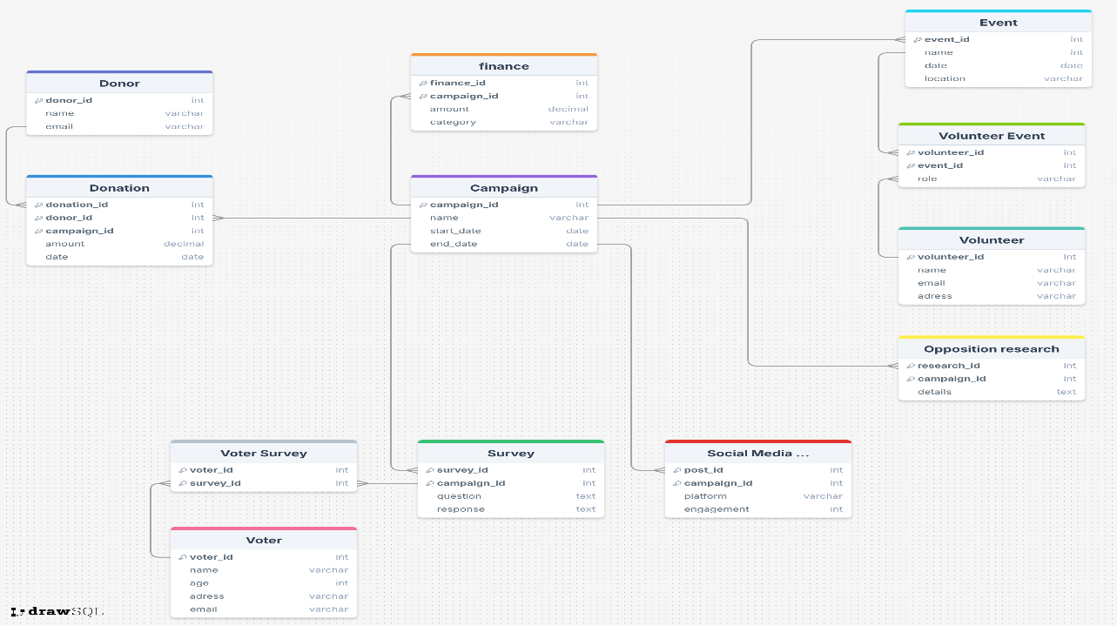

Objects
1. Donor Table
The Donor table stores information about individuals or organizations that contribute donations to political campaigns.

Table Name | Field name | Field Description | Data Type
Donor | Donor_id | Unique identifier for each donor, PK | Int
 | name | Name of the donor, NOT NULL | VARCHAR(255)
 | email | Email address of the donor, UNIQUE | VARCHAR(255)

One Donor can make multiple Donations (1:M relationship with Donation table).

Example with data

Donor_id | name | email
1 | Migle Skystimaite | miglesky@gmail.com
2 | Jane doe | Jane.doe@gmail.com

2. Donation Table
The Donation table records financial contributions made by donors to specific campaigns.

Table Name | Field name | Field Description | Data Type
Donation | Donation_id | Unique identifier for each donation, PK | Int
 | Donor_id | Donor reference, FK | Int
 | Campaign_id | Campaign reference, FK | Int
 | amount | Donation amount, NOT NULL | Decimal
 | date | Date of donation, NOT NULL | Date

Each Donation is linked to one Donor (M:1 with Donor).
Each Donation is linked to one Campaign (M:1 with Campaign).

Example with data
Donation_id | Donor_id | Campaign_id | amount | date
101 | 1 | 10 | 500.00 | 2024-01-15
102 | 2 | 11 | 300.00 | 2024-02-10

3. Campaign Table
The Campaign table represents a political campaign, storing details about the campaign and its timeline.

Table Name | Field name | Field Description | Data Type
Campaign | Campaign_id | Unique identifier for each campaign, PK | Int
 | Name | Name of the campaign, NOT NULL | VARCHAR(255)
 | Start_date | Start date of the campaign, NOT NULL | Date
 | End_Date | End date of the campaign, NOT NULL | Date

Campaign has multiple Donations (1:M with Donation).
Campaign has multiple Finance records (1:M with Campaign Finance).
Campaign has multiple Surveys (1:M with Survey).
Campaign has multiple Social Media Posts (1:M with Social Media Post).
Campaign has multiple Opposition Research records (1:M with Opposition Research).
Campaign has multiple Events (1:M with Events).

Example with data
Campaign_id | Name | Start_date | End_date
10 | 2024 Presidential | 2024-01-01 | 2024-12-01
11 | Governor Election | 2024-03-01 | 2024-11-01

4.Campaign Finance table
The Campaign Finance table tracks financial expenses related to a campaign.

Table Name | Field name | Field Description | Data Type
CampaignFinance | Finance_id | Unique identifier for each finance record, PK | Int
 | Campaign_id | Campaign reference, FK | Int
 | Amount | Amount spent | Decimal
 | Category | Category of expense | VARCHAR(255)

Each Finance record is linked to one Campaign (M:1 with Campaign).

Example with data
Financce_id | Campaign_id | Amount | Category
201 | 10 | 2000.00 | Advertising
202 | 11 | 1500.00 | Logistics

5. Event table
The Event table stores details about campaign-related events.

Table Name | Field name | Field Description | Data Type
Event | Event_id | Unique identifier for each event, PK | Int
 | Campaign_id | Unique identifier for each event, FK | Int
 | Name | Name of the event, NOT NULL | Int
 | Date | Date of the event, NOT NULL | Date
 | Location | Location of the event, NOT NULL | VARCHAR(255)

Events have multiple Volunteers (M:M through Volunteer_Event).
Each event is linked to one Campaign (M:1 through Campaign).

Example with data
Event_id | Name | Date | Location
301 | Rally in NY | 2024-05-20 | New York
302 | Debate Night | 2024-06-15 | Washington

6. Volunteer Table
The Volunteer table stores information about campaign volunteers..

Table Name | Field name | Field Description | Data Type
Volunteer | Volunteer_id | Unique identifier for each volunteer, PK | Int
 | Name | Name of the volunteer, NOT NULL | VARCHAR(255)
 | Contact_info | Contact information of the volunteer, NOT NULL | VARCHAR(255)
 | Availability | Availability of the volunteer, NOT NULL | Boolean

Volunteers participate in multiple Events (M:M through Volunteer_Event).

Example with data
Volunteer_id | Name | Contact_info | Availability
401 | Migle Skystimaite | miglesky@gmail.com | Yes
402 | Mike Ross | mike@yahoo.com | No

7. Volunteer_Event Table (Junction Table)
This table connects volunteers to events they participate in.

Table Name | Field name | Field Description | Data Type
Volunteer_Event | Volunteer_id | Unique identifier for each volunteer, FK | Int
 | Event_id | Unique identifier for each event, FK | Int
 | Role | Role of the volunteer at the event, NOT NULL | VARCHAR(255)

Many-to-Many between Volunteer and Event.

Example with data
Volunteer_id | Event_id | Role
401 | 301 | Speaker
402 | 302 | Organizer

8. Survey Table
The Survey table records survey questions and responses related to a campaign.

Table Name | Field name | Field Description | Data Type
Survey | Survey_id | Unique identifier for the survey, PK | Int
 | Campaign_id | Unique identifier for the campaign, FK | Int
 | Question | Survey question, NOT NULL | Text
 | Response | Response to the survey, NOT NULL | Text

One campaign can have multiple surveys (1:M).
A survey can be answered by multiple voters (M:M through VoterSurvey).

Example with data
Survey_id | Campaign_id | Question | Response
301 | 201 | Do you support clean energy policies? | Yes
302 | 202 | Do you think education should be free? | No

9. VoterSurvey Table
The VoterSurvey table tracks which voters participated in which surveys.

Table Name | Field name | Field Description | Data Type
Voter Survey | Voter_id | Unique identifier for the voter, FK | Int
 | Survey_id | Unique identifier for the survey, FK | Int

Many-to-Many between Voter and Survey.

Example with data
Voter_id | Survey_id
101 | 301
202 | 302

10. Opposition Research Table
The OppositionResearch table stores data about the campaign’s research on opposing candidates.

Table Name | Field name | Field Description | Data Type
OppositionResearch | Research_id | Unique identifier for the research, PK | Int
 | Campaign_id | Unique identifier for the campaign, FK | Int
 | Details | Research details, NOT NULL | Text

One campaign can have multiple research records (1:M).

Example with data
Research_id | Campaign_id | Details
501 | 201 | Competitor's policy review
502 | 202 | Environmental impact analysis

11. SocialMedia Table
The SocialMedia table tracks campaign-related social media activity.

Table Name | Field name | Field Description | Data Type
SocialMedia | Post_id | Unique identifier for each post (PK) | Int
 | Campaign_id | Campaign associated with the post (FK) | Int
 | Platform | Social media platform (e.g., Instagram, Facebook), NOT NULL | VARCHAR(255)
 | Engagement | Number of interactions (likes, shares, comments), NOT NULL | Int
 | URL | URL to the campaign social media site, NOT NULL | VARCHAR(255)

One Campaign can have multiple SocialMedia posts (1:M).
Example with data
Post_id | Campaign_id | Platform | Engagement
1201 | 201 | Facebook | 150
1202 | 202 | Instagram | 300

12. Voter Table
The Voter table stores information about individuals eligible to vote in the campaign.

Table Name | Field name | Field Description | Data Type
Voter | Voter_id | Unique identifier for each voter (PK) | Int
 | Name | Name of the voter,NOT NULL | VARCHAR(255)
 | Age | Age of the voter, NOT NULL | Int
 | Address | Residental address of the voter, NOT NULL | VARCHAR(255)
 | Email | Contact email of the voter, NOT NULL To maintain data integrity and consistency, the following constraints are applied across the database:  - Primary Key (PK): Each table has a unique primary key constraint to ensure unique identification of records.  - Foreign Key (FK): Referential integrity is enforced through foreign key constraints linking related tables.  - NOT NULL: Critical fields (such as names, emails, and dates) are required to be non-null to prevent incomplete data entries.  - CHECK: Constraints are used to enforce data validity, such as ensuring donation amounts are greater than zero.  - UNIQUE: Applied to prevent duplicate entries where necessary, such as ensuring unique email addresses for donors and volunteers. | VARCHAR(255)

A voter can participate in multiple surveys (M:M through VoterSurvey).

Example with data
Voter_id | Name | Age | Address | Email
101 | John Doe | 35 | Chicago, IL | john@gmail.com
102 | Luke Ham | 29 | New York, NY | haml@gmail.com

