Baseband Design Report

- Symbols Interleaver
The design interleaves the symbols coming from the ADC

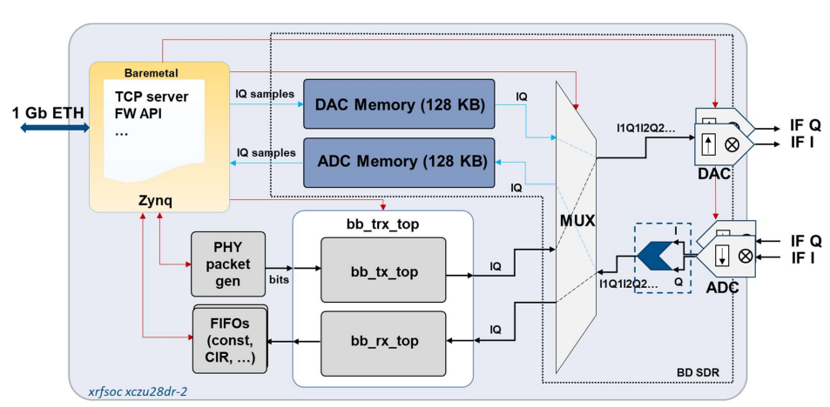

Transmitter Design
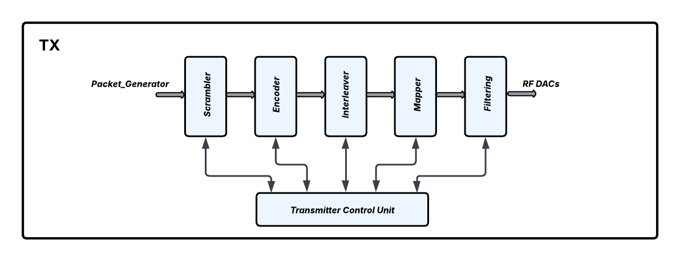

- Scrambler
The scrambler design is realized using a 32-bit Linear Feedback Shift Register, the selected Pseudo-Random Binary Sequence (PRBS) is
PRBS31 = $x^{31}+x^{28}+1$

- Encoder
The encoder design was implemented using the Xilinx Soft-Decision FEC IP, with LDPC selected as the encoding algorithm. It is fundamental that the license of the IP is uploaded in Vivado, defining the specific Linux server in use; otherwise, it does not work. The design supports running four LDPC cores in parallel with four different code rates, as well as operating in a single-core mode. The available code rates and their corresponding block sizes are:
Code Rate | Block size N (bits)
1/2 | 648
2/3 | 1296
3/4 | 1944
5/6 | 1944

The encoder supports padding, inserting a fixed pseudo-random value to fill the input block to the required size. The encoded output is then valid only for the information bits and parity bits. Moreover, for certain code rates, the SD-FEC IP truncates the last input word; therefore, to avoid data loss, the last word is padded, sending the same word twice.
- Interleaver
The Interleaver implements a rectangular interleaving process, writing in input row-wise and then reading in output column-wise. The size of the rectangular block is automatically adjusted depending on the block size N of the encoded bits from the encoder, defined as an input port in the design.
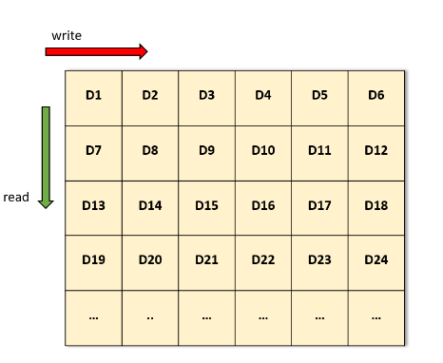
Input data: D1, D2, D3, D4, D5, D6, …
Output data: D1, D7, D13, D19, …

- Mapper
The symbol mapper design implements 8 possible modulation schemes:
Type of modulation | Modulation schemes | Bits per symbol
Phase Shift Keying  (PSK) | BPSK | 1
Phase Shift Keying  (PSK) | QPSK | 2
Amplitude and Phase Shift Keying  (APSK) | 16-APSK | 4
Amplitude and Phase Shift Keying  (APSK) | 32-APSK | 5
Amplitude and Phase Shift Keying  (APSK) | 64-APSK | 6
Quadrature Amplitude Modulation  (QAM) | 16-QAM | 4
Quadrature Amplitude Modulation  (QAM) | 32-QAM | 5
Quadrature Amplitude Modulation  (QAM) | 64-QAM | 6

- Pre-Distortion Filter
The filter design implements the typical multiply-and-accumulate operation of FIR filters. The values of the coefficients used in the design are randomly generated, so they must be adjusted depending on the specific case study.

- Polyphase Filter
The filter design works in up-sampling mode with an up-sampling factor of L = 4. It operates in a pipelined manner, processing multiple coefficients simultaneously for the different time stages of the multiply-and-accumulate operation. Additionally, in this filter, the coefficients are randomly generated, and the values need to be adjusted according to the specific case study.
- Transmitter Control Unit

The design manages the entire data transmission and packet formation; there are 3 main synchronous processes:
- Payload process, which manages the data transmission of the signal field and the data stream coming from the packet generator.
- Control Unit process, which controls the sending of the 2 preamble sequences, which are BPSK-mapped values (not filtered yet), and manages the Pilot insertion, whose values are BPSK-mapped too.
- Data Splitter process, which splits the input 32-bit vectors coming from the interleaver into 6-bit vectors.

Important: In the testbench files of the VHDL designs, the path of the input stimuli file must be changed depending on the current path otherwise, the simulation does not work.
Cadence Xcelium simulator setup in Vivado
Preparing for simulation
1. Select the supported version of Xcelium for Vivado. (i.e. For Vivado 2019.1 -> Xcelium 18.09.005 and newer versions)
2. Define the ”.cshrc ” configuration file which sets all the useful paths of Xcelium simulator and check that the installation path points to the correct version of Xcelium. Then before running Vivado, from command line source the file.
Vivado setting
- To define the installation path:
3. Select Tools > Settings > Tool Settings > 3rd Party Simulators.
4. In the 3rd Party simulators tab of the Settings dialog box, select the simulator under the Install Paths and browse to the installation path.
i.e for Xcelium 22.03 -> /ihp/ihpusr/cadence/xcelium/22.03/tools.lnx86/inca/bin
- To compile simulation libraries using Vivado IDE
5. Select Tools > Compile Simulation Libraries to open the dialog box shown in
Set the following options:
- Simulator: From the simulator drop-down menu, select a simulator.
- Language: Compiles libraries for the specified language. If this option is not specified, then the language is set to correspond with the selected simulator (above). For multi-language simulators, both Verilog and VHDL libraries are compiled.
Library: Specifies the simulation library to compile. By default, the compile_simlib command compiles all simulation libraries.
Family: Compiles selected libraries to the specified device family. All device families are generated by default.
Compiled library location: Specifies the directory path for saving the compiled library results. By default, the libraries are saved in the current working directory in Non-Project mode, and the libraries are saved in the /.cache/compile_simlib directory in Project mode.
Simulator executable path: Specifies the directory to locate the simulator executable. This option is required if the target simulator is not specified in the $PATH or %PATH% environment variable, or to override the path from the $PATH or %PATH% environment variable. If you have already set the installation path in step 4 you don’t need to define the installation path again.
6. Press compile, this process takes time.
If, after the compilation process, there are several errors for different libraries, it is possible that the initialization file for Xcelium, named cds.lib, is not defined correctly.
In this case, go to your current project folder -> simulation folder and then to the Xcelium folder. Open the cds.lib file and check if the first line of the file points to projectname.cache/compile_simlib/xcelium/cds.lib , If not , add the path manually.
7. Run the simulation, if everything is set correctly the Xcelium simulator window will pop up.

Xcelium Fault Injection Report

To run fault-injection simulations with Cadence Xcelium, execute the following four scripts:
- Compile.sh – This script compiles the VHDL/Verilog files. When running fault-injection simulations using the gate-level netlist, the path to the post-synthesis file generated by Vivado must be added. After running this script, a flt_target_dbg.list file containing all the fault_id nodes is generated.
- Elaborate.sh – This script adds the fault-injection parameters for the simulation, such as the top file and the fault-list file. Additional parameters may be included depending on the case study.
- Good_sim.sh – This script runs the fault-free (“good”) simulation. Here, the fault-injection parameters must also be specified based on the case study, such as the fault type and the input strobe file.
- Fault_sim.sh – This script runs the fault-injection campaign. It allows injecting faults into single fault nodes by specifying the corresponding fault ID from the flt_target_dbg.list file. The script is designed to launch multiple fault simulations in parallel, depending on the number of available jobs.
To retrieve the results of the fault campaigns, run the fault_print script. It is essential to specify the path to the fault work folder—usually named fault_db—generated by Xcelium.
To run all scripts with a single command, execute the run_all script.
All scripts are stored in the symbol_mapper directory located at Symbol_mapper/Symbol_mapper.sim/sim_1/behav/xcelium_FI.

