5 Zero-shot context selection with controllable risk
Revised review copy · Expected-risk predictor and selectable harm profiles
Sections 3–4 established that the native context is often unnecessarily long, but also that the best shorter window is not stable enough to treat as an ordinary classification label. The deployment question is therefore not simply which window will win? It is how much risk of degradation are we willing to accept in exchange for less context compute?
We answer that question with a zero-shot risk predictor. For every candidate window, it estimates loss relative to native context, uncertainty in that estimate, and the probability of a material error increase. Synthetic-only calibration converts these estimates into five ordered operating profiles, from Conservative to Max efficiency. A profile selects the shortest window that passes its risk threshold and otherwise abstains to native context. The result is an explicit compute–harm dial rather than a single brittle guess.

5.1 Predict risk relative to the native action
Each frozen TSFM labels a synthetic pool independently over six forecast horizons, h ∈ 16, 32, 64, 128, 512, 1024, and an 18-point context grid from 32 to 8,192 steps, truncated to the model's supported context. For synthetic series i, candidate window Lₖ, horizon h, and forecast MAE Eᵢ,ₖ,ₕ, the regression target is the log-risk relative to the model's native window,
rᵢ,ₖ,ₕ = log(Eᵢ,ₖ,ₕ / Eᵢ,native,ₕ) (1)
The regressor is fitted to this target after clipping it to [-3,3]. A separate classifier predicts a material-harm event,
bᵢ,ₖ,ₕ = 𝟙[Eᵢ,ₖ,ₕ > 1.05 · Eᵢ,native,ₕ] (2)
This relative formulation makes native context the explicit safe action and avoids asking the predictor to reproduce a noisy exact argmin. Positive risk means that the shorter window is expected to hurt; negative risk means that it is expected to improve on native context.
The predictor is deliberately lightweight. A 192-tree ExtraTrees regressor and classifier consume 94 scale-invariant features describing recent and remote summaries, autocorrelation, spectrum, regime shifts, valid-history length, forecast horizon, and candidate-window geometry. For each TSFM, the models use 12,000 synthetic training series, 2,000 disjoint synthetic calibration series, and 600,000 sampled series–window–horizon pairs. No GiftEval target, error, or model-selection signal enters fitting or calibration.
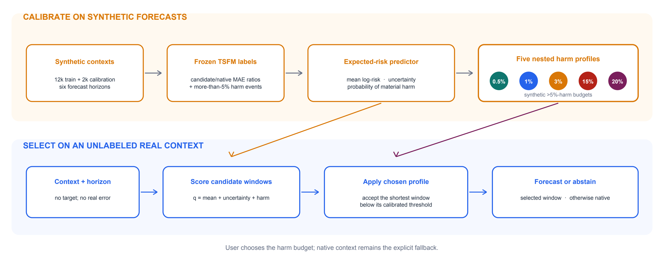
Figure 1. Risk-calibrated context selection. Offline, a frozen TSFM labels synthetic context actions relative to its native window; a lightweight predictor learns expected log-risk, uncertainty, and the probability of more than 5% harm. Synthetic calibration turns one frozen risk score into five nested profiles. At deployment, the chosen profile returns the shortest acceptable window or abstains to native context. Real forecast outcomes are revealed only for final evaluation.

5.2 Calibrate a selectable harm profile
Let μ̂ᵢ,ₖ,ₕ be predicted mean log-risk, σ̂ᵢ,ₖ,ₕ the standard deviation across regression trees, and p̂⁽⁵⁾ᵢ,ₖ,ₕ the predicted probability of the event in Equation (2). Candidate actions are ordered by the composite risk score
qᵢ,ₖ,ₕ = μ̂ᵢ,ₖ,ₕ + u · σ̂ᵢ,ₖ,ₕ + v · p̂⁽⁵⁾ᵢ,ₖ,ₕ (3)
where (u,v) is selected once for each TSFM using the balanced synthetic profile. Holding that score fixed, profile-specific thresholds are calibrated on the same disjoint synthetic split. The deployed decision is
L̂⁽ᵃ⁾ᵢ,ₕ = min{Lₖ : qᵢ,ₖ,ₕ ≤ τₐ}, or Lnative if the set is empty (4)
for profile a. For Chronos2-Base, calibration selects (u,v)=(0,0.5), so the deployed score is the predicted log-error ratio plus one half of the predicted probability of more than 5% harm. This makes the safety preference explicit without changing the shortest-acceptable-window decision rule.
Because a looser profile raises the accepted-risk threshold, the profiles are nested: increasing the harm budget can only retain or shorten the chosen context. Calibration constrains both the rate of instances harmed by more than 5% and the mean error ratio. The five budgets and their real zero-shot operating points are reported together in Table 1.
Table 1. The calibrated compute–harm dial. Budget columns are constraints on the disjoint synthetic calibration split. Real columns aggregate 97 GiftEval cells for each of 11 TSFMs: coverage and FLOPs saved are macro averages across models, harm is pooled across model–instance evaluations, and ΔMASE is the change implied by the geometric mean of the 11 cell-geometric MASE ratios. Positive ΔMASE denotes improvement.
Profile | Harm budget | Mean-ratio cap | Coverage | FLOPs saved | Real harm >5% | ΔMASE
Conservative | 0.5% | 1.000 | 6.43% | 4.77% | 0.70% | -0.015%
Balanced | 1.0% | 1.001 | 17.77% | 9.04% | 1.54% | -0.014%
Aggressive | 3.0% | 1.005 | 29.77% | 19.17% | 3.01% | -0.045%
Efficiency | 15.0% | 1.040 | 49.21% | 45.43% | 8.52% | -0.401%
Max efficiency | 20.0% | 1.070 | 56.01% | 52.57% | 11.15% | -0.795%
​
The central result is the ordering of these operating points. Moving from the Conservative to the Max-efficiency profile increases average theoretical TSFM FLOPs savings from 4.77% to 52.57%, while the pooled rate of instances whose MASE worsens by more than 5% rises from 0.70% to 11.15%. The corresponding model-geometric MASE change is 0.795% worse than native at the most aggressive endpoint. The risk predictor therefore exposes a useful continuum: deployments can preserve native behavior almost everywhere, or deliberately accept more tail risk to unlock substantially more context reduction.
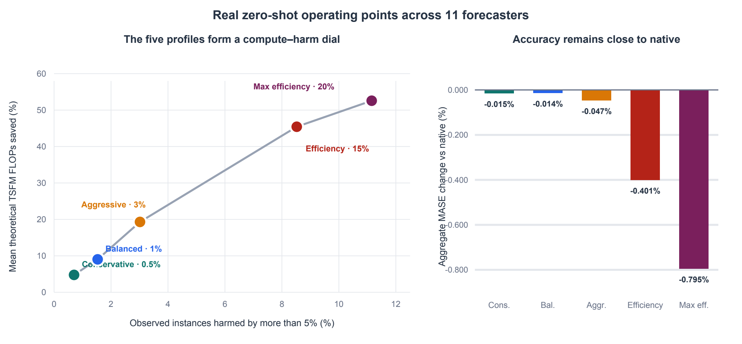
Figure 2. Aggregate real-data behavior of the five synthetic-calibrated profiles. Left: mean theoretical TSFM FLOPs saved versus pooled incidence of more than 5% harm. Right: aggregate MASE stays close to native while profiles move along the compute–harm curve. The labels show synthetic harm budgets; they are calibration targets, not real-domain guarantees.

5.3 The same dial behaves differently across forecasters
The average curve hides substantial model dependence (Table 2 and Figure 3). At the Max-efficiency profile, Chronos2-Base and Chronos2-Synth save 77.44% and 74.18% of theoretical FLOPs with 12.45% and 15.48% observed harm, respectively. Chronos2-Small saves 64.73% with a 0.563% aggregate MASE cost. Moirai2-Small reaches 70.13% savings at 11.16% harm. ChronosBolt-Base is much more cautious, saving 20.71% with a 0.070% aggregate MASE cost.
The Chronos2-Base result is also meaningful across model sizes. Under Max efficiency, its cell-geometric MASE is 0.9995, compared with 1.0176 for full-context Chronos2-Small, while its selected theoretical compute is 77.4% below the full-context Small run. On this benchmark, the risk-controlled Base model therefore beats full Small in both aggregate accuracy and theoretical compute, making Max efficiency the strongest efficiency endpoint rather than the safest operating default.
Other models are naturally conservative. Toto and ChronosBolt abstain almost entirely under the conservative profile. Sundial shortens many instances but realizes little theoretical FLOPs reduction because many accepted changes are small relative to its native compute profile. These cases are not failures of the abstention mechanism: they show that the same harm target can imply very different amounts of useful compression.
Table 2. Per-forecaster operating points on GiftEval. The balanced and Max-efficiency columns report theoretical TSFM FLOPs saved and the instance rate with more than 5% MASE harm. The final column reports the cell-geometric MASE change under the Max-efficiency profile; positive is better.
Model | Balanced FLOPs | Balanced harm | Max-eff. FLOPs | Max-eff. harm | ΔMASE
Chronos2-Base | 18.05% | 0.96% | 77.44% | 12.45% | -1.368%
Chronos2-Small | 12.44% | 2.13% | 64.73% | 9.20% | -0.563%
Chronos2-Synth | 15.05% | 0.96% | 74.18% | 15.48% | -1.301%
ChronosBolt-Base | 1.95% | 0.39% | 20.71% | 7.89% | -0.070%
FlowState-R1 | 18.90% | 5.58% | 48.30% | 10.30% | -0.844%
Moirai2-Small | 12.15% | 1.00% | 70.13% | 11.16% | -0.352%
PatchTST-FM-R1 | 8.45% | 1.05% | 49.89% | 7.58% | -0.747%
Sundial-Base-128M | 0.72% | 3.85% | 4.93% | 16.15% | -0.455%
TimesFM2.5-200M | 6.87% | 0.39% | 70.62% | 11.27% | -0.900%
TiRex2 | 4.82% | 0.45% | 53.34% | 11.44% | -1.243%
Toto-2.0-313m | 0.01% | 0.01% | 44.02% | 9.77% | -0.914%
​
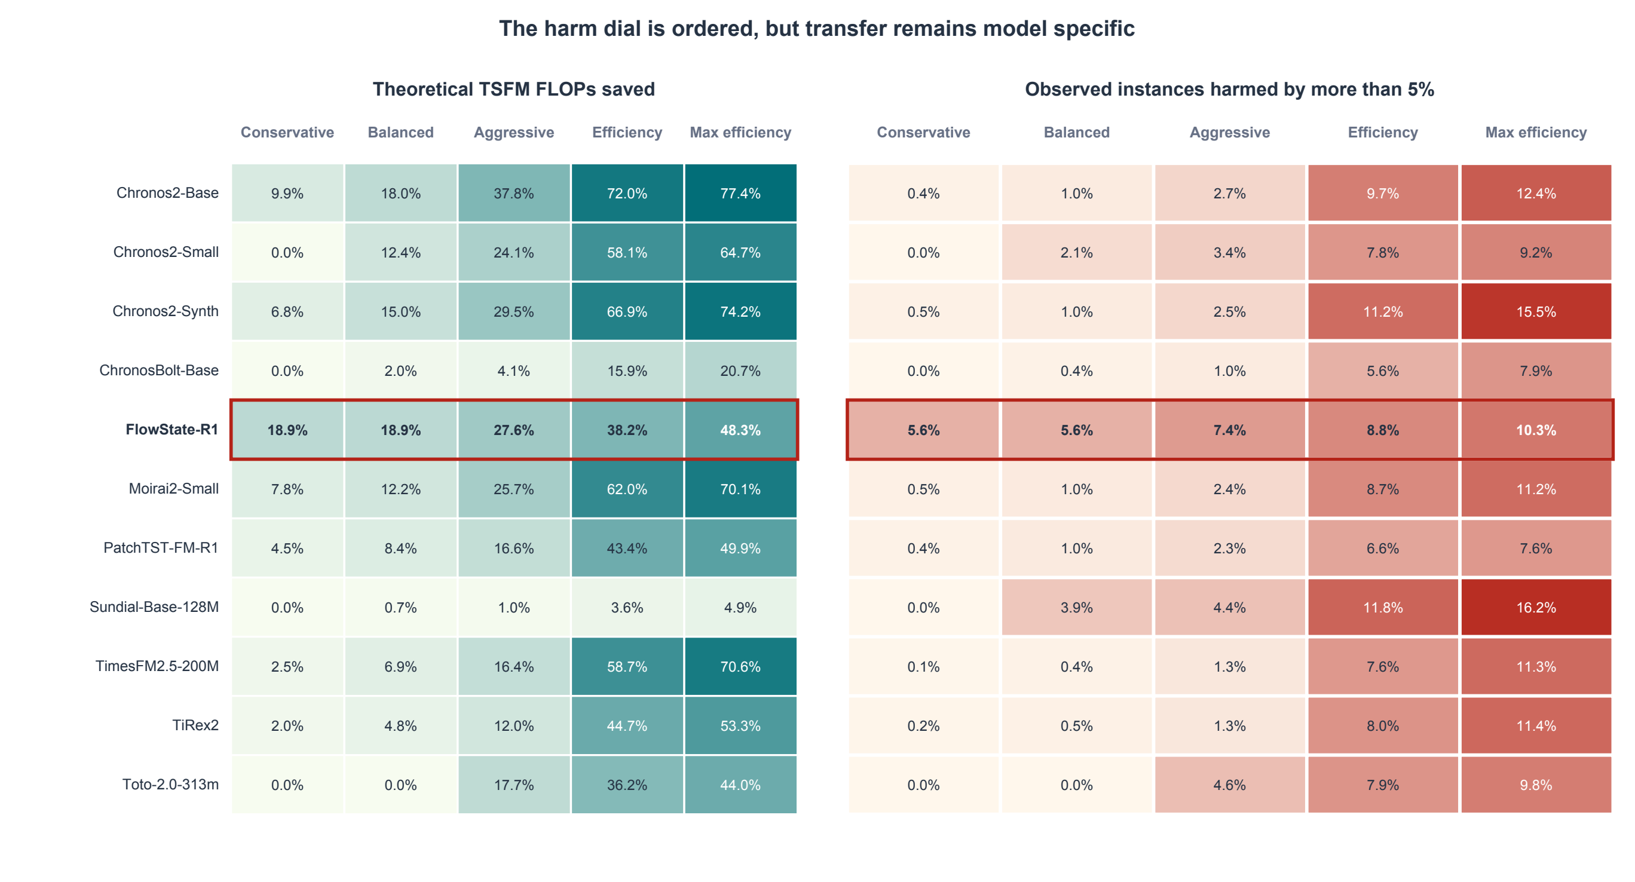
Figure 3. How the risk dial transfers across forecasters. Each row is one independently trained predictor and each column is a harm profile. Cells show theoretical FLOPs saved (left) and observed incidence of more than 5% MASE harm (right). The nested profiles produce an ordered trade-off, but the attainable savings and calibration error remain model specific.

5.4 Where the efficiency profiles help–-and where they fail
The model-wide result is not uniform across recognizable data domains. Table 3 groups the Chronos2-Base cells by dataset family. Here ΔMASE is relative to full-context Chronos2-Base (negative is better), context saved pools selected and native context tokens across all family instances, and shortened is the fraction that does not abstain.
Table 3. Dataset-level behavior of the Chronos2-Base Max-efficiency profile. Large aggregate context savings can coexist with high instance-level tail risk. M4 and COVID Deaths show the opposite regime: selective or complete abstention.
Dataset family | ΔMASE | Context saved | Shortened | Harm >5%
M4 | -1.12% | 11.5% | 5.1% | 1.4%
Electricity | +0.22% | 80.7% | 97.0% | 18.1%
Solar | +0.64% | 72.1% | 95.4% | 23.2%
Shenzhen Taxi | +0.79% | 69.0% | 99.1% | 17.8%
ETTm1 | +1.01% | 75.3% | 97.0% | 27.5%
Jena Weather | +1.89% | 76.7% | 97.1% | 35.6%
ETTm2 | +2.06% | 77.3% | 95.9% | 25.8%
Seattle Traffic | +2.39% | 76.1% | 97.5% | 30.8%
COVID Deaths | +0.00% | 0.0% | 0.0% | 0.0%
​
M4 is the cleanest reliability result. Short histories make the policy abstain on 94.9% of instances; the remaining selective shortening reduces aggregate MASE by 1.12%. COVID Deaths triggers complete abstention, the intended response when no shorter action appears acceptable. Electricity is the strongest efficiency result: 80.7% of context is removed for only a 0.22% aggregate MASE cost. Solar is also attractive in aggregate, with 72.1% context reduction for a 0.64% MASE cost.
The same aggregates expose a reliability gap. ETT and Jena Weather are horizon sensitive: some long- or medium-horizon cells improve while their short-horizon counterparts degrade. For example, ETTm1 hourly-medium improves by about 2%, whereas ETTm1 hourly-short worsens by about 5.3%. Jena Weather 10-minute long improves by 2.6%, but its short-horizon cell worsens by 9.8%. Seattle Traffic is the weakest familiar family, combining 76.1% context reduction with a 2.39% aggregate MASE increase and 30.8% instance-level harm.
The Efficiency profile is a more credible operational choice when individual series reliability matters. It retains most of the compute benefit on Electricity (75.9% context saved) while improving MASE by 0.27%. Relative to Max efficiency, it also lowers MASE costs on ETTm1 (0.22% versus 1.01%), ETTm2 (1.04% versus 2.06%), Jena Weather (1.67% versus 1.89%), and Seattle Traffic (1.73% versus 2.39%). Solar is the exception: Max efficiency has the lower aggregate MASE cost (0.64% versus 1.22%) despite its looser threshold. M4 remains selective and improves by 1.47%. Thus Max efficiency is the efficiency-first endpoint, whereas Efficiency is the stronger default for reliability-sensitive deployment.
These discrete profiles are operating-point samples, not the final frontier. We will next evaluate the dense threshold sweep and retain only nondominated accuracy–compute points to construct a Pareto front. That analysis will show whether the named profiles lie near the attainable frontier or whether better thresholds dominate them.

5.5 Calibration is a control target, not a guarantee
The profiles are calibrated without real labels, so their budgets should be read as deployment controls rather than distribution-free guarantees. This distinction is visible in the balanced profile: its synthetic harm budget is 1%, whereas pooled real harm is 1.54%. FlowState-R1 is the clearest calibration failure. Even its conservative profile produces 5.58% real harm and a 0.330% aggregate MASE degradation, despite satisfying the 0.5% synthetic calibration target. For this model, native context remains the appropriate default until calibration data better matches the deployment distribution.
Two compute qualifications also remain. Reported savings cover the TSFM forecast stage and do not yet include feature extraction or tree inference. They are theoretical proxies: TiRex2 internally pads inputs to a fixed length, and the quadratic proxy is only approximate for the linear-state-space FlowState architecture. These two models therefore require measured latency and memory profiling before their apparent context savings are interpreted as deployment speedups.

5.6 Implications
The useful-context problem is better posed as selective risk management than as exact window prediction. Relative-risk targets align learning with the native action, abstention prevents forced shortening, and calibrated profiles make the deployment preference explicit. Across 11 forecasters, this design turns one zero-shot predictor into a family of operating points spanning roughly 5–53% average theoretical FLOPs savings. Its main limitation is equally informative: synthetic calibration does not transfer uniformly across architectures. The practical next step is therefore not a more aggressive argmin predictor, but stronger calibration diagnostics and model-specific safeguards around a user-chosen harm budget.

