5 The zero-shot useful-context predictor
Manuscript review copy · Full section with figures and tables
Sections 3–4 established both the opportunity and the difficulty of context selection. Useful context is heterogeneous, often shorter than the available history, and responsive to genuine distant dependencies; however, its operational boundary is noisy and does not coincide with a literal last-used timestep. We therefore predict the forecast-error response over a discrete context grid, rather than trying to regress a latent causal memory length. The resulting selector is zero-shot with respect to the real benchmark: it is trained only on synthetic series labeled offline by a frozen TSFM, and it receives no GiftEval series or forecast outcomes during training or checkpoint selection.

5.1 Synthetic supervision from a frozen forecaster
We generate a shared pool of 50,000 synthetic series with one to four regimes, and each frozen TSFM labels that pool independently. The generator varies level, scale, trend, autoregressive dynamics, seasonal period and waveform, abrupt or gradual transitions, and impulse outliers. Ten percent of the pool contains shorter genuine histories, left-padded only at the predictor input. The common pool is 15,360 steps wide; predictors for models capped at 8,192 steps consume its most recent 8,192 values.
The frozen TSFM labels each series at every supported context action Lₖ ∈ Gₘ and forecast horizon
h ∈ H = {16, 32, 64, 128, 512, 1024} (1)
One longest-horizon forecast supplies prefix errors for the shorter horizons. For Chronos2-Small, Gₘ contains 18 suffix lengths from 32 to 8,192. Other models use the same base grid truncated at their supported context, with an off-grid native cap added where necessary. The label is the complete MAE surface
E⁽ᵐ⁾ᵢ,ₖ,ₕ = (1/h) ∑ₜ₌₁ʰ | yᵢ,ₜ − fₘ(xᵢ,₋Lₖ:)ₜ | (2)
not a generator parameter. Thus the supervisor includes the forecaster's architecture, preprocessing, and failure modes. A separate labeled surface and a separate selector are built for each TSFM; the main experiment does not assume that the useful-context policy transfers across forecasters.
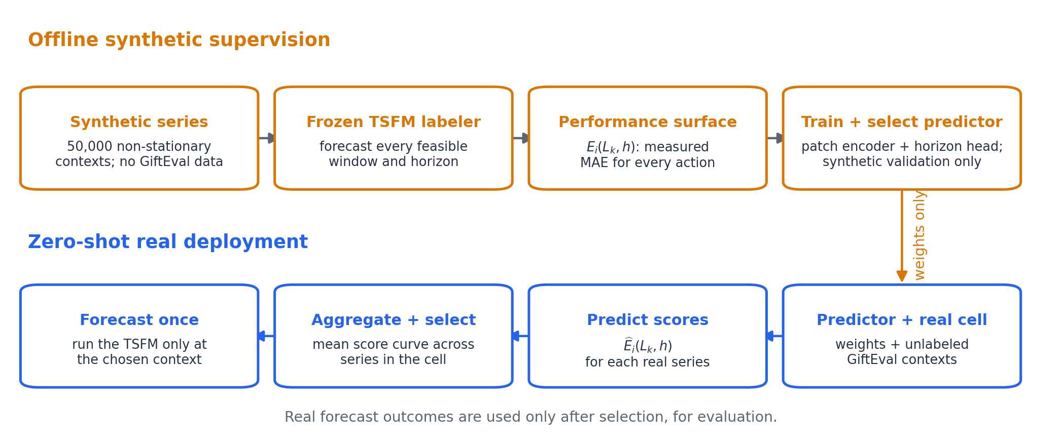
Figure 1. Training and deployment of the zero-shot selector. Offline, a frozen TSFM measures the error surface of 50,000 synthetic series over context and horizon. At deployment, the learned predictor scores every feasible window from unlabeled real contexts; scores are averaged within a dataset–term cell and one context action is selected. GiftEval forecast outcomes are revealed only afterward for evaluation.

5.2 Horizon-conditioned curve prediction
The input series is divided into non-overlapping patches and projected into a latent sequence. A learned summary token, augmented by an embedding of the requested horizon, is prepended before the sequence encoder. Its final state is mapped to one score per candidate context. We study two encoders under the same input and output interface: a low-capacity Patch-Transformer and a bidirectional Mamba stack. The constrained search uses patch lengths 64 or 128, width 128, and two or four layers. Mamba is linear in the number of patch tokens, whereas dense self-attention is quadratic.
For curve regression, each synthetic error curve is standardized over its valid windows,
zᵢ,ₖ,ₕ = (Eᵢ,ₖ,ₕ − μᵢ,ₕ)/(σᵢ,ₕ + 10⁻⁸), μᵢ,ₕ = |Vᵢ,ₕ|⁻¹ ∑ₖ∈Vᵢ,ₕ Eᵢ,ₖ,ₕ (3)
where Vᵢ,ₕ contains the windows that the TSFM can serve. Standardization removes arbitrary error level and scale while preserving the argmin. During training, a random subset of input patches is masked and a second head reconstructs their raw values. The loss is
L = λcurve · [∑ᵢ,ₖ,ₕ Mᵢ,ₖ,ₕ(ẑᵢ,ₖ,ₕ − zᵢ,ₖ,ₕ)² / ∑ᵢ,ₖ,ₕ Mᵢ,ₖ,ₕ] + λrec · MSEmasked(x̂, x), (λcurve, λrec) = (1, 0.5) (4)
with M masking unsupported labels. The auxiliary reconstruction objective regularizes the representation; it is not evaluated at inference.
We also test decision-focused targets on Chronos2-Small. The strongest is a soft top-k classifier in which the best, second-best, and third-best windows receive independent binary targets 1, 1/2, and 1/4. Additional ablations predict calibrated risk relative to full context, adjacent pairwise preferences, or the set of actions within 3% of the row oracle. All variants retain the same synthetic-only split: 45,000 training and 5,000 validation series. Thirty random-search trials are ranked by mean synthetic validation regret,
Rval = Eᵢ,ₕ [(Eᵢ,k̂ᵢ,ₕ − minₖ∈Vᵢ,ₕ Eᵢ,ₖ,ₕ) / minₖ∈Vᵢ,ₕ Eᵢ,ₖ,ₕ] (5)
For the selected Chronos2-Small curve model, Mamba uses 64-step patches, width 128, and four bidirectional layers; its synthetic validation regret is 0.1956.

5.3 Zero-shot decision protocol
At real-data inference, the predictor emits a score vector ŝᵢ,ₕ for each forecast instance. We use the same cell-shared decision granularity as the principal oracle in Section 3: for dataset–term cell c, the curve-regression policy selects
L̂c = Lk̂c, k̂c ∈ arg minₖ∈Vc (1/nc) ∑ᵢ∈c ŝᵢ,ₖ,ₕc (6)
The classification variant replaces the argmin by the maximum mean predicted probability. This aggregation uses cell membership and input contexts, but neither targets nor realized forecast errors. It is therefore a batch-level zero-shot policy, not a fully online per-series rule. After selecting L̂c, the TSFM is run at that context and scored on the same 97 GiftEval cells and 371,330 instances used in Section 3.
Accuracy follows the normalized-MASE definition in Section 3. The main compute number is the cell-balanced sum of theoretical TSFM FLOPs, matching the oracle analysis; measured time sums cached TSFM forward-pass timings. Unless stated otherwise, neither number includes selector inference, which we audit separately below.

5.4 Proof of concept on Chronos2-Small
Table 1 reports every decision target evaluated end-to-end on Chronos2-Small. Native context obtains normalized MASE 0.726708. The Mamba curve predictor lowers it to 0.724344, a 0.325% relative improvement, while saving 56.49% of cell-balanced theoretical TSFM FLOPs and 52.62% of measured TSFM forward time. The soft top-k classifier gives the best zero-shot accuracy, 0.722412 (0.591% better than native), but adopts a more conservative compute point with 27.89% FLOPs saved. The two targets therefore expose a genuine operating trade-off: learning the response-curve shape favors aggressive shortening, whereas rank-weighted classification better protects forecast quality.
Table 1. Synthetic-only decision objectives on Chronos2-Small. Positive Δ denotes a relative improvement in normalized MASE over native context. FLOPs are cell-balanced theoretical TSFM costs; time is measured TSFM forward time. Both exclude selector inference. The cell oracle uses GiftEval outcomes and is shown only as diagnostic headroom.
Policy | nMASE | Δ | FLOPs saved | Time saved | Wins / 95
Native/full | 0.726708 | – | 0.00% | 0.00% | –
Mamba curve | 0.724344 | +0.325% | 56.49% | 52.62% | 54
Soft top-k classification | 0.722412 | +0.591% | 27.89% | 39.61% | 46
Risk-aware | 0.726155 | +0.076% | 57.80% | 51.27% | 56
Adjacent pairwise | 0.725725 | +0.135% | 54.24% | 39.62% | 58
3% acceptable set | 0.723630 | +0.423% | 26.39% | 32.24% | 46
Cell-shared accuracy oracle | 0.704681 | +3.031% | 53.88% | – | 77
​
The count of cell wins does not determine the aggregate ranking. Pairwise learning beats native in 58 of the 95 selection-eligible cells, more than any other learned target, yet its normalized-MASE gain is only 0.135%. A small number of larger errors outweigh many small improvements. Conversely, the classification policy wins in fewer than half of eligible cells but limits the aggregate harm tail more effectively.
Figure 2 places the learned operating points next to selected points from the hindsight oracle frontier. At comparable compute, the Mamba curve remains 2.78% worse than the oracle; the classification point is 2.52% above the minimum-MASE oracle. Candidate-window coverage is therefore not the bottleneck. The unresolved problem is predicting which region of the measured response surface will transfer from synthetic to real data.
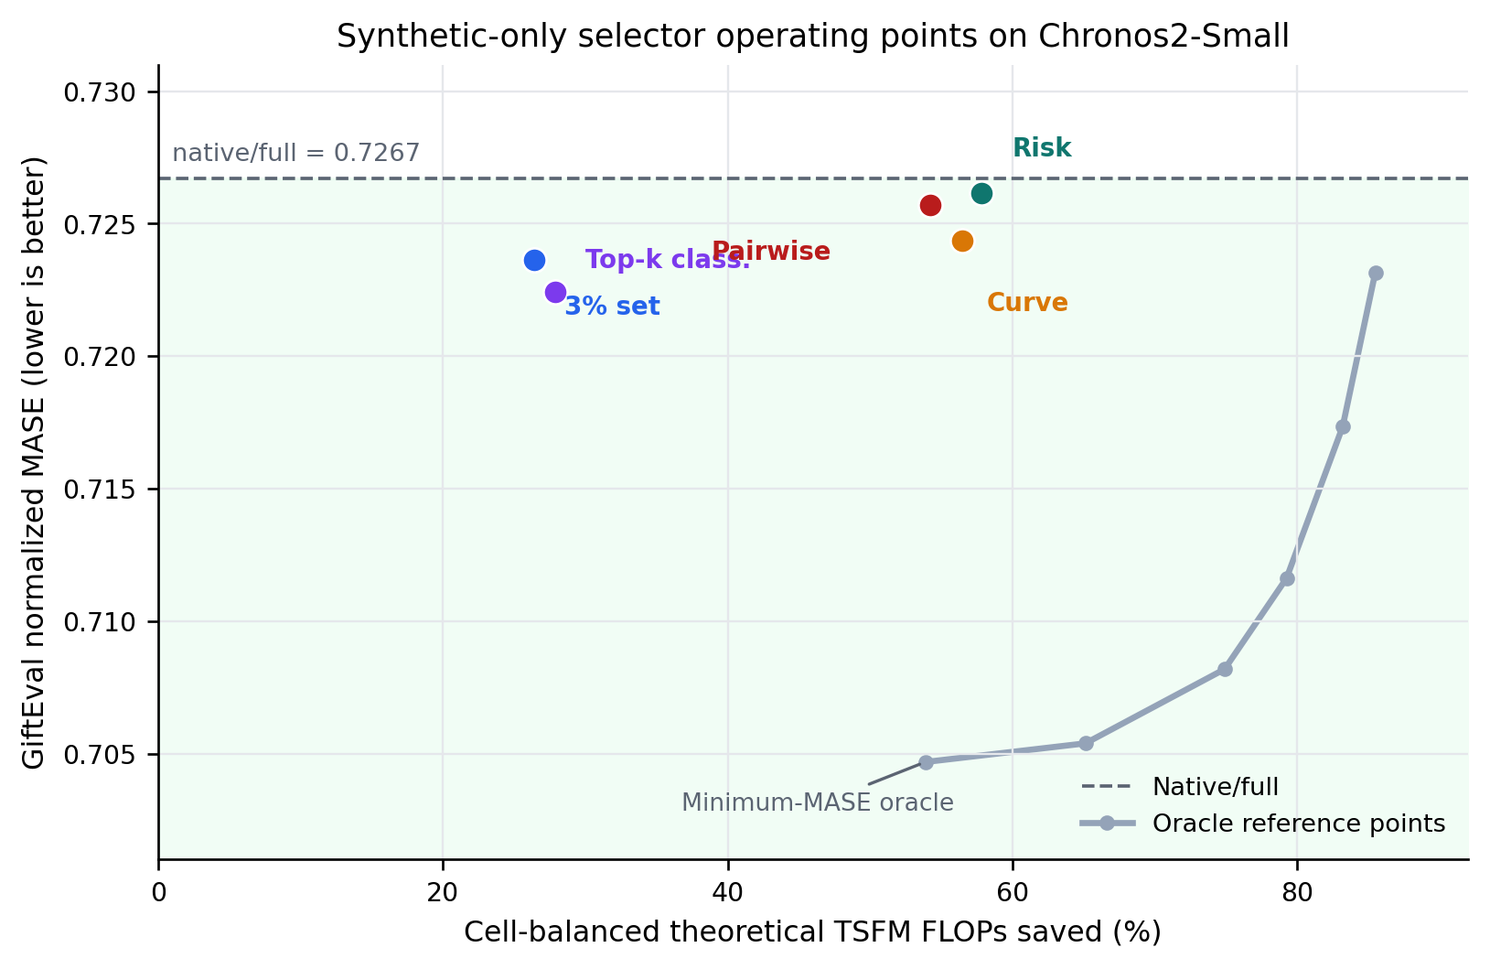
Figure 2. Accuracy–compute locations of the five synthetic-only Chronos2-Small selectors. The gray line joins selected supported oracle reference points and is not an attainable zero-shot curve. Green shading marks accuracy better than native/full. Curve regression and soft top-k classification occupy complementary compute and accuracy regimes.

5.5 Cross-model scope and the calibration gap
We next repeat curve-regression training independently for 11 TSFMs, keeping the real evaluation cohort fixed. The result is mixed (Table 2). Mamba improves native accuracy for Chronos2-Small and Moirai2-Small. The latter is the strongest result: normalized MASE falls from 0.737778 to 0.731958 (0.789%) while theoretical TSFM FLOPs fall by 65.17%. The remaining nine Mamba selectors reduce theoretical context compute but worsen normalized MASE, with relative degradations from 0.256% to 1.906%.
Table 2. Zero-shot bidirectional-Mamba curve predictor across 11 TSFMs. Each row uses a separately labeled synthetic pool and a separately selected checkpoint. Positive Δ is better than native. FLOPs savings are cell-balanced TSFM forecast costs and exclude predictor inference.
Model | Native nMASE | Predicted nMASE | Δ | FLOPs saved
Chronos2-Base | 0.704738 | 0.706544 | -0.256% | 32.66%
Chronos2-Small | 0.726708 | 0.724344 | +0.325% | 56.49%
Chronos2-Synth | 0.735228 | 0.738399 | -0.431% | 34.59%
ChronosBolt-Base | 0.809586 | 0.820556 | -1.355% | 27.48%
FlowState-R1 | 0.709001 | 0.713912 | -0.693% | 27.28%
Moirai2-Small | 0.737778 | 0.731958 | +0.789% | 65.17%
PatchTST-FM-R1 | 0.704527 | 0.717957 | -1.906% | 22.98%
Sundial-Base-128M | 0.750750 | 0.756259 | -0.734% | 17.63%
TiRex2 | 0.696689 | 0.709750 | -1.875% | 31.41%
TimesFM2.5-200M | 0.705040 | 0.713009 | -1.130% | 46.86%
Toto-2.0-313m | 0.703999 | 0.707562 | -0.506% | 15.99%
​
Changing the backbone does not remove the domain gap (Figure 3). The low-cost Patch-Transformer also improves two of 11 models, Moirai and Sundial, while its worst degradation is 3.01% on PatchTST-FM. The identity of the successful models changes, so neither encoder dominates uniformly. These results support a narrower claim than the single-model proof of concept: synthetic curve supervision contains transferable signal, but its calibration is strongly forecaster dependent.
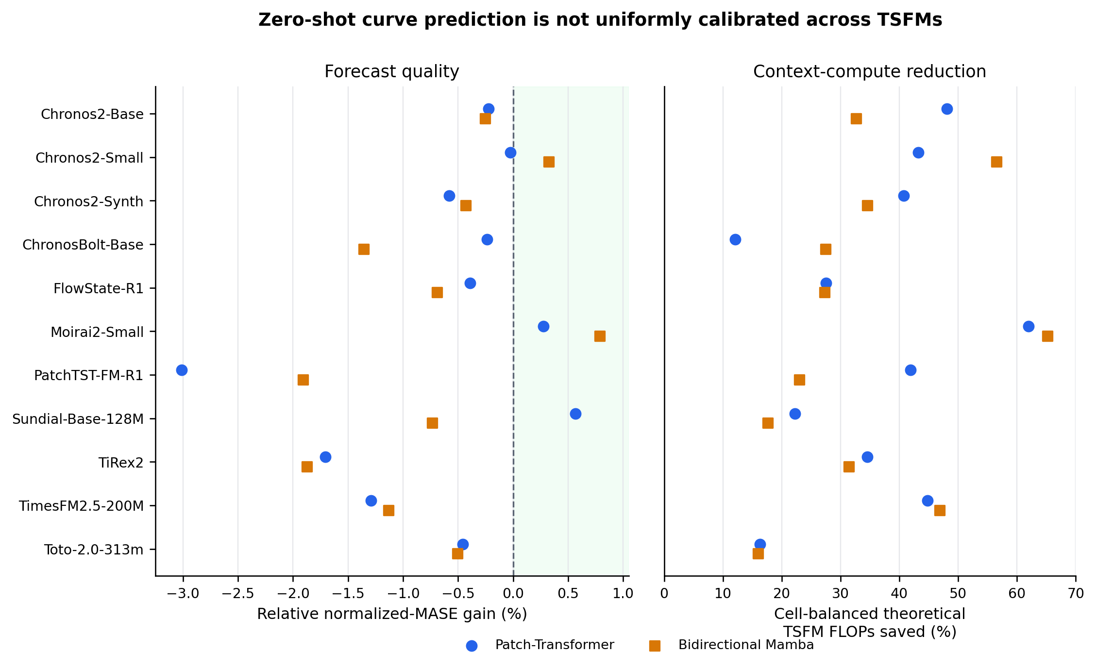
Figure 3. Zero-shot curve prediction across 11 TSFMs. The left panel shows relative normalized-MASE gain over native context (positive is better); the right shows cell-balanced theoretical TSFM FLOPs saved. Both the Patch-Transformer and Mamba predictors shorten context broadly, but neither is uniformly accuracy-safe. TiRex internally pads to a fixed context, so its theoretical shortening proxy should not be interpreted as realized hardware savings.

Checkpoint robustness.
Synthetic validation regret is an imperfect model-selection proxy. For the five best Chronos2-Small Mamba checkpoints, real normalized MASE ranges from 0.722221 to 0.732506 (mean 0.726533, standard deviation 0.003881); three of five beat native. The real-best checkpoint is ranked third on synthetic regret, while the synthetic runner-up is the worst on real data. The five Patch-Transformer checkpoints are more concentrated (standard deviation 0.001612), but their synthetic winner is the only one that does not improve native. The headline checkpoint is therefore reproducible as a fixed synthetic selection rule, but the rule is not a reliable surrogate for real-world ranking.

Selector overhead.
The selected Mamba predictors contain 0.53–1.00 million parameters and require 0.033–0.241 GMAC per series in the analytic proxy. Against one maximum-window TSFM call at horizon 48, this is 0.092%–2.355% across the 11 models (mean 0.566%). The fraction can be larger for cells whose native history is much shorter than the model maximum. Consequently, the FLOPs and timing values above should be read as savings in the forecasting backbone, not as a measured end-to-end latency claim; a deployment study must include predictor batching, data transfer, and aggregation.

5.6 What the zero-shot result establishes
The learned selector establishes that useful-context behavior is predictable zero-shot in at least some forecaster–domain pairs. On Chronos2-Small, two synthetic-only objectives improve real normalized MASE while occupying distinct accuracy–compute regimes; on Moirai, independent curve training produces a still larger gain. This is non-trivial because no real error curve is observed at selection time.
The cross-model failures are equally informative. First, synthetic validation regret does not reliably rank real checkpoints. Second, raw per-instance score curves are noisier than their unlabeled cell consensus, so the present policy requires batch-level aggregation. Third, a separate TSFM must label the synthetic pool for every forecaster, making the expensive offline sweep part of the method's cost. Finally, the selector has no formal safety guarantee: a majority of small cell wins can coexist with a worse aggregate because rare shortening errors have heavy consequences.
The appropriate conclusion is therefore a calibrated proof of concept, not a universal context controller. The next methodological step is to align synthetic and real decision margins using clean validation origins, predict sets of regret-bounded actions instead of brittle exact argmins, and expose a native-context fallback when confidence is low. Until such calibration holds across forecasters, native context remains the safe default outside the models and operating points validated here.

