5 The zero-shot useful-context predictor
Revised review copy · Stronger results flow and redesigned tables
Sections 3–4 showed that the best context is neither fixed nor directly observable: it varies across forecasting problems, responds to genuine distant dependencies, and can trade accuracy against substantial computation. This section turns that diagnostic opportunity into a selection problem. Instead of estimating a latent memory length, we learn the forecast-error response over a discrete context grid and choose an operating point from the predicted curve.
The key question is whether that response can be learned without real-domain error curves. Our selector is trained only on synthetic series labeled by a frozen TSFM; no GiftEval series or forecast outcomes enter training or checkpoint selection. We first establish the accuracy–compute trade-off on Chronos2-Small, then test whether the same synthetic-supervision recipe remains calibrated across 11 forecasters.

5.1 Synthetic supervision from a frozen forecaster
We generate a shared pool of 50,000 synthetic series with one to four regimes, and each frozen TSFM labels that pool independently. The generator varies level, scale, trend, autoregressive dynamics, seasonal period and waveform, abrupt or gradual transitions, and impulse outliers. Ten percent of the pool contains shorter genuine histories, left-padded only at the predictor input. The common pool is 15,360 steps wide; predictors for models capped at 8,192 steps consume its most recent 8,192 values.
The frozen TSFM labels each series at every supported context action Lₖ ∈ Gₘ and forecast horizon
h ∈ H = {16, 32, 64, 128, 512, 1024} (1)
One longest-horizon forecast supplies prefix errors for the shorter horizons. For Chronos2-Small, Gₘ contains 18 suffix lengths from 32 to 8,192. Other models use the same base grid truncated at their supported context, with an off-grid native cap added where necessary. The label is the complete MAE surface
E⁽ᵐ⁾ᵢ,ₖ,ₕ = (1/h) ∑ₜ₌₁ʰ | yᵢ,ₜ − fₘ(xᵢ,₋Lₖ:)ₜ | (2)
not a generator parameter. Thus the supervisor includes the forecaster's architecture, preprocessing, and failure modes. A separate labeled surface and a separate selector are built for each TSFM; the main experiment does not assume that the useful-context policy transfers across forecasters.
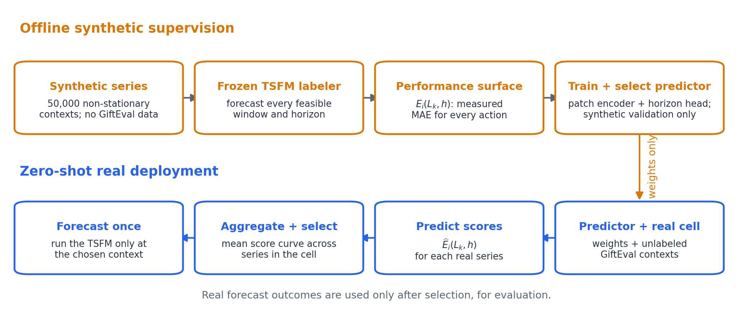
Figure 1. Training and deployment of the zero-shot selector. Offline, a frozen TSFM measures the error surface of 50,000 synthetic series over context and horizon. At deployment, the learned predictor scores every feasible window from unlabeled real contexts; scores are averaged within a dataset–term cell and one context action is selected. GiftEval forecast outcomes are revealed only afterward for evaluation.

5.2 Horizon-conditioned curve prediction
The input series is divided into non-overlapping patches and projected into a latent sequence. A learned summary token, augmented by an embedding of the requested horizon, is prepended before the sequence encoder. Its final state is mapped to one score per candidate context. We study two encoders under the same input and output interface: a low-capacity Patch-Transformer and a bidirectional Mamba stack. The constrained search uses patch lengths 64 or 128, width 128, and two or four layers. Mamba is linear in the number of patch tokens, whereas dense self-attention is quadratic.
For curve regression, each synthetic error curve is standardized over its valid windows,
zᵢ,ₖ,ₕ = (Eᵢ,ₖ,ₕ − μᵢ,ₕ)/(σᵢ,ₕ + 10⁻⁸), μᵢ,ₕ = |Vᵢ,ₕ|⁻¹ ∑ₖ∈Vᵢ,ₕ Eᵢ,ₖ,ₕ (3)
where Vᵢ,ₕ contains the windows that the TSFM can serve. Standardization removes arbitrary error level and scale while preserving the argmin. During training, a random subset of input patches is masked and a second head reconstructs their raw values. The loss is
L = λcurve · [∑ᵢ,ₖ,ₕ Mᵢ,ₖ,ₕ(ẑᵢ,ₖ,ₕ − zᵢ,ₖ,ₕ)² / ∑ᵢ,ₖ,ₕ Mᵢ,ₖ,ₕ] + λrec · MSEmasked(x̂, x), (λcurve, λrec) = (1, 0.5) (4)
with M masking unsupported labels. The auxiliary reconstruction objective regularizes the representation; it is not evaluated at inference.
We also test decision-focused targets on Chronos2-Small. The strongest is a soft top-k classifier in which the best, second-best, and third-best windows receive independent binary targets 1, 1/2, and 1/4. Additional ablations predict calibrated risk relative to full context, adjacent pairwise preferences, or the set of actions within 3% of the row oracle. All variants retain the same synthetic-only split: 45,000 training and 5,000 validation series. Thirty random-search trials are ranked by mean synthetic validation regret,
Rval = Eᵢ,ₕ [(Eᵢ,k̂ᵢ,ₕ − minₖ∈Vᵢ,ₕ Eᵢ,ₖ,ₕ) / minₖ∈Vᵢ,ₕ Eᵢ,ₖ,ₕ] (5)
For the selected Chronos2-Small curve model, Mamba uses 64-step patches, width 128, and four bidirectional layers; its synthetic validation regret is 0.1956.

5.3 Zero-shot decision protocol
At real-data inference, the predictor emits a score vector ŝᵢ,ₕ for each forecast instance. We use the same cell-shared decision granularity as the principal oracle in Section 3: for dataset–term cell c, the curve-regression policy selects
L̂c = Lk̂c, k̂c ∈ arg minₖ∈Vc (1/nc) ∑ᵢ∈c ŝᵢ,ₖ,ₕc (6)
The classification variant replaces the argmin by the maximum mean predicted probability. This aggregation uses cell membership and input contexts, but neither targets nor realized forecast errors. It is therefore a batch-level zero-shot policy, not a fully online per-series rule. After selecting L̂c, the TSFM is run at that context and scored on the same 97 GiftEval cells and 371,330 instances used in Section 3.
Accuracy follows the normalized-MASE definition in Section 3. The main compute number is the cell-balanced sum of theoretical TSFM FLOPs, matching the oracle analysis; measured time sums cached TSFM forward-pass timings. Unless stated otherwise, neither number includes selector inference, which we audit separately below.

5.4 Accuracy–compute operating points
Chronos2-Small provides the clearest test of whether synthetic supervision can recover a useful real-data operating point. Table 1 compares five objectives selected without GiftEval feedback. Every learned policy improves on native context, but they occupy different regions of the accuracy–compute plane.
The curve predictor is the most compute-efficient policy: it lowers normalized MASE from 0.726708 to 0.724344 while saving 56.49% of cell-balanced theoretical TSFM FLOPs and 52.62% of measured forward time. The soft top-k classifier reaches the best accuracy, 0.722412 (0.591% better than native), with a more conservative 27.89% FLOPs reduction. Thus the learned target controls the operating point: curve regression favors aggressive shortening, whereas rank-weighted classification better protects accuracy.
Table 1. Accuracy–compute operating points on Chronos2-Small. Positive Δ denotes improvement over native context. FLOPs and time refer to the TSFM forecast stage and exclude selector inference. The hindsight cell oracle is included only to show remaining headroom.
Policy | nMASE | Δ | FLOPs saved | Time saved | Wins / 95
Native/full | 0.726708 | – | 0.00% | 0.00% | –
Mamba curve | 0.724344 | +0.325% | 56.49% | 52.62% | 54
Soft top-k classification | 0.722412 | +0.591% | 27.89% | 39.61% | 46
Risk-aware | 0.726155 | +0.076% | 57.80% | 51.27% | 56
Adjacent pairwise | 0.725725 | +0.135% | 54.24% | 39.62% | 58
3% acceptable set | 0.723630 | +0.423% | 26.39% | 32.24% | 46
Cell-shared accuracy oracle | 0.704681 | +3.031% | 53.88% | – | 77
​
Cell wins and aggregate accuracy capture different aspects of the policy. Pairwise learning improves 58 of the 95 selection-eligible cells, the highest count in the table, but gains only 0.135% in normalized MASE. The soft top-k classifier wins fewer cells yet achieves the best aggregate score, indicating that controlling the magnitude of harmful selections matters more than maximizing the raw win count.
Figure 2 locates the learned policies relative to the hindsight frontier. The selectors move beyond the native baseline, but a visible calibration gap remains: at comparable compute, the curve predictor is 2.78% worse than the oracle, and the classification point is 2.52% above the minimum-MASE oracle. The window grid already contains substantially better actions; the remaining challenge is to rank them reliably from synthetic supervision.
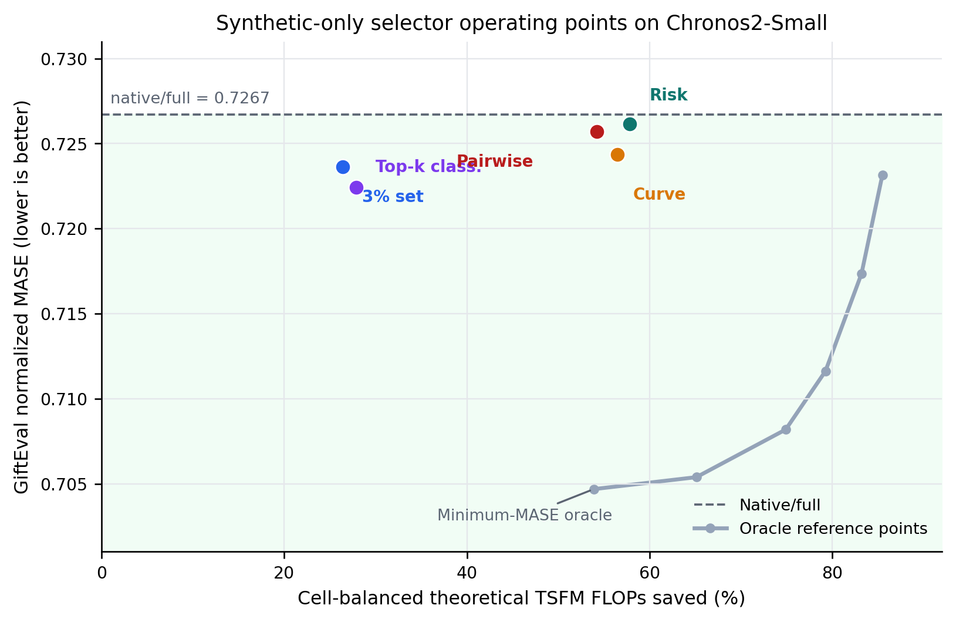
Figure 2. Accuracy–compute locations of the five synthetic-only Chronos2-Small selectors. The gray line joins selected supported oracle reference points and is not an attainable zero-shot curve. Green shading marks accuracy better than native/full. Curve regression and soft top-k classification occupy complementary compute and accuracy regimes.

5.5 Transfer across forecasters
We next repeat the complete labeling and curve-training procedure independently for 11 TSFMs while holding the GiftEval cohort fixed. The selectors consistently learn to shorten context, but accuracy transfer is model dependent (Table 2). Mamba improves native accuracy for Chronos2-Small and Moirai2-Small. Moirai gives the strongest transfer result: normalized MASE falls from 0.737778 to 0.731958 (0.789%) while theoretical TSFM FLOPs fall by 65.17%. For the other nine forecasters, the learned policies still reduce context compute but incur accuracy costs between 0.256% and 1.906%.
Table 2. Transfer of the bidirectional-Mamba curve predictor across 11 TSFMs. Each row uses model-specific synthetic labels and checkpoint selection. Positive Δ denotes improvement over native context; FLOPs savings exclude predictor inference.
Model | Native nMASE | Predicted nMASE | Δ | FLOPs saved
Chronos2-Base | 0.704738 | 0.706544 | -0.256% | 32.66%
Chronos2-Small | 0.726708 | 0.724344 | +0.325% | 56.49%
Chronos2-Synth | 0.735228 | 0.738399 | -0.431% | 34.59%
ChronosBolt-Base | 0.809586 | 0.820556 | -1.355% | 27.48%
FlowState-R1 | 0.709001 | 0.713912 | -0.693% | 27.28%
Moirai2-Small | 0.737778 | 0.731958 | +0.789% | 65.17%
PatchTST-FM-R1 | 0.704527 | 0.717957 | -1.906% | 22.98%
Sundial-Base-128M | 0.750750 | 0.756259 | -0.734% | 17.63%
TiRex2 | 0.696689 | 0.709750 | -1.875% | 31.41%
TimesFM2.5-200M | 0.705040 | 0.713009 | -1.130% | 46.86%
Toto-2.0-313m | 0.703999 | 0.707562 | -0.506% | 15.99%
​
The same pattern holds with the low-cost Patch-Transformer (Figure 3): it also improves two models, Moirai and Sundial, while its largest accuracy cost is 3.01% on PatchTST-FM. Because the successful forecasters change with the predictor backbone, encoder choice alone does not explain transfer. Synthetic labels contain useful ranking signal, but the mapping from synthetic response curves to real operating points must be calibrated for the forecaster as well as the data domain.
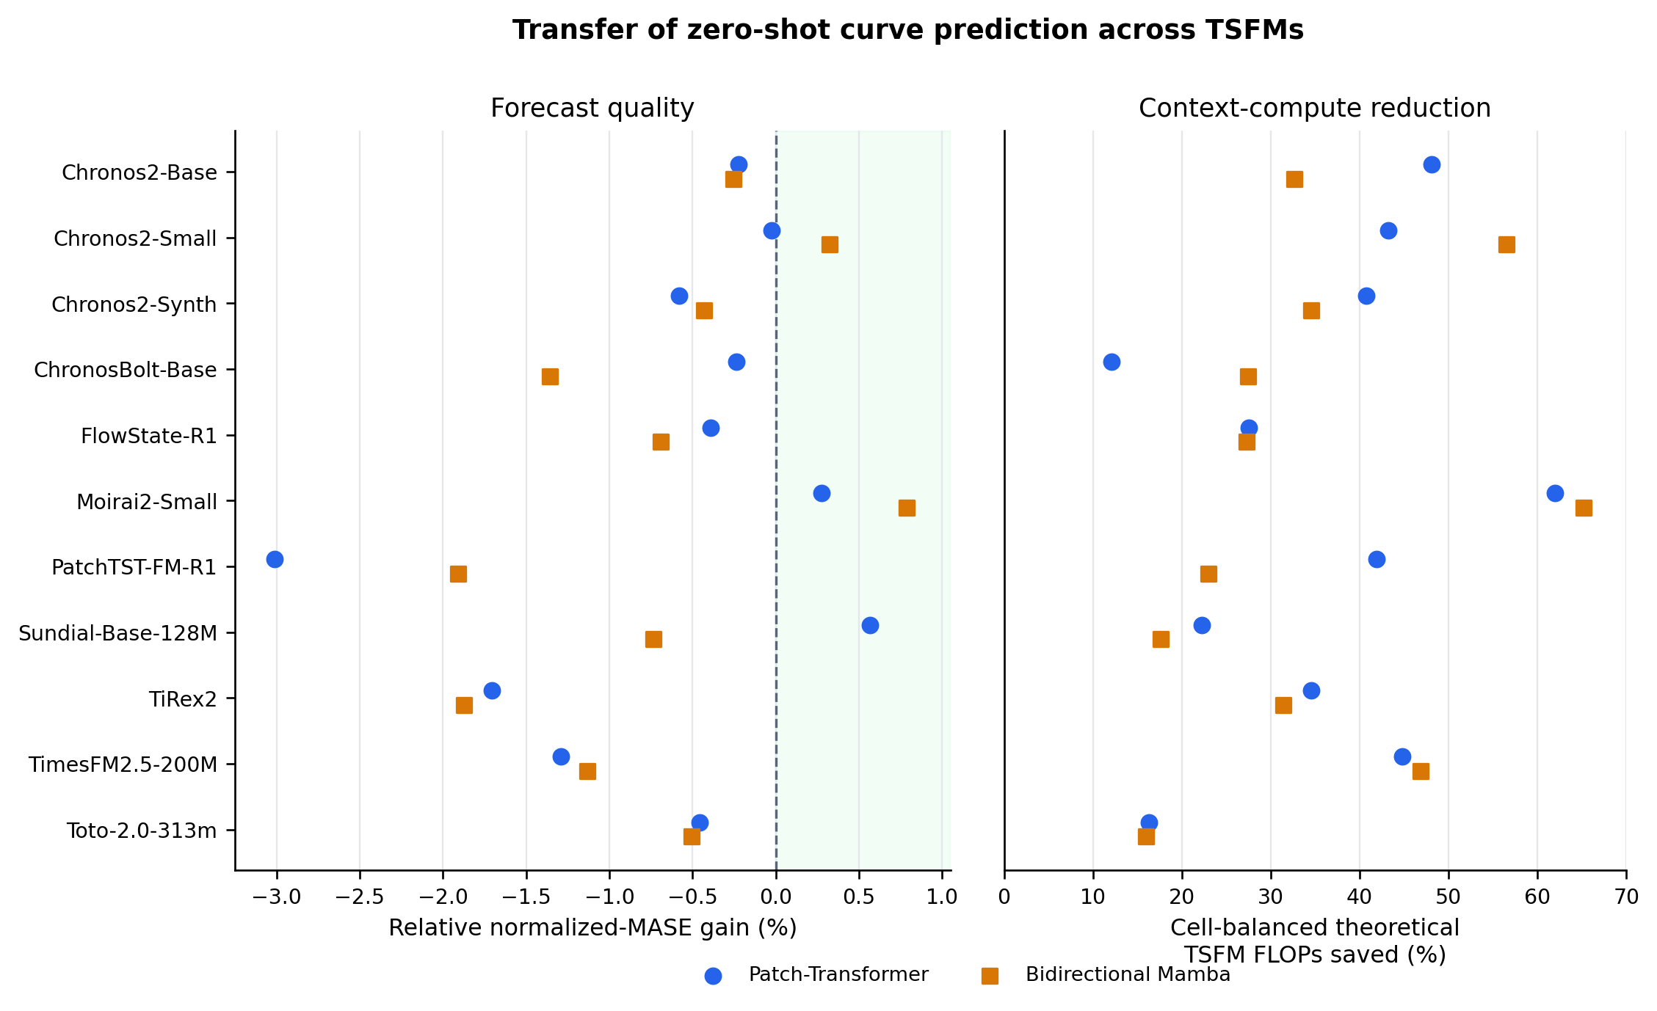
Figure 3. Transfer of zero-shot curve prediction across 11 TSFMs. The left panel shows relative normalized-MASE gain over native context (positive is better); the right shows cell-balanced theoretical TSFM FLOPs saved. Both the Patch-Transformer and Mamba predictors shorten context broadly, while accuracy transfer remains forecaster dependent. TiRex internally pads to a fixed context, so its theoretical shortening proxy should not be interpreted as realized hardware savings.

Selection stability.
The top synthetic checkpoints confirm that model selection is a central part of the calibration gap. Across the five best Chronos2-Small Mamba trials, real normalized MASE ranges from 0.722221 to 0.732506 (mean 0.726533, standard deviation 0.003881), and three beat native. The best real checkpoint ranks third by synthetic regret, whereas the synthetic runner-up ranks last on real data. Patch-Transformer trials are more concentrated (standard deviation 0.001612), but their synthetic winner is again the only checkpoint that does not improve native. Synthetic regret is therefore sufficient to define a reproducible zero-shot rule, but not yet to rank close checkpoints reliably.

Selector overhead.
The selected Mamba predictors contain 0.53–1.00 million parameters and require 0.033–0.241 GMAC per series in the analytic proxy. Against one maximum-window TSFM call at horizon 48, this is 0.092%–2.355% across the 11 models (mean 0.566%). The fraction can be larger for cells whose native history is much shorter than the model maximum. Consequently, the FLOPs and timing values above should be read as savings in the forecasting backbone, not as a measured end-to-end latency claim; a deployment study must include predictor batching, data transfer, and aggregation.

5.6 Implications
Synthetic supervision can recover useful real-data accuracy–compute policies: on Chronos2-Small, all five objectives improve on native context, and on Moirai the curve predictor combines the largest accuracy gain with the largest FLOPs reduction. These gains are obtained without observing a real error curve at training or selection time.
The cross-model study identifies calibration, rather than action-space coverage, as the limiting factor. Synthetic validation regret does not always rank nearby checkpoints correctly, and the best predictor backbone varies by forecaster. In addition, the present policy relies on cell-level aggregation and requires a model-specific offline labeling sweep. These are concrete design constraints rather than evidence against adaptive context selection.
A stronger selector should therefore learn uncertainty over the response curve, choose sets of regret-bounded actions, and retain native context when the predicted margin is weak. The results here establish the central opportunity: forecast context can be selected from unlabeled inputs to improve accuracy, reduce compute, or trade between the two. Achieving that trade-off consistently across forecasters is the remaining calibration problem.

