
Migra Whistle Kit
Included Supplies
This kit contains enough supplies to assemble 360 complete Migra Whistle baggies.
- Instructions
- 1 Example finished baggie
- 360 MN flag whistles
- 360 Lanyards
- 360 “Form a Crowd, Stay Loud” unfolded pamphlets
  - Localized for MSP with Monarca Rapid Response Line phone number
- 45 pages of uncut red cards
- 360 Baggies
What You Need
- One or more people to assemble Migra Whistle baggies
  - The recommended way to assemble the baggies is with an “assembly line” as described in the following instructions.
- Table or similar working surface.
- Scissors
  - Required to cut a slit in the pamphlets
  - May also be used to cut the red cards
- Optional: Paper guillotine capable of cutting multiple sheets of card stock
  - Useful to quickly cut the red cards
- Containers for assembled baggies
- Optional: Containers for work-in-progress items

Instructions
- IMPORTANT: Read through the entire set of instructions before starting.
- Prepare baggie contents. These tasks may be done at the same time by different groups of people.
  - Fold and cut the zine papers into pamphlets. Form an assembly line of people at a table with the unfolded papers on one end, and a container for completed pamphlets at the other. Each person at the table will be responsible for one or more steps.
  - Attach whistles to lanyards. One or more people may perform this task at the same time.
  - Cut out the red cards. One or more people may perform this task at the same time. Use a paper guillotine if one is available to speed this process, otherwise scissors will work.
- Once there are completed pamphlets, lanyards with whistles, and red cards available, one or more people may assemble them into baggies. See the included assemblied baggie as an example.

Pamphlet

Step 1

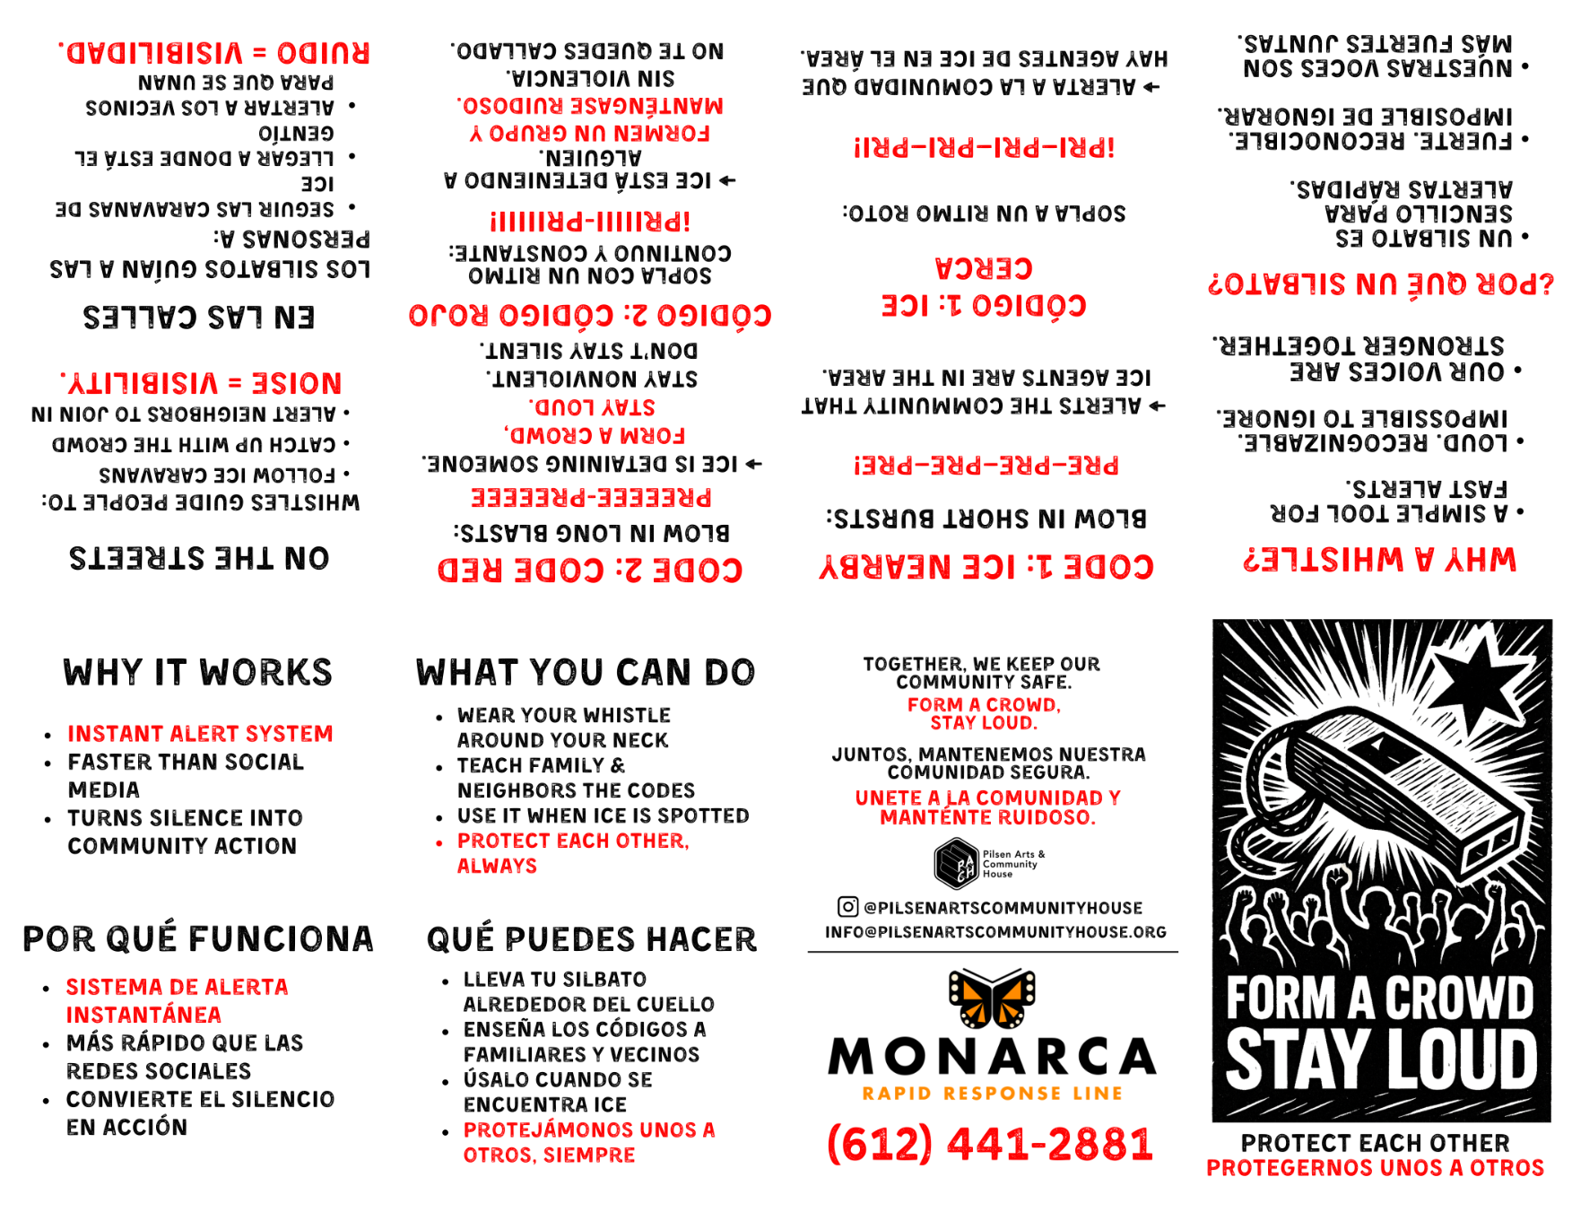
Fold the paper in half lengthwise to create a crease, then open up.

Pamphlet

Step 2

Fold the paper in half the other way, and keep it folded.

Pamphlet

Step 3

Fold both halves of the paper back on themselves.

Pamphlet

Step 4

Partially unfold the paper and use the crease marks to guide a cut in the middle.

Pamphlet

Step 5

Fold the paper the long way along the existing crease.

Gently push the sides together and let the middle open up naturally...
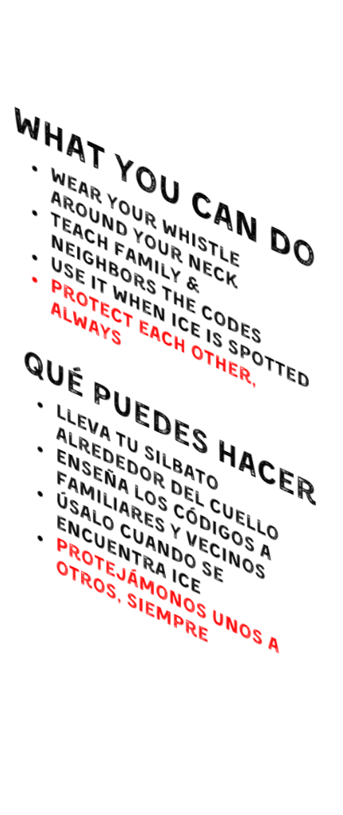
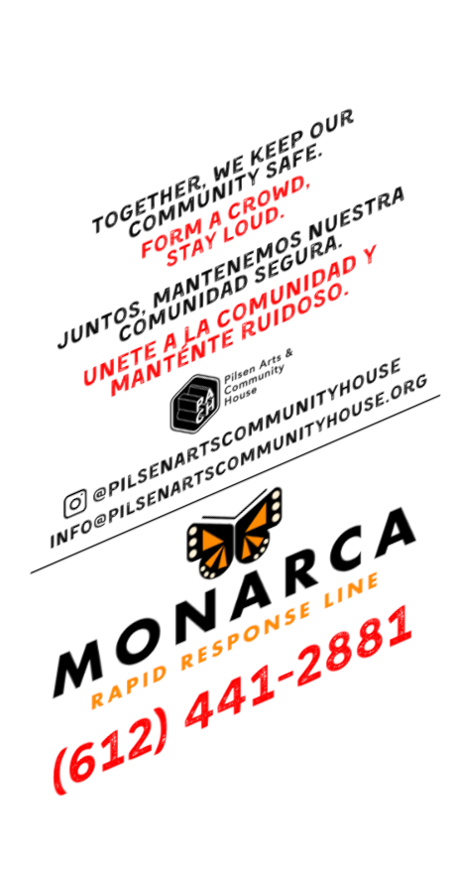

Pamphlet

Step 5 (cont.)

...keep pushing together until the middle closes up in the other direction.
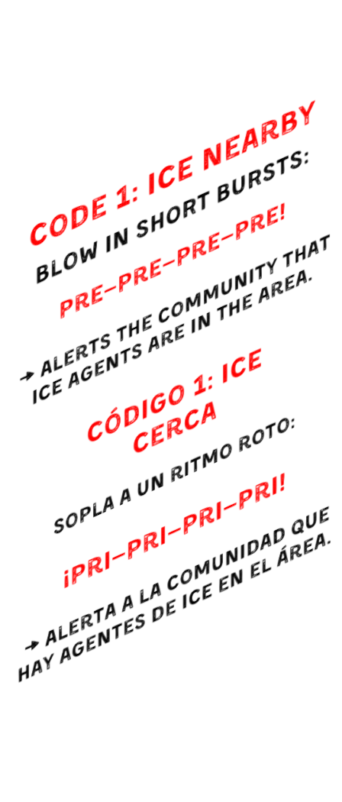

Fold the pamphlet so the phone number is on the back cover,
and “Form a crowd, stay loud” is on the front cover.

