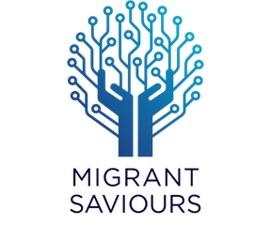

MIGRANT SAVIOURS

Integrating Migrant Worker’s skillset for local employment with refined Data Bank

Table of Contents

Scope 2

PROBLEM STATEMENT 3

**MIGRANT SAVIOURS**: A GAME CHANGING SOLUTION 3

WHAT MAKES IT DIFFERENT 3

HIGH LEVEL ARCHITECTURE 4

DATA VISUALIZATION – WEB DASHBOARD 5

Migrant Labourer ON-BOARDING JOURNEY 6

TELEGRAM APPLICATION 6

Text parsing flow 7

OCR flow 8

ANDROID APP DESIGN PROTOTYPE 8

TECHNOLOGY STACK 9

VIDEO 9

GITHUB LINK 9

FUTURE ROADMAP 9

IBM Cloud Services or IBM Systems 10

TEAM MEMBERS 10

TEAM MENTORS 10

**Document: Rev. A**

**Release Date: June 6, 2020**

# Scope

This document outlines the detailed solution of integration of Migrant Workers’ skillset for local employment with refined Data Bank.

# PROBLEM STATEMENT

COVID-19 storm has already upended lives of the people all across the globe. These emergencies have shown us how vital it is to address the fears and anxiety of people especially **Migrant Workers**. Due to lockdown and other containment measures adopted by various Govt. departments and industries, these people have ended up in lot of distress in terms of **unemployment**. It is not just about providing them ration or transport facilities to reach their respective hometowns, authorities need an after-plan so that they could come back on track and have enough employment opportunities.

Currently there is no efficient way to collect or access data of migrants, which can be used by Govt/Non Govt agencies to roll out employment opportunities. This leads to a huge gap between Employment services and labourers.

# **MIGRANT SAVIOURS**: A GAME CHANGING SOLUTION

Technologically enabled solution to collect, save and prepare a real-time, location based **data bank of the Migrant Workers** with skillset mapping along with personal and demographic details using UIDAI Aadhaar services, Google Location services and Data analytics.

This data bank will prove out to be boon in current situation. This will be used by different Govt. / Non Govt. agencies to provide employment opportunities at their native places, which would result in below benefits:

* Upliftment of socio-economic status of Migrant labourers.
* Revival of MSME sector.
* Better utilization of resources and funds for the welfare.
* Reduce migration of labourers to reduce the possibilities of COVID-19 spread.
* Easy management and visualization of consolidated labourer’s data to match demand with supply at district level.
* Provide employment opportunities to labourers so they could stay along with their families.
* Agencies can have access to the data and offer jobs on the portal, which will be visible to labourers based on their relevant skill set and locality.
* Direct access to labourers’ data without any intermediary involvement.

# WHAT MAKES IT DIFFERENT

* Aggregation of data on PAN India basis through multiple channels vs current limitation of data being confined within certain authorities/territories.
* Unified data bank vs duplicity of data and redundancy.
* Use of all popular communication tools for Migrant Labourer onboarding.
* Regional language support to reduce User friction.
* Unique verification of each record through UIDAI e-KYC process.
* Complete Privacy of Migrant Labourer information from unauthorized access.
* An intuitive UI dashboard backed up with data analytics for data visualization.

# HIGH LEVEL ARCHITECTURE

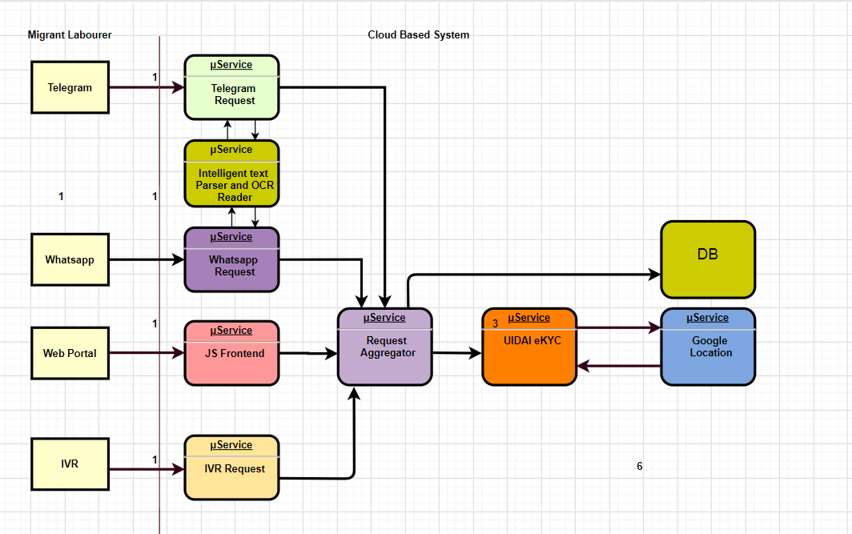

# DATA VISUALIZATION – WEB DASHBOARD

Web Link: <http://www.migrantsaviours.com/migrants/>

Web dashboard offers user-friendly, easy visualization of data bank while maintaining the data privacy of each user.

Some of the features of web dashboard includes:

* Web form to onboard user
* Access to database to authenticated registered agencies only to be as part of future roadmap
* Real time data analysis on the registered users.
* A location based heat map to show the hot spots of Migrant Labourers.

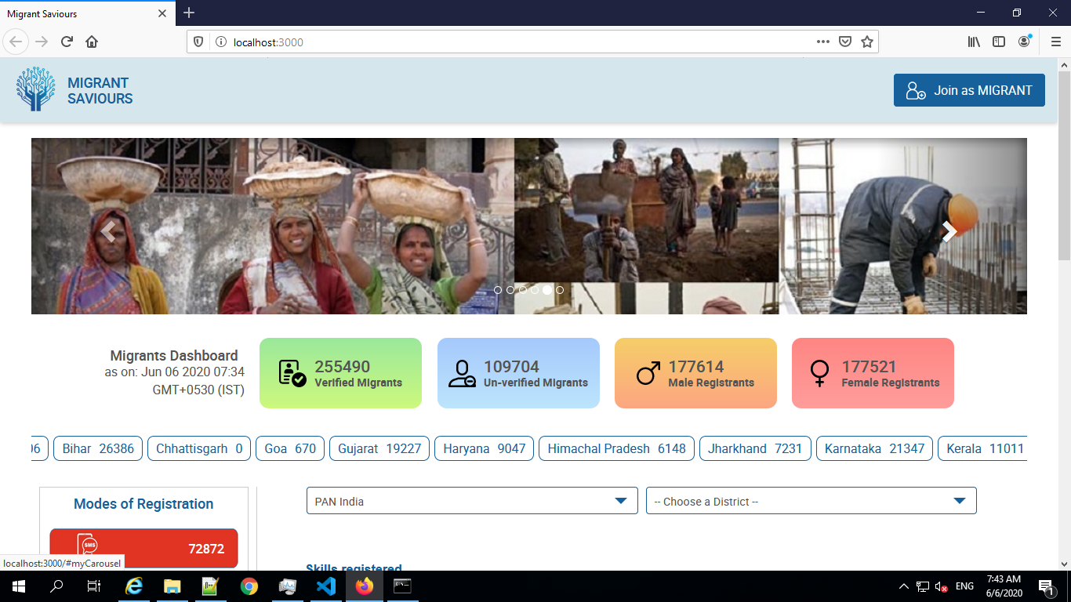

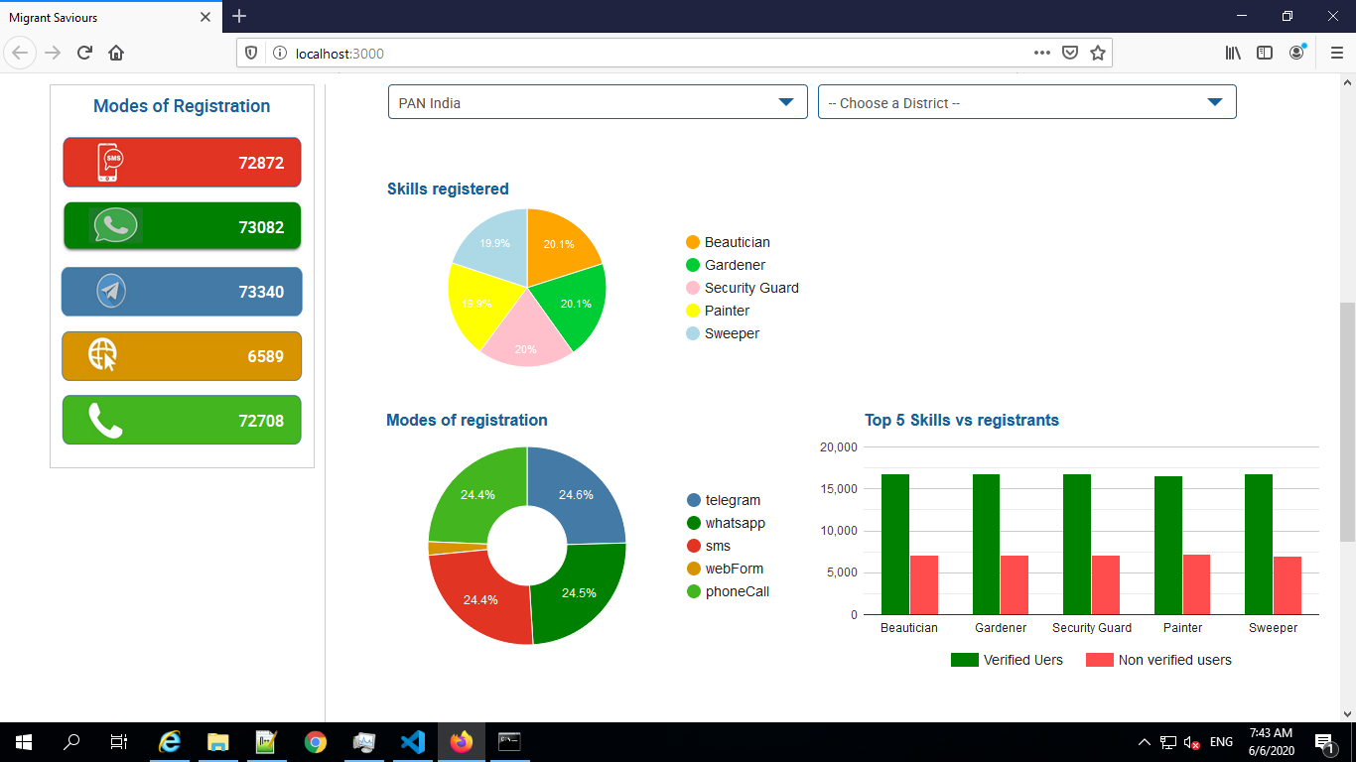

# Migrant Labourer ON-BOARDING JOURNEY

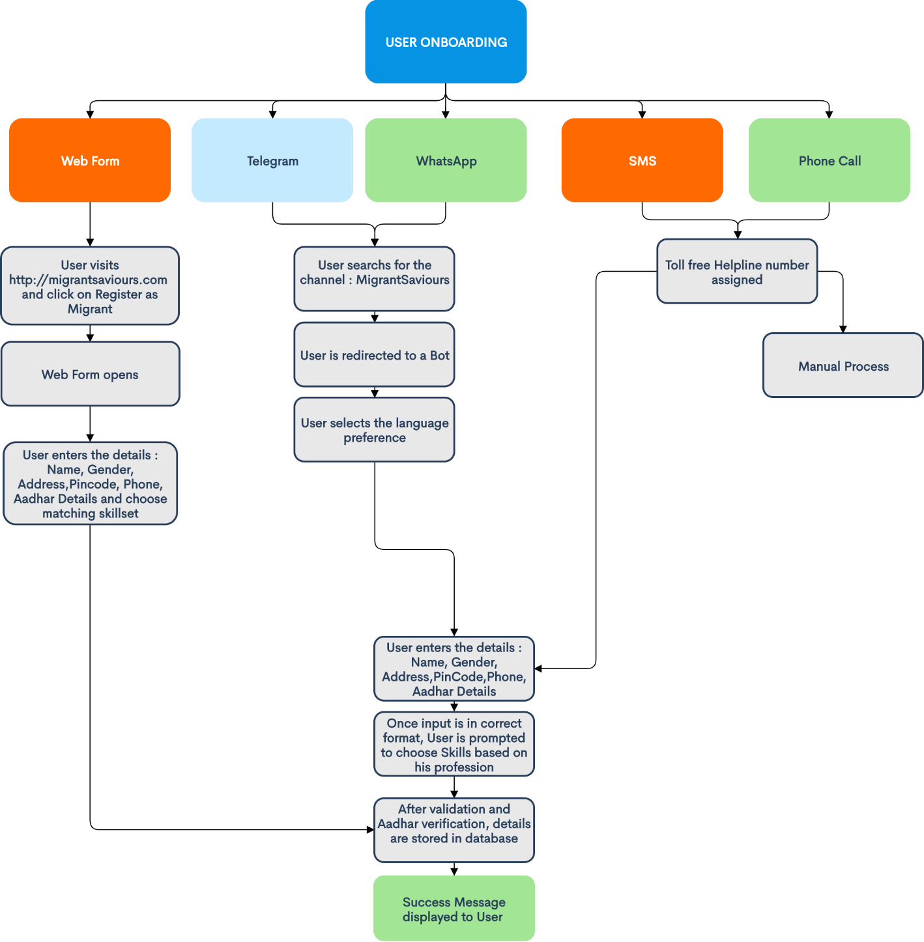

# TELEGRAM APPLICATION

End to end functional Telegram channel is setup as part of the hackathon.

Two methods used to capture data of Migrant Labourers:

* Using text parsing where user manually enters the details in required format
* Using OCR technique where user needs to upload Aadhaar card image

Language support: English, Hindi

Here are some of the screenshots depicting the flow of both methods:

## Text parsing flow

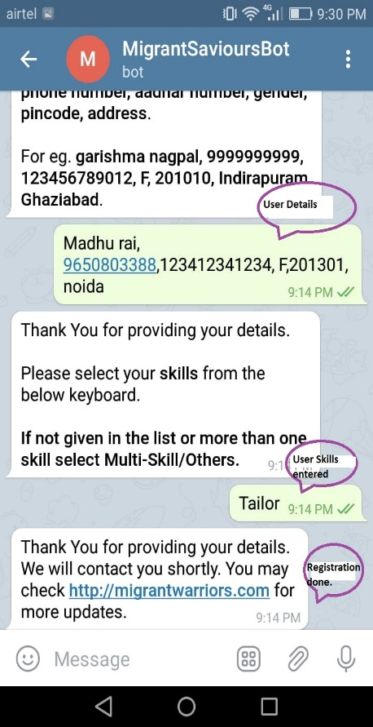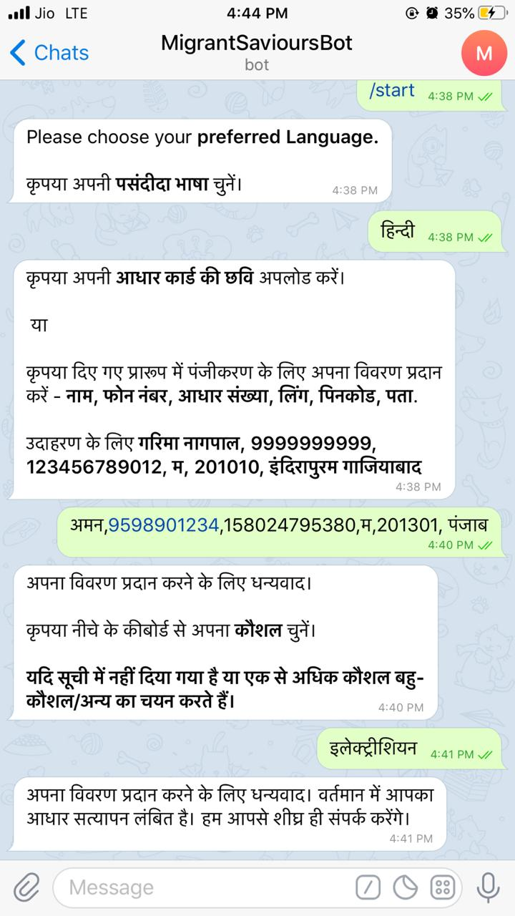

## OCR flow

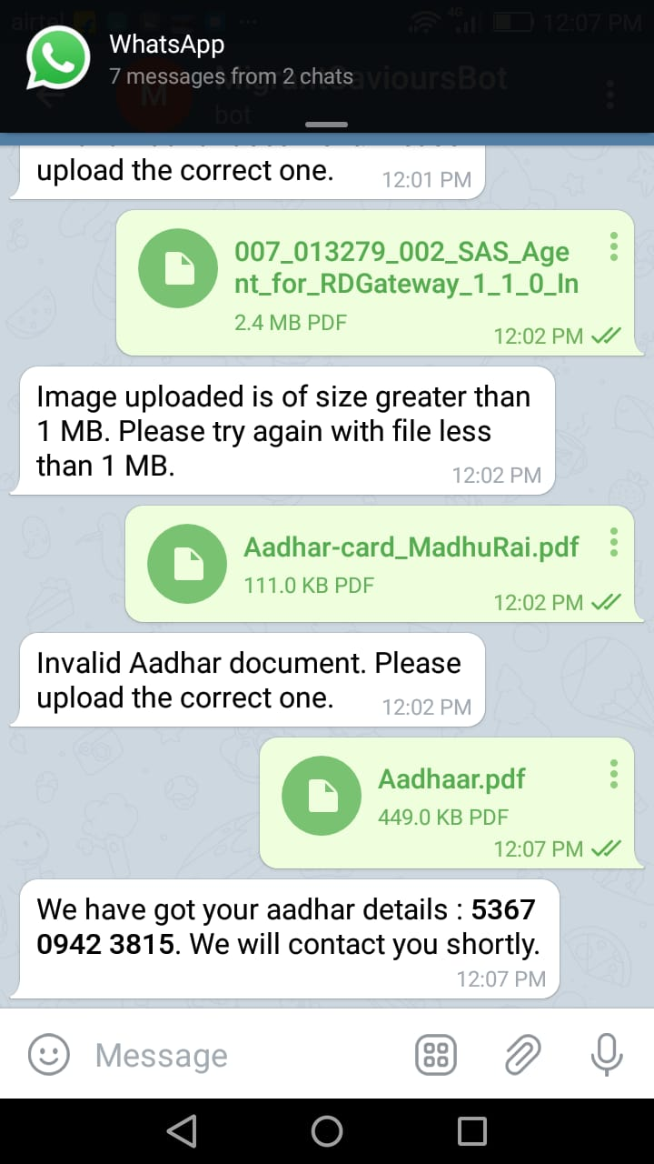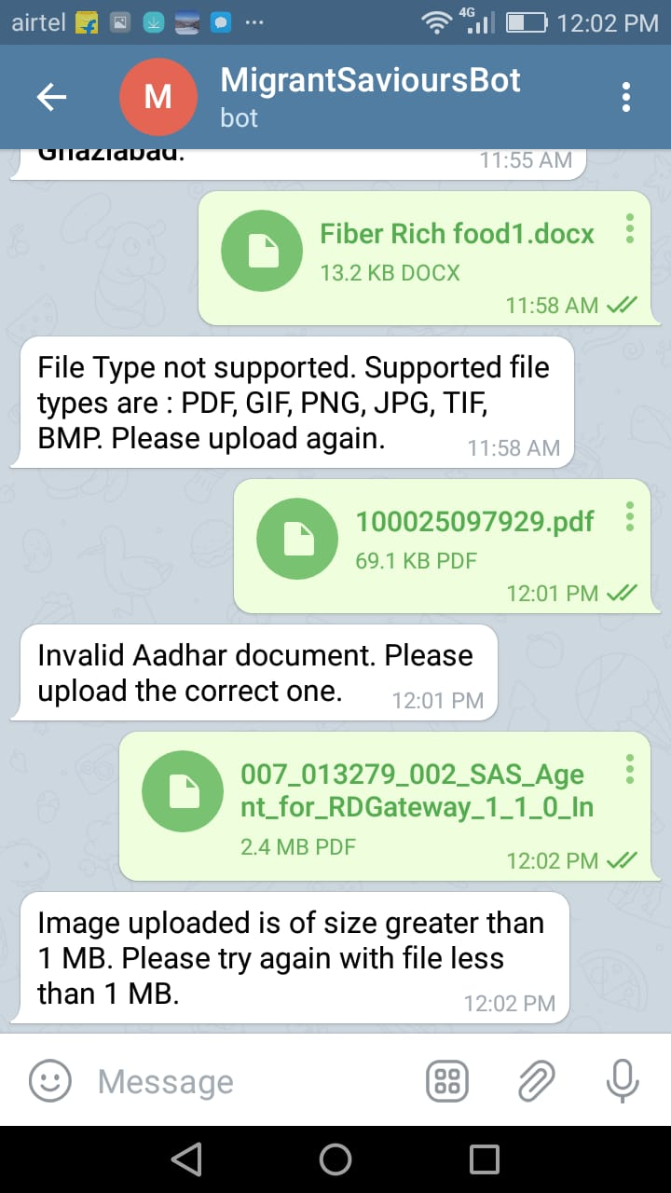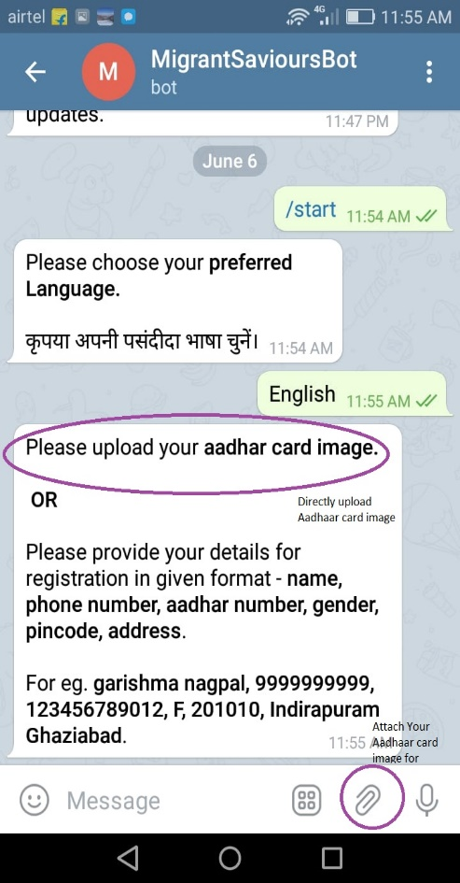

# TECHNOLOGY STACK

**Webserver:** IIS

**Backend:** Node.js, REST API**, .**NET framework

**Frontend**: HTML, CSS, JavaScript

**Database**: MongoDB

**Chart Rendering**: Google chart

**Location service**: MapBox

**Other**: Telegram API bot, Adhar Integration, OCR APIs

# VIDEO

<https://www.youtube.com/watch?v=lqX6Yjs_LVc>

# GITHUB LINK

[https://github.com/migrantwarriors/migrant-saviours.git](http://www.migrantsaviours.com:8009/)

# FUTURE ROADMAP

* Integration with WhatsApp Channel
* Information of MSME data to be shown in the web dashboard
* More regional language support
* Login creation of various verified govt/non-govt agencies
* User login to update his/her own profile
* Android App for User registration
* Integration with other authorities to get Migrants data
* UIDAI eKYC commercial integration
* Roll out of other services with this data bank like in distress situations, rolling out medical services, PDS service, transportation service etc.

# ANDROID APP DESIGN PROTOTYPE

Here is the prototype designed for Android application.

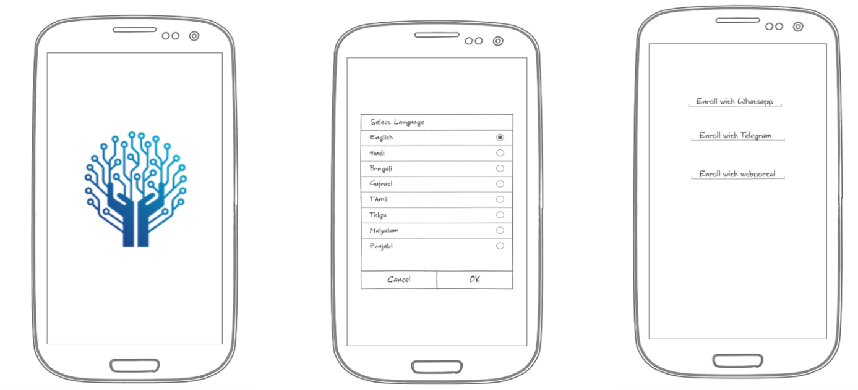

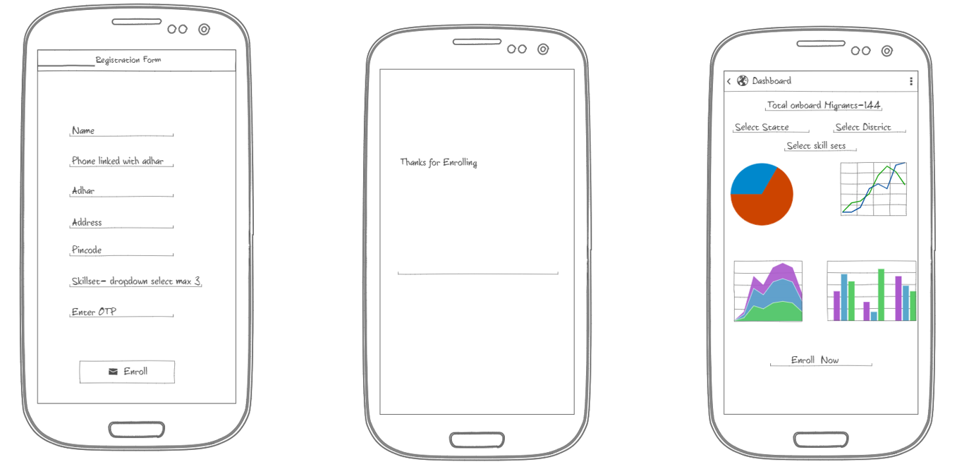

# IBM Cloud Services or IBM Systems

Due to time constraint and certain glitches, this POC has not leveraged any IBM service for current submission. However, we do have started on using Android app development and Database service of IBM Cloud as part of complete solution.

# TEAM MEMBERS

Garishma Nagpal [garishma.nagpal@thalesgroup.com](mailto:garishma.nagpal@thalesgroup.com)

Mona Kumari [mona.kumari@thalesgroup.com](mailto:mona.kumari@thalesgroup.com)

Chanpreet Grover [chanpreet.grover@thalesgroup.com](mailto:chanpreet.grover@thalesgroup.com)

Kamalpreet Kaur [kamalpreet.kaur@thalesgroup.com](mailto:kamalpreet.kaur@thalesgroup.com)

Manpreet Kaur [manpreet.kaur@thalesgroup.com](mailto:manpreet.kaur@thalesgroup.com)

Dimple Kumawat [dimple.kumawat@gemalto.com](mailto:dimple.kumawat@gemalto.com)

# TEAM MENTORS

Nitin Aggarwal [nitin.aggarwal@thalesgroup.com](mailto:nitin.aggarwal@thalesgroup.com)

Madhu Rai [madhu.rai@thalesgroup.com](mailto:madhu.rai@thalesgroup.com)