K.J.S.E.A

JUNIOR SCHOOL EDUCATION ASSESSMENT

TERM 2: ENDTERM ASSESSMENT 2026
GRADE 8 – MATHEMATICS
Time: 2 Hours
LEARNER’S DETAILS
Name:_____________________________________________________________. School: ____________________________________________.
Assessment Number: _______________________________________________. Date: ____________________________________________.
School Code: ______________________________________________________. Signature: _______________________________________.

INSTRUCTIONS TO CANDIDATES
- Write your full name in the space provided above.
- Indicate your school, stream, admission number, and date clearly.
- This paper has TWO sections: A and B.
- Attempt ALL questions in both sections.
- Show all working clearly where necessary. Silent non-programmable calculators may be used
- Write all answers in the spaces provided.
- Do NOT remove any page from this paper.

FOR OFFICIAL USE ONLY
SECTION | SECTION A | SECTION B | % SCORE | EE1 | EE2 | ME1 | ME2 | AE1 | AE2 | BE1 | BE2
SCORE RANGE | 20 MARKS | 30 MARKS |  | 90-100 | 75-89 | 58-74 | 41-57 | 31-40 | 21-30 | 11-20 | 1-10
POINTS |  |  |  | 8 POINTS | 7 POINTS | 6 POINTS | 5 POINTS | 4 POINTS | 3 POINTS | 2 POINTS | 1 POINT
LEARNER’S TOTAL SCORE

SECTION A (20 MARKS) Answer ALL questions in this section.

- A submarine was at –8 m below sea level. It rose by 5 m and then descended by 9 m. What is its final position in relation to the sea level?
A. –14 m B. 12 m
C. –12 m D. –10 m
- What is the value of the following?
1 + 9 ÷ 18 − 1 of 1
A. $\frac{51}{200}$ B. $\frac{17}{360}$ C. 9 D. 7
- In a class, 0.72 of the learners are boys. What fraction of the learners are girls?
A. $\frac{72}{99}$ B. $\frac{7}{25}$ C. $\frac{18}{25}$ D. $\frac{27}{99}$
- Express 0.0075402 to 4 significant figures.
A. 0.0075 B. 0.007540
C. 0.007541 D. 7540
WORKING SPACE

- A factory produced 420 000 bottles of juice in a month. How is this number written in standard form?
A. 42 × 10⁴ B. 0.42 × 10⁶
C. 4.2 × 10⁵ D. 420 × 10³
- What is the value of 11.9968 correct to two decimal places?
A. 12.0 B. 11.99
C. 12.0000 D. 12.00
- The price of an item increased from Sh. 400 to Sh. 500. What was the percentage increase?
A. 125% B. 80% C. 25% D. 20%
- In a class of 50 pupils, 5 are girls. On a certain day, 20% of the boys were present. How many boys were absent?
A. 20
B. 40
C. 30
D. 16
- What is the value of
$\frac{{\left(x - y\right)}^{2}}{xy}$ when x = 4 and $y =\frac{1}{x - 1}?$
A. 9 B. $3\frac{1}{7}$C. 4 D. 2 4
- In a bus, the number of women passengers was n. The number of children in the bus was three more than that of women, while the number of men was two less than the total number of women and children. How many passengers were in the bus?
A. 2n + 1
B. 2n + 4
C. 4n + 4
D. 4n – 2
- Which of the following ratios represents 75%?
A. 5:7
B. 7:5
C. 3:4
D. 4:3
- The cost of 7 exercise books and 3 pencils is sh. 340, whereas the cost of 4 similar exercise books and 6 similar pencils is sh. 280. What is the price of one exercise book and one pencil?
A. Exercise book = Sh. 40, Pencil = Sh. 20
B. Exercise book = Sh. 35, Pencil = Sh. 25
C. Exercise book = Sh. 30, Pencil = Sh. 30
D. Exercise book = Sh. 45, Pencil = Sh. 15

WORKING SPACE

- A park designer is creating a flower bed in the shape of a sector of radius of 28 m and substends an angle of 72° at the centre as shown below.
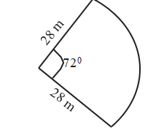
Calculate the perimeter of the flower bed.
(Take π=$\frac{22}{7}$ ).
A. 91.2 m B. 35.2 m C. 56 m D. 98.4 m
- A rectangular cuboid measuring 9 cm by 6 cm by 15 cm was painted on one side as shown below.
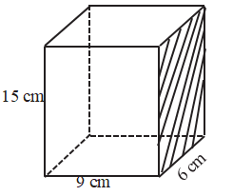
What is the total surface area of the cuboid that was not painted?
A. 90 cm² B. 468 cm²
C. 558 cm² D. 333 cm²
- A cylindrical container has a diameter of 28 cm and a height of 40 cm. What is the capacity of the container in litres? (take π = 22/ )
A. 2 464 litres B. 246.4 litres
C. 24.64 litres D. 24 640 litres
- A train covered a distance of 144 km in 8 hours. What was its speed in metres per second?
A. 5 m/s
B. 10 m/s
C. 18 m/s
D. 4 m/s

WORKING SPACE

- A welder designed a window in the shape of a regular pentagon as shown.
Determine the size of the angle marked x.
A. 140°
B. 194°
C. 116°
D. 104°
- A map is drawn to a scale of 1:1000. A rectangular plot of land of dimensions 9 cm by 6 cm is drawn on the map. Find the actual area of the plot in hectares.
A. 54 ha
B. 5.4 ha
C. 0.54 ha
D. 0.054 ha
- Construct a triangle XYZ in which XY = 7.2 cm, YZ = 5.8 cm and ZX = 6.2 cm.
What is the size of angle XYZ?
A. 125°
B. 55°
C. 75°
D. 50°
- The pie chart below shows how Toi uses his land.

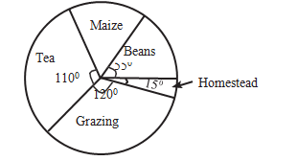
Maize – 55°
Tea – 110°
Beans – 120°
Grazing
Homestead
If Toi uses 6 hectares for maize, what area of his land does he use for both beans and homestead?
A. 1.5 ha
B. 7 ha
C. 5.5 ha
D. 6 ha
WORKING SPACE

SECTION B (30 MARKS)
- Use mathematical tables to evaluate the following. (3 marks)
$\frac{\sqrt{2546}}{1}$ + (0.4286)²

- In a meeting, $\frac{3}{5}$of the attendants were women, ¼ of the remainder were men and the rest were children. There were 80 men in that meeting. How many children were there? (3 marks)

- Without using mathematical tables or a calculator, evaluate the following. (3 marks)

0. 18 × 4

3.24 × 4

- Factorise completely: (2 marks)
am + bm + an + bn.

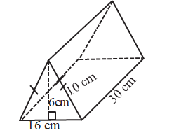
- Becky made a pencil pouch in the shape of a triangular prism as shown below. Determine the total surface area of the pouch. (3 marks)

- Kingsley deposited Sh 250 000 in a bank that gave compound interest at the rate of 6% per annum. What was the amount in the bank after 3 years? (4 marks)

- Determine the area of the shaded part in the figure below. (Take π = 3.14) (3 marks)

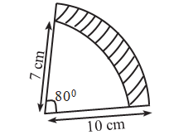

- Draw a line PQ = 8 cm. Divide the line proportionally into 4 parts. (2 marks)

- The total number of learners in a class is 10. Twice the number of boys exceeds the number of girls by 2.
- Form two simultaneous equations to represent this information. (2 marks)

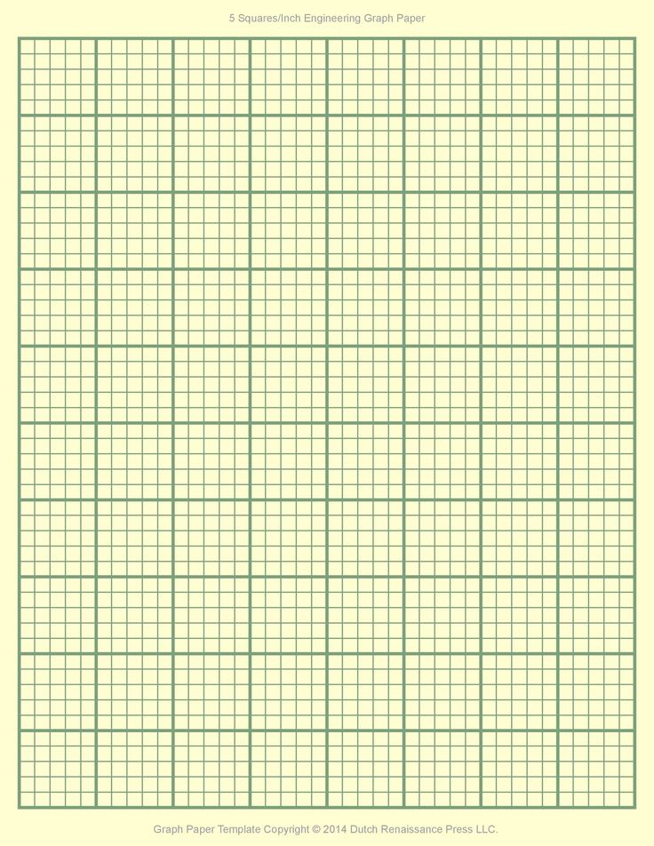

(b) Use graphical method to find the number of boys and the number of girls in the class. (3 marks)

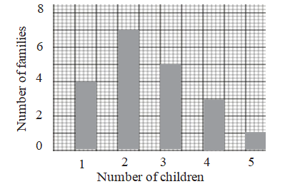
- The bar graph below shows the number of children in each of the families in Pema estate. What is the total number of children in the estate? (2 marks)

THIS IS THE LAST PRINTED PAGE

