Discovery Approach Description
The description provided below will be used to evaluate the approach developed by your team to automatically identify public web sources of annual financial data of MNE Groups. This description will be evaluated by the Evaluation panel based on the criteria described in the Evaluation tab of the Discovery Challenge and used for the ranking of your team for the Reusability and Innovativeness Awards.

Methodology (Data-driven approaches; Availability and quality of documentation)
Please provide a detailed description of the methodology used for automatically identifying the public web sources of annual financial data of MNE Groups. The description should contain (1) the data processing steps, (2) the methods and models used, (3) references to the scientific papers/sources that present the methods and models used, and (4) the time it took to process the data set.
Bear in mind that the workflow will be also evaluated based on the criteria for the Reusability and Innovativeness Awards.
This section will be evaluated for:
(1) Data-driven approaches: The described approach is evaluated based on whether it is data-driven rather than heuristic. More data-driven approaches will receive higher scores. The code will be inspected visually by the evaluation panel. Well documented code which allows evaluators to determine the steps of the approach will yield higher scores.
(2) Availability and quality of documentation: Based on the clarity of the provided documentation describing the approach, the evaluation panel is asked to assess the likeliness that the described approach can successfully reproduce the solution submitted by the team for the Accuracy award.
My approach is fully data-driven and based on dynamic querying of public search engines to identify annual financial information about multinational enterprise (MNE) groups. The core idea is to use the group name as a query base and systematically extract URLs pointing to relevant financial data sources such as annual reports or financial summaries.

1.- Data Processing Steps: The Python pipeline processes a structured list of groups and follows a multistep logic:

- Configuration and Input Load:
  - All relevant parameters (keywords, valid reference years) are read from a config.yaml file.
  - The input CSV contains company IDs, names, and a classification type (FIN_REP or OTHER).

- Preprocessing: ISIN Discovery
  - For each group, a preliminary Google search is performed to retrieve its ISIN (International Securities Identification Number) code.
  - This ISIN is then included in the main search queries to increase precision and relevance of the retrieved URLs. Moreover, it provides the country of the MNE's head office (ISIN | ISIN Organization: international securities identification numbers organization)

- Main Search and Extraction:
  - Based on the group type:
a) FIN_REP (Annual Reports)
    - A search query is constructed using the company name and report-related keywords.
    - Results are filtered for PDF links. If a year is not found in the URL, the PDF is downloaded and its first page parsed using PyPDF2 to extract the reference year.
b) OTHER (Additional Financial Information)
    - A broader query is generated using financial terms and optionally the ISIN.
    - Pages are filtered by domain to ensure diversity and parsed with BeautifulSoup.
    - A score is computed based on keyword presence, and the reference year is extracted from text if found.
- Output Integration:
  - The best match per group and type is recorded, including: the source URL (SRC), the year (REFYEAR), and semantic score (SCORE, for OTHER).
  - The results are exported to a CSV file.

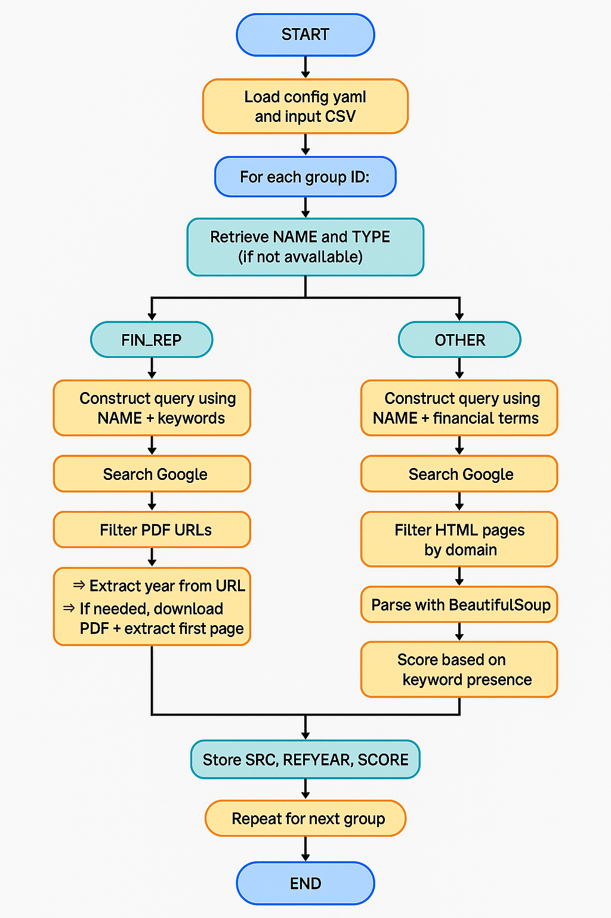
1Program flow

2.- Methods and Models Used:
- Semantic scoring using keyword sets and synonyms.
- Year detection in URLs and textual content via regex.
- PDF parsing with PyPDF2 and decryption support via pycryptodome.
- Web scraping with requests + BeautifulSoup.
- Domain diversity filtering.
- Reinforcement of company identity using discovered ISINs.
- Language targeting (lang="en" in queries).
- Randomized pauses and retry handling to avoid blocking.

3.- Scientific References:
This approach has been developed independently, without the use of formal scientific references. It is based on practical reasoning, domain-specific needs, and general programming knowledge acquired through self-learning. The methodology focuses on transparency, reproducibility, and adaptability to the public web context.

4.- Processing Time:
For 200 groups, the complete pipeline takes approximately 3 hours, depending on the number of available URLs, website load times and need for PDF parsing. Randomized pauses and throttling prevention mechanisms contribute to this duration.

Architecture (Algorithm reusability and scalability)
Please provide a description of the architecture of your approach. A diagram of the architecture is considered of additional value. Indicate what modifications would be required to apply the approach to similar datasets on a larger scale.
This section will be evaluated for:
- The described approach is evaluated based on:
  - Are the components well separated and encapsulated to allow for independent modification?
  - What is the degree of modification required to add new companies?
  - Is it possible to implement the approach by running it on parallel machines?
  - What is the extent of effort required to track performance?
  - Is the method robust if scaled to larger number of cases?
  - Is the performance of the approach stable as scale increases?
The system is composed of modular and independently testable components:
- Search logic (annual reports vs. other financial info)
- URL filtering and scoring
- Year extraction and HTML parsing
- Data integration and export

Scalability considerations:
- Each group is processed independently: trivially parallelizable.
- Components are encapsulated in functions, allowing reusability.
- Adding new groups is as simple as updating the CSV.
- External APIs are not used, ensuring full reproducibility.
- Can be scaled horizontally by distributing company subsets across machines.

Modifications for large-scale use:
- Introduce multiprocessing or distributed execution (e.g., Dask, Spark).
- Integrate with APIs (e.g., Bing Search API) for more stable query handling.

Hardware Specifications (Algorithm reusability and scalability)
Please describe the hardware specifications of the machines that were used to run the methodology.
This section will be evaluated for:
- Algorithm reusability and scalability
  - Is it possible to implement the approach by running it on parallel machines?
  - Is the method robust if scaled to larger number of cases?
  - Is the performance of the approach stable as scale increases?
Machine 1 (The approach runs efficiently on standard laptop)
CPUs | Intel(R) Core(TM) i5-8265U CPU @ 1.60GHz (4 cores)
GPUs | None
TPUs | None
Disk space | < 1 GB required (mainly for CSV output and temporary HTML content)

Machine 2
CPUs | CPU name and capacity
GPUs | GPU name and capacity
TPUs | TPU name and capacity
Disk space | The space required to calculate and store the data

Libraries
Please provide the libraries used for approach, if any, as well as the links to these libraries, if available.
- pandas: https://pandas.pydata.org/docs/
- requests: https://requests.readthedocs.io/en/latest/
- beautifulsoup4: https://beautiful-soup-4.readthedocs.io/en/latest/
- googlesearch-python: googlesearch-python · PyPI
- PyPDF2: PyPDF2 · PyPI
- pycryptodome: https://pycryptodome.readthedocs.io/en/latest/
- pyyaml: https://pyyaml.org/

Similarities/differences to State-of-the-Art techniques (Originality of the approach)
Please provide a list of similarities and differences between the used methodology and to the state-of-the-art techniques.
This section will be evaluated for:
(1) the Originality of the approach criterion: compare the approach used to the state of the art, i.e. currently published approaches that are closest to the approach applied for the submission, and the extent to which the submission represents an improvement over these approaches. The submission will be evaluated based on the degree to which it is new or unique. This could be in terms of technology, methodology, or application.
Similarities:
- Like other modern web mining approaches, this method applies keyword-driven search logic and HTML parsing to derive structured data from unstructured web sources.
- It employs common text extraction and regular expression techniques to identify key variables such as dates, financial indicators, and document types.
- Relies on a modular, pipeline-oriented structure similar to typical data ingestion frameworks.

Differences / Original Contributions:
- Incorporates a preliminary ISIN discovery step to reinforce the accuracy and identity resolution in subsequent searches.
- Avoids any reliance on fixed domains, APIs, or structured databases. It is designed to adapt to open, multilingual, and variable web content.
- Introduces a prioritization strategy that balances:
  - Format detection (e.g. prioritizing PDFs for annual reports),
  - Domain uniqueness (to avoid redundant or circular references),
  - Semantic scoring based on keyword presence, and
  - Dynamic year inference from either URL structure or document content (PDF or HTML).
- It is entirely lightweight and local — requiring no API keys, subscriptions, or cloud infrastructure — making it accessible and reproducible across institutional or individual environments.

Contribution to scientific field (Future orientation)
Please describe how your submission contributed to the scientific field, what impact it could have and what could potentially be future work to improve the solution.
This section will be evaluated for:
(1) the Future orientation and impact criterion: The potential effect of the approach used will be evaluated. This includes the scale of impact it has on the problem of discovering sources of financial data from the Internet. The impact will be evaluated based on potential efficiency improvements and cost reductions.
This approach demonstrates that robust, large-scale discovery of financial information from the public web is achievable using fully open-source tools and without reliance on proprietary APIs, paywalled platforms, or scraping of pre-defined websites. It offers a flexible, transparent, and reproducible method for gathering multinational enterprise (MNE) data.
By combining:
- adaptive search logic,
- PDF and HTML parsing,
- lightweight infrastructure, and
- identity reinforcement through ISIN integration,
the solution contributes a versatile and low-cost alternative to traditional web mining systems.

Future improvements may include:
- Integrating NLP models to extract more granular structured fields (e.g. entity recognition, table parsing).
- Training classifiers to distinguish document types (e.g. investor presentation vs. annual report).
- Building an indexable and queryable database of all discovered URLs for internal validation or reuse.
- Enhancing multilingual support and classification to improve coverage across different reporting cultures.
- Scaling with distributed architectures (e.g. using Dask or multiprocessing for thousands of companies).

Lessons Learned (Future orientation)
Please state any lessons learned during the competition.
This section will be evaluated for:
(1) the Future orientation and impact criterion: what were the lessons learnt during the competition, and what could potentially be future work to improve the solution.
- Public web data is broadly accessible but structurally inconsistent. Flexibility in query design, parsing techniques, and fallback mechanisms is essential to accommodate the heterogeneity of corporate disclosures across countries and platforms.
- Ensuring domain diversity prevents reliance on a single information source, which improves resilience and reduces bias in the discovery process.
- Incorporating random delays and robust error handling is critical for ethical, respectful, and sustainable web interactions — particularly when using search engines or accessing corporate websites repeatedly.
- A hybrid strategy — combining broad open-ended discovery with targeted domain-specific refinement — provides the best balance between coverage and precision.
- The integration of auxiliary identifiers such as ISINs significantly enhances the accuracy of entity resolution, especially when dealing with multinational groups with similar or ambiguous names.

Short description of the Team – area of expertise
Please provide a description of the team, your area of expertise and contact information.
The team is composed of a single member:
- Name: Miguel Ureña Asensio
- Education: Degree in Mathematics and PhD in Industrial Engineering. My background in programming is limited to introductory courses and self-taught learning through publicly available resources.
- Current Position: National responsible for the EuroGroups Register (EGR) at the Spanish National Statistical Institute (INE), working within the Subdirectorate General for Economic Sector Statistics in the Business Registers unit.
- Contact: miguelurenya@gmail.com

