Venn Diagram Application

# User Manual

Group 12

Version 1.2.0

02/23/2020

Table of Contents

1. Introduction 1

2. Working Principles 1

3. Common Usage Scenarios 2

4. How To Get Started 4

5. Using the System 4

5.1 ‘Insert Title’ Feature 5

5.2 ‘Adding entries to the Venn Diagram’ Feature 5

5.3 ‘Menu Bar’ Feature 7

5.3.1 ‘File’ Button 7

5.3.1.1 ‘Save’ Button 7

5.3.1.2 ‘Open’ Button 8

5.3.1.3 ‘Exit’ Button 8

5.3.2 ‘Help’ Button 8

5.3.2.1 ‘About’ Button 8

Appendix A: Record of Changes 9

List of Figures

Figure 1: Venn Diagram Application uses Java SE 1.8 AND Java SE Runtime Environment 9 1

Figure 2: eclipse based on Java SwingBuilder coding 2

Figure 3: Venn Diagram Application Common Usage Scenario 3

Figure 4: Venn Diagram Application Startup Page 4

Figure 5: Venn Diagram Application ‘Insert Title’ 5

Figure 6: Venn Diagram Application new title ‘Basketball v Soccer’ 5

Figure 7: New entry to the left side of the Venn Diagram 5

Figure 8: User entry to the left side of the Venn Diagram 6

Figure 9: New entry to the middle of the Venn Diagram 6

Figure 10: User entry to the middle of the Venn Diagram 6

Figure 11: New entry to the right side of the Venn Diagram 7

Figure 12: User entry to the right side of the Venn Diagram 7

Figure 13: Menu Bar 7

Figure 14: File Button 7

Figure 15: Exit Button 8

Figure 16: File Button 8

Figure 17: Exit Button 8

Figure 18: Help Button 8

List of Tables

Table 1: Record of changes 9

## Introduction

The Venn Diagram Application is a software tool for maximizing customizability to the user’s desire to view and see the relationship between sets of information/items.

Learning to use this software is easy, however you should read and review this document thoroughly before making use of the software.

The user manual presents an overview of the application’s features and gives step-by-step instructions for completing a variety of tasks.

This User Manual (UM) provides the information necessary for users to effectively use the Venn Diagram Application.

**2. Working Principles**

This software is based on JRE, the UI style uses java SwingBuilder for processing, and all coding is done on eclipse.

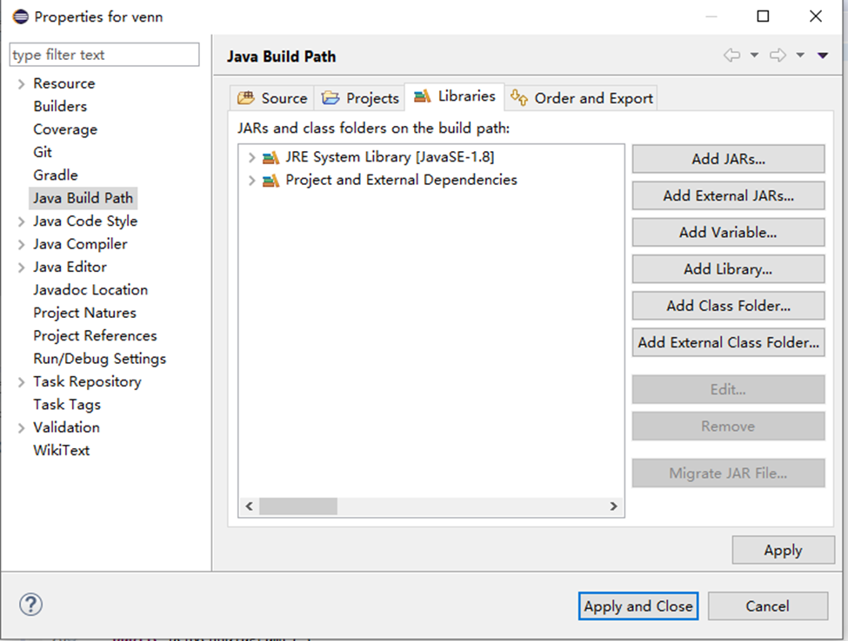

Figure 1: Venn Diagram Application uses Java SE 1.8 AND Java SE Runtime Environment 9

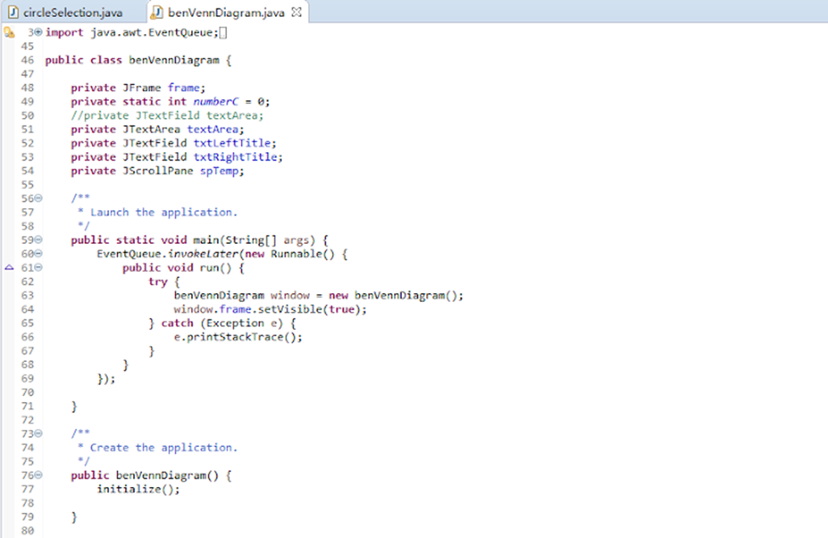

Figure 2: eclipse based on Java SwingBuilder coding

**3. Common Usage Scenarios**

If a user completed a survey consisting of 3 people on which sport, they would rather play, Soccer or Basketball. The user may want to create a simple Venn diagram to display the names of the individuals who chose Soccer or Basketball.

After launching the Venn diagram application, the user may change the title located at the top of the Venn diagram to ‘Soccer v Basketball’. In order to do this the user will have to click the ‘Insert Title’ located on the top of the Venn Diagram and type ‘Soccer v Basketball’. And after pressing enter the Venn diagram will have user’s desired title.

Now the user may want to add sub-titles (Soccer on the Left and Basketball on the right), and in order to do this, the user will have to click the ‘Insert Title’ located inside of the left circle and type ‘Soccer’, and then user will click the ‘Insert Title’ located inside of the right circle and type ‘Basketball’.

After doing all that, the user will enter the names of the individuals who selected Soccer. In order to do this the user will click the under the subtitle ‘Soccer’ the amount of times of how many individuals chose Soccer. In this case, the user will click 2 times and the following text should appear:

- This is text number 1

- This is text number 2

Now the user can highlight this text, erase it and type the names of the two individuals that selected Soccer. In this case those names are Messi Ronaldo and Alex White

For the right side the user will click once under the subtitle ‘Basketball’ and the following text should appear.

- This is text number 1

Now the user can highlight this text, erase it and type the names of the individual that selected Basketball. In this case that name is James Kobe.

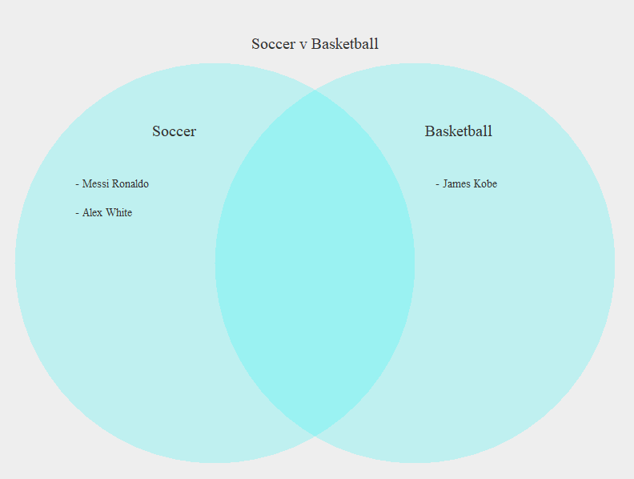And the Venn diagram should look like:

Figure 3: Venn Diagram Application Common Usage Scenario

**4. How to Get Started**

After downloading the Venn Diagram Application, run the .jar file in order to launch the application.

Once the application is launched successfully, read the next section for help on using the Application.

If there is any trouble downloading the application refer to the google drive below.

[*https://drive.google.com/open?id=1A6OWV_i_tlbMZk5hJzyhaUVV07LPR8vK*](https://drive.google.com/open?id=1A6OWV_i_tlbMZk5hJzyhaUVV07LPR8vK)

Copy and paste the link into the Google Chrome browser or any other browser and click on the .jar file. Then click the download option and the application will launch itself.

**5. Using the System**

Once you start the Venn Diagram Application, the program should look like this:

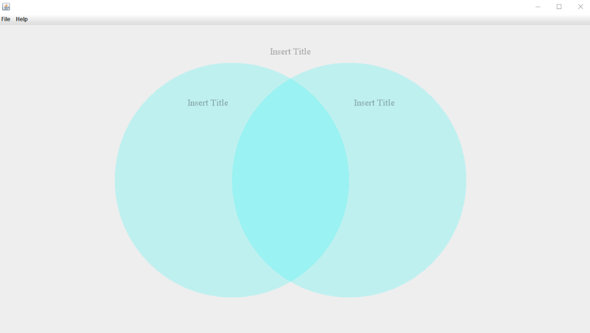

Figure 4: Venn Diagram Application Startup Page

The following sub-sections provide detailed, step-by-step instructions on how to use the various functions or features of the Venn Diagram Application.

### 5.1 ‘Insert Title’ Feature

In this area you can customize the title to your desire

*To customize the title:*

* 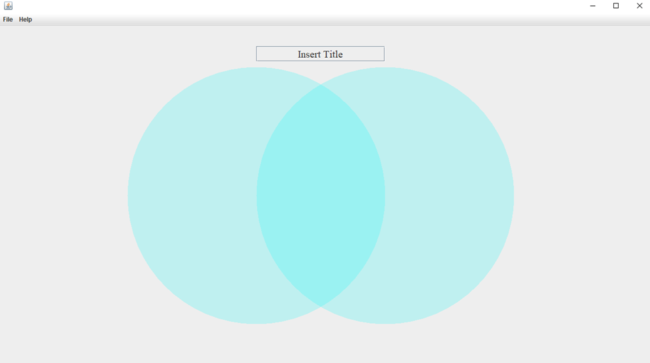Click on the ‘Insert title’ box to edit the title

Figure 5: Venn Diagram Application ‘Insert Title’

* Now type the desired title edit for your Venn Diagram and press the ‘Enter’ key

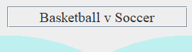

Figure 6: Venn Diagram Application new title ‘Basketball v Soccer’

*The same process is with the sub-title*

**5.2** **‘Adding entries to the Venn Diagram’ Feature**

These entries allow you to customize the text to your desire

*To add an entry to the left side of the Venn Diagram:*

* Click anywhere inside the boundaries of the left circle which does not intersect the boundaries of the right circle, and is underneath the sub-title
* Upon clicking, a text should appear ‘This is text number (entry number)’

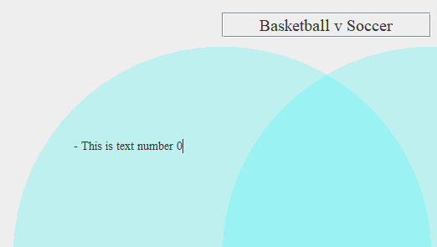

Figure 7: New entry to the left side of the Venn Diagram

* In order to change the text, you must erase the current text and then enter your desired text

Figure 8: User entry to the left side of the Venn Diagram

*To add an entry to the middle of the Venn Diagram:*

* Click anywhere inside the boundaries of the left circle which intersect the boundaries of the right circle
* Upon clicking, a text should appear ‘This is text number (entry number)’

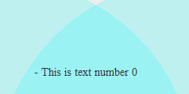

Figure 9: New entry to the middle of the Venn Diagram

* 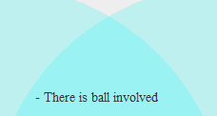In order to change the text, you must erase the current text and then enter your desired text

Figure 10: User entry to the middle of the Venn Diagram

*To add an entry to the right side of the Venn Diagram:*

* Click anywhere inside the boundaries of the right circle which does not intersect the boundaries of the left circle, and is underneath the sub-title
* Upon clicking, a text should appear ‘This is text number (entry number)’

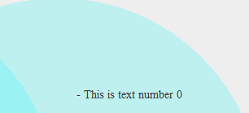

Figure 11: New entry to the right side of the Venn Diagram

* 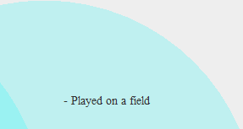In order to change the text, you must erase the current text and the enter your desired text

Figure 12: User entry to the right side of the Venn Diagram

**5.3** **‘Menu Bar’ Feature**

Menu bar contains the buttons ‘file’ and ‘help’ that contain sub-buttons that have functions.



Figure 13: Menu Bar

#### 5.3.1 ‘File’ Button

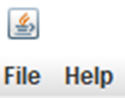 The ‘File’ button contains a save, open, and exit button.

Figure 14: File Button

**5.3.1.1 ‘Save’ Button**

The ‘Save’ button allows the user to save the current Venn Diagram Application file to their computer.

This button will be functional in a later version of the application.

**5.3.1.2 ‘Open’ Button**

The ‘Open’ button allows the user to open a saved Venn Diagram Application file from their computer.

This button will be functional in a later version of the application.

**5.3.1.3 ‘Exit’ Button**

The ‘Exit’’ button allows the user to close the current Venn Diagram Application without saving.

Figure 15: Exit Button

* Click the ‘File’ button on the top left corner

Figure 16: File Button

* Click the ‘Exit’ button on the drop-down menu of ‘File’ to exit the program

Figure 17: Exit Button

#### 5.3.2 ‘Help’ Button

The ‘Help’ button contains an about button.

Figure 18: Help Button

**5.3.2.1 ‘About’ Button**

The ‘About’ button allows the user to access help information regarding the Venn Diagram Application.

This button will be functional in a later version of the application.

Appendix A: Record of Changes

Table 1 - Record of Changes

| Version Number | Date | Author/Owner | Description of Change |
| --- | --- | --- | --- |
| 1.0.0 | 01/26/2020 | Group 12 | 1st Version of Product |
| 1.1.0 | 02/09/2020 | Group 12 | 1st Version of Prototype |
| 1.2.0 | 02/23/2020 | Group 12 | 2nd Version of Prototype |