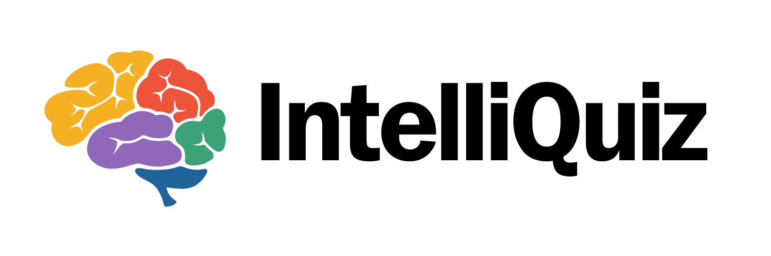

**Your Score {{score}}**

{% repeating-section questions %}

1. **{{question}}**
   * Correct answer: {{correctAnswer}}
   * Your answer: {{userResponse}}
   * Explanation: {{explanation}}

{% end-section %}

**Feedback**

{{feedback}}