Code Deploy Configuration

## Create CodeDeploy Service role.

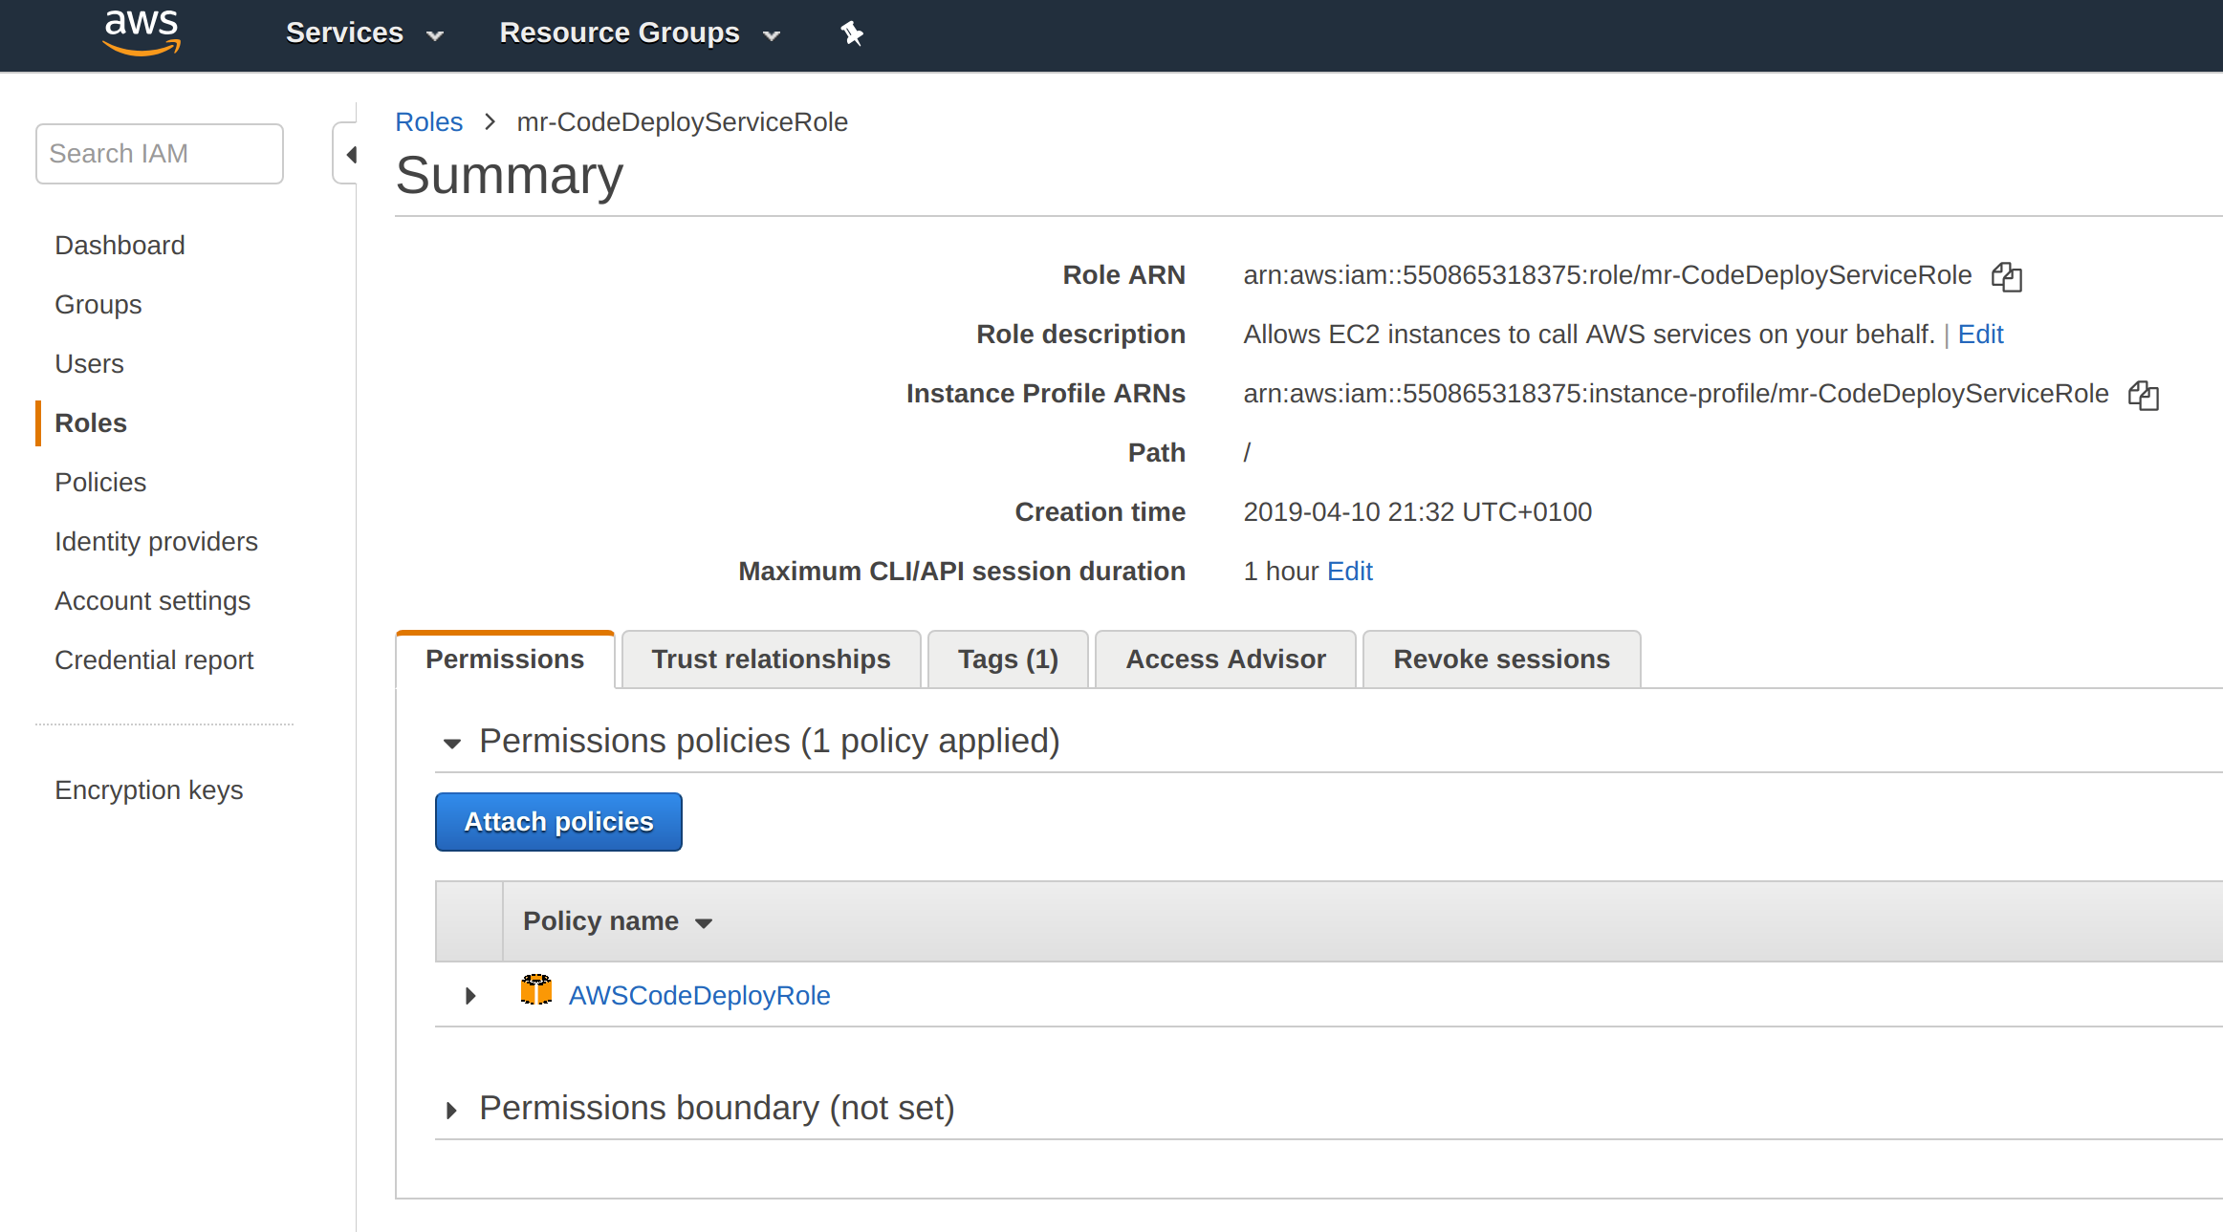

Edit the "Trust relationships" and change the service to "codedeploy.amazon.com"

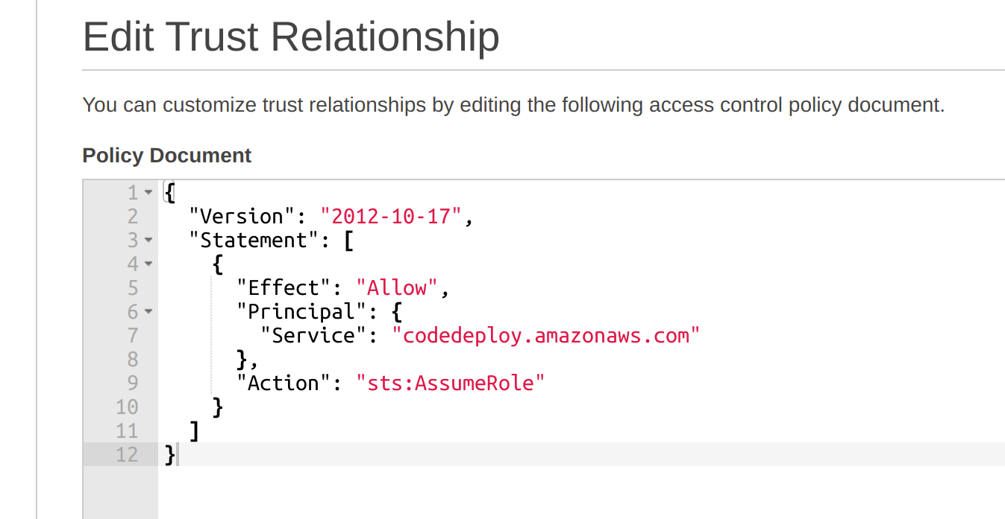

## Create Code Deploy Application

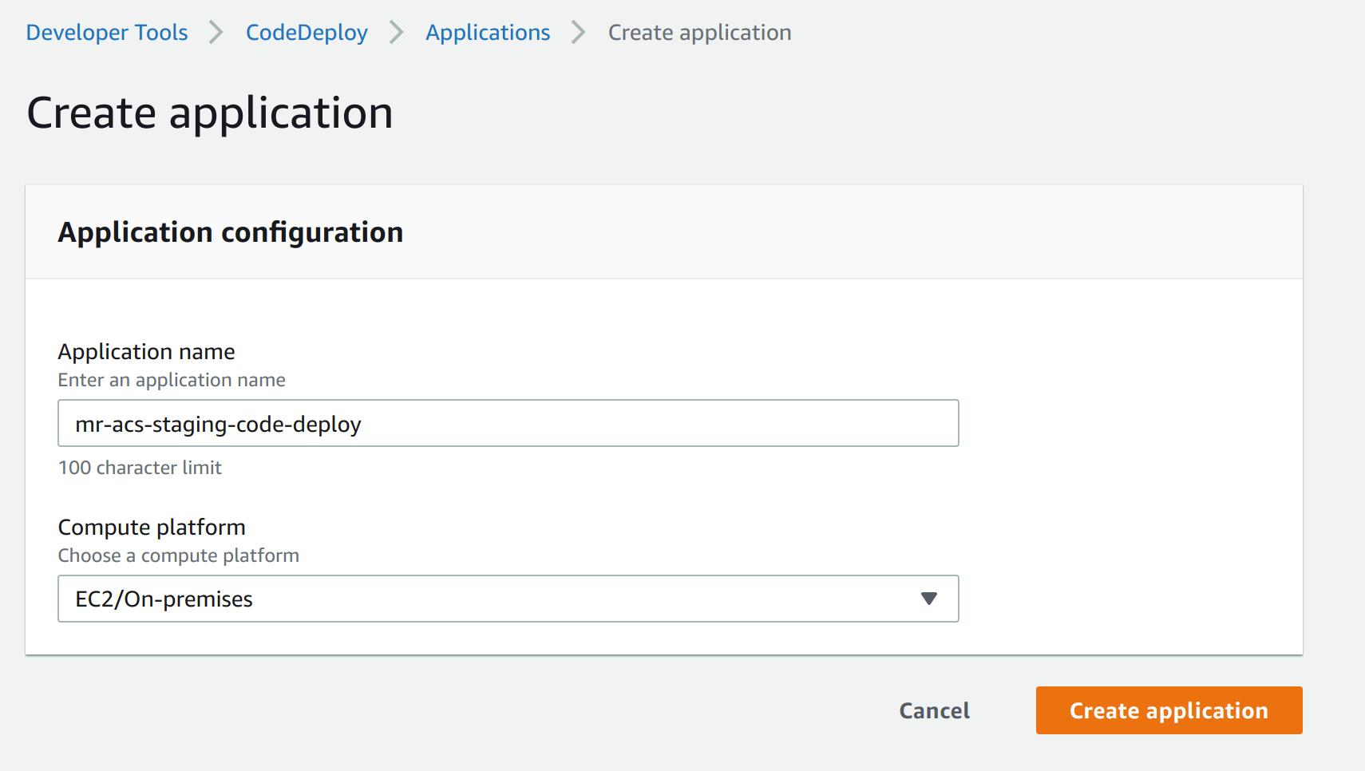

## Create deployment group

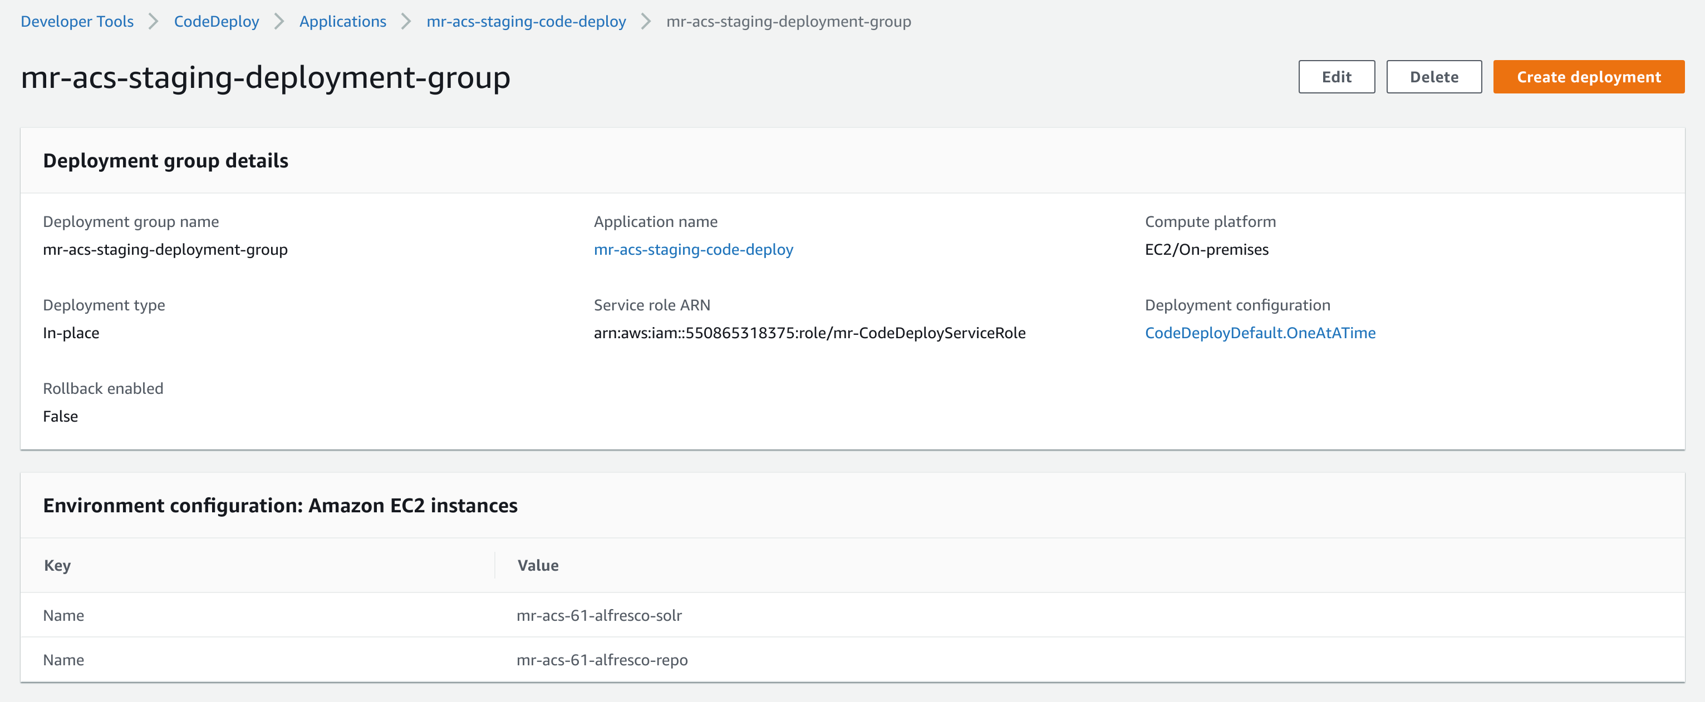

## Create deployment

Upload CodeDeployment application zip file to a S3 bucket i.e. s3://mr-acs-61-code-deploy/alfresco-code-deploy.zip

