**ATOC7500 – Application Lab #4**

**Spectral Analysis of Timeseries**

**Notebook #1 – Spectral analysis of hourly surface air temperatures from Fort Collins, Colorado at Christman Field**

**ATOC7500_applicationlab4_fft_christman.ipynb**

**LEARNING GOALS:**

1) Complete a spectral analysis using two different functions in Python (direct FFT from numpy and using scipy which has more options). Describe the results including an interpretation of the spectral peaks and an assessment of their statistical significance.

2) Contrast applying a Boxcar and a Hanning Window when calculating the power spectra. What are the advantages/disadvantages of these two window types? What are the implications for the resulting power spectra?

**DATA and UNDERLYING SCIENCE:**

In this notebook, you analyze two years (January 1, 2013 thorugh December 31, 2014) of hourly surface temperature observations from Christman Field in Fort Collins, Colorado. Missing data have been already treated. The data are in .csv format and are called Christman_data_nomissing.csv.

**Questions to guide your analysis of Notebook #1:**

1) Look at your data. What are the autocorrelation and e-folding time of your data? What spectral peaks do you expect to find in your analysis and how much power do you think they will have?

The autocorrelation is 0.99 and the e-folding time is 100.92 hours. This suggests the dataset contains a lot of memory. We would expect spectral peaks for 1-day long periods $\left(1.1×{10}^{-5} Hz\right)$ and 1-year long periods $\left(3.17×{10}^{-8} Hz\right)$. The small frequency peaks are expected to have more power (1-year-long periods) compared to the diurnal frequency peaks because the temperature change is larger.

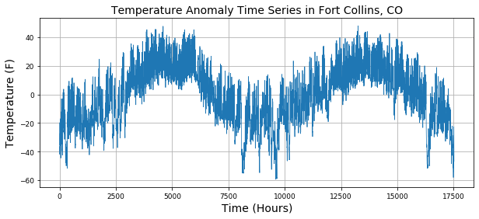

2) Calculate the power spectra using the Numpy method, which assumes a Boxcar window that is the length of your entire dataset. Graph the power spectra, the red noise fit to the data, and the 99% confidence interval. What statistically significant spectral peaks did you find? What do they represent? How did you assess the statistical significance (what is the null hypothesis that you are trying to reject)? Compare back to Barnes and Hartman notes to make sure all of the equations and functions in the notebook are working as you expect them too.

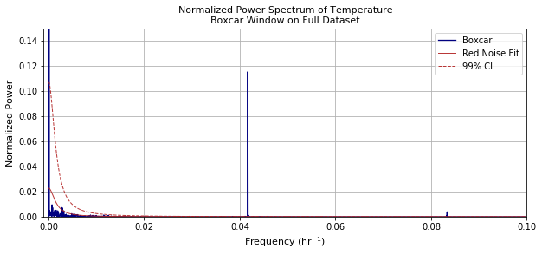

Statistically significant peaks at following periods: [1 year, 1 day, 0.99 day, 0.5 day].

Null hypothesis: The data is red noise.

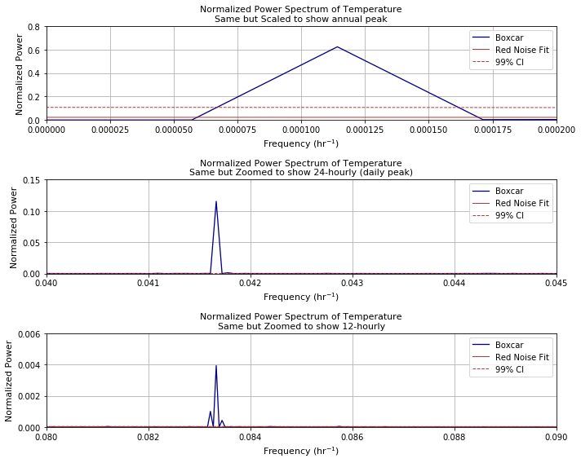

3) Calculate the power spectra using the scipy method. Check that you get the same result as you got using the Numpy method. Next – compare the power spectra obtained using both a Boxcar window and a Hanning window. Assume a window length that is the entire length of the dataset. Do you get the same statistically significant peaks when applying the Hanning window and the Boxcar window? How do they differ? Can you explain why?

Both methods display the same result. The Hanning window displays more significant spectral peaks than the Boxcar window. The Boxcar window adds side lobes to the spectrum, while the Hanning window broadens the peaks in the spectrum

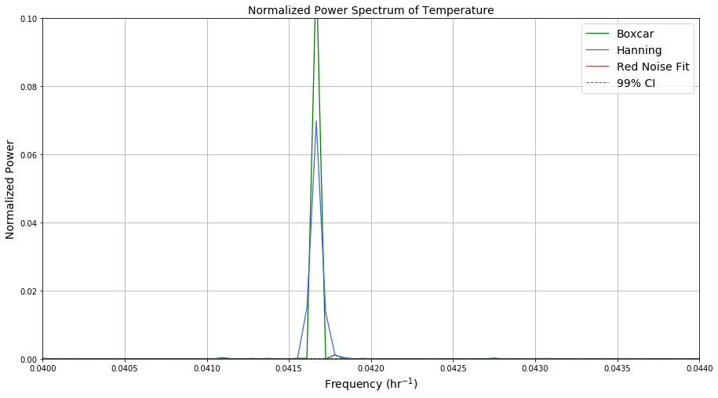

*4) If time – take a look at other surface meteorological variables in the dataset. Do you obtain similar spectral peaks?*

**Notebook #2 – FFT analysis using Dome-C Ice Core Data**

**ATOC7500_applicationlab4_fft_EPICA.ipynb**

**LEARNING GOALS:**

1) Calculate power spectra of a dataset available on a non-uniform temporal grid. Describe the results including an interpretation of the spectral peaks and an assessment of their statistical significance.

2) Contrast applying a Boxcar and a Hanning Window when calculating the power spectra. What are the advantages/disadvantages of these two window types? What are the implications for the resulting power spectra?

3) Apply a Hanning Window with various window lengths - What are the advantages/disadvantages of changing the window length and the implications for the resulting power spectra in terms of their statistical significance and temporal precision?

4) Apply a Hanning Window with various window lengths and use Welch’s method (Welch’s Overlapping Segment Analysis, WOSA). How does WOSA change the results and why?

**DATA and UNDERLYING SCIENCE:**

In this notebook, you will perform a power spectral analysis of the temperature record from the Dome-C Ice Core, taken at 75 South and 123 East (Jouzel et al. 2007). The temperature data go back ~800,000 years before present. They are unevenly spaced in time. The data are available on-line here, courtesy of the NOAA Paleoclimatology Program and World Data Center for Paleoclimatology:

ftp://ftp.ncdc.noaa.gov/pub/data/paleo/icecore/antarctica/epica_domec/edc3deuttemp2007.txt More information on the data is available at:

https://www.ncdc.noaa.gov/paleo-search/study/6080

**Questions to guide your analysis of Notebook #2:**

1) Look at your data and pre-process for FFT analysis: Power spectra analysis assumes that input data are on an evenly spaced grid. The Dome-C temperature data are not uniformly sampled in time. Regrid the Dome-C temperature data to a uniform temporal grid in time. Plot the data before and after re-gridding to make sure the re-gridding worked as expected.

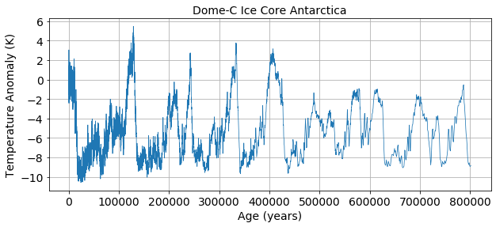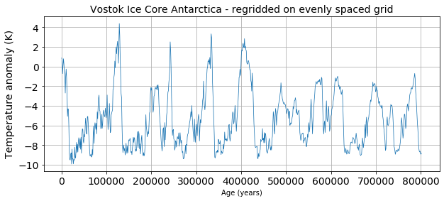

2) Signal and Noise: What is the autocorrelation and e-folding time of your data? What spectral peaks do you expect to find in your analysis and how much power do you think they will have? *Hint: Think back to the Petit 1999 Vostok ice core dataset discussed in class.*

The autocorrelation is 0.96 and the e-folding time is 25 years.

We expect to have spectral peaks at the following periods: 100000 year and 40000 year. The power of the 100000 year period is expected to be larger than for the 40000 year period.

3) Use Boxcar Window to calculate power spectra: Calculate the power spectra using the Numpy method, which assumes a Boxcar window that is the length of your entire dataset. Graph the power spectrum, the red noise fit to the data, and the 99% confidence interval. What statistically significant spectral peaks did you find? What do they represent?

The statistically significant spectral peaks occur at frequencies of $0.01 {milenia}^{-1}$, $0.025 {milenia}^{-1}$, $0.0425 {milenia}^{-1}$ and $0.04375 {milenia}^{-1}$.

The $0.0425 {milenia}^{-1}$ and $0.04375 {milenia}^{-1}$ frequencies correspond to Earth precession. The $0.01 {milenia}^{-1}$ frequency corresponds to glacial-interglacial changes.

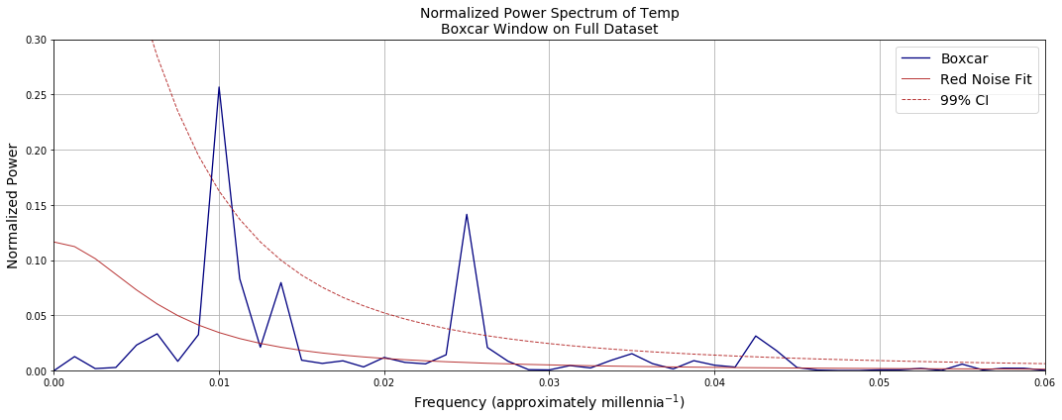

4) Compare Boxcar Window vs. Hanning Window: Calculate the power spectra using the SciPy method. Compare the results obtained using a Boxcar window that is the length of your entire dataset to those obtained using a Hanning window that is the length of your entire dataset. Graph the power spectrum, the red noise fit to the data, and the 99% confidence interval. What statistically significant spectral peaks did you find? What do they represent? What are the differences between the results obtained using the Boxcar window and the Hanning window? Is the intuition that you gained by looking at Fort Collins temperatures the same as what you are seeing here with Dome-C temperature records? Why or Why not?

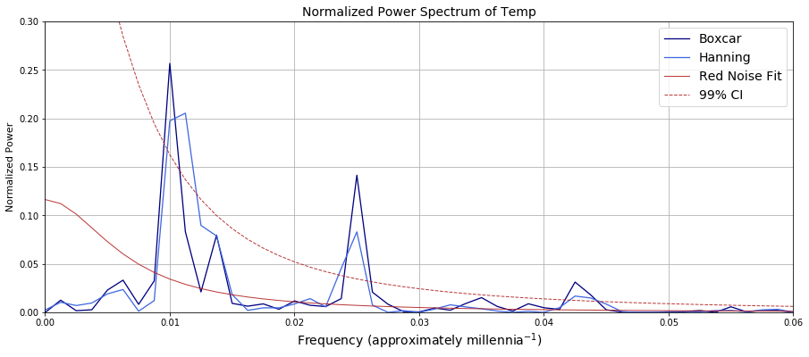

Using the Hanning window, the statistically significant spectral peaks occur at frequencies of $0.01 {milenia}^{-1}$, $0.01125 {milenia}^{-1}$ $0.02375 {milenia}^{-1}$ and $0.025 {milenia}^{-1}$. This method filters out the precessional cycle of the Earth. In general, the Hanning window redistributes power over similar frequencies.

5) Hanning Window with different window lengths: Using the SciPy method, compare the power spectra obtained using Hanning window with different window lengths. Graph the power spectra, the red noise fit to the data, and the 99% confidence interval. Did you find any statistically significant spectral peaks? How does decreasing the window length affect the temporal precision of the spectral peaks and their statistical significance? Did you find the classic tradeoff between 1) high spectral/temporal resolution but low quality statistics, and 2) high quality statistics but low spectral/temporal resolution?

Smaller Hanning windows results in broadening of the spectral peaks. Further, reducing the Hanning window emphasizes power at higher frequencies.

Reducing the Hanning window by half allows capturing both high and low frequency peaks for this dataset. 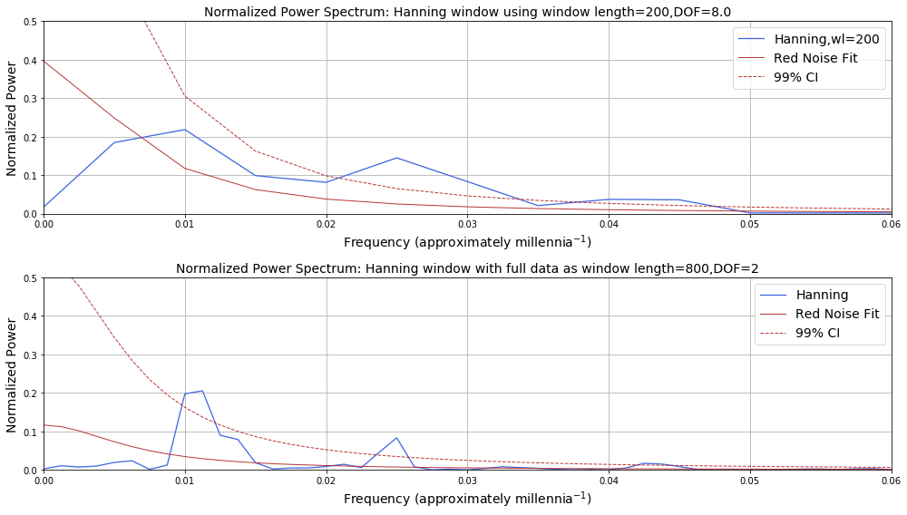

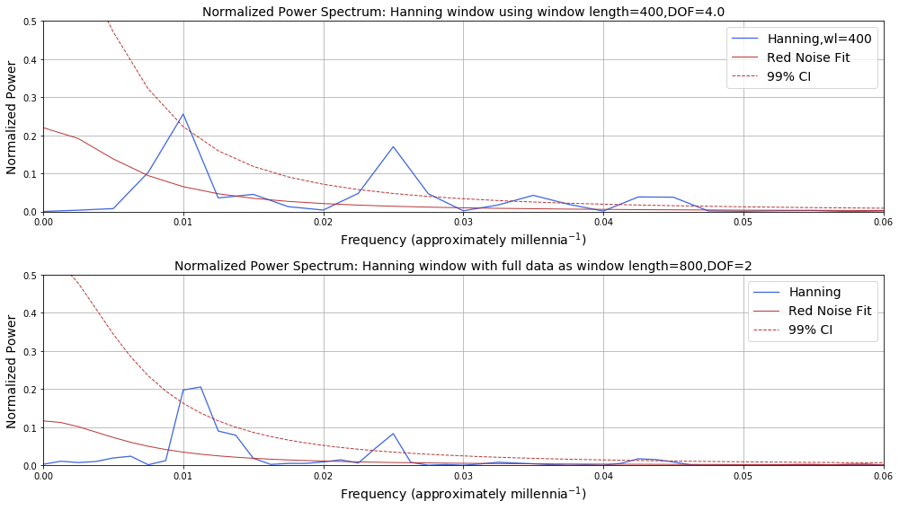

6) Add WOSA (Welch Overlapping Segment Averaging): Having found what you think is a good balance between precision in the identification of the spectral peaks and statistical significance – Try applying WOSA (Welch Overlapping Segment Averaging) in addition to using the Hanning Window with different window lengths. How does this change your results?

The Welch Overlapping Segment Averaging enables having higher spectral resolution and at the same time high-quality statistics.

