Response to Reviewer #2

General comments:
Andrew has made some interesting comments on our paper. He compares many of our results with his analytic theories. Andrew’s analytic work is of high quality, elegant and rigorous. The problem lies in the fact that he is necessarily describing idealised magnetic domain states, and transitions between these idealised states. The domain states and transitions in the analytic models are highly constrained because of the need to reduce an N-dimensional tensor that represents the highly structured internal demagnetising field, to that of a simple variable representing a nucleation field of a pre-defined magnetic state such as those proposed by Eisenstien and Aharoni (1977). The work of Eisenstein and Aharoni was a breakthrough in its time since it provided a way to consider different classes of non-uniform domain structures, beyond the classical Kittel view of domains and domain walls.
The advent of numerical micromagnetics, however, has vastly enhanced our ability to examine complex inhomogeneous domain structures. Numerical micromagnetics has applications in materials science, earth sciences and medical physics. From the early days of the first 3D unconstrained models in 1987, numerical micromagnetic analysis now results in nearly a thousand peer reviewed publications per year.
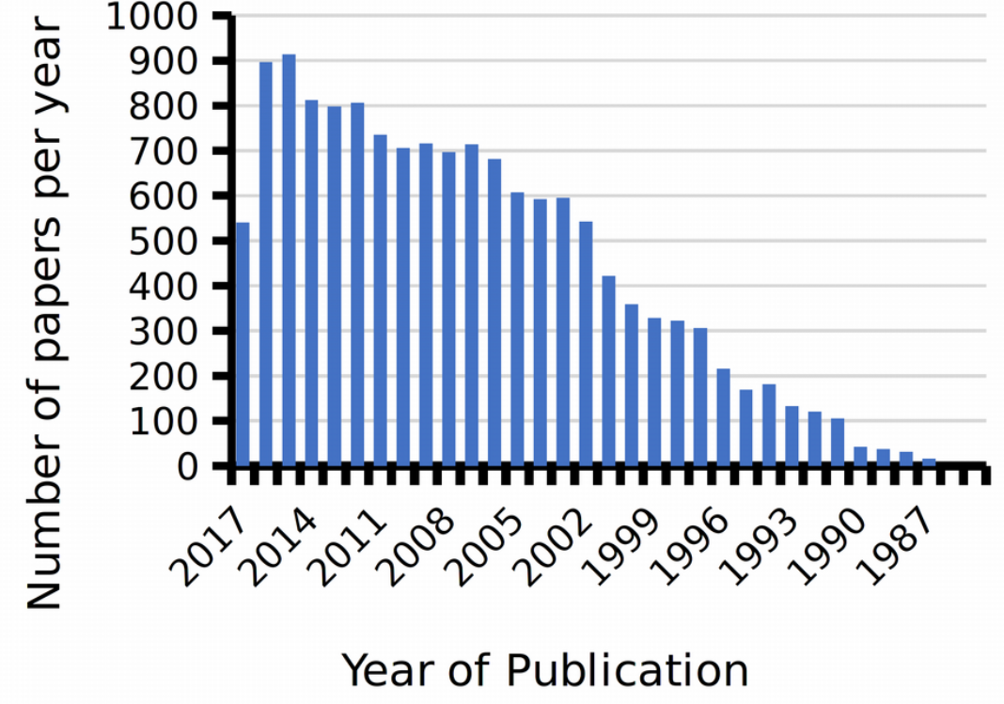
Figure 1: The number of peer-reviewed publications in micromagnetic modelling since the first 3-dimensional model published in 1987 (from Web of Science).

Reply to specific comments.

1) The value of K1 used.

The micromagnetic magnetic calculations we made are CPU intensive and it is impractical to repeat all our computations for a variety of different K values. The value of K1 we used after discussion with Michael Winklhofer, who made the original estimates in his 2014 paper. The negative anisotropy value we have used is now the most widely accepted value. Also, in Winklhofer’s study one of the conclusions is that both the negative and positive values for K1 give roughly the same value of anisotropic field, so large deviations in the micromagnetic behaviour using one value or the other are not to be expected.

2) Particle shape.

We are happy to use the term equant. In nature a variety of grain shapes will exist, both regular and irregular, equant and elongated. We do not attempt to replicate every possible grain shape here, and focus on equant shapes for simplicity and on the balance of evidence from publications.
The reviewer states that there has been a lot of work on greigite; however, few have examined grain morphology, and those that have all indicate that diagenetic greigite (the most common form of greigite) is nearly always equant, for example, see the work of Rowan and Roberts (2006) and Roberts (2015). Furthermore, the reviewer states that we only reference Snowball 1997 regarding greigite fine grains morphologies when in fact, we also have Chang et al. 2008, Vasiliev et al. 2008, Guowei et al. 2014 in section 2.2 (lines 125–127).

Rowan, C. J., and Roberts, A. P., 2006, Magnetite dissolution, diachronous greigite formation, and secondary magnetizations from pyrite oxidation: Unravelling complex magnetizations in Neogene marine sediments from New Zealand: Earth and Planetary Science Letters, v. 241, no. 1-2, p. 119-137

Roberts, A. P., 2015, Magnetic mineral diagenesis: Earth-Science Reviews, v. 151, p. 1-47.

3) SD/PSD critical sizes.

The reviewer here is simply wrong, and I find his statement puzzling. Contrary to the reviewer’s claim, grains with a size d<d_min does mean that it is not possible to nucleate a single vortex (SV) state in grains smaller than this value. For any random initial magnetization state grains smaller than d_min will form a uniform single domain state. If at d<d_min you put in as initial condition a domain state that nucleates in grains slightly larger size, then it spontaneously reverts to a SD state. This effect is explicitly calculated for seven different morphologies in our study.
The reviewer goes on to cast doubt on our values for d_max and d_min because they fail to agree with his analytic calculations. The problem with the analytic calculations, as stated before, is that they only consider nucleation fields resulting from perfectly uniform SD states and the perfect curling mode of Aharoni. Numerical micromagnetics have shown that even the SD state is not perfectly uniform, and that a certain amount of ‘flowering’ of the magnetisation results from the effect of the internal demagnetising field, and the vortex state will be slightly deformed from the analytic solution since the numerical micromagnetic solutions are able to more fully account for the effects of crystal anisotropy.
Nevertheless the reviewer finds a grains size of the single domain (SD) to single vortex (SV) in the middle of our range of d_min to d_max, which is exactly what one might expect of an analytic solution. Confusingly, the reviewer calls his computed transition grain size d_max, which it is not. Since he only finds a single size for the transition it should, in fairness, be compared to our value of d_0.
Of course, the stability and viability of any domain structure is most properly determined in terms of the energy barrier to other domain states, and this is exactly what we have done in this paper.
Finally, the reviewer suggests that since he sees a discrepancy with his analytic theories in the critical grain sizes for spheres, then the critical grain sizes for other grain morphologies are likely to be wrong. Our view is that the analytical calculations are consistent with our solutions given the limitations in the analytical models. Furthermore, numerical models are essential for determining domain structures in more realistic grain geometries (i.e. other than spheres).

4) How many states are there?

The review is quite right there are 16 possible states. However, when you examine the energy barriers between all possible domain states, then they infact reduce to one, which is the transition of the vortex core between neighbouring easy anisotropy axes. This effect has been published by Nagy et al. 2017, and we now include this reference.
Text has been added to lines 432–438.

5) Energy barriers.

This problem is related to that of item 4 above. The stability of any local energy minimum domain state will be dominated by the lowest energy barrier to any other domain state that can be found. Without a doubt there will be more than two domain states possible in any equant shaped grain (although not 60 as claimed here; there are exactly 16 possible states as indeed the reviewer stated previously). If we calculate all energy barriers between all possible combinations of domain states we might end up with N different energy barriers ΔE_{N}, and relaxation times τ_{N}. The effective relaxation time of the system will be given approximately as and so dominated by the smallest relaxation time. Where the lowest energy barrier is degenerate then indeed we need to take this into account. In real grains this will rarely be the case. However, in the regular geometries modelled here the review is correct and it is an effect that we must take into account. The number of degenerate states will be defined by the crystal anisotropy, and so in our case will mean there are three degenerate paths from the lowest energy [111] aligned vortex. Thus our relaxation times will be three times lower than those quoted in the paper.
We appreciate that the reviewer would like us to use his analytic method for determining stability of domain states, but instead we use the tried and tested nudged elastic band method, appropriate to unconstrained numerical models.
Text has been added to lines 432–438. Figure 9 has been amended to reflect these changes. The changes are very small as the relaxation time increases exponentially with size so our conclusions hold.

Reply to detailed comments

Line 32 – We quoted the Ms value in the units obtained from the reference. We concede that it is not in the most ready form for micromagnetic calculations. This has been amended to units A/m.

Line 99 – The LLG equation describes the equation of motion of the internal effective field on the local magnetisation. The fact that numerically we add far greater damping than physically likely, does not invalidate the statement that the LLG disturbs the magnetisation towards a lower energy state in a way that is “more robust and physically meaningful” than a direct energy minimisation technique just such as Euler or Conjugate Gradient.

Line 172 – We do not agree with the suggestion from the reviewer that precession on an atomic scale invalidates the requirement for a macroscopic domain structure to follow the minimum energy path during domain switching. Analytic calculations of Stoner and Wohlfarth (1948) and Néel (1955) are the cornerstone of early Paleomagetism and Magnetic recording industry – all based on the idea of coherent rotation of magnetisation along a minim energy path. Of course thermal fluctuations produce a random perturbation of the magnetisation, but clearly these, nor the spin precession, nor the magnon amplitudes break the exchange coupling between atoms or dominate the effective fields that constrain the magnetisation to occupy the lowest energy domains states, even during a domain reversal. This is really a standard and widely accepted technique. A few references are given below.

Dittrich R, Schrefl T, Suess D, Scholz W, Forster H, Fidler J. A path method for finding energy barriers and minimum energy paths in complex micromagnetic systems. J Magn Magn Mater. 2002;250(1-3):L12–9.
Neu V, Schulze C, Faustini M, Lee J, Makarov D, Suess D, et al. Probing the energy barriers and magnetization reversal processes of nanoperforated membrane based percolated media. Nanotechnology. 2013 Apr 12;24(14):145702.
Song K, Lee SC, Lee KJ. Magnetic field dependence of energy barrier of perpendicular nanomagnet. Ieee T Magn. 2014 Nov 1;50(11):1–4.
Trushin OS, Barabanova NI. Peculiarities of the energy landscape of a rectangular magnetic nanoisland. Russian Microelectronics. 2017 Sep 1;46(5):309–15.

