Template and instructions
First Author¹, Second Author2 and Third Author3*

^{1, 2} Authors’ Department, Organization, Country
³ Author’s Department, Organization, Country
*Corresponding author: thirdauthorsname@aaaa.bbb

ABSTRACT – Abstract should contain approximately 100 to 150 words.
Keywords: One; two; three
- INTRODUCTION
Papers must be written in English and not exceed 12 pages (including figures and appendices). Contributions should include unpublished results of research, case studies or experiences that provide new evidence about the research or application regarding to the main topics.
- FORMAT
Please ensure that your papers are formatted correctly using the provided template.
2.1 Table, figure and equations
Examples for tables and figures are, respectively Table 1 and Figure 1.
Table 1: Table caption
Properties | Data
xxxx | 1234
xxxx | 1234

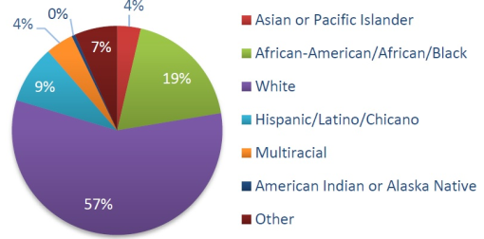
Figure 1: Figure title
Equations should be labeled as in Equation (1), with a number towards the right margin, if there is more than one equation.
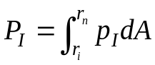 (1)
- SUBMISSION
You can fill in this template and then convert to Pdf format.
Your extended abstract must be submitted using the SMaDE 2025 submission page, accessing “Submit via CMT-3”:
https://eddsac.com/SMaDE/Smade2025.html

REFERENCES
References should be listed as cited in the text, using reference numbers and presented in the following format:
[1] Berawi, M.A., (2004). Quality Revolution: Leading the Innovation and Competitive Advantages. International Journal of Quality & Reliability Management, Volume 21(4), pp. 425–438 (Journal articles)
[2] Harris, M. (2014). The GRO Green Roof Code. Final report of Green Roof Code of Best Practice for the UK 2014. Available online at: https://livingroofs.org/wp-content/uploads/2016/03/grocode2014.pdf, Accessed on 14 February 2017

