VBA_challegue

Table of Contents

Instructions 1

Screenshots 2

2016 2

2014 4

# Instructions

• Create a script that will loop through all the stocks for one year for each run and take the following information.

* The ticker symbol.
* Yearly change from opening price at the beginning of a given year to the closing price at the end of that year.
* The percent change from opening price at the beginning of a given year to the closing price at the end of that year.
* The total stock volume of the stock.

• You should also have conditional formatting that will highlight positive change in green and negative change in red.

Your solution will also be able to return the stock with the "Greatest % increase", "Greatest % Decrease" and "Greatest total volume".

### Other Considerations

* Use the sheet alphabetical_testing.xlsx while developing your code. This data set is smaller and will allow you to test faster. Your code should run on this file in less than 3-5 minutes.
* Make sure that the script acts the same on each sheet. The joy of VBA is to take the tediousness out of repetitive task and run over and over again with a click of the button.

# Running the macro(script)

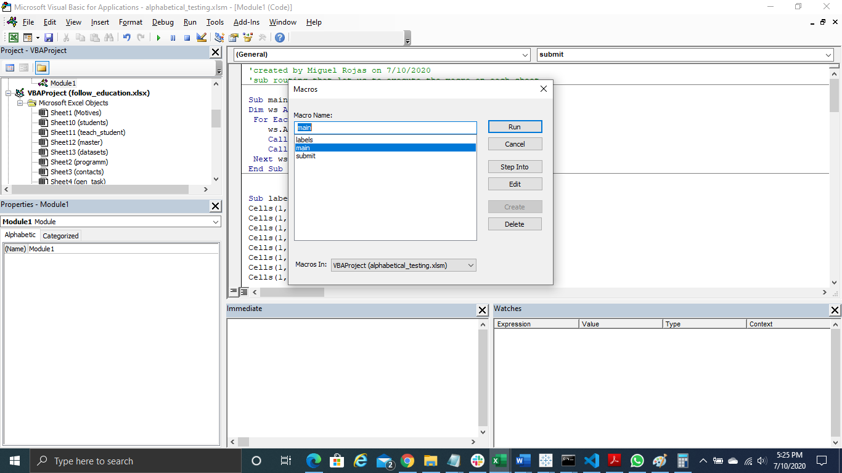

# Screenshots

The macro was ran by the entire Multiple_year_stock_data (2016,2015,2014), I uploaded to github a small set of data, the file is called Multiple_year_stock_data_small_ver (it includes the macro), just in case you need to run the macro.

I did not load the complete file to GitHub because of git hub size file restriction; the following results were ran on my local computer that include the complete set of data of Multiple_year_stock_data (2016,2015,2014) file.

## 2016

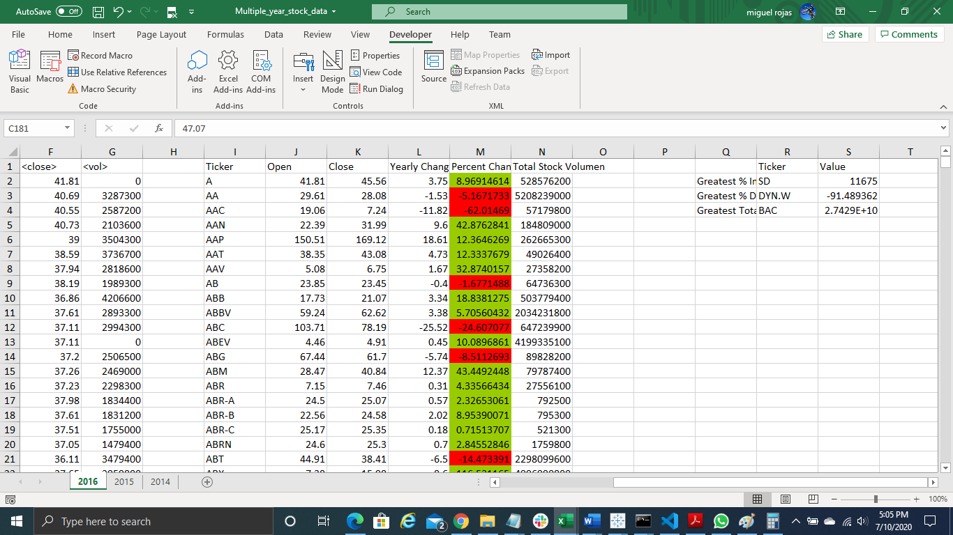

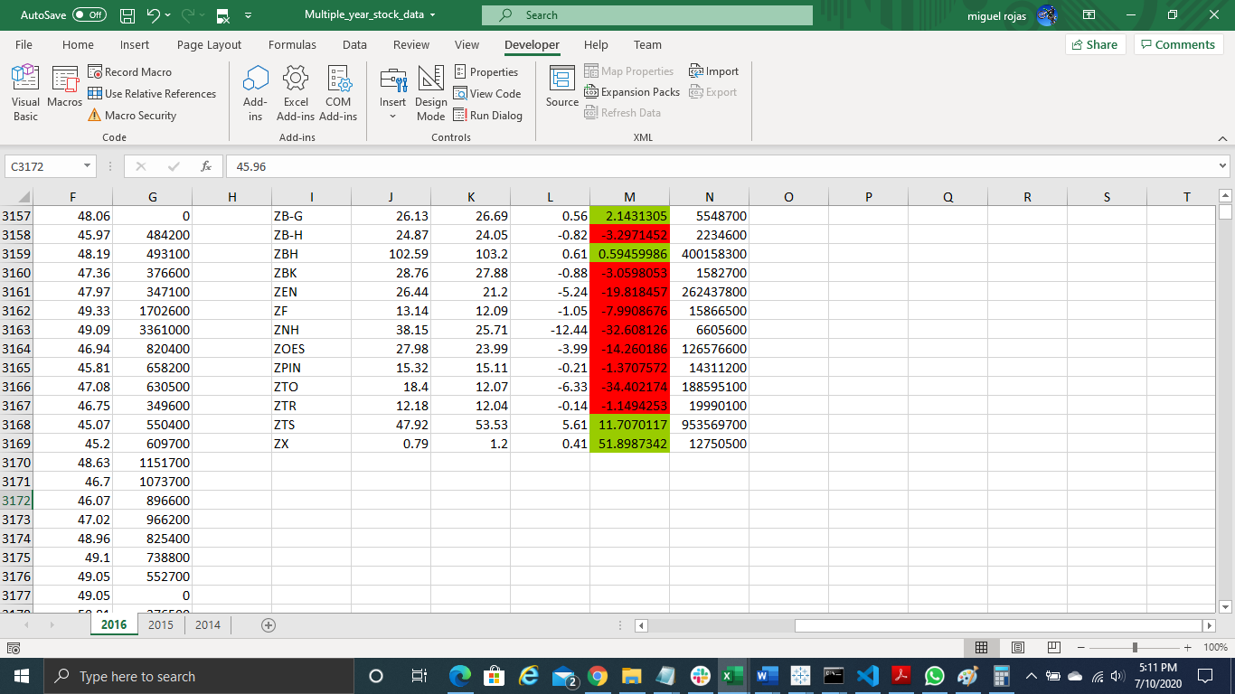

2015

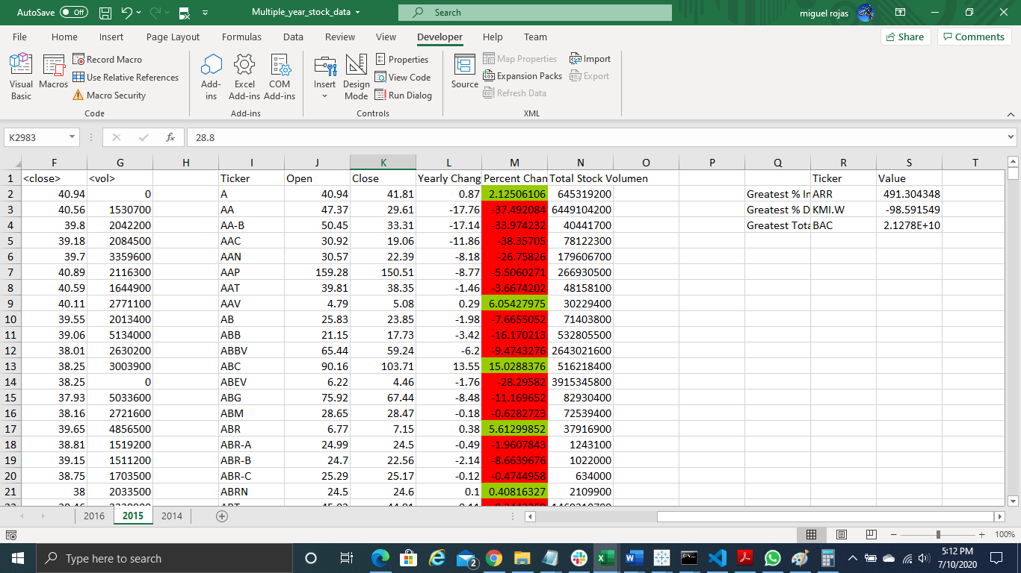

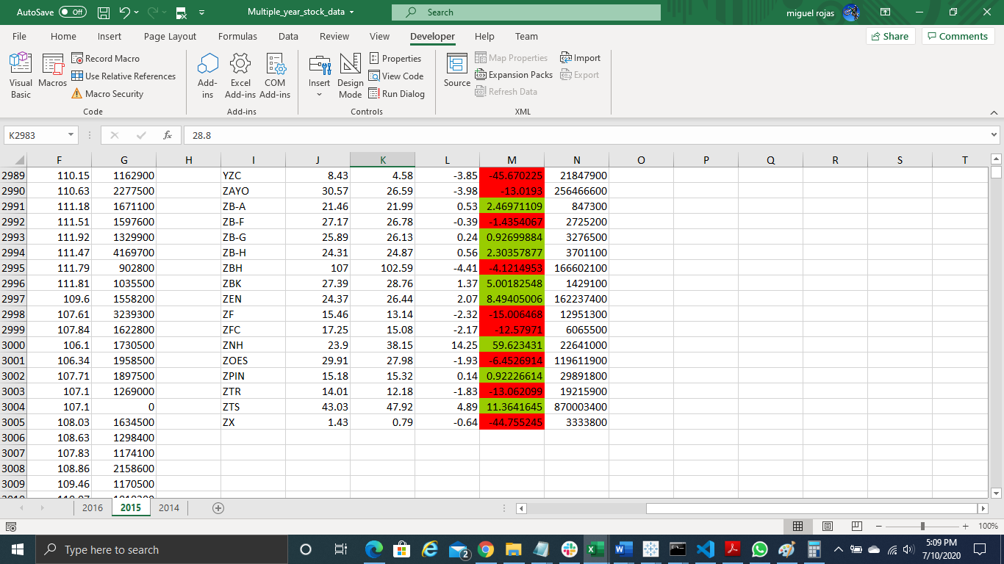

## 2014

