# UFO-level-1

# Selecting data from table:

Enter date as a filter to get the corresponding records.

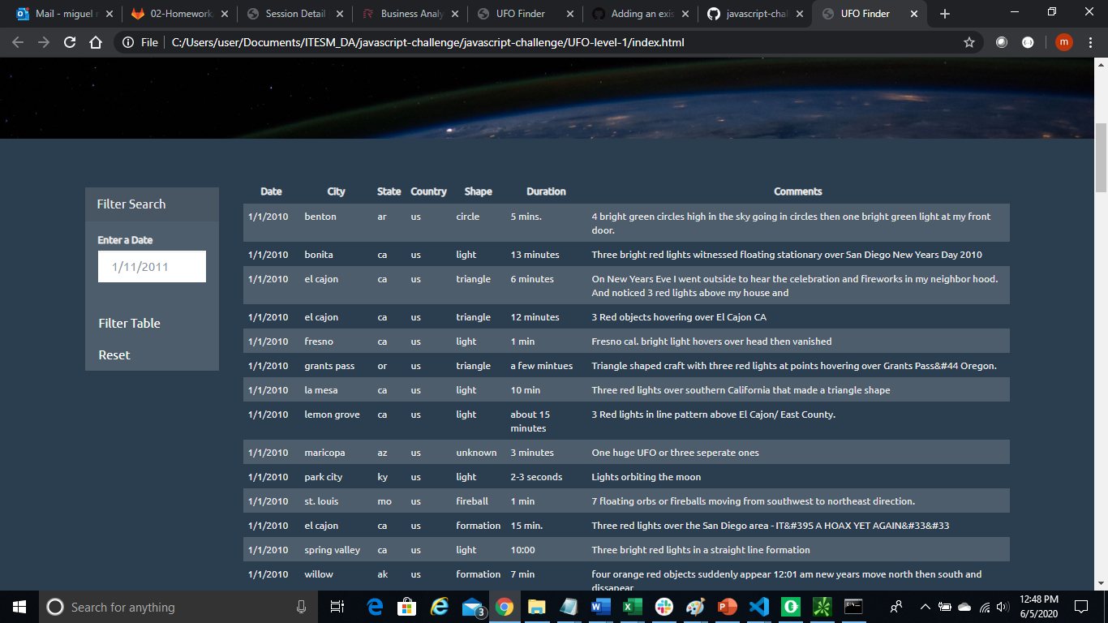

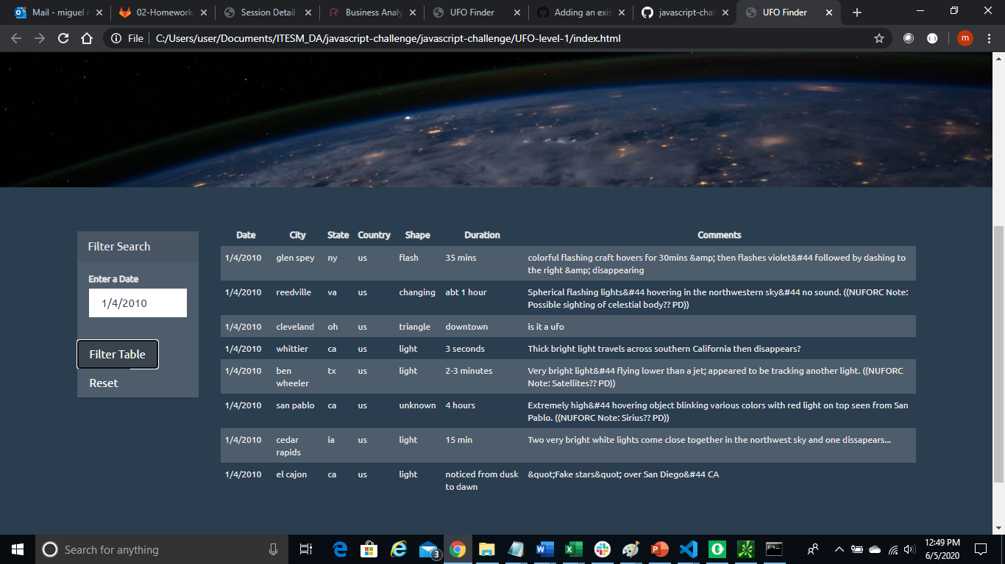



# UFO-level-2.

Select criteria works on the below fields, the application use only one input to search across all of them.

Selecting data from :

1. date/time
2. city
3. state
4. country
5. shape

by State

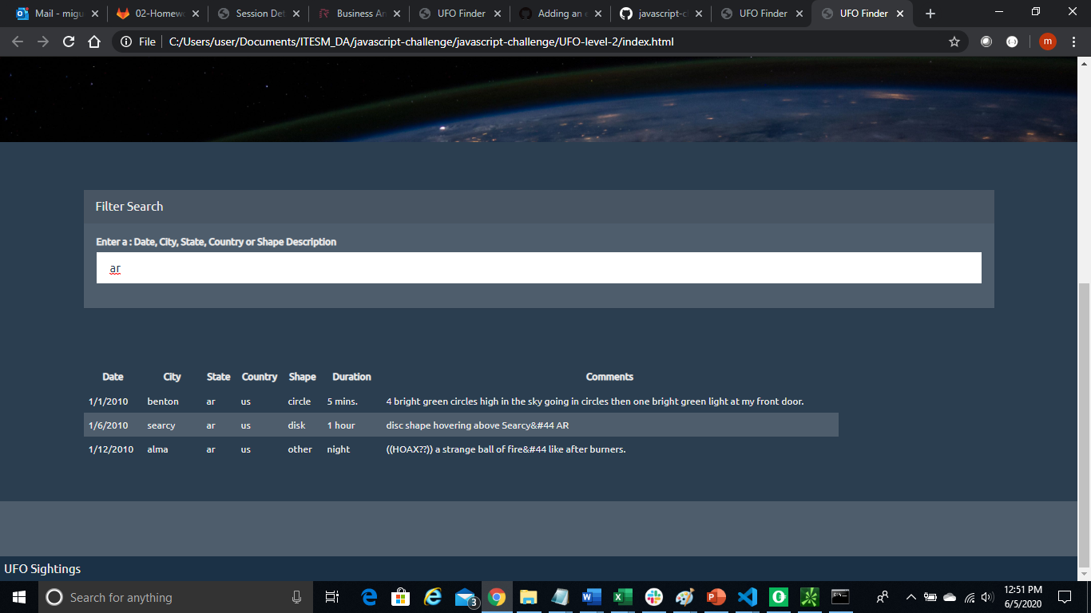

All option (display all base data table)

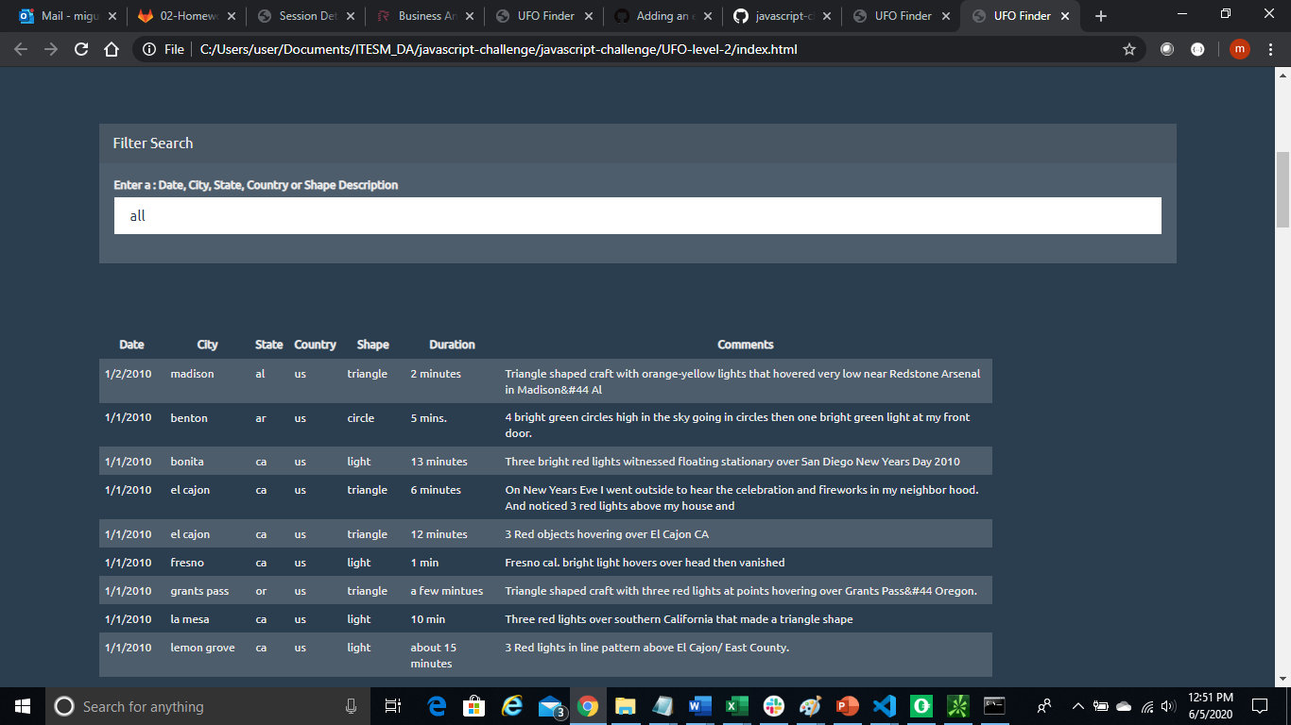

By shape:

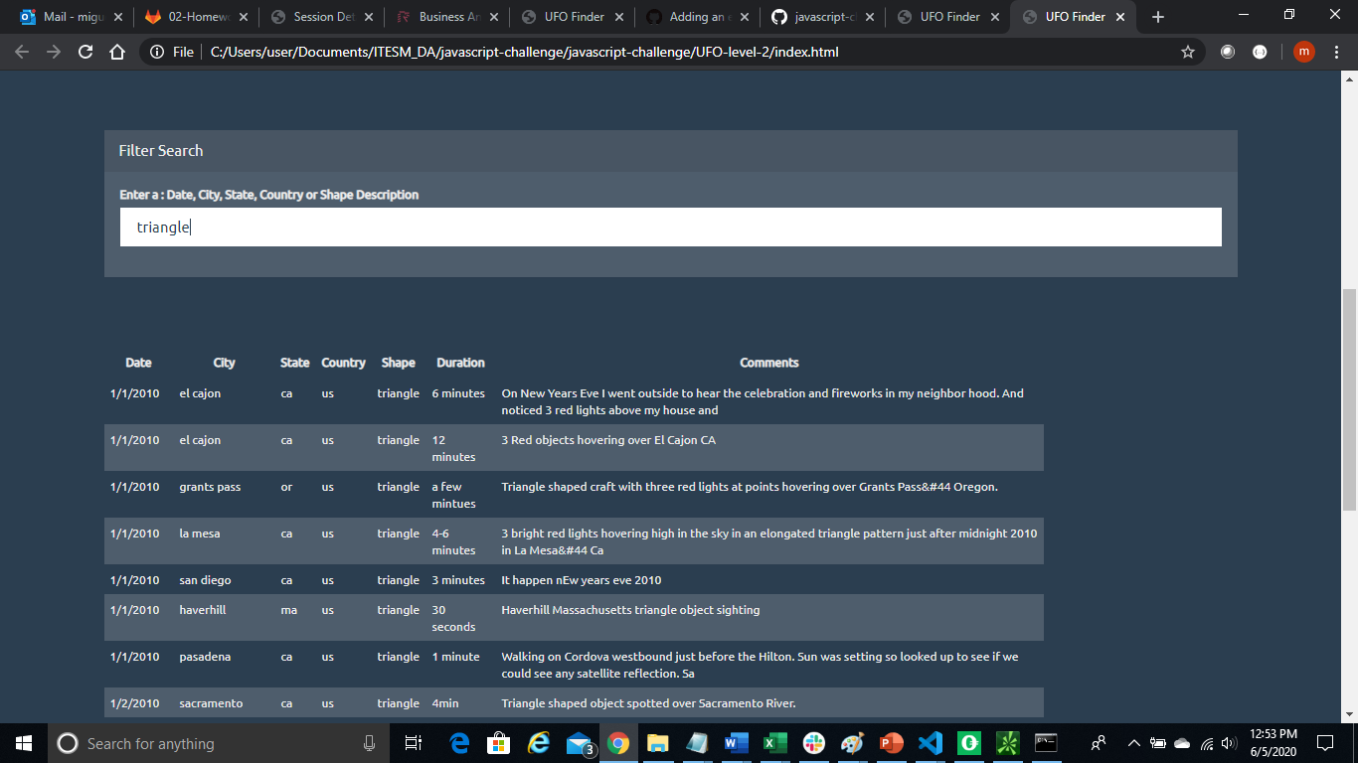

By country:

