Contents

Web Scraping Mission to Mars 1

Step 1: Get the latest mar news. 1

Step 2: Get the picture feature. 1

Step 3: Get the current weather from tweeter post. 2

Step 4: Get mars hemisphere pictures: 3

Mongo DB and Collection 5

Application Architecture Diagram: 5

# Web Scraping Mission to Mars

# Step 1: Get the latest mar news.

# Step 2: Get the picture feature.

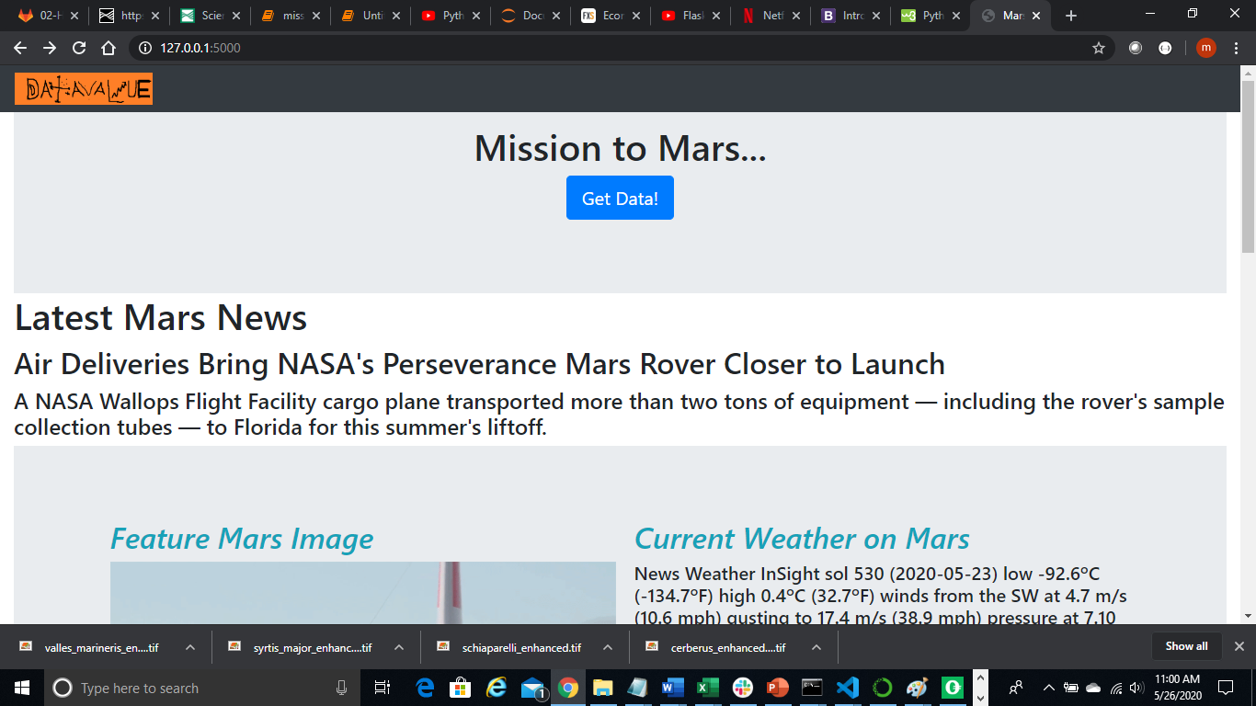

# Step 3: Get the current weather from tweeter post.

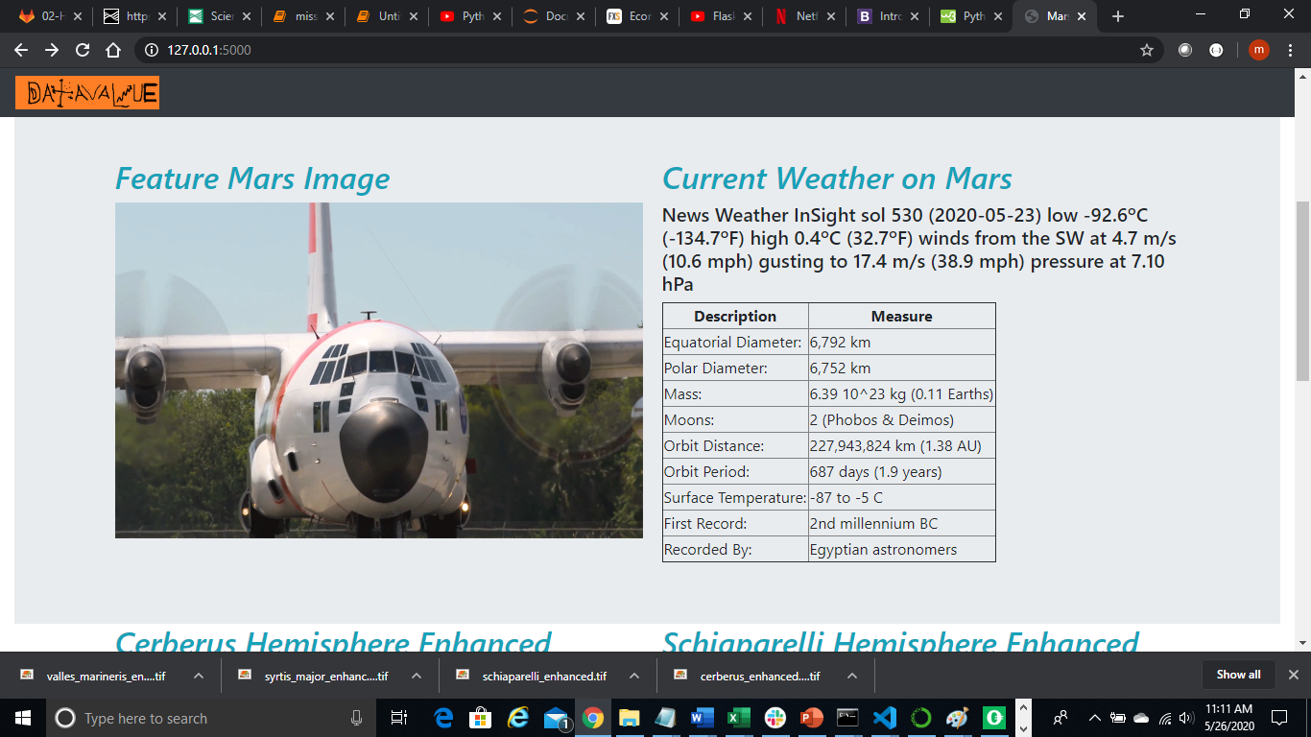

# Step 4: Get mars hemisphere pictures:

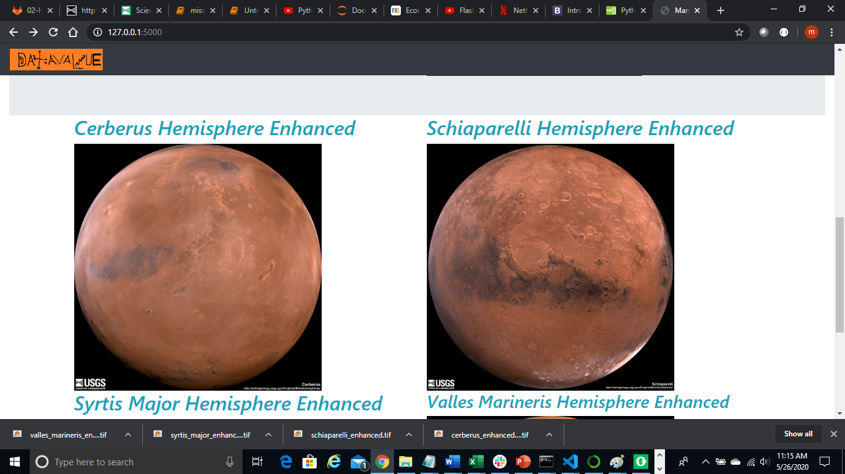

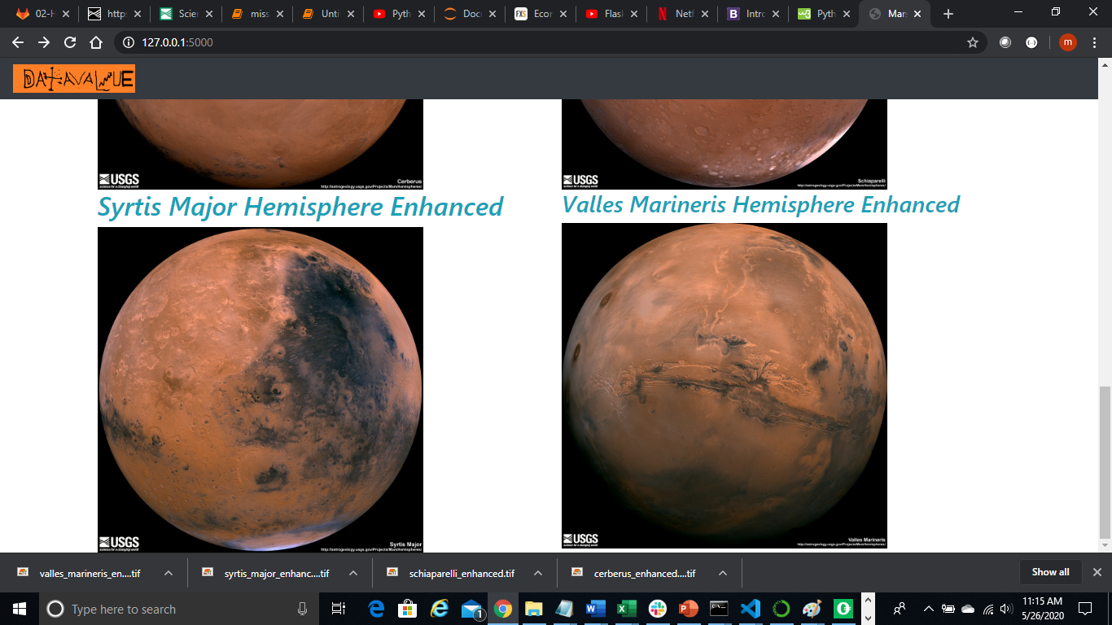

# Mongo DB and Collection

DB: marsinfo_db

Collection: mars_news

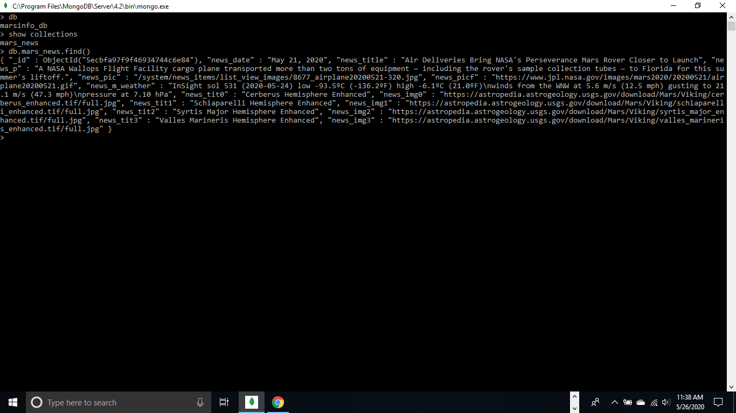

# Application Architecture Diagram:

