**2 Materials and Methods**

**2.1 ACOUSTOFLUIDIC DEVICE**

**2.1.1 Fabrication AND MODELLING**

The acoustofluidic device is made by integrating a piezoelectric transducer with a polydimethylsiloxane (PDMS) microchannel sealed with a glass reflector layer. The surface displacement transducer was created by milling a 0.1 mm-deep indent into the backside of a 30×20 mm2 piezoelectric transducer (*Pz-26, Parker Meggitt, UK*), determining the trapping region. The tilted shape of this indentation and its milling files were designed and generated using AutoCAD and Fusion 360 (*Autodesk Inc, CA, US*). For the milling of both the SDT and the mould, a computerized numerical control (CNC) milling machine (*Modela MDX-40A 3D Milling Machine, Roland DGA, CA, US*) was used.

The transducer was then integrated with the PDMS microchannel. This was done through standard soft lithography. The polymethyl methacrylate mold was milled from a 0.5-mm PMMA substrate and placed in a petri dish. PDMS was mixed in a 10:1 ratio of monomer to curing agent (*SYLGARD 184, Dow Corning, MC, US*) and was then poured into the mould, where the SDT had already been placed. This assembly was degassed for 45 minutes and then cured at 60ºC for 90 minutes. After fluidic connection were done with a 20 ga syringe (*Instech Laboratories Inc., PA, US*), the microchannel was sealed with a glass reflector layer. This was done by using an oxygen plasma treatment to activate the surface of a 75×38×1 mm3 borosilicate microscope slide (*Corning Inc, NY, US*) and of the PDMS slab, which were then bonded together through direct contact.

**2.1.2 DEVICE Modelling**

Similarly to previous work, two theoretical models were combined to predict the operation of the device. A 1D model based on an acoustic transmission line was used to determine the main axial resonances generated by the various material layers of the transducer. Then, COMSOL Multiphysics (*COMSOL 6.1, COMSOL Multiphysics, Sweden*) was used to find the adequate lateral dimensions of the SDT-protrusion to maximize the lateral resonances of the system through an eigenmode simulation. This work allowed a sweep of various eigenmodes and lateral indent dimensions that informed the selection of an ideal acoustic field node distribution. The frequency that generated this acoustic field was then confirmed by an impedance sweep (*Z-Check 16777k,**Analog Instruments*) to determine the SDT’s admittance peaks. Based on this, the frequency of 2.020 MHz was selected to provide a stable and well-defined grid.

**2.1.2 Acoustic field tilt modelling**

The analysis of fluid interactions with the acoustic field was conducted using a scoring system implemented in Python. A 7x7 grid square was constructed based on data obtained from COMSOL Multiphysics simulations. Given the assumption that particles at the nanoscale in laminar flow follow flow lines, the grid was overlaid with equidistant lines to represent flow paths. Both the grid and the flow lines can be observed in figure 1.

Subsequently, a scoring system was developed, leveraging the acoustic pressure decay data obtained from COMSOL Multiphysics simulations, which was then normalized to a range of 0 to 1. In this scoring system, a score of 1 indicates that the flow line passes through the center of the cluster, while a score of 0 signifies that the flow line falls outside the effective range of the cluster's influence.

The algorithm tilted the grid across a range of angles (0 to 90 degrees), to evaluate the interactions between flow lines and the acoustic cluster field across various orientations. Each flow line was assigned a score based on its interaction with the clusters. To determine the overall effectiveness of the acoustic field at each tilt angle, a final score was computed by taking the median value of all the individual scores. The median was chosen due to its robustness against outliers, providing a reliable representation of the typical interaction score.

Based on the median scores observed in figure 2, it was concluded that the highest score, representing optimal flow line interaction with the acoustic cluster field, was observed at a tilt angle of 16º.

Figure 1: Representation of a tilted 7x7 square grid with the clusters as red and blue circles. The flowlines are represented as black horizontal lines.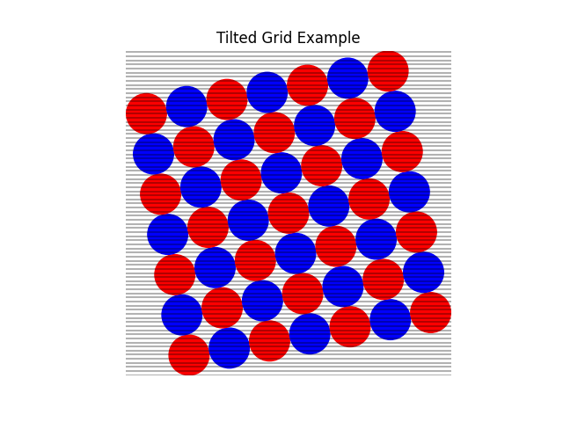

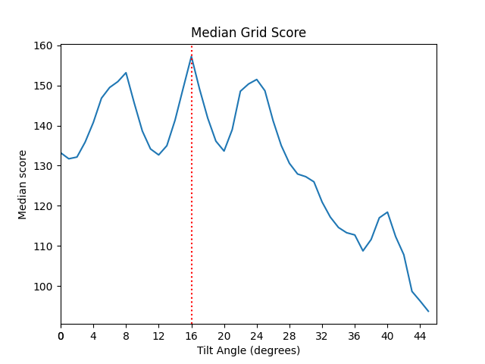

Figure 2: Plot of the median flow line score (arbitrary units) as function of the tilt angle (degrees) of the cluster grid.

**2.2 Experimental**

**2.2.1 Setup and samples**

The experimental setup used with the EchoTilt was composed of a signal generator (*DS345, Stanford Research Systems, CA, US*), a 4× current amplifier (*ADA4870ARR-EBZ, Analog Devices, MA, US*), a syringe pump (*PHD Ultra, Harvard Apparatus, MA, US) and a* fluorescence microscope (*Axiovert 135M, Carl Zeiss AG, Germany*). In terms of fluorescence acquisition, the exposure time used was XXXX ms, the gain was XXX at a magnification of 10×. The fluidic connections were made with plastic tubing (*BTPE-60, Instech Laboratories Inc., PA, US*), metallic connectors (*SC20/15, Prime Bioscience, Singapore*) and plastic syringes (*Plastipak, BD Bioscience, NJ, US*).

The nanoparticle suspensions were created by diluting a stock of polystyrene nanoparticles. The ratio used was 1/100 mL (100× dilution). This method was followed for every particle size, including 500 nm ( ), 200 nm ( ), 100 nm ( ) and 50 nm ( ). The silica solution was created by mixing 1 wt% detergent (Tween-20) with 10 µm silica particles (*Sigma-Aldrich, Switzerland*) in deionized water. To prime the chip, deionized water was used. To clean the chip between experiments, 50% ethanol was used.

**2.2.2 Experimental procedure**

This work relied on the silica-enhanced seed particle method. For this, a high concentration silica solution is flowed through the channel and then the acoustic field is activated. This creates the grid of silica clusters, which is then washed with MQ water at 15 mL/min to remove the excess silica from the device. Finally, the nanoplastic sample is loaded into the device at the flow rate relevant for the experiment which results in the capture of the nanoparticles within the silica clusters. An image was taken every time point with the fluorescence microscope. This data was processed using ImageJ and graphed with GraphPad (*Graphpad Software Inc, US*).