GTI - Banco de dados - 2025 - Anotações de aula

Professor Miguél Suares

2025-07-30

Table of Contents

# Sobre estas anotações

—————————————————————————————————————————————

Estas anotações são apenas lembretes das aulas expostas em sala, durante a disciplina de Banco de dados.

## 0.1 ACESSO AO GITBOOK CELULAR

—————————————————————————————————————————————

#### 0.1.0.1 <https://miguel7penteado.github.io/2025-2sem-GTI-BancoDeDados>



## 0.2 Leitores de formato de arquivo EPUB para SmartPhone

—————————————————————————————————————————————

### 0.2.1 ANDROID

#### 0.2.1.1 **Moon+ Reader**



## 0.3 Livros Texto da Disciplina

—————————————————————————————————————————————

### 0.3.1 [“Introdução a sistemas de bancos de dados” do autor “**Christopher John Date**”](https://www.kufunda.net/publicdocs/Introdu%C3%A7%C3%A3o%20a%20Sistemas%20de%20Bancos%20de%20Dados%20(C.%20J.%20Date)%20(z-lib.org).pdf)

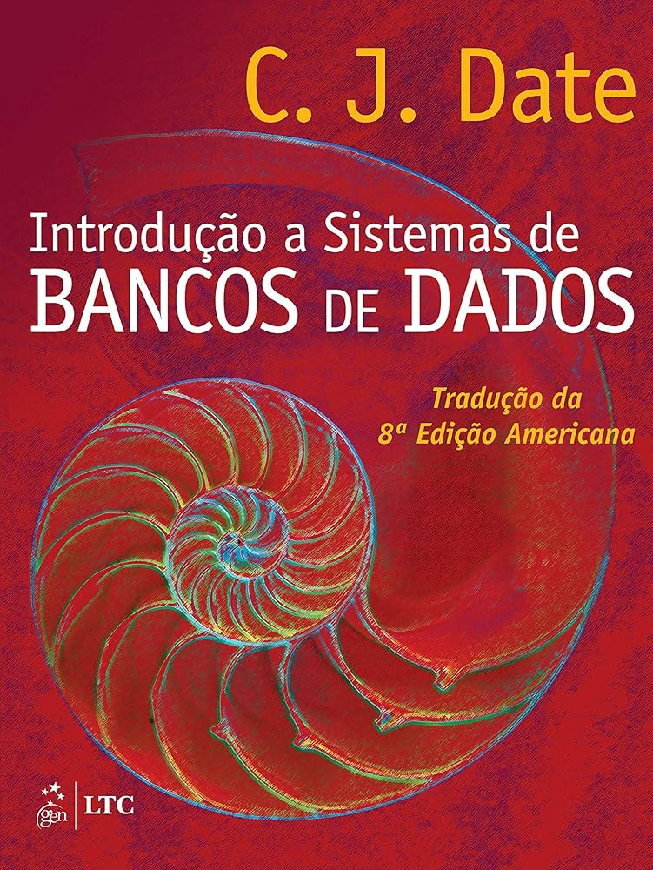

|  |  |
| --- | --- |
| **Autor(es)** | [**Christopher John Date**](https://en.wikipedia.org/wiki/Christopher_J._Date) |
| **Editora** | LTC |
| **Idioma** | Português |
| **ISBN** | 978-85-352-8445-4 |
| **Formato** | Capa dura |
| **Páginas** | 1623 |
| **Código Biblioteca** |  |

### 0.3.2 [“**Projeto de bancos de dados**” do autor “Carlos Alberto HEUSER”](https://drive.google.com/file/d/0B452rmbcudPSVFdCZ09vVkJUUUd2dlpMNS1vaEczUQ/view?pli=1&resourcekey=0-3MTcHlAYjPX6YSvBQGweUQ)

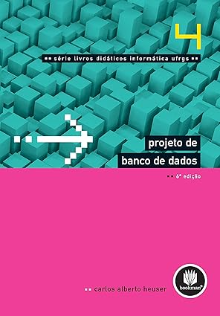

|  |  |
| --- | --- |
| **Autor(es)** | [Carlos Alberto HEUSER](https://www.inf.ufrgs.br/site/docente/carlos-alberto-heuser/) |
| **Editora** | Bookman |
| **Idioma** | Português |
| **ISBN-10** | 8577803821 |
| **Formato** | Impresso |
| **Páginas** | 282 |
| **Código Biblioteca** |  |

## 0.4 Calendário das aulas

—————————————————————————————————————————————

##### 0.4.0.0.1 AGOSTO DE 2025

| Data | Dia da Semana | Aulas | Conteúdo |
| --- | --- | --- | --- |
| 04/08/2025 | Segunda-Feira | Aula Inaugural |  |
| 11/08/2025 | Segunda-Feira | Aula 2 |  |
| 18/08/2025 | Segunda-Feira | Aula 3 |  |
| 25/08/2025 | Segunda-Feira | Aula 4 |  |

##### 0.4.0.0.2 SETEMBRO DE 2025

| Data | Dia da Semana | Aulas | Conteúdo |
| --- | --- | --- | --- |
| 01/09/2025 | Segunda-Feira | Aula 5 |  |
| 08/09/2025 | Segunda-Feira | Aula 6 |  |
| 15/09/2025 | Segunda-Feira | NP1 | PROVA |
| 22/09/2025 | Segunda-Feira | Aula 7 |  |
| 29/09/2025 | Segunda-Feira | Aula 8 |  |

##### 0.4.0.0.3 OUTUBRO DE 2025

| Data | Dia da Semana | Aulas | Conteúdo |
| --- | --- | --- | --- |
| 06/10/2025 | Segunda-Feira | Aula 9 |  |
| 13/10/2025 | Segunda-Feira | Aula 10 |  |
| 20/10/2025 | Segunda-Feira | Aula 11 |  |
| 27/10/2025 | Segunda-Feira | Aula 12 |  |

##### 0.4.0.0.4 NOVEMBRO DE 2025

| Data | Dia da Semana | Aulas | Conteúdo |
| --- | --- | --- | --- |
| 03/11/2025 | Segunda-Feira | NP2 | PROVA |
| 10/11/2025 | Segunda-Feira |  | N/A |
| 17/11/2025 | Segunda-Feira | SUB | PROVA |
| 24/11/2025 | Segunda-Feira |  | N/A |

##### 0.4.0.0.5 DEZEMBRO DE 2025

| Data | Dia da Semana | Aulas | Conteúdo |
| --- | --- | --- | --- |
| 01/12/2025 | Segunda-Feira |  | N/A |
| 08/12/2025 | Segunda-Feira | EXAME | PROVA |
| 15/12/2025 | Segunda-Feira |  | N/A |

## 0.5 Alunos 2025 - 2o Semestre

—————————————————————————————————————————————

### 0.5.1 Campus Chácara Santo Antônio

#### 0.5.1.1 Turma TI2P40

| Matrícula | Nome do aluno |
| --- | --- |
| F362BF0 | BRUNO ANTONIO MARQUES |
| R536FA6 | CAIO CESAR BALBINO DA SILVA |
| H6094I1 | DOUGLAS VINICIUS M DOS SANTOS |
| R6607G5 | GABRIEL ROQUE DOS SANTOS |
| R8133G7 | ÍTALO KEVIN RODRIGUES DA SILVA |
| R837AA0 | LUCAS SOUZA RODRIGUES |
| H714419 | MARCOS PAULO CORDEIRO GOES |

# 1 Hello bookdown

All chapters start with a first-level heading followed by your chapter title, like the line above. There should be only one first-level heading (#) per .Rmd file.

## 1.1 A section

All chapter sections start with a second-level (##) or higher heading followed by your section title, like the sections above and below here. You can have as many as you want within a chapter.

### An unnumbered section

Chapters and sections are numbered by default. To un-number a heading, add a {.unnumbered} or the shorter {-} at the end of the heading, like in this section.

# 2 Cross-references

Cross-references make it easier for your readers to find and link to elements in your book.

## 2.1 Chapters and sub-chapters

There are two steps to cross-reference any heading:

1. Label the heading: # Hello world {#nice-label}.
   * Leave the label off if you like the automated heading generated based on your heading title: for example, # Hello world = # Hello world {#hello-world}.
   * To label an un-numbered heading, use: # Hello world {-#nice-label} or {# Hello world .unnumbered}.
2. Next, reference the labeled heading anywhere in the text using \@ref(nice-label); for example, please see Chapter 2.
   * If you prefer text as the link instead of a numbered reference use: any text you want can go here.

## 2.2 Captioned figures and tables

Figures and tables *with captions* can also be cross-referenced from elsewhere in your book using \@ref(fig:chunk-label) and \@ref(tab:chunk-label), respectively.

See Figure 2.1.

par(mar = c(4, 4, .1, .1))  
plot(pressure, type = 'b', pch = 19)

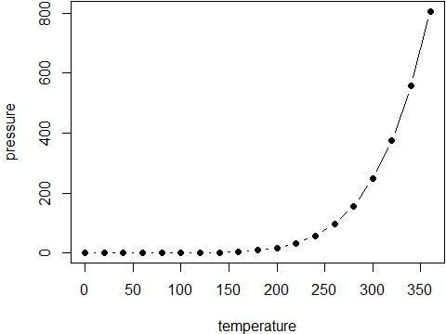

Figure 2.1: Here is a nice figure!

Don’t miss Table 2.1.

knitr::kable(  
 head(pressure, 10), caption = 'Here is a nice table!',  
 booktabs = TRUE  
)

Table 2.1: Here is a nice table!

| temperature | pressure |
| --- | --- |
| 0 | 0.0002 |
| 20 | 0.0012 |
| 40 | 0.0060 |
| 60 | 0.0300 |
| 80 | 0.0900 |
| 100 | 0.2700 |
| 120 | 0.7500 |
| 140 | 1.8500 |
| 160 | 4.2000 |
| 180 | 8.8000 |

# 3 Parts

You can add parts to organize one or more book chapters together. Parts can be inserted at the top of an .Rmd file, before the first-level chapter heading in that same file.

Add a numbered part: # (PART) Act one {-} (followed by # A chapter)

Add an unnumbered part: # (PART\*) Act one {-} (followed by # A chapter)

Add an appendix as a special kind of un-numbered part: # (APPENDIX) Other stuff {-} (followed by # A chapter). Chapters in an appendix are prepended with letters instead of numbers.

# 4 Footnotes and citations

## 4.1 Footnotes

Footnotes are put inside the square brackets after a caret ^[]. Like this one [1].

## 4.2 Citations

Reference items in your bibliography file(s) using @key.

For example, we are using the **bookdown** package (**R-bookdown?**) (check out the last code chunk in index.Rmd to see how this citation key was added) in this sample book, which was built on top of R Markdown and **knitr** (Xie 2015) (this citation was added manually in an external file book.bib). Note that the .bib files need to be listed in the index.Rmd with the YAML bibliography key.

The RStudio Visual Markdown Editor can also make it easier to insert citations: <https://rstudio.github.io/visual-markdown-editing/#/citations>

# 5 Blocks

## 5.1 Equations

Here is an equation.

You may refer to using \@ref(eq:binom), like see Equation (5.1).

## 5.2 Theorems and proofs

Labeled theorems can be referenced in text using \@ref(thm:tri), for example, check out this smart theorem ??.

For a right triangle, if $c$ denotes the *length* of the hypotenuse and $a$ and $b$ denote the lengths of the **other** two sides, we have

$$a^{2}+b^{2}=c^{2}$$

Read more here <https://bookdown.org/yihui/bookdown/markdown-extensions-by-bookdown.html>.

## 5.3 Callout blocks

The R Markdown Cookbook provides more help on how to use custom blocks to design your own callouts: <https://bookdown.org/yihui/rmarkdown-cookbook/custom-blocks.html>

# 6 Sharing your book

## 6.1 Publishing

HTML books can be published online, see: <https://bookdown.org/yihui/bookdown/publishing.html>

## 6.2 404 pages

By default, users will be directed to a 404 page if they try to access a webpage that cannot be found. If you’d like to customize your 404 page instead of using the default, you may add either a _404.Rmd or _404.md file to your project root and use code and/or Markdown syntax.

## 6.3 Metadata for sharing

Bookdown HTML books will provide HTML metadata for social sharing on platforms like Twitter, Facebook, and LinkedIn, using information you provide in the index.Rmd YAML. To setup, set the url for your book and the path to your cover-image file. Your book’s title and description are also used.

This gitbook uses the same social sharing data across all chapters in your book- all links shared will look the same.

Specify your book’s source repository on GitHub using the edit key under the configuration options in the _output.yml file, which allows users to suggest an edit by linking to a chapter’s source file.

Read more about the features of this output format here:

<https://pkgs.rstudio.com/bookdown/reference/gitbook.html>

Or use:

?bookdown::gitbook

Xie, Yihui. 2015. *Dynamic Documents with R and Knitr*. 2nd ed. Boca Raton, Florida: Chapman; Hall/CRC. <http://yihui.org/knitr/>.

1. This is a footnote.