Task 1
  - Section 1
In recent years, various health benefits have been associated with regular physical activity [1]. As a result, long-distance endurance sports such as marathons, ultra-marathons, and triathlons have increased in popularity [2-4]. Esteve-Lanao et al. [2] state that participation in marathon events by recreational runners has become immensely popular worldwide. Additionally, wearable tracking devices have become a common necessity [5][6] as they provide real-time sport-related data (e.g., pace, heart rate). This, in turn, helps individuals achieve a target performance, either during training or a race.
Predicting a marathon race time (MRT) is highly important and provides various entities with insightful information, but some researchers [2][5][7] considered it a difficult task. Amongst others, the underlying reasons point toward the complexity of the sport itself, including the event landscape, unpredictable environmental conditions, different runner biometrics [7], and different tracking devices [5]. This led to the introduction of machine learning (ML) to improve accuracy, including tree-based algorithms (supervised), clustering (unsupervised), and time-series algorithms.
The purpose of this experimental study [8] is to investigate the use of tree-based ML models to predict an athlete's MRT and subsequently evaluate the comparative predictive performance of Random Forest (RF) and Extreme Gradient Boosting (XGBoost) regressors across diverse historical data. The dependent variable of this study is the predictive performance of the ML algorithms in estimating the continuous MRT value, whilst the independent variables will be the dataset and the model type (RF against XGBoost). Specifically, 12-week and 16-week training blocks of historical data will be aggregated and used for each experiment. Moreover, the control variables will be the dataset features, including activity metrics and demographic information, and the train-test data split strategy, so that each ML regressor can make decisions on the same data. This research does not take into consideration the landscape or weather conditions, nor any anthropometric or physiological factors that might alter the result.
To achieve this, the study aims to explore the effectiveness of tree-based ML models in predicting an athlete’s MRT and to identify the optimal model based on predictive performance. Furthermore, this study seeks to determine whether the number of weeks of historical data yields a quantifiable increase in the models’ predictive performance and robustness. Specifically, the hypothesis of this research states that an XGBoost ML regressor will achieve higher predictive performance than an RF regressor. Additionally, it is expected that XGBoost will be most accurate when trained on larger volumes of historical activity data (16-week training block), as this will supply the model with more comprehensive data about an individual's marathon buildup.
In view of the previously mentioned factors and as illustrated in Fig. 1, a positivist philosophy will be adopted as this study is highly focused on gathering quantifiable outcomes (predictive performance) and continuous values (the MRT). A deductive approach will be implemented because a hypothesis has been established, and the study is designed to prove or disprove it. In addition, an experimental strategy will be conducted, given that the research has a dependent variable (accuracy), two independent variables (model type and timeframe of historical data), and various control variables to ensure an unbiased investigation. Thus, a mono-method quantitative research choice will be adhered to, as no surveys, interviews, or questionnaires will be held. It will depend exclusively on an open-source dataset as input and values obtained from different experiments as output. Consequently, although the dataset encompasses a period of time, a cross-sectional time horizon will be utilized. This is because the experiments will leverage a snapshot of aggregated data, rather than monitoring athletes during a specific training block.
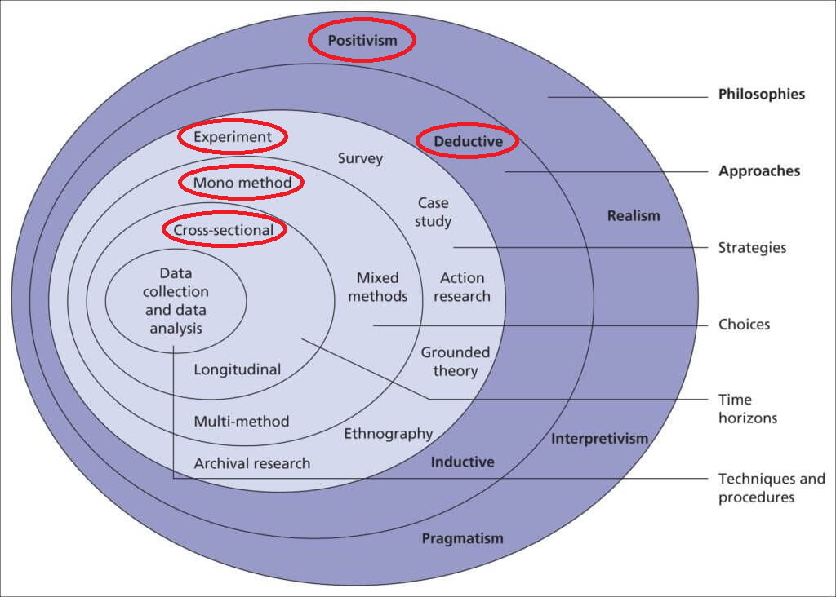
Figure 1 The Research Onion - Adopted from [9]

References:
[1] S. Wiecha, P. S. Kasiak, I. Cieśliński, M. Maciejczyk, A. Mamcarz, and D. Śliż, “Modeling Physiological Predictors of Running Velocity for Endurance Athletes,” JCM, vol. 11, no. 22, p. 6688, Nov. 2022, doi: 10.3390/jcm11226688.
[2] J. Esteve-Lanao, S. Del Rosso, E. Larumbe-Zabala, C. Cardona, A. Alcocer-Gamboa, and D. A. Boullosa, “Predicting Recreational Runners’ Marathon Performance Time During Their Training Preparation,” Journal of Strength & Conditioning Research, vol. 35, no. 11, pp. 3218–3224, Nov. 2021, doi: 10.1519/JSC.0000000000003199.
[3] M. Thuany et al., “An analysis of the 6-h ultra-marathon race using a machine learning approach,” Front. Sports Act. Living, vol. 7, p. 1577470, Sep. 2025, doi: 10.3389/fspor.2025.1577470.
[4] J. Martínez-Gramage, J. P. Albiach, I. N. Moltó, J. J. Amer-Cuenca, V. Huesa Moreno, and E. Segura-Ortí, “A Random Forest Machine Learning Framework to Reduce Running Injuries in Young Triathletes,” Sensors, vol. 20, no. 21, p. 6388, Nov. 2020, doi: 10.3390/s20216388.
[5] A. Karahanoğlu, R. Gouveia, J. Reenalda, and G. Ludden, “How Are Sports-Trackers Used by Runners? Running-Related Data, Personal Goals, and Self-Tracking in Running,” Sensors, vol. 21, no. 11, p. 3687, May 2021, doi: 10.3390/s21113687.
[6] M. Pobiruchin, J. Suleder, R. Zowalla, and M. Wiesner, “Accuracy and Adoption of Wearable Technology Used by Active Citizens: A Marathon Event Field Study,” JMIR Mhealth Uhealth, vol. 5, no. 2, p. e24, Feb. 2017, doi: 10.2196/mhealth.6395.
[7] M. S. Sainin, “Regression-based Finish Time Prediction of 100km Trail Running using Structured Athlete Performance,” in 2025 International Conference on Advances in Machine Intelligence, and Cybersecurity Technologies (AMICT), Kota Kinabalu, Sabah, Malaysia: IEEE, Nov. 2025, pp. 290–295. doi: 10.1109/AMICT65811.2025.11402768.
[8] J. W. Creswell and J. D. Creswell, Research design: qualitative, quantitative, and mixed methods approaches, Sixth edition. Los Angeles: SAGE, 2023.
[9] M. N. K. Saunders, P. Lewis, and A. Thornhill, Research methods for business students, Ninth edition. Harlow, England ; New York: Pearson, 2023.

